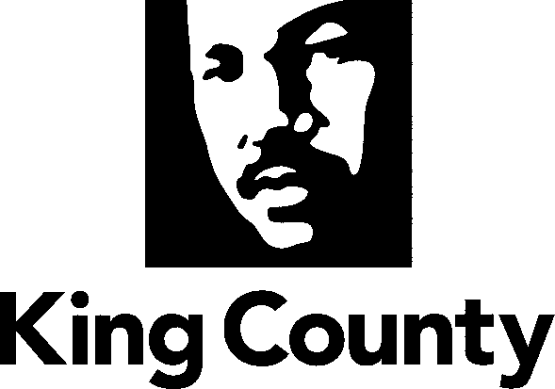

**Adult Services Division**

Women’s Advisory Board

Department of Community and Human Services

401 Fifth Avenue, Suite 510

Seattle, WA 98104

**206 263-9069** FAX: 206-205-6565

TTY Relay: 711

**WOMEN’S ADVISORY BOARD**

**MINUTES FROM THE June 12, 2024, MEETING**

|  |  |  |  |  |  |  |
| --- | --- | --- | --- | --- | --- | --- |
| Meeting Type:  Regular: X  Special: _ | Location: Chinook Building- 401 5th Ave., Seattle, WA  Join Zoom Meeting: Join Zoom Meeting  <https://kingcounty.zoom.us/j/84312053856>  Meeting ID: 843 1205 3856  Passcode: KCWAB | | | Called to Order:  4:00 PM | | By:  Tanya Matthews |
|  |  | | |  | |  |
| **Members Present:** | |  | | | | |
| Sarah Reyneveld- *po.4*  Councilmember Jorge Baron | | | Leslie Kay Hamada- *po.9* Council At-Large | | *Po. 12 Vacant*  Council At-Large | |
| Tanya Matthews- *po.2*  Councilmember Zahilay | | | Sarah Brusig- *po.5* Councilmember Upthegrove | | *Po. 14 Vacant*  Council At-Large | |
| Hend Alhinnawi- *po.10* Council At-Large | | | *Po. 1 Vacant*  Councilmember Dembowski | | *Po. 15 Vacant*  Council At-Large | |
| Hafsa Azaz- *po.13* Council At-Large | | | *Po.8 Vacant*  Councilmember Mosqueda | |  | |
| Ramsey Mayhew- *po.3* Council At-Large | | | *Po. 9 Vacant*  Councilmember Dunn | |  | |
| Yasmin Ali- *po.3*  Councilmember Sarah Perry | | | *Po. 11 Vacant*  Council At-Large | |  | |
| **Excused/Absent:** | |  | | | | |
|  | | | | | | |
| **Speakers:** | Lorrie Alfonsi- King County Metro Accessible Services; Rick Ybarra- King County Boards and Liaisons | | | | | |
| **Staff:** | Marjan Didra King County Staff Liaison; Colton Myers King County Staff | | | | | |
| **Guests:** | Lorrie Alfonsi; Rick Ybarra | | | | | |
| **Approval of Agenda:** N/A | | | | Vote: N/A | | |
| **Approval of Minutes:** N/A | | | | Vote: N/A | | |

**AGENDA ITEMS:**

|  |  |  |  |
| --- | --- | --- | --- |
| **Agenda Item 1:** | **Welcome & Introductions** | | |
|  |  | | |
| **Action Items:** Chair Tanya Matthews | | Person(s) Responsible: | Deadline/Due Date |
|  | | WAB members |  |

|  |  |  |  |
| --- | --- | --- | --- |
| **Agenda Item 2:** | **Public Comment** | | |
|  | None | | |
| **Action Items:** | | Person Responsible | Deadline/Due Date |
|  | |  |  |
| **Agenda Item 3:** | **Announcements** | | |
|  | **Board member Updates:** WAB member Sarah Reyneveld shared an upcoming opportunity for a panel to join former King County Council member Jeanne Kohl-Welles to present to the members of the King County Council the childcare recommendations that WAB members had previously developed. This meeting will take place on Tuesday, June 25th, 2024. The council aims to continue its efforts to provide an affordable childcare opportunity and assess the progress made through the WAB recommendations and efforts through implementation to ensure quality childcare access throughout King County.  Chair Tanya Matthews shared an inspiring initiative. The Seattle Women’s Commission will host a community night event and present an award titled Mothering Social Change.  WAB member Sarah Reyneveld also announced their continued effort to work with King County council members to share their GBV recommendations. Sarah also invited the new members to join them in those meetings. | | |
| **Action Items:** | | Person Responsible | Deadline/Due Date |
|  | | WAB members |  |
| **Agenda Item 4:** | **Transportation Presentation- Metro** | | |
| **Action Items:** The presentation included Metro’s reduced fare program for people with disabilities or who are over 65. It also highlighted the Hyde Shuttle program, which fills the gap in supporting people with disabilities or those who are over 65 and are not qualified for the King County access program. | | Person Responsible | Deadline/Due Date |
|  | | Lorrie Alfonsi | 6-12-2024 |
| **Agenda Item 5:** | **Orientation of the New Members** | | |
| **Action Items:** WAB members actively engaged in the discussion, presenting the history of WAB, and exploring the various elements of the WAB recommendation process. They also demonstrated their commitment by discussing the creation of a comprehensive process for developing the next set of recommendations.  Rick Ybarra from King County joined the WAB members to answer questions and provide information. Rick delivered a comprehensive overview of the advisory boards' role and offered valuable technical insights on the Public Records Act, WAB email utilization, and financial disclosure. | | Person Responsible | Deadline/Due Date |
|  | | Tanya Matthews/ Sarah Reyneveld; Rick Ybarra | 6-12-2024 |
| **Action Items:** | |  |  |
| Members to reach out to their Councilmembers to brief them on Gender-Based Violence Recommendations and share the existing vacant positions. | | WAB members | ASAP |
| Members to reach out to the Transit Riders Union to join WAB meeting to present. | | WAB members | ASAP |
| Members to reach out to the King County Health and Human Services Committee to present the GBV recommendations. | | WAB members | ASAP |
| Members to create a comprehensive list of processes for the next set of recommendations. | | WAB members | ASAP |

**AJOURNMENT**

Time: 6:00 p.m.

**NEXT MEETING**

Date: July 10, 2024, Chair: Sarah Reyneveld Time: 4:00-6:00 p.m. Location: Chinook Building- 401 5th Ave., Room 118, Seattle, WA OR Zoom/Call-In