Exhibit B- Microsoft Word Skills Assessment
For Assessor Only:
Total Points: / 28 points
Name:
Date:
The purpose of this assessment is to test your Microsoft Word skills. This will help us to determine your qualification for the Language Access Program. There is a possible total score of 28 points. Each section has a score corresponding to the steps in each task. A score of 20 or higher will be necessary to be included in the program.
The total points for this assessment will be categorized as:
0-19 Points: Does Not Qualify for Program
20 Points or more: Qualifies for Program
Please follow the instructions carefully in each section and complete each task and step.
Section One: Commenting Score: /5 Points
Scoring Criteria: 1 point for each step that is completed correctly.
Task A
Step One: Create a comment box for the entire first sentence.
Step Two: Copy the phrase below into the comment box.
- [This looks good]
Task B:
Step One: Make the edits that are written in the comment in sentence three.
Step Two: remove the comment box from the paragraph.
Task C:
Step One: Respond to the comment in sentence five and copy the phrase below as the response.
- [Yes, it includes important information]

Isolation and quarantine centers are available to provide a safe, clean, and comfortable place to stay for people who can’t safely self-quarantine or isolate in their own home, or don’t have a home. These places are free and confidential for everyone, and your stay is not reported to any authority outside Public Health.
To access services, call the King County COVID-19 Call Center at 206-477-3977 from 10 a.m. to 10:00 p.m. daily to see if isolation and quarantine services are right for you. Say your language to be connected to an interpreter.
Learn more about King County Isolation and Quarantine support services here.

Section Two: Updates Score: /6 points
Scoring Criteria: Each update is worth 2 points—1 point for completing the update correctly and 1 point if the format is correct in the final text. Please note that you do not need to translate this section. The final text should be in English.
Step One: Read through the instructions below for updates to Cell 1, 2, and 3 and place the new update in the final text column of the table. Make sure that the final text doesn’t include any highlights.
  - Yellow highlights indicate removal of words in an existing translated document, strikethrough language should be removed.
  - Blue highlights indicate new words to be added to an existing translated document.
  - Make sure that the final text is the same font, size, and format as the Initial Text column.
 | Initial Text | Updates | Final Text
Cell 1 | If you are NOT fully vaccinated or boosted: | Remove the highlighted phrase. Replace it with up-to-date on vaccination and booster:
Cell 2 | If you are up-to-date with vaccination and booster:  - You do not need to quarantine.  - Wear a high-quality, well-fitting mask (i.e. N95, K95, KF94, surgical mask, cloth mask with double layer or filter) around others for 10 days after the exposure.  - Test on day 5, if possible.  - Pay attention for symptoms. If you develop symptoms, immediately quarantine unless you get a negative COVID-19 test result. | Remove the highlighted text.
Cell 3 | familiarize yourself with where masks are still required. Please respect people’s choice to still wear a mask. | Remove the yellow highlighted text and add in this phrase after the first sentence: Thank you for respecting people’s choice to still wear a mask.

Section Three: Formatting Score: / 6 points Scoring Criteria: 1 point for each step that is completed correctly. Please note that there are three tasks for this section.

Task A:
Step One: Format the bullet points so that they are lined up evenly.
Step Two: Make sure that each of the bullet points match.
Masks are required in:
- Healthcare and medical facilities, including hospitals, outpatient, dental facilities, and pharmacies
- Long-term care settings
- Public transit, taxis, rideshare vehicles (federal requirement)
    - Correctional facilities

Task B:
Step One: Reformat this box so all of the words are visible and they fit in the box above the picture.

Locations where masks are required by federal and state law
These posters are for use in places where federal and state law require masks (he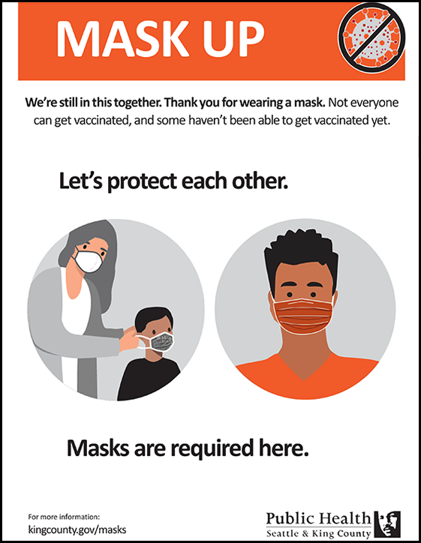althcare, long-term care, public transit, taxis/rideshares, correctional facilities).

Task C
Step One: Copy and paste the below text into the box.
Step Two: Reformat the text to make it fit in the box. Do not change the size of the box.
Step Three: Change the font in the second sentence to Calibiri (Body) to match the font in the rest of the text.

Face Masks
Masks remain an important tool in helping to limit the spread of COVID-19.
People who are immunocompromised, unvaccinated, or feel sick should wear masks to protect themselves and others when in indoor public spaces. Children ages 2-4 are encouraged to wear a mask with adult supervision. Babies and toddlers under age 2 should never wear masks.

Section Four: Hyperlinks Score: /4 points
Scoring Criteria: 1 point for each step that is completed correctly.
Step One: Create a hyperlink for the phrase “CDC’s guidance for improved mask use.”
Step Two: Insert the English web link in the comment box into the hyperlink.
Step Three Check all of the web links to make sure that they are working correctly. Answer the question below the box.
Step Four: Remove the comment box once you have inserted the hyperlink into the paragraph.

- Make sure masks fit snugly against your face. Gaps can let air with respiratory droplets leak in and around the edges of the mask.
- Use a cloth mask with multiple layers of fabric or wear a disposable mask underneath a cloth mask.
- Choose masks with a nose wire or mask fitter
- For visuals of these tips, visit the CDC's guidance for improved mask use.

Are there any links that are not working? If so, please indicate which link is not working.

Section Five: Track Changes Score: /7 points
Scoring Criteria: 1 point for each step that is completed correctly.

Task A: Place the words and edits below into track changes formatting in the paragraph.
Step One: In the title, change Medical Advice so that it is not capitalized.
Step Two: In sentence two, add the word “call” after the comma and before “the King County COVID-19 call center”.
Step Three: In sentence three add a period between “symptoms” and “if”. Capitalize the word “if”.
Step Four: In sentence four change the spelling of “emergancy” to emergency.

Task B: In the section with the bullet points, resolve and remove the track changes from the paragraph.
Step One: Accept the edit made to the first bullet point.
Step Two: Remove the comment and accept the suggested word change in the second bullet point.
Step Three: Do not accept the change made in the third bullet point. Remove the edit, and keep it as the original
sentence.

Seek Medical Advice, if needed
Connect by phone with your healthcare provider or a nurse consulting line, especially if the sick person is age 60 or older or is at risk for severe illness because of a medical condition (examples: diabetes, heart disease, lung disease, or a weakened immune system). If you do not have a healthcare provider, the King County COVID-19 call center between 8 a.m.-7 p.m. at 206-477-3977.
Pay attention to the symptoms if the symptoms get worse, call a healthcare provider for guidance.
Watch for emergancy signs. Call 9-1-1 if the sick person has:
  - Trouble breathing
  - Persistent pain or pressure in the chest
  - Unusual feelings of confusion or the person is not able to respond
  - Lips or face have a blue or purple tint
Need help finding a doctor or getting health insurance?
Call the Community Health Access Program (CHAP): 1-800-756-5437 or the Help Me Grow Washington Hotline: 1-800-322-2588.

