Technical Assistance for Applicants

Health Care for the Homeless Network (HCHN)
RFP for Services 2025-2027

Application Assistance

We know that there are many systemic barriers and inequities that make it challenging for organizations grounded in community to apply for funding opportunities. To support organizations as they navigate the application process, we partner with Technical Assistance (TA) consultants who bring a wide range of skills, areas of expertise, and language abilities to listen, support, and amplify the strengths of community-based organizations across King County. TA is free of charge to applicants!

We are excited to introduce our TA consultants! They can support by:
- Helping to determine appropriate fit between your proposal and the funding opportunity.
- Providing guidance on how best to answer application questions.
- Supporting your application development, including editing and budget review.

If you are applying for an open and/or upcoming funding opportunity and would like the help of a TA consultant, please reach out directly to them using their email addresses provided below. We encourage you to only contact one TA consultant and provide them 24 hours to respond before contacting any other consultants.

Please reach out to a TA Consultant as early as possible. We cannot guarantee TA provider availability within 5 business days of when the funding opportunity closes.

Read on to learn more about the TA consultants (in alphabetical order)!

Bulle Consulting

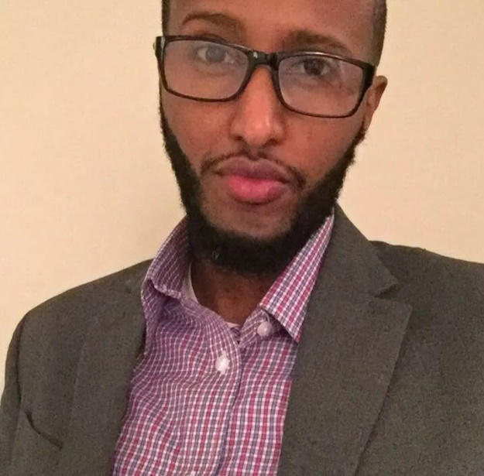
Hassan Wardere and his team focus on an equity-driven Return on Relationship (RoR) framework that is centered on strengths-based practices. Their holistic experience enables them to provide capacity building services that help organizations strengthen their internal infrastructure, continuously improving their ability to scale and adapt to change. Bulle has helped over 104 organizations across the U.S., and has worked with clients in Brazil, Rwanda, Ghana, South Africa, and Senegal. Language is an important factor in their work, and they have a diverse team that values language justice. Bulle promotes co-creation within a holistic process that champions King County’s diversity and utilizes culturally congruent strategies that enable families and children to thrive.
Contact: projects@bulleconsulting.com

Crux Consulting Consortium
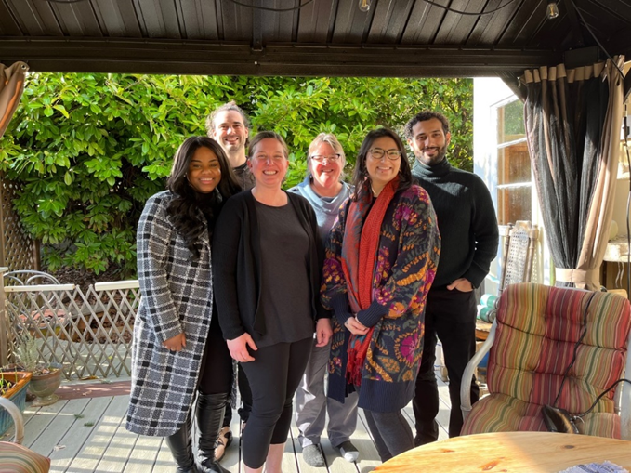

Crux provides wide-ranging technical assistance and capacity building services to passionate, equity driven organizations. Catherine Verrenti, the primary lead for grant assistance with Crux, brings over 20 years in direct service leadership, including extensive successful grant writing, to this work, leveraging programmatic experience in areas including youth development, education, workforce development, health, homelessness, seniors, immigrant/refugee issues, food security and more. She listens deeply to what organizations seek to accomplish through each grant opportunity to customize a partnership that ensures each proposal submitted is compelling, responsive, and achievable. She sees her role as ensuring that community providers tell their stories through the proposal process to best meet their missions.
Contact: catherine@verrenticonsulting.com

Dicentra
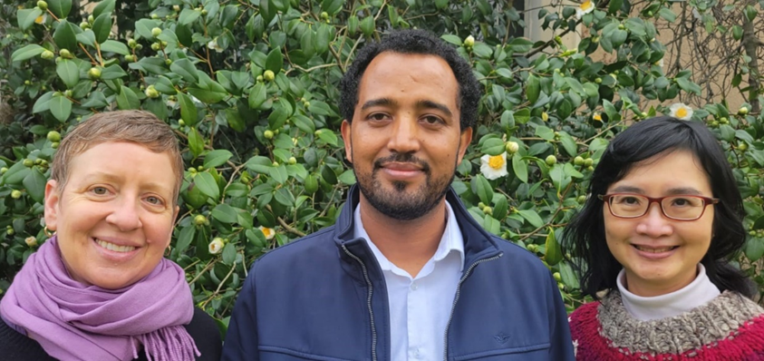
Dicentra Consulting’s team — Swee May Cripe, Ashenafi Cherkos, and Karen Cowgill — is delighted to have this opportunity to support community-based organizations (CBOs) as they apply for Best Starts funds. Our team speaks Amharic, Tigrigna, Spanish, French, Malay, and Cantonese. We have skills and many years of experience in writing proposals that get funded, designing projects, analyzing data, and conducting evaluations. We focus on building transformational relationships that are based on trust and respect. We understand that every person has value, and we want to help you promote voices from your community. We will first listen to understand the vision and mission of your CBO and what you hope to do with Best Starts funds. Then we will agree together on how we can best support you to tell your story. We are excited to help you craft strong proposals that will be funded and lead to successful programs!
Contact: askdicentra@gmail.com

Inclusive Data
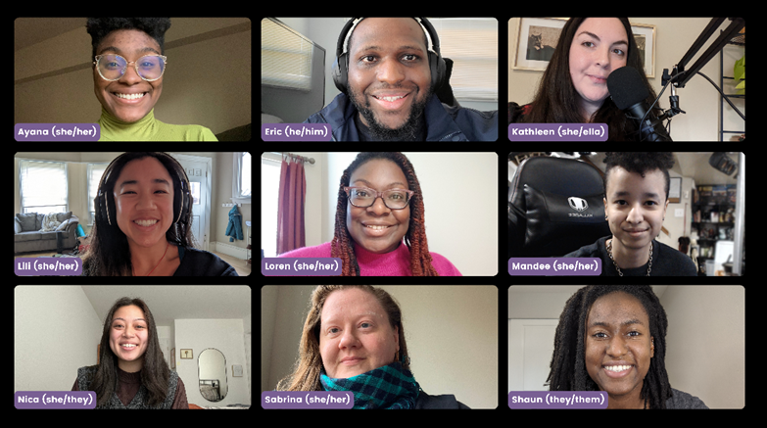
Inclusive Data is a consulting team of grant winners and tech wizards who teach and support clients to create community-led solutions. We’ve honed our grant skills into an $18+ million playbook for Black non-profits and small businesses in our community all while centering liberation frameworks. For Best Starts for Kids, we provide both Technical Assistance and IT Capacity-Building in English, Spanish, and Mandarin. A strong grant proposal demonstrates an organization’s ability to build effective partnerships. If you want help creating your own irresistible grant proposals or robust coalitions, we’re your team. We will work with you on grant proposal strategies, planning, checklists, and reviews. We can provide a website audit and asynchronous video interview to better understand your needs. Contact us today to start your winning proposal.
Contact: bsk@inclusivedatasolutions.com or (253) 693-0235

Optimum Nonprofit Consulting
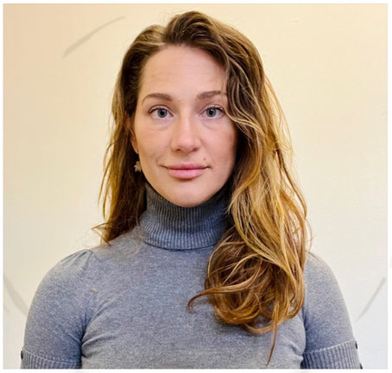
Optimum Nonprofit Consulting (ONC) is a collective of experts (DeAndrea, Hillary, Chase, and Donald) with experiences across the fields of grant writing, accounting, human resources, marketing, education, and social justice services. With over 60 years of combined involvement supporting non-profits and social service organizations throughout King County, our track record is lined with successes. ONC realizes that small, diverse organizations are well connected to their communities with specialties for addressing the needs of families and children. Thus, for Community Based Organizations seeking BSK funding, ONC will provide enlightening assistance for meeting request for proposal (RFP) requirements. Proposals are thoroughly reviewed, suggesting edits, metrics, and giving guidance for uplifting the power and personality of an organization in their submission. ONC’s Hillary Rose provides technical assistance. ONC’s coaching fosters growth while ensuring proposals are culturally responsive and centered in equity strategies.
Contact: info@optimumnonprofitconsulting.com

reimagine collective

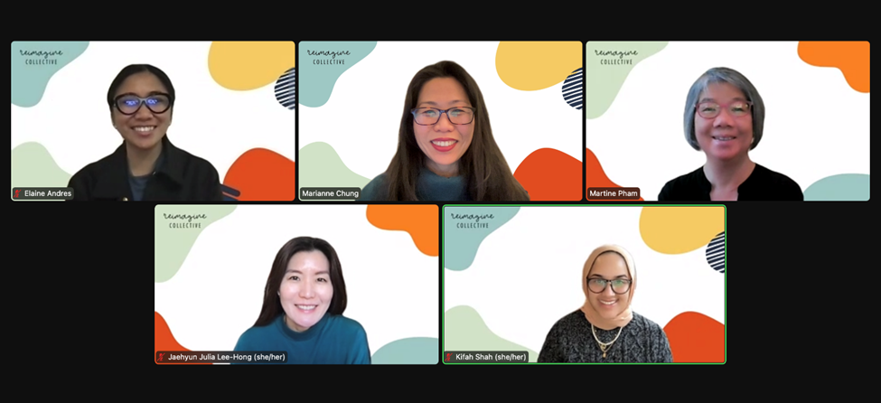
reimagine collective is an association of mission-driven Asian American strategists, organizers, coaches, and designers. With decades of technical assistance and capacity building experience to draw upon, the collective strives to reimagine how people come together to cultivate themselves and their communities. reimagine has 20+ years of experience training community-based organizations in grant writing. For community outreach and coalition building, we work with leaders to build strategy, tactics, and tools to advance their goals. We also help set up appropriate infrastructures for human resources.
Contact: Marianne Chung, marianne@reimaginecollective.co or (404) 530-9054

