Public Health, Seattle-King County  Environmental Health Services |  | 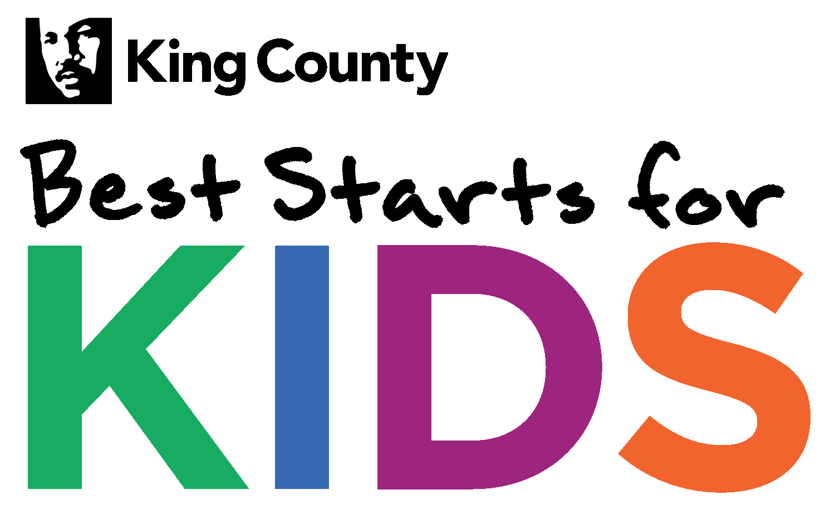
REQUEST FOR Proposal (RFP)

LEAD AND TOXICS, Reducing Toxics Exposures in our Communities
RFP Release Date: February 23, 2024
Due Date: | April 17, 2024 by 2:00 p.m.
RFP Lead | Phillip Thompson, phithompson@kingcounty.gov
Funding: | Up to $750,000 in Best Starts for Kids funding

Submitting a Proposal Proposals are hereby solicited and will be received using the link below through ZoomGrants no later than 2:00 p.m. on the due date noted above. The services procured through this RFP shall be provided in accordance with the following and the attached instructions, requirements and specifications. Applicants are responsible for regularly checking ZoomGrants for any updates, clarifications or amendments to this RFP.
Submit proposals through ZoomGrants at:
https://www.zoomgrants.com/gprop.asp?donorid=2209&limited=5199
OPTIONAL INFORMATION SESSIONS
Session 1: March 5, 2024. 11 am to 12 pm
Join Zoom Meeting
https://kingcounty.zoom.us/j/81162633409
Meeting ID: 811 6263 3409
Passcode: 211567

Session 2: March 18, 2024. 2:30 to 3:30 pm
Join Zoom Meeting
https://kingcounty.zoom.us/j/88580773749
Meeting ID: 885 8077 3749
Passcode: 024694

TABLE OF CONTENTS

Contents
I. Introduction 3
A. Equity and Social Justice 4
B. Program Purpose Statement and BSK Investment Area 4
II. RFP Description 5
A. RFP Background 5
B. RFP Details 7
C. Required Project Activities 13
III. Eligibility 14
IV. Available Funding 15
V. RFP Process 15
A. Timeline 15
B. Questions 16
C. Information Sessions (optional) 17
D. Communication 17
VI. Proposal Process 17
A. Proposal Package 18
VII. Application Assistance 18
A. Rating Criteria 19
B. Review Process 21
C. Selection Process 22
D. Funding Allocation and Contract Negotiations 22
VIII. Glossary of Terms 22
IX. RFP and Contract Terms 24
A. RFP Terms 24
B. Contract Terms 25

- Introduction

Best Start for Kids (BSK) Public Health - Seattle & King County (PHSKC) is pleased to release this Request for Proposal (RFP) for Environmental Supports: Lead and Toxics with funding from Best Starts for Kids
Environmental racism and other injustices have resulted in toxics waste and polluting industries being concentrated in areas where communities of color and low-income families work, live, and play. This has resulted in those communities experiencing higher exposure to toxics and higher rates of health problems from those exposures.
Despite these challenges, communities have long been charting the path forward on environmental justice, pushing for equitable policies and practices to address and prevent harm from toxics exposures in underserved communities. The purpose of this RFP is to support the work of communities most impacted by toxics to address exposure sources harming families and young children in King County.
PHSKC seeks to fund pilot projects that do one or more of the following:
- Create opportunities for community organization coalition-building, skill-building, and cross-sector partnerships with the aim of informing systems-level policies and programs to reduce toxics exposures in children, pregnant people, and their families,
- Support community-based participatory research or citizen science projects that create opportunities to better understand and address toxics exposures in priority communities,
- Create workforce development opportunities in healthcare to increase medical professionals’ ability to prevent and equitably address toxics exposures children, pregnant people, and their families,
- Create workforce development opportunities or focused programs in industries that put children and families at risk for take-home exposures.

The RFP is specifically focused on reducing exposures amongst children, pregnant people, and their families to the toxics listed in:
- The Washington State Department of Ecology’s priority toxic chemicals list,
- The Safer Products for Washington program’s priority chemicals,
- The priority toxic chemicals and chemicals of high concern to children listed in the Children’s Safe Products Act,
- And the chemicals and chemical classes listed in Toxic-Free Cosmetics Act (HB 1047).

Organizations can and are encouraged to submit a joint application, however individual applications are still welcome.

Best Starts for Kids (Best Starts) is King County’s community-driven initiative to support every baby born and child raised in King County to be happy, healthy, safe, and thriving. Initially approved by voters in 2015 and in place since 2016, Best Starts invests in comprehensive supports for children, youth, young adults, and families and caregivers, catalyzing strong starts in early childhood, and sustaining those gains as children progress to adulthood. Best Starts was renewed by voters in August 2021. Implementation of Best Starts is guided by the BSK Implementation Plan, approved by the King County Council in November 2021 for Levy 2022-27.

Equity and Social Justice

For many in our region, King County is a great place to live, learn, work, and play. Yet we have deep and persistent inequities - especially by race and place - that in many cases are getting worse and threaten our collective prosperity. In 2020 Executive Constantine declared racism as a public health crisis and set forth policy priorities to bolster King County’s commitment to being intentionally anti-racist and accountable to Black, Indigenous People, and People of Color. Equity and Social Justice (ESJ) is an integrated part of the County’s work and foundational to the work of BSK. Our goal is to ensure that all people, regardless of who they are and where they live, have the opportunity to thrive, with full and equal access to opportunities, power, and resources. For all Best Starts-funded programs, we seek to support community-led and community-informed organizations that are reflective of and embedded in the communities they serve across all aspects of their leadership and service. We further seek to support organizations that recognize and address the health inequities that exist in our communities, particularly agencies that serve low-income families, families of color, immigrant, and refugee families, LGBTQ families, families with disabilities, families with foster children, and those geographically isolated – furthering Best Starts’ commitment to equity.

Applicants may be asked to demonstrate an understanding and a commitment to the principles of equity and social justice as shown through their staffing and their board, services tailored to community need and through their commitment to social justice and continuous improvement. One aspect of this work includes understanding, at both a program and system level, structural and institutional racism that impacts individuals served through BSK-funded services, and the inequitable impacts on individuals’ collective experiences and outcomes compared to the population as a whole.

More information about King County’s ESJ work is available at: https://kingcounty.gov/elected/executive/equity-social-justice.aspx

Program Purpose Statement and BSK Investment Area
The Public Health – Seattle & King County (PHSKC) Lead and Toxics Program (LTP) receives funds from BSK, the Centers for Disease Control and Prevention (CDC) Childhood Lead Poisoning Prevention Program, the WA Department of Ecology, and the Environmental Protection Agency (EPA). With these funds, we partner with community-based organizations to raise awareness and strengthen systems to protect those most at risk of lead poisoning and other toxic exposures.
The LTP is a part of the Best Starts for Kids' Investing Early (prenatal to 5 years old) strategy. Best Starts invests early to support pregnant and parenting families, infants, very young children, and caregivers during the critical first five years of life with a robust system of support services and resources that meet families either at home, in the community, or wherever children are cared for.
- RFP Description

RFP Background
There is a wide range of research showing the relationship between toxic exposures and human health. For example, lead exposure can cause damage to the brain resulting in learning and behavior challenges; mercury exposure is known to damage the kidney and liver; and flame retardants have been linked to cancer.
Young children, aged six and under, are more sensitive to toxic exposures due to their smaller size and developing brains and bodies. During pregnancy harmful toxics can pass from a parent to their developing fetus, increasing the risk of miscarriage, premature birth, and low birth weight. Toxics exposures during pregnancy can also continue to harm a child’s health after they are born. For example, if a fetus is exposed to lead while in the womb, it can harm their brain and cause developmental challenges later in life.

We are exposed to toxics through inhalation, ingestion, and skin contact. For example, we breathe in chemicals in the air from smoke, vehicle exhaust, dust from products in our homes, or chemical gases given off by sealants, glues, and polishes. We eat food and drink water that may have chemicals in or on them. We also touch and use products that contain chemicals that can be absorbed through the skin.

The RFP is specifically focused on reducing exposures amongst children, pregnant people, and their families to the toxics listed in:

- The Washington State Department of Ecology’s priority toxic chemicals list,
- The Safer Products for Washington program’s priority chemicals list,
- The priority toxic chemicals and chemicals of high concern to children listed in the Children’s Safe Products Act,
- And the chemicals and chemical classes listed in Toxic-Free Cosmetics Act (HB 1047).

We are focused on these chemicals or chemical classes because of their use in consumer products and because they are “considered the ‘worst of the worst’ and raise special challenges for society and the environment”. For example, the priority toxic chemicals included in the Washington State Department of Ecology’s list were identified using three criteria:

- Persistence — Chemicals that stick around in the environment for a long time cause more concern than those that quickly dissipate or react with other substances into more stable forms.
- Bioaccumulative — Chemicals that accumulate over time in plants, animals, and people are a threat because they build up through the food chain — and we are at the top of the food chain.
- Toxicity — Exposure to the chemical has been linked to a wide range of toxic effects in fish, wildlife, and humans. Toxicity includes both immediate effects, such as damage to the lungs, and long-term effects, such as increasing the risk of cancer.

Due to environmental racism, not all people experience the same types or levels of toxics exposures, and many communities lack access to the resources needed to take actions to protect their health. Discriminatory policies such as redlining and segregation have forced communities of color, especially Black communities, to live closer to sources of pollution and toxic substances. Hazardous industries and facilities are often located in or near these communities, leading to increased exposure to pollutants. Additionally, due to discrimination and a lack of investment, these areas often lack the infrastructure, resources, and regulations needed to lower the risk from these harmful toxics.

The impact of environmental racism extends beyond housing. People of color are employed at higher rates than white people in industries with higher exposure to toxics, which can also lead to take home exposures for children. In addition, limited access to quality healthcare, economic opportunity, and spaces where environmental policy and funding decisions are made increase the challenges these communities face in addressing toxics exposures.

Despite these challenges, communities have successfully moved environmental justice forward, pushing for equitable policies and practices that have brought resources to communities experiencing toxics exposures and for changes in policies and practices to prevent future harm. From communities living in the Duwamish River Valley fighting for proper cleanup and source control of the EPA Superfund site, to community organizations advocating for a ban on lead in cookware in Washington State, communities most affected by toxics exposures are advocating for real changes and protections that improve everyone’s health.

RFP Details
The purpose of this RFP is to support the work of community-based organizations who serve communities most impacted by toxics to address exposure sources harming families and young children in King County.
The RFP is specifically focused on reducing exposures amongst children, pregnant people, and their families to the toxics listed in:

- The Washington State Department of Ecology’s priority toxic chemicals list,
- The Safer Products for Washington program’s priority chemicals list,
- The priority toxic chemicals and chemicals of high concern to children listed in the Children’s Safe Products Act,
- And the chemicals and chemical classes listed in Toxic-Free Cosmetics Act (HB 1047).

Organizations can focus on more than one chemical or chemical class.

All selected applicants will be required to work with the BSK’s Innovation Supports team in year one of funding (See Section II, C. Required Project Activities for details). The Innovations Supports team will help applicants in their initial project development and planning processes.

Organizations can and are encouraged to submit a joint application, however individual applications are still welcome. For joint applications, one organization should be identified as the primary applicant, who will serve as the fiscal agent with the partner organization(s) listed as sub-recipients.

Who Should Apply?

Ideal applicants will:

- Uphold and center community needs, strengths, and interests in all decisions and recommendations.
- Seek to build relationships with other organizations and individuals from the focus communities they are serving.
- Intentionally design programming and projects to be reflective of the communities they are serving. This includes considering language and other access needs, as well as including community members throughout the design of the project to ensure it is culturally informed and appropriate.
- Recognize and seek to address the historical and current systemic racism and structural violence that puts communities of color and other focus communities at increased risk of toxic exposures.

Focus Communities
All proposals for this RFP must prioritize serving pregnant people, parents, caregivers, babies, and young children.

All proposals for this RFP should also prioritize serving one or more of the focus communities most impacted by toxics. These communicates include:

- Families with lower income,
- BIPOC communities,
- Children eligible for Medicaid (Apple Health),
- Families living in subsidized or low-income housing,
- Families living unhoused or with unstable housing,
- Immigrants, refugees, and people who are undocumented or living in mixed immigration-status households,
- Families with parents/caregivers working in industries with high risk for toxics exposures,
- Other communities that live in areas with legacy pollution.

Project Outcomes
To ensure projects are meeting the goals of this RFP, applicants must demonstrate how their project will result in at least two of the outcomes listed below:

Outcome 1: Build skills and networks amongst community-based organization(s) serving the RFP’s focus communities to develop and participate in systems change and policy work to reduce toxics exposures.
Outcome 2: Increase cross-sector partnerships and collaboration to reduce toxics exposures in focus communities.
Outcome 3: Increase data and research available on current and emerging source(s) of toxics exposure(s) in King County affecting focus communities.
Outcome 4: Take actions that support policies or programs that reduce toxic exposures in focus communities.

Types of Projects Eligible for Funding
This RFP seeks to support projects that fall into one of four categories:
Project Category A: Community Organization Coalition Building to Address Toxics Exposures through Policy and Systems Changes. Create opportunities for community coalition-building, skill-building, and cross-sector partnerships with the aim of informing systems-level policies and programs to reduce toxics exposures.
Project Category B: Community Based-Participatory Science or Citizen Science. Support community-based participatory research or citizen science projects that create opportunities to better understand and address toxics exposures in priority communities.
Project Category C: Workforce Development in Healthcare. Create workforce development opportunities in healthcare to prevent and address toxics exposures in youth and children.
Project Category D: Workforce Development in Housing, Construction, and Other High-Risk Industries. Create workforce development opportunities or focused programs in industries that put children and families at risk for take-home exposures.

Examples of relevant activities and specific projects are provided below under each project category. If you wish to propose activities that are not included in the lists below, your proposal must:
- Explain how your project falls into one of the four project categories,
- Clearly describe your activities,
- And explain how your activities will result in the two outcomes you’ve selected.
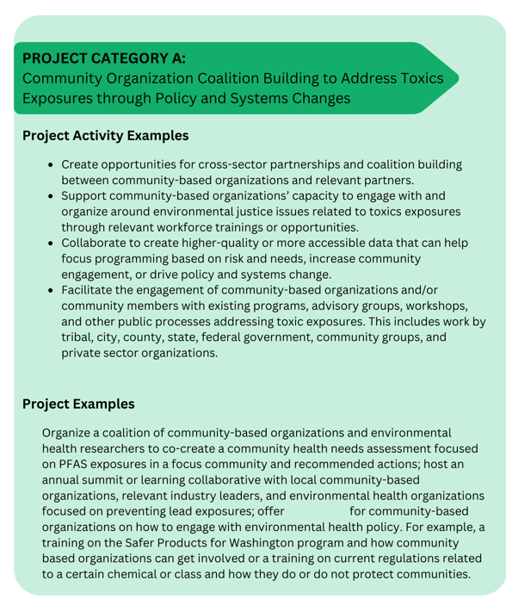
workshopsps

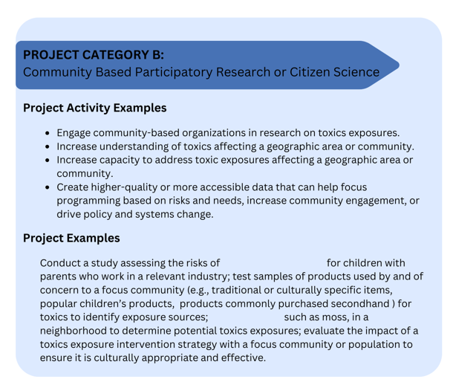
study samples,
take-home exposures
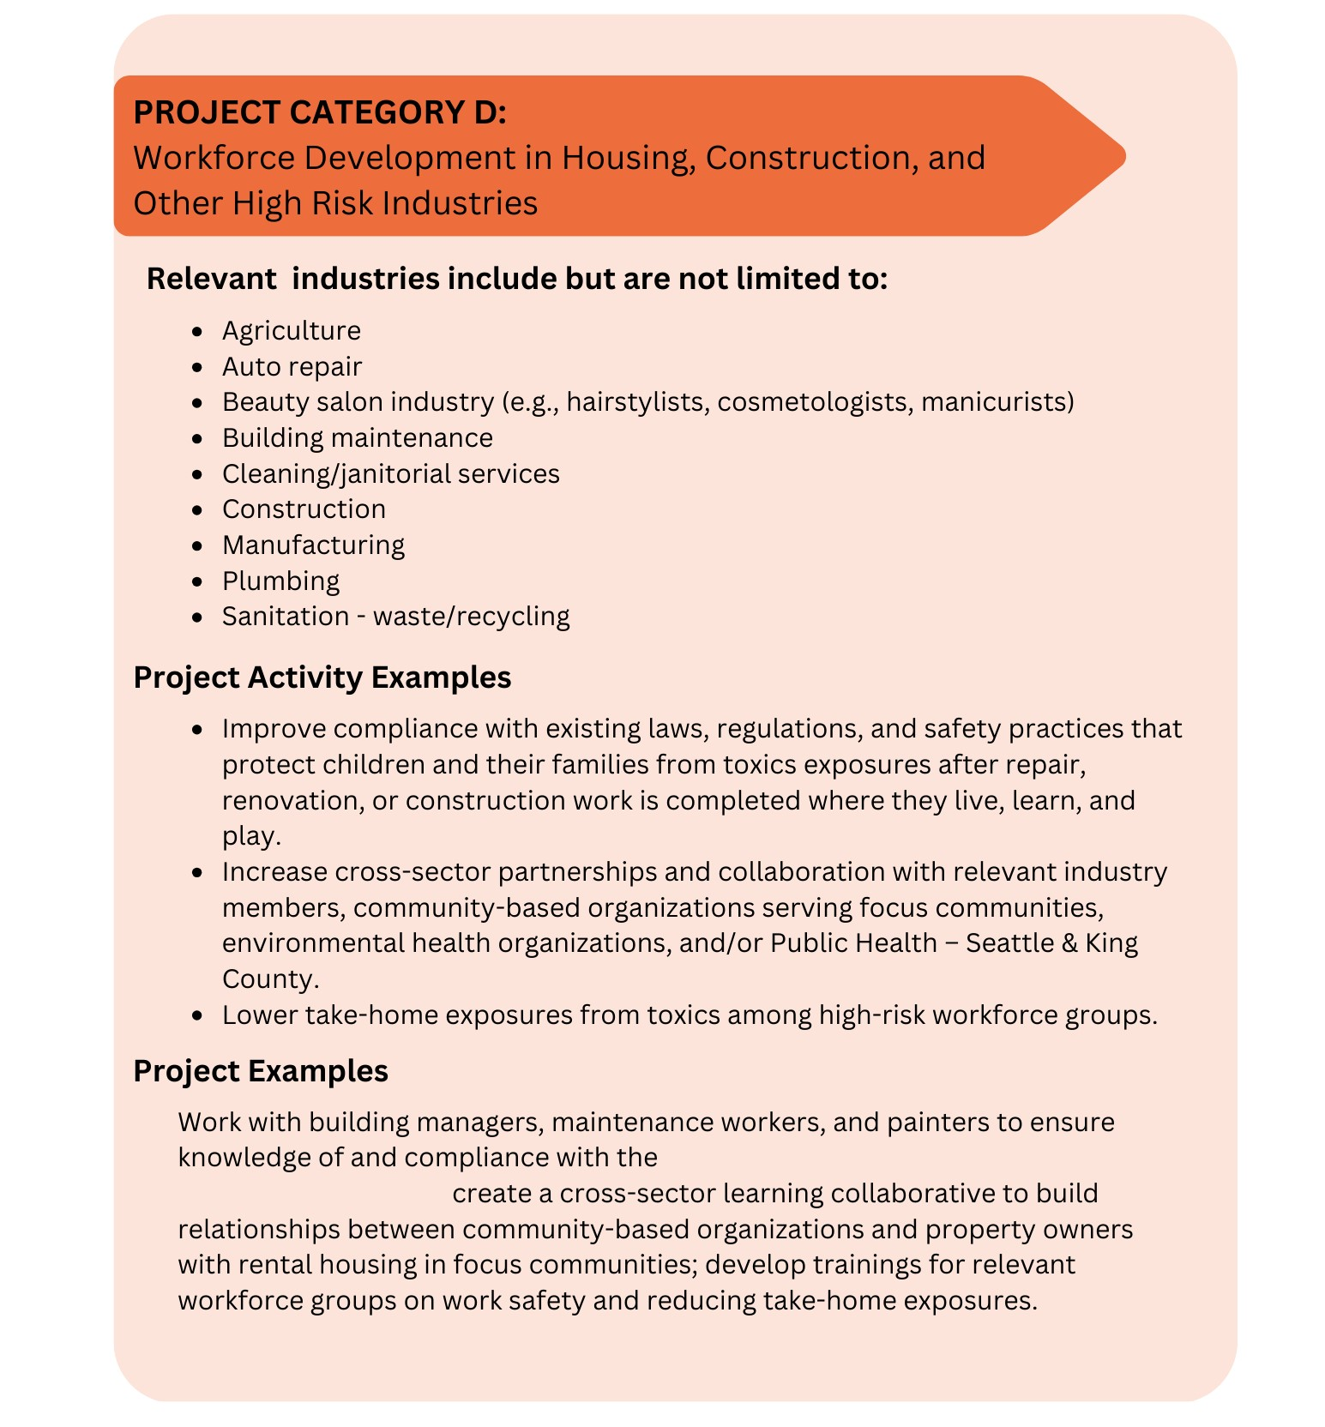
Lead Renovation, Repair and Painting, and
Lead Disclosure laws;

Required Project Activities
All selected applicants will be required to evaluate their project and participate in innovations supports capacity building. Below is an overview of both project activities. Grantees will learn more about these requirements once selected and during our grant agreement process.
Data Collection and Evaluation.
Best Starts evaluators will lead evaluation efforts and will work with selected partners to identify data collection and evaluation goals. Groups or organizations selected as partners will have a large role in collecting and using data to inform their work.

In the proposal, applicants are encouraged to identify their capacity to collect and evaluate program data as well as the supports they may need to build capacity to collect and evaluate program data. When needed, Best Starts can provide tailored training and capacity building supports to facilitate project data collection and evaluation activities.

Innovation Supports Project Capacity Building
Selected partners are required to participate in Innovation Supports capacity building activities during the initial phase of their project development. The Innovation Supports team is a group of BSK staff consultants with expertise in helping organizations develop, design, implement, and evaluate programs and projects.

Selected partners will meet with BSK staff and consultants leading Innovation Supports work to co-design an Innovation Supports workplan that outlines:
  - What tools the organization and Innovation Supports team will work on together,
  - What support activities the organization would like to participate in,
  - A timeline.

These support activities can be delivered through a series of workshops and/or individual one on one meetings. Organizations that are interested can continue to work with the Innovation Supports team throughout the implementation of their project, but it is not required.

Selected partners must use funding from their award to cover the cost of staff participation in the Innovation Supports activities.

Innovation Supports Requirements:
  - A minimum of two staff people must participate in Innovation Supports activities.
  - Organizations are required to develop an evaluation plan and a Practice Profile (or equivalent tool) in year one of funding.
  - Most partners develop tools within three to six months and average between 8 to 15 hours per month on the related work. Partners can opt for a shorter timeline if:
    - An evaluation plan and a Practice Profile (or equivalent tool) have already been developed,
    - Or the partner can demonstrate experience creating similar tools and presents a reasonable plan for completing the tools.

Organizations are encouraged to complete a Theory of Change with the Innovations Supports team, but it is not required.

Innovation Supports Tools:
Typical support activities apply the IDEAS Impact Framework™ and focus on developing tools that clarify project activities and outcomes, guide implementation , and identify meaningful ways to use data collection and evaluation for continued learning and quality improvement. Tools most frequently developed include a Theory of Change, Practice Profile, and Evaluation Plan (see definitions below) which can guide effective project implementation and promote sustainability.

THEORY OF CHANGE, a detailed set of beliefs about specific changes that are expected to result from a project. A Theory of Change can be useful to describe how a project works to create the change and impact it desires.

PRACTICE PROFILE, a tool that helps identify and strengthen the core elements of a community-designed project. The Practice Profile documents what a project "looks like" when it is done well and guides implementation. A Practice Profile may also be known as a "practice model", or "project implementation guide".

EVALUATION PLAN, an overview of what and how the project seeks to evaluate. Evaluation holds projects accountable to a shared vision, encourages on-going learning and improvement, and helps to illustrate the impact and value of the work the project does in the community.

- Eligibility

This request is open to nonprofit organizations, community-based organizations, tribes and tribal organizations, for-profit entities and public or governmental agencies serving communities in King County. Small nonprofits, organizations serving communities impacted by inequities, and community-based organizations (501c3 or a 501c3 fiscal sponsor) are encouraged to submit proposals. Organizations are encouraged to partner on applications when applicable.

Selected applicants must provide staff equitable compensation. Equitable pay may vary according to an organization’s size, access to funding, history, and other factors, so this RFP will not impose a set dollar amount to define equitable pay. Instead, applicants will be asked to cultivate comprehensive plans to facilitate staff retention and demonstrate how they:
  - At a minimum, pay the living wage applicable to the geographic area where organization’s staff work.
  - Offer incentives like bonuses and regularly scheduled performance-based raises.
  - Provide benefits, which may include, but are not limited to health, dental and vision insurance; paid time off (PTO); retirement plans; flexible schedules; and professional development.
  - Maintain justifiable pay gaps between the highest paid and lowest paid employees within the organization or group.

The following types of activities will not be considered for funding under this RFP:
- Capital projects,
- Construction projects,
- Individual or direct services,
- Lobbying, including grassroots lobbying, or other unallowable costs. Lobbying is defined in the Revised Code of Washington (RCW) as “attempting to influence the passage or defeat of any legislation or the adoption or rejection of any rule, standard, rate, or other enactment of any governmental body. Neither "lobby" nor "lobbying" includes an association's or other organization's act of communicating with the members of that association or organization”.

- Available Funding

Approximately $750,000 is available for up to three years through Best Starts for Kids to support the work described in this RFP. The contract exhibit expected start date is July 1, 2024 with an end date no later than June 30, 2027. Between one to three applicants will be selected to receive funding.
The maximum award amount applicants may request is $250,000 per year or $750,000 total for three years. The funding amount requested should be aligned with proposed strategies outlined in the application.
Any contract awarded as a result of this procurement is contingent upon the availability of funding.
King County PHSKC reserves the right to not award all funds advertised in this RFP.
Applicants are expected to estimate and develop a 3-year budget covering proposed goals, activities and outcomes. Awarded partners will be asked to submit an updated budget each award year.

- RFP Process

Timeline

The following timeline represents the tentative schedule of the entire RFP process, from solicitation to program implementation. The dates listed here are subject to change. Applicants are responsible for monitoring ZoomGrants for any changes prior to the submittal deadline.

Information Session 1 (optional)  Join Zoom Meeting  https://kingcounty.zoom.us/j/81162633409  Meeting ID: 811 6263 3409  Passcode: 211567  Join by telephone  +1 253 215 8782 US (Tacoma)  +1 253 205 0468 US  +1 719 359 4580 US  See Section V. RFP Process, C. Information Session for information. | March 5, 2024,  11 a.m. - 12 p.m.
Information Session 2 (optional)  Join Zoom Meeting  https://kingcounty.zoom.us/j/88580773749  Meeting ID: 885 8077 3749  Passcode: 024694  Join by telephone  +1 253 215 8782 US (Tacoma)  +1 253 205 0468 US  +1 719 359 4580 US  See Section V. RFP Process, C. Information Session for information. | March 18, 2024,  2:30 - 3:30 p.m.
Final day to initiate request for technical assistance | April 9, 2024
Final day to submit questions via ZoomGrants | April 9, 2024
Proposals due | April 17, 2024 by 2:00 p.m.
Responses reviewed | April 18, 2024 through May 16, 2024
Interviews with applicants (if applicable)  King County reserves the right to conduct interviews as needed to make award determinations. | May 2024
Notification of selected and non-selected applicants | June 2024
Anticipated program/contract start date | July 2024

Questions

Interested parties may submit questions in writing prior to the date and time indicated in the RFP schedule through the Contact Admin tab in ZoomGrants. The PHSKC response to all questions received will be posted as an RFP addendum on ZoomGrants.

If potential Applicants experience technical difficulties with ZoomGrants leading up to the due date, please email your proposal to the RFP Coordinator directly to avoid a late submission.

Applicants are encouraged to complete their applications early to avoid any difficulties or errors in submission. PHSKC is not responsible for any technical difficulties that an applicant may experience, and late submissions may result in rejection of proposal.

Information Sessions (optional)

Pre-proposal information sessions are scheduled to be held at the date and time indicated in the schedule. The location of the pre-proposal conference will be via Zoom. Attendance is recommended but not mandatory.

PHSKC will only be held to the PHSKC written answers to questions. Questions arising at the pre-proposal conference or in subsequent communication with the RFP Coordinator will be documented and answered in written form. A copy of the questions and answers will be posted as an RFP amendment on ZoomGrants. Applicants are responsible to check ZoomGrants for any posted amendments to this RFP.

Communication

- RFP Communication

All RFP documents will be uploaded through ZoomGrants.

The RFP Lead is the sole point of contact for this procurement. All communication regarding the subject matter of this opportunity between the applicants and PHSKC upon release of this RFP must be through ZoomGrants or the RFP Lead, as follows:

Phillip Thompson
RFP Lead
phithompson@kingcounty.gov
Any other communication will be considered unofficial and non-binding on King County. Applicants are to rely on written statements issued by the RFP Lead. Communication directed to parties other than the RFP Coordinator on this opportunity may result in disqualification of the applicant.

- Applicant Communication

Unless otherwise requested, letters and other communications about this RFP will be issued to the e-mail address noted in the proposals created within ZoomGrants. If other personnel should be contacted via e-mail in the evaluation of this proposal, or to be notified of evaluation results, please complete the information in the area provided in ZoomGrants.

- Proposal Process

Responses are hereby solicited and will be received using the link below through ZoomGrants no later than 2:00 p.m. on the due date noted on this RFP. Responders are responsible for regularly checking ZoomGrants for any updates, clarifications or amendments.
Note: Applicants bear the risk that technical difficulties may result in late or undelivered applications. Therefore, applicants are encouraged to submit materials through ZoomGrants on a timely basis, and to reach out to ZoomGrants as noted on this RFP early in the process if encountering technical difficulties. If the issue cannot be addressed through ZoomGrants, then reach out to the procurement lead as noted on this RFP.

Submit proposals through ZoomGrants at: https://www.zoomgrants.com/gprop.asp?donorid=2209&limited=5199

Proposal Package

Complete proposal packages will include the following:
- Unrated questions answered via ZoomGrants
- Rated questions attachment
- Budget attachment
- Letters of commitment (if applicable)

Applicants must download the rated questions attachment and budget attachment from ZoomGrants. Completed versions of both attachments should be uploaded to ZoomGrants as PDF documents before the application is submitted.

If you are applying with and/or plan to sub-contract with another organization as a part of your project, upload a signed Letter of Commitment (LOC) from the organization via ZoomGrants. The LOC should state that the organization understands their roles and responsibilities in the project and supports your application.

- Application Assistance
Application assistance (also known as technical assistance) is available to support organizations in applying to this RFP. The main purpose of this opportunity is to eliminate linguistic, cultural and other barriers that might prevent organizations from seeking government funding. Application assistance is free of charge.
Technical assistance consultants can:
- Assist in determining appropriate fit between your proposal and this funding opportunity.
- Provide guidance on how best to answer questions.
- Support your application development, including editing and budget review.
- Consultants are not grant writers but can support you in explaining your proposal in the most clear and concise way.
See Technical Assistance document in the ZoomGrants library and/or the BSK website for a list of TA consultants and their contact information. Organizations wishing to access application assistance should email the consultants directly. We encourage you to reach out to a TA consultant as early as possible. We cannot guarantee TA consultant availability within 5 business days of the deadline (the RFP’s closing date). Assistance in languages other than English is available; let a TA consultant know your language need and BSK will try to accommodate that.
We encourage you to only contact one TA consultant at a time and allow them 24 hours to respond before contacting any other consultants.

BSK Capacity Building Services

Once the contract is finalized, BSK grantees may receive free capacity building services from BSK-contracted consultants. The goal of BSK capacity building is to support grantees' program and organizational development, implementation, and sustainability while being rooted in community strengths, needs, and values. Consultants provide resources and training along with individualized, responsive, and ongoing coaching and support. BSK capacity building consultants can also help BSK grantees create tools and build skills needed to meet BSK contract requirements. Categories of BSK capacity building support include board development, data & evaluation, equity & social justice, finance, human resources, IT, legal, marketing, needs assessment, and organizational development.

Rating Criteria

Responsive proposals will be reviewed strictly in accordance with the requirements stated in this RFP and any addenda issued.

All proposals received by the stated deadline will be reviewed by the RFP Lead to ensure that the proposals contain all the required information requested in the RFP. Only responsive proposals that meet the threshold requirements will be evaluated by the PHSKC designated review panel. Any applicant who does not meet the stated qualifications or any proposal that does not contain all the required information may be rejected as incomplete.

The RFP Lead may, at their sole discretion, contact the applicant for clarification of any portion of the applicant’s proposal. Applicants should take every precaution to ensure that all answers are clear, complete, and directly address the specific requirement.

Proposals will be reviewed and evaluated by a review panel. The process for choosing projects will include evaluation of the narrative and accompanying documents, and potentially, interviews. Below are the selection criteria that will be used during the evaluation process.

The selection process will consider achieving a balance of proposed issues, project categories, and geographic focus in the final slate of grantees. Proposals that do not address one or more toxics listed in Section II, B RFP Details will not be considered.

 | Rating Criteria
Section | High score rating response | Low score rating response | Points
EXPERIENCE | - Organizational leaders and staff are reflective of or have shared lived experiences with the communities they are working with.  - Organization’s description reflects similar themes and values as those outlined in the ‘Equity and Social Justice’ section and ‘Who Should Apply’ section of the RFP.  - The organization explains why the values that they identify are important to their work and provides examples of how those values show up or are operationalized in their work.  - Demonstrated experience project managing related projects. Strong responses will provide an example of similar project(s) AND describe how the staff or organization will apply what they learned from the past project to the new work.  - Demonstrated history of meaningful collaboration with community and other organizations or groups. Strong responses will describe past projects, detail how community and/or other organizations were involved throughout the project, addresses the successes and challenges. | - Organizational leaders and staff are not reflective of or do not have shared lived experiences with the communities they are working with.  - Organization’s description does not reflect similar themes and values as those outlined in the ‘Equity and Social Justice’ section ‘Who Should Apply’ section of the RFP.  - The organization is not able to connect their values to how they do their work or the way they describe their work does not align with the values they described.  - No or minimal demonstrated experience project managing related projects.  - No or minimal demonstrated history of meaningful collaboration with community and other organizations or groups. | 25
FOCUS COMMUNITY | - The focus community or communities described in the proposal align with the focus communities outlined in the RFP.  - Describes what steps the organization took to gather input from the community on the proposal OR clearly describes how past input from community was used to inform the proposal.  - Provides concrete examples of input that community members provided and how it was used to inform the proposal.  - The methods they used to collaborate with community align with the values and themes that they outlined in question 1 of their proposal.  - Category B proposals only. Provides examples of research or other programs that informed the proposal topic or design. | - The focus community or communities in the proposal do not align with the focus communities outlined in the RFP.  - The proposal was not designed with any input from community.  - Does not share details on the input that community members provided or only provides vague details.  - The methods they used to work with community does not align with the values and themes that they outlined in question 1 of their proposal.  - Category B proposals only. Does not provide examples of research or other programs that informed the proposal topic or design OR the research and examples provided are not clear or do not support the project proposal. | 25
PROJECT GOALS AND OUTCOMES | - The applicant clearly communicates how their project activities will result in the two or more outcomes that they selected.  - The applicant provides clear and measurable examples of success for all outcomes they identified.  - Project proposal clearly illustrates how the proposed activities will result in the selected outcomes. | - The applicant does not clearly communicate how their project activities will result in the two or more outcomes that they selected.  - The applicant does not provide clear and measurable examples of success for all outcomes they identified.  - The proposal lacks enough detail to assess if the activities will help reduce toxics exposures in the Lead and project’s focus communities and populations. Or the project activities are unlikely to have the described impact on the focus communities and populations. | 20
PROJECT PLAN | - The staffing plan is clear and aligns with the activities described in the project plan.  - The year 1 project plan includes clear activities and outlines reasonable steps for completing the deliverables.  - Activities identified in the project proposal appear to be achievable within the proposed timeline, staffing, and funding level.  - Application clearly describes their project’s focus communities and shares concrete examples of when and how various community representatives will be involved in the project. | - The staffing plan is not clear and/or does not align with the activities described in the project plan.  - The year 1 project plan does not include clear activities and/or does not outline reasonable steps for completing the deliverables.  - Activities identified are unlikely to be achieved within proposed funding, staffing and timeframe.  - Applicant provides limited, vague, or unclear descriptions of how their focus communities will be involved in the project. | 30
Budget | • Proposed budget costs are reasonable and justified  • Budget is complete and aligns with proposed activities |  | Not scored
 |  | Total | 100

Review Process

Review panels may consist of King County staff, external subject matter experts, evaluators, community members, advisory board members, participants with past of current lived experience, and members or designees of the King County Council (who will serve as nonvoting members). PHSKC values the perspectives of community members, including those with lived experience. All efforts will be made to include a minimum of 2 individuals representing community. Following application review, applicants may be asked to participate in an interview with the review panel prior to final scoring of proposals.

The RFP review panel will score each proposal based on the rating criteria described in Section VII, A. Rating Criteria, of this RFP and create a ranking of proposals based on highest to lowest scoring. The reviewer’s scores will be a factor used by the RFP rating panel to develop recommendations on the selection of proposals to the County along as well as factors such as geographic areas and population served. King County also reserves the right to serve as a its own reference.

Selection Process

Final selection of awardees will be made by King County division and department directors based upon recommendations from the review panel and based upon equity and geographic considerations to ensure services are responsive to funding priorities and community need. The PHSKC reserves the right to make such selections based on the best interests of King County, and as a result, may not select the highest scoring or lowest cost proposals for award, and it will execute contracts based upon the final selections.

Funding Allocation and Contract Negotiations

PHSKC anticipates that requests for funding from the pool of selected applicants may exceed the total dollar amount of funding available through this RFP. If this occurs, the County reserves the right to enter discussions with applicants to assess if proposed services and activities can be scaled to match the dollar amount offered by the County. If the proposal is not scalable, or the applicant rejects the dollar amount offered by the County, the County reserves the right, to withdraw the funding offer to the applicant, and enter discussions with other high-ranking RFP applicants. Contract negotiations and development will begin when a funding amount for each proposal has been reached between the applicant and the County.

- Glossary of Terms

A list of general procurement and contract definitions can be found here: Contract Glossary. All other definitions specific to this RFP are as follows:

Capital Project: A capital project is a project to construct either new facilities or make significant, long-term renewal improvements to existing facilities.

Citizen Science: Research conducted in collaboration with individuals from the public or non-professional researchers.

Community Based Organization (CBO): An organization that is representative of a community or significant segments of a community and that provides culturally-rooted services.

Community-Based Participatory Research: An equitable approach to research in which researchers, organizations, and community members collaborate on all aspects of a research project.

Contractor: Term used within the King County PHSKC Boilerplate Agreement, signifying the entity awarded funding in consideration for the performance of certain services and as described in the resulting contract.

Cross-Sector Partnerships: When two or more organizations work together across sectors – industry, nonprofit, and government – to achieve mutually beneficial outcomes. Successful collaboration may lead to a cross-sector partnership, in which partners formally agree to leverage their resources to work toward shared, measurable goals.

Direct Service: Activities that are to assist an individual or family and do not assist in impacting a policy or system. Examples include, providing or helping to navigate resources, childcare, or educational services.

Environmental Racism: Racial discrimination in policies, practices, enforcement, or regulations that harm or disadvantage communities of color at a higher rate than white communities.

Racial Equity: Racial equity is the condition that would be achieved if one's racial identity no longer predicted, in a statistical sense, how one fares. When we use the term, we are thinking about racial equity as one part of racial justice, and thus we also include work to address root causes of inequities not just their manifestation. This includes elimination of policies, practices, attitudes, and cultural messages that reinforce differential outcomes by race or fail to eliminate them.

Reflective of community: To share similar racial, ethnic, cultural, or geographic backgrounds or histories of a community group.

Take Home Exposure: When a person accidentally carries a toxic chemical to their car or home from work. They can carry the chemical on their skin, hair, bags, clothes, shoes, or other personal items. Most of the time the person will not know they are carrying the chemical home. Once the toxic chemical is in the car or home, other people can be exposed to it, causing health problems. Children are especially sensitive to take home exposures.

Toxics Abatement: The process of removing or sealing off toxic hazards from a building or location. Lead-based paint abatement is a common example of an abatement activity. Depending on the type of toxic involved, abatement activities are governed by different regulations and standards, such as the Model Toxics Control Act and the Renovation, Repair and Painting requirements.

Toxics Control: To identify, investigate, and clean up facilities where hazardous substances have been released. Depending on the type of toxic involved, control activities are governed by different regulations and standards, such as the Model Toxics Control Act and the Renovation, Repair and Painting requirements.

Toxics Remediation: The process of addressing the underlying source causing the toxics exposure, with the goal of preventing it from happening again. Toxics remediation typically includes abatement as one stage of a larger plan. Depending on the type of toxic involved, remediation activities are governed by different regulations and standards, such as the Model Toxics Control Act and the Renovation, Repair and Painting requirements.

Toxic (plural: Toxics): A substance that has the potential to harm the health of people, animals, and plants. They include poisonous chemicals and chemical compounds, some metals, physical materials that disrupt biological processes, and organisms that cause disease. Toxics are typically manmade. There are some toxics that are naturally occurring, including lead.

ZoomGrants: an online application portal where applicants can access and view RFP information and submit bids for programs/services outlined in the RFP.

- RFP and Contract Terms

RFP Terms

Revisions to the RFP

If PHSKC determines in its sole discretion that it is necessary to revise any part of this RFP, an addendum to this RFP will be posted on ZoomGrants. For this purpose, the published questions and answers and any other pertinent information will also be provided as an addendum to the RFP and will be placed on ZoomGrants.

PHSKC also reserves the right to cancel or to reissue the RFP in whole or in part, prior to execution of a contract.

Cost to Propose

PHSKC will not be liable for any costs incurred by the applicant in preparation of a proposal submitted in response to this RFP, in conduct of a presentation, or any other activities related in any way to this RFP.

No Obligation to Contract

This RFP does not obligate PHSKC to enter into any contract for services specified in this proposal.

Rejection of Proposals

PHSKC reserves the right, at its sole discretion, to reject any and all proposals received without penalty and not to issue any contract as a result of this RFP.

Acceptance Period

Proposals must provide 45 calendar days for acceptance by PHSKC from the due date for receipt of proposals.

Best and Final Offer (BAFO)

PHSKC reserves the right to use a BAFO before awarding any contract to further assist in determining the successful Applicants. Terms of the BAFO will be communicated by the RFP Coordinator.

Award

Final selection of awardees may be made by King County division and department directors based upon final calculations and recommendations from the RFP review panel. PHSKC will execute contracts based upon the final selections.

PHSKC intends to award one or more contracts to potential Applicants. The RFP Coordinator will notify all Applicants in writing of the acceptance or rejection of their RFP. Written notification will be sent via email to the email address(s) submitted on the cover sheet.

Protest

King County has a process in place for receiving protests / Appeals based upon the RFP or contract awards. The protest / Appeal procedures are available at http://www.kingcounty.gov/depts/finance-business-operations/procurement/for-business/do-business/protest.aspx.

Contract Terms

King County Boilerplate

Organizations awarded through this procurement process will contract with King County PHSKC. Funded organizations will be required to meet baseline requirements, including insurance, equal employment opportunity, record keeping, and more. See a sample of the department’s standard services contract boilerplate with terms and conditions here.

A contract may be negotiated with the applicants(s) whose proposal would be most advantageous to King County in the opinion of the PHSKC, all factors considered.

The contents of the selected applicant’s proposal shall become contractual obligations if a contract ensues.

A contract between the selected applicant(s) and King County shall include the contract instrument, the original RFP as issued by King County, the response to the RFP, and any other documents mutually agreed upon. The contract must include, and be consistent with, the specifications and provisions stated in the RFP.

Equity and Social Justice

In order to effectively operate and provide services within a culturally responsive framework, an organization shall intentionally consider equity and integrate it into its values and principles, decisions and policies. King County expects funded organizations to incorporate an equity lens in their service delivery models and administration in order to challenge systemic and structural inequality, reduce prejudice and racism, and advance equity. As part of this effort, organizations will be asked to provide individual-level demographic information (including zip codes) to inform analysis and understanding of barriers created by institutional racism. See Section IX, CONTRACT REQUIREMENTS: Data Collection and Reporting below.

Performance Measurement and Evaluation

The primary purpose of performance measurement and evaluation is to use data to inform ongoing work, understand which activities are effective and why, and support shared and transparent responsibility for your programs’ success. Another key purpose is to comply with initiative reporting requirements and offer transparency to the public about the programs we fund and their outcomes. If awarded funds through this RFP, there is an expectation that awardees will collect data aligned with the goals of this RFP.

BSK will work in partnership with funded organizations to develop a performance measurement and evaluation plan for funded programs. The plan will include key performance measures, type of data collection (individual identifiable or deidentified client-level, aggregate, and/or qualitative data), additional external evaluation activities if applicable, and quality improvement activities.

Part of the process of developing performance measurement plans will be conversations about program goals and how to know if participants are “better off”. What change is your program trying to create and why? What will tell us when program adjustments are necessary? How will we know that the adjustments are working?

Performance measures are developed in partnership by the funded organization with King County and are informed by the program’s model and purpose. As programs grow and evolve within the award period, King County staff will be available to make any necessary adjustments to the evaluation plan in collaboration with the funded organization. Programs which set performance goals may collect baseline data in advance of goal-setting.

Partners that are awarded funded will be asked to create a performance measurement plan that answers these three questions:

1. How many people were served/reached by this program, or how many services were provided?
2. How well did your program serve people?
3. How are those you served better off?

Data Collection and Reporting

Data collection types detailed in the evaluation plan may include:

- Individual-Level Data
When appropriate for the program model, individual-level data will be reported by the funded program and will typically be reported quarterly or semiannually.

Individual-level data elements may include individual demographics (including age, gender, race/ethnicity, and zip codes), basic information about services provided, survey information from regular times during program participation (for example at program entry and exit), and individual outcomes. Individual-level data is typically reported through King County’s Client Outcomes Reporting Engine, also known as CORE.

- Aggregate-Level Data

When appropriate for the program model, aggregate-level data will be reported by the funded program and will typically be reported quarterly.

Aggregate-level data may include demographics (including age, gender, race/ethnicity, and zip codes), basic information about services provided, and outcome information of those services.

- Qualitative Data

When appropriate for the program model, qualitative data (such as from focus groups, open-ended surveys and questionnaires, and interviews) may be reported by the funded program.

- Narrative Reports

Funded organizations will also submit annual or semiannual narrative reports to share information about successes, challenges, system change efforts and other requested information.

Public Records Act

  - Washington State Public Records Act (RCW 42.56) requires public organizations in Washington to promptly make public records available for inspection and copying unless they fall within the specified exemptions contained in the Act or are otherwise privileged.

  - All submitted proposals and RFP materials become public information and may be reviewed by anyone requesting to do so at the conclusion of the RFP, negotiation, and award process. This process is concluded when a signed contract is completed between the County and the selected applicant.

  - Proposals submitted under this RFP shall be considered public documents and with limited exceptions, proposals that are recommended for contract award will be available for inspection and copying by the public.

If an applicant considers any portion of his/her proposal to be protected under the law, the applicant shall clearly identify on the page(s) affected such words as “CONFIDENTIAL,” PROPRIETARY” or “BUSINESS SECRET.” The applicant shall also use the descriptions above in the following table to identify the effected page number(s) and location(s) of any material to be considered as confidential. If a request is made for disclosure of such portion, the County will review the material in an attempt to determine whether it may be eligible for exemption from disclosure under the law. If the material is not exempt from public disclosure law, or if the County is unable to make a determination of such an exemption, the County will notify the applicant of the request and allow the applicant ten (10) days to take whatever action it deems necessary to protect its interests. If the applicant fails or neglects to take such action within said period, the County will release the portion of the proposal deemed subject to disclosure. By submitting a proposal, the applicant assents to the procedure outlined in this paragraph and shall have no claim against the County on account of actions taken under such procedure.

American with Disabilities Act

King County complies with the Americans with Disabilities Act (ADA). Applicants may contact the RFP Coordinator to receive materials for this RFP in alternative formats, such as Braille, large print, audio tape, or computer disc.

- Language Accessibility
Upon request, this RFP can be made available in other languages.

Connection Between Environmental Exposure and Health Outcomes | US EPA
Addressing priority toxic chemicals - Washington State Department of Ecology
Disparities in the Impact of Air Pollution | American Lung Association
Chapter 42.17a RCW: CAMPAIGN DISCLOSURE AND CONTRIBUTION (wa.gov)
https://www.racialequitytools.org/glossary (link from King County site: https://kingcounty.gov/elected/executive/equity-social-justice/tools-resources/Racial-Justice.aspx)

