King County Youth Well-Being Network – Renton Area Lead

REQUEST FOR PROPOSAL (RFP)

RFP Release Date: September 15, 2026
Due Date: | October 27, 2026 by 2:00 p.m.
RFP Lead | Phil Thompson
Funding: | Up to $500,000 in PHSKC

Submitting a Proposal Proposals are hereby solicited and will be received using the link below through Agiloft no later than 2:00 p.m. on the due date noted above. The services procured through this RFP shall be provided in accordance with the following and the attached instructions, requirements and specifications. Applicants are responsible for regularly checking Agiloft for any updates, clarifications or amendments to this RFP.

If you do not have an existing Agiloft account, start here:
Accessing Agiloft to apply for and manage contracts with DCHS​ - King County, Washington

Provider Training: How to Apply for Funding Opportunities in Agiloft

Direct link to submit proposals through Agiloft at: Solicitation: King County Youth Well-Being Network (Renton)

TABLE OF CONTENTS

Contents
I. Application Process 3
II. Introduction 3
A. Division/Funding Source 3
B. Equity and Social Justice 4
III. RFP Overview 4
A. Program Purpose Statement 4
B. Background 5
C. The Request 7
IV. Eligibility 10
V. Available Funding 11
VI. RFx Process 12
A. Timeline 12
B. Questions 13
C. Information Session 13
D. Communication 13
VII. Proposal Process 14
VIII. Application Assistance 14
IX. Selection Process 15
1. Rating Criteria 15
2. Review Process 17
3. Selection Process 18
4. Funding Allocation and Contract Negotiations 18
X. Glossary of Terms 18
XI. RFP and Contract Terms 19
A. RFP Terms 19
B. Contract Terms 20
XII. List of Attachments 24

Application Process

Responses are hereby solicited and will be received using the link below through Agiloft no later than 5:00 p.m. on the due date noted on this RFP. Responders are responsible for regularly checking Agiloft for any updates, clarifications, or amendments.
Note: Applicants bear the risk that technical difficulties may result in late or undelivered applications. Therefore, applicants are encouraged to submit materials through Agiloft on a timely basis, and to reach out to Agiloft as noted on this RFP early in the process if encountering technical difficulties. If the issue cannot be addressed through Agiloft, then reach out to the RFP Lead as noted on this RFP.

Introduction

Best Start for Kids (Best Starts) Public Health - Seattle & King County (PHSKC) is pleased to release this Request for Proposal (RFP) for Strategy with funding from Best Starts for Kids

Best Starts for Kids (Best Starts) is King County’s community-driven initiative to support every baby born and child raised in King County to be happy, healthy, safe, and thriving. Initially approved by voters in 2015 and in place since 2016, Best Starts invests in comprehensive supports for children, youth, young adults, and families and caregivers, catalyzing strong starts in early childhood, and sustaining those gains as children progress to adulthood. Best Starts was renewed by voters in August 2021. Implementation of Best Starts is guided by the Best Starts Implementation Plan, approved by the King County Council in November 2021 for Levy 2022-27.

The King County Youth Wellbeing Network (KC-WYN) is a King County Best Starts for Kids-facilitated, community-driven initiative designed to create conditions for young people to thrive. It connects current referral systems to broader promotion and prevention supports to improve youth behavioral health, educational success, and housing stability and reduce use of crisis systems of care. KC-WYN strengthens coordinated prevention systems using a shared governance and learning structure that harnesses the insight and resources of local communities. Currently in a pilot phase in three thoughtfully chosen communities, KC-WYN is focused on learning what works. KC-WYN is also well-timed to inform the early stages of Washington Thriving, the state strategic plan for child and youth wellbeing. More than a program pilot, KC-WYN is developing youth wellbeing infrastructure built to last.

For this funding opportunity, we will be accepting applications from organizations serving the Renton area (please refer to the eligibility section for more information) who are aligned with KC-WYN’s goals. This funding opportunity is best suited for well-established organizations that are versed in coordinating community partnerships and have a deep understanding of youth prevention and promotion approaches.

Division/Funding Source

Best Starts for Kids/Public Health-Seattle & King County Health Sciences Division.

Equity and Social Justice

For many in our region, King County is a great place to live, learn, work and play. Yet we have deep and persistent inequities - especially by race and place - that in many cases are getting worse and threaten our collective prosperity. In 2020, Executive Dow Constantine declared racism as a public health crisis and set forth policy priorities to bolster King County’s commitment to being intentionally anti-racist and accountable to Black, Indigenous People, and People of Color. Equity and Social Justice (ESJ) is an integrated part of the County’s work and foundational to the work of Best Starts. Our goal is to ensure that all people, regardless of who they are and where they live, have the opportunity to thrive, with full and equal access to opportunities, power, and resources.

For all Best Starts-funded programs, we seek to support community-led and community-informed organizations that are reflective of and embedded in the communities they serve across all aspects of their leadership and service. We further seek to support organizations that recognize and address the disparities that exist in our communities, particularly agencies that serve low-income families, families of color, immigrant, and refugee families, LGBTQ families, families with disabilities, families with foster children, and those geographically isolated – furthering Best Starts’ commitment to equity

Applicants may be asked to demonstrate an understanding and a commitment to the principles of equity and social justice as shown through their staffing and their board, services tailored to community need and commitment to social justice and continuous improvement. One aspect of this work includes understanding – at both a program and system level – structural and institutional racism as it plays out for individuals served through Best Starts-funded services, and the disparate impacts on individuals’ collective experiences and outcomes compared to the population as a whole.

More information about King County’s ESJ work is available at: https://kingcounty.gov/elected/executive/equity-social-justice.aspx

RFP Overview

Program Purpose Statement

This project will be led by Best Starts for Kids’ and PHSKC’s Community Well-Being Initiative. The Community Well-Being Initiative is a strategy within Best Starts 2.0 and builds community capacity to share resources and deliver culturally relevant programming on emotional health and wellbeing to reduce stigma associated with mental health topics and reinforce compassion, connection, and care in communities.

The King County Wellbeing Youth Network (KC-WYN) is a King County–led public–private partnership with philanthropic co-investors and community partners, The partnership seeks to improve youth wellbeing for ages 12–19 through upstream prevention and promotion. KC-WYN will align and strengthen school- and community-based supports and referral systems (e.g., School Based-SBIRT, School Based Health Centers, Community Prevention & Wellness Initiative (CPWI) coalitions and related behavioral health and basic-needs pathways) to be more holistic and responsive to community needs while also building shared governance, measurement, and policy learning that can inform countywide scale.
- Over a 3-year period, KC-WYN will launch coordinated, place-based prevention pilots in three communities in King County. For the intents of this RFP, all proposals should be focused on the Renton Community (see additional information in Eligibility section below). This will be paired with a countywide youth well-being learning network that aligns investments, improves systems coordination, and translates evidence into practice.

The partnership aims to reduce population level homelessness, legal system contact, and emergency health service use for youth while improving well-being outcomes for youth and families. Schools, community centers, and healthcare partners in local communities will adopt efficient and streamlined processes to identify needs earlier (in younger grades and before crises begin) to connect youth and families to culturally relevant social, behavioral health and youth development services.

- Expand access to programs that build youth resilience and social connection. Local communities will engage youth in programs and activities that build connection, belonging, and a vision for a meaningful future. Activities will include arts, sports, and leadership programs.

- Reduce housing instability and criminal and legal system involvement.

- Improve educational engagement by addressing behavioral health, basic needs, and belonging.

Background

In 2024, King County’s PHSKC and Community and Community and Human Services (DCHS) partnered with the University of Washington’s CoLab for Community & Behavioral Health Policy (CoLab) to facilitate a policy codesign process with the end goal of improving youth mental health & substance misuse prevention.
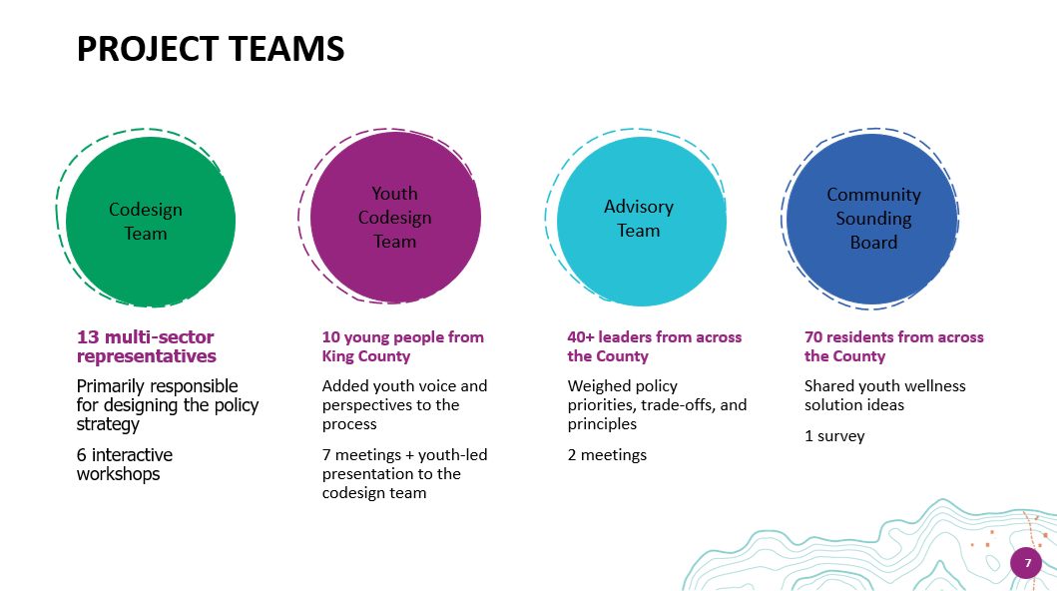

Stakeholders in this process included a codesign team composed of 13 multi-sector representatives, 10 young people from King County to inform and add youth voice to the process, an advisory team of 40+ leaders from across the County, and a community sounding board of 70 residents who shared youth wellness solution ideas. From this generative process emerged several themes.

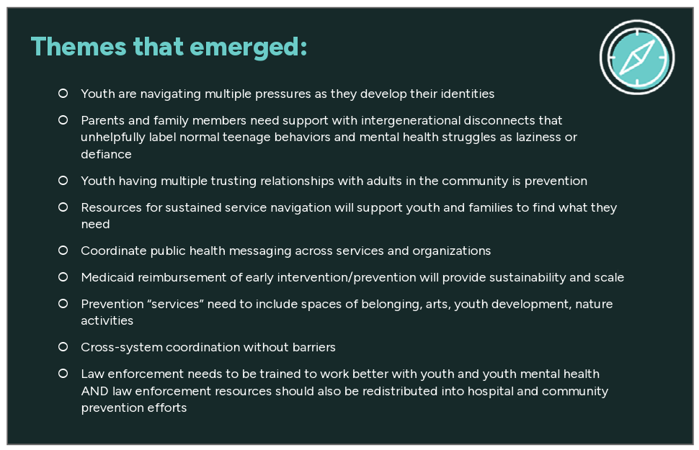

These themes were then further refined and developed into policy recommendations and solutions:

- A shared governance model that can be replicated
- A unified measurement and accountability framework
- Scalable prevention pathways
- A countywide youth wellbeing network

The Request

This project will address outcomes related to prevention of youth homelessness and legal system involvement. Many of the challenges young people face – mental health, substance use, violence, housing instability, and legal system involvement – share similar root causes and risk factors. BIPOC and LGBTQ+ young people face significant disparities related to behavioral health, homelessness, and legal system involvement. Young people need and deserve more upstream investment in their well-being, reaching them before more significant challenges occur, as well as better coordination among the sectors and systems that may touch their lives.

This proposal builds on the strength of existing County funded school-based referral systems by investing in place-based, community and youth-designed approaches to building upstream supports and services.

Organizations will be well-suited to apply if they are interested in aligning and strengthening school- and community-based support and referral systems to be more holistic and responsive to community needs while also building shared governance, measurement, and policy learning that can inform countywide scale. Over a 3-year period, KC-WYN will launch coordinated, place-based prevention pilots—paired with a countywide youth well-being learning network that aligns investments and improves systems coordination.

- The scope of work should be focused on the following activities and outcomes:

- Building partnerships to promote local, community and youth-driven governance of approaches.
- Expanding existing referral systems to be more inclusive of upstream promotion and prevention opportunities for young people.
- Measurably reducing population level youth homelessness, legal system contact, and emergency health service use for youth.
- Improving well-being outcomes for youth and families.

- Organizations serving as KC-WYN site leads will have the following key roles:

- Act as fiscal sponsor for the Board in allocating program funds (see above under Community Youth Wellness Boards - years 2 & 3)
- Establish, support, regularly convene and partner with a Community Youth Wellness Board for their site.
- Identify specific metrics for process & outcome measures – for their site and in collaboration with other project sites
- Participate in a learning collaborative with King County and other project sites

- Community Youth Wellness Boards will do the following:
- Co-design prevention, promotion, and engagement approaches that can be integrated into existing referral structures (SB-SBIRT, SBHCs, CPWI Coalitions, and others).
- Co-lead governance where appropriate
- Ensure cultural responsiveness and relevance
- Guide implementation priorities and continuous improvement.

- Boards will be formed for each site in quarters 1 and 2 of year 1 (with support as needed from the Learning Collaborative detailed below) and will convene at least quarterly for the duration of the award period. Members should be compensated appropriately for their participation.

- Representatives on the board will include:
- Existing referral systems (e.g. SB-SBIRT, SBHCs, and Community Prevention and Wellness Initiative/CPWI coalitions)
- Other relevant community leaders (e.g. key entities supporting youth homelessness prevention, prevention of youth legal system involvement
- And other aspects of youth well-being), and young people involved with existing referral systems and/or other youth leaders in the region
- Support implementation of KC-WYN in their service area by partnering with school leaders, youth and families, and local program providers to map existing resources, identify gaps, and align additional supports so that youth experience coordinated pathways rather than disconnected referrals.
- Guide investment of new KC-WYN funds to build out a continuum of services meeting the specific needs of young people in their catchment area towards the goal of reducing crisis systems of care through upstream promotion and prevention activities
- Help to translate their local work into actionable guidance for broader King County policy design and implementation. This could include collaboration with existing and future County governance structures including the Children and Youth Advisory Board and the Youth Commission and promoting alignment with existing and future King County policy efforts including the Youth Action Plan, Best Starts for Kids, the Bridge Behavioral Health Sales Tax, and others.

- The awardee’s budget will include program funds in years 2 and 3 of the project (at least $50,000 per year) to support integration of upstream promotion and prevention opportunities for young people into their existing referral structures. The Lead Organization will serve as the fiscal sponsor for the Board in managing these funds, including:

- Supporting selection & procurement processes as applicable and in accordance with PHSKC/Best Starts for Kids funding requirements
- Dispersing funds to selected entities on behalf of the Board, including managing and processing invoices, program and fiscal monitoring as appropriate, and providing technical assistance or capacity building supports as needed

Site lead organizations will lead development of relevant metrics for their site and participate in development of a Network-wide measurement framework via the KC-WYN learning collaborative (see below).

- King County will convene the learning network with community co-leadership to coordinate partners around:
- Shared goals, areas for collective learning, and improvement cycles.
- The network will create regular spaces for youth and family input, partner problem-solving, and strategy pivots based on data and lived experience.

- The learning collaborative will:

- Develop a shared measurement framework as well as a framework for collaborative progress monitoring across relevant programs and funding sources during year 1.

The collaborative monitoring framework will anchor blended and braided funding at the County level for replicating investments in prevention and align with Best Starts for Kids reporting requirements.

- Provide opportunities for shared learning, including successes and challenges, across sites.
- Support implementation quality, coordinate investments, translate evidence into practice, and generate practice and budget insights across KC-WYN sites that can be translated to inform policy decision-making and sustainable scale.

- Investment Area(s)

Community Well-Being is an investment area that will build community capacity to share resources and deliver culturally relevant programming on emotional health and wellbeing in order to reduce stigma associated with mental health topics and reinforce compassion, connection, and care in communities. It falls under our Sustaining the Gain strategy, which directs resources to our young people ages 5 – 24, so that young people have equitable opportunities to be safe, healthy, and thriving.

- Focus Population(s)

We are seeking organizations that serve youth and/or hold relevant community partnerships in the Renton service area (City of Renton, Renton School District, and/or adjacent unincorporated King County service areas e.g. Skyway, Fairwood, and East Renton Highlands) between the ages 12-19. Youth served should be youth most impacted by systems and inequities including mental health and behavioral health systems, unstable housing, incarceration/justice system, education disparities.

- Outcomes

Our overall goal is to improve youth wellbeing (ages 12–19) by strengthening upstream prevention and belonging-centered supports, with measurable improvements in housing stability, reduced justice system contact, improved educational outcomes, and improved behavioral health and wellbeing. Outcomes can include but are not limited to the following:

Intermediate Outcomes

- Improved youth-reported belonging, safety, and connectedness at school and in community settings.

- Increased identification of needs and successful linkage to supports (behavioral health, basic needs, mentoring, academic supports).

- Improved school engagement indicators (attendance, chronic absenteeism, credit attainment/grade progression where available).

- Reduced crisis escalation indicators (e.g., fewer acute behavioral health crises requiring emergency response, where measurable).

- Improved family stability indicators (e.g., access to benefits/resources, reduced unmet basic needs).

Youth and Family Outcomes

- Behavioral health and wellbeing: improved youth-reported wellbeing and resilience; improved access to culturally responsive behavioral health supports; reduced unmet behavioral health needs; improved family-reported wellbeing and stress indicators (as feasible).

- Prevention of youth homelessness / housing instability: reduced episodes of homelessness or housing instability among participating youth/families; reduced school-identified homelessness flags; increased housing stability connections (as defined with partners and data availability).

- Prevention of justice system contact: reduced arrests/referrals/detentions (as measurable and appropriate); increased diversion and restorative responses; reduced school discipline exclusions that are associated with later justice contact (where applicable).

- Education outcomes: improved attendance and reduced chronic absenteeism; improved course completion/credit accumulation; improved on-track-to-graduation indicators; reduced suspensions/expulsions.

Specific metrics, data sources, and targets will be finalized with youth/community input and County partners to ensure feasibility, privacy protections, and equity-centered interpretation.

Eligibility

This request is open to nonprofit organizations, community-based organizations, tribes and tribal organizations, for-profit entities and public or governmental agencies serving communities in the City of Renton, the Renton School District, and/or adjacent areas of unincorporated King County service areas (e.g. Skyway, Fairwood and East Renton Highlands). Small nonprofits and community-based organizations are encouraged to submit proposals. Organizations with a demonstrated history of partnerships in the geographic region will be most competitive.

Financial Readiness
Organizations must demonstrate that they have the financial infrastructure necessary to manage funds as required by ER 2. An attachment assessing organizations’ fiscal readiness will be part of the required application materials.

Available Funding

PHSKC has the budgeted amount not to exceed ($500,000) per award from January 2027-December 2029 for this project. Proposals in excess of $500,000 will be considered incomplete and will not be evaluated. We anticipate funding ONE organization for the 3-year award period.

Any contract awarded as a result of this procurement is contingent upon the availability of funding.

King County PHSKC and DCHS reserves the right to not award all funds advertised in this RFP.

Applicants are expected to estimate and develop a 3 yr budget covering proposed goals, activities and outcomes. Please note that program funds are required to be included in years two and three. See Section VII., APPLICATION PROCESS.

Example Budget:

Description Yr 1 | Expense
Staff | 100k
Admin | 15k
Overhead | 10k
Stipends | 5k
Program Funds
Total yr 1 | 130k
Description Yr 2 | Expense
Staff | 100k
Admin | 20k
Overhead | 10k
Stipends | 5k
Program Funds | 50k
Total yr 2 | 185k
Description Yr 3 | Expense
Staff | 100k
Admin | 20k
Overhead | 10k
Stipends | 5k
Program Funds | 50k
Total Yr 3 | 185k
Total for all 3 Years | 500k

RFx Process

Timeline

The following timeline represents the tentative schedule of the entire RFP process, from solicitation to program implementation. The dates listed here are subject to change. Applicants are responsible for monitoring Agiloft for any changes prior to the submittal deadline.

Release Date | September 15, 2026
Information Sessions  See Section VI C for information.  . | September 22, 2026,  1 - 2 p.m. and October 15, 2026,  2 - 3 p.m.
Final day for to initiate request for technical assistance | October 23, 2026
Final day to submit questions via Agiloft | October 23, 2026
Proposals due | October 27, 2026 by 5:00 p.m.
Responses reviewed | October 30, 2026 through November 13, 2026
Interviews with applicants (if applicable)  King County reserves the right to conduct interviews as needed to make award determinations. | November 2026
Notification of selected and non-selected applicants | November 2026
Anticipated program/contract start date | January 2027

Questions

Interested parties may submit questions in writing prior to the date and time indicated in the RFx schedule through the Contact Admin tab in Agiloft. The PHSKC response to all questions received will be posted as an RFx addendum on Agiloft.

If potential Applicants experience technical difficulties with Agiloft leading up to the due date, please email your Proposal to the RFx Coordinator directly to avoid a late submission.

Applicants are encouraged to complete their applications early to avoid any difficulties or errors in submission. PHSKC is not responsible for any technical difficulties that an applicant may experience, and late submissions may result in rejection of proposal.

Information Session

A pre-proposal information session is scheduled to be held at the date and time indicated in the schedule. The location of the pre-proposal conference will be via Zoom. All prospective Applicants should attend; however, attendance is not mandatory.

PHSKC will only be adhere to the PHSKC-written answers to questions. Questions arising at the pre-proposal conference or in subsequent communication with the RFx Coordinator will be documented and answered in written form. A copy of the questions and answers will be posted as an RFx amendment on Agiloft. applicants are responsible to check Agiloft for any posted amendments to this RFx.

Communication

- RFP Communication

All RFP documents will be uploaded through DCHS Agiloft.

The RFP Lead is the sole point of contact for this procurement. All communication regarding the subject matter of this opportunity between the applicants and PHSKC upon release of this RFP must be through Agiloft or the RFP Lead, as follows:

Phil Thompson
RFP Lead
phithompson@kingcounty.gov

Any other communication will be considered unofficial and non-binding on King County. Applicants are to rely on written statements issued by the RFP Lead. Communication directed to parties other than the RFP Coordinator on this opportunity may result in disqualification of the applicant.

- Applicant Communication
Unless otherwise requested, letters and other communications about this RFx will be issued to the e-mail address noted in the proposals created within Agiloft. If other personnel should be contacted via e-mail in the evaluation of this proposal, or to be notified of evaluation results, please complete the information in the area provided in Agiloft.

Proposal Process

Responses are hereby solicited and will be received using the link below through Agiloft no later than 5:00 p.m. on the due date noted on this RFP. Responders are responsible for regularly checking Agiloft for any updates, clarifications or amendments.
Note: Applicants bear the risk that technical difficulties may result in late or undelivered applications. Therefore, applicants are encouraged to submit materials through Agiloft on a timely basis, and to reach out to Agiloft as noted on this RFP early in the process if encountering technical difficulties. If the issue cannot be addressed through Agiloft, then reach out to the procurement lead as noted on this RFP.

Submit proposals through Agiloft at: https://kingcountydchs.agiloft.com/ui/-kcdchs/view/solicitation/303

Complete proposal packages will include the following:

- Uploaded Completed Application Checklist and Narrative Questions
- Answers to every field visible on Agiloft response record when in Edit Mode
- Completed and submitted Summary Questions in Agiloft
  - Zip code questions
  - Organizational Capacity Questionnaire
Completed or Updated Agiloft Provider Profile (details, locations, and contacts)

Application Assistance
Application assistance (also known as technical assistance) is available to support organizations in applying to this RFx. The main purpose of this opportunity is to eliminate linguistic, cultural and other barriers that might prevent organizations from seeking government funding. Application assistance is free of charge.
Technical assistance consultants can:
- Assist in determining appropriate fit between your proposal and this funding opportunity.
- Provide guidance on how best to answer questions.
- Support your application development, including editing and budget review.
- Consultants are not grant writers but can support you in explaining your proposal in the most clear and concise way.
See Agiloft and/or the Best Starts website for a list of TA consultants and their contact information. Organizations wishing to access application assistance should email the consultants directly. We encourage you to reach out to a TA consultant as early as possible. We cannot guarantee TA consultant availability within 5 business days of the deadline (the RFP’s closing date). Assistance in languages other than English is available; let a TA consultant know your language need and Best Starts will try to accommodate.
Please contact only one TA consultant at a time and allow them 24 hours to respond before contacting any other consultants. Each organization should only work with one TA consultant at a time.

Best Starts Capacity Building Services

Once the contract is finalized, Best Starts grantees may receive free capacity building services from Best Starts-contracted consultants. The goal of Best Starts capacity building is to support grantees' program and organizational development, implementation, and sustainability while being rooted in community strengths, needs, and values. Consultants provide resources and training along with individualized, responsive, and ongoing coaching and support. Best Starts capacity building consultants can also help Best Starts grantees create tools and build skills needed to meet Best Starts contract requirements. Categories of Best Starts capacity building support include board development, data & evaluation, equity & social justice, finance, human resources, IT, legal, marketing, needs assessment, and organizational development.

Selection Process

Responsible and Responsive Criteria

- Responsive
The County will consider all the material submitted by the Applicant, and other evidence it may obtain otherwise, to determine whether the Applicant is in compliance with the terms and conditions set forth in this RFA.
- Responsible
In determining the responsibility of the Applicant, the County may consider:
- the ability, capacity and skill to perform the Agreement and provide the service required;
- the character, integrity, reputation, judgment and efficiency;
- financial resources to perform the Agreement properly and within the times proposed;
- the quality and timeliness of performance on previous agreements with the County and other agencies, including, but not limited to, the effort necessarily expended by the County and other agencies in securing satisfactory performance and resolving claims;
- compliance with federal, state and local laws and ordinances relating to public contracts;
- other information having a bearing on the decision to award the Agreement.
Failure of an Applicant to be deemed responsible or responsive may result in the rejection of an Application.

Rating Criteria

Responsive proposals will be reviewed strictly in accordance with the requirements stated in this RFP and any addenda issued.

All proposals received by the stated deadline will be reviewed by the RFP Lead to ensure that the proposals contain all of the required information requested in the RFP. Only responsive proposals that meet the threshold requirements will be evaluated by the PHSKC designated review panel. Any applicant who does not meet the stated qualifications or any proposal that does not contain all the required information may be rejected as incomplete.

The RFP Lead may, at their sole discretion, contact the applicant for clarification of any portion of the applicant’s proposal. Applicants should take every precaution to ensure that all answers are clear, complete, and directly address the specific requirement.

Proposals will be reviewed and evaluated by a review panel. The process for choosing projects will include evaluation of the narrative and accompanying documents, and potentially, interviews. Below are the selection criteria that will be used during the evaluation process.

CRITERIA | POINTS
Organization’s mission and vision are clear and aligned with the proposed scope of work. | 10
Does the organizations mission and vision align with the RFP?
Organization has demonstrated capacity to work with priority communities as outlined in the RFP. | 10
Geographic area, existing referral networks, school district, middle/high schools, other youth serving programs or services
Organization demonstrates experience centering youth voice and leadership | 10
Does the organization have direct experience incorporating youth voice and leadership into its work, including partnerships?
Organization demonstrates capacity in convening and coordinating partners, including in the proposed Renton and unincorporated King County Service area. | 10
Who are the organization’s key current partners? How do current partnerships support the goals of the RFP?
Does the organization clearly define its project service area, and articulate why this area was chosen?
Organization clearly illustrates a plan to deliver activities outlined in the RFP, and how they will advance the project goals and outcomes. | 10
Does the organization have a clear idea of what activities they will deliver?
Does the organization demonstrate its capacity to deliver the proposed activities?
EQUITY AND SOCIAL JUSTICE | 10
Proposal clearly illustrates and reflects deep understanding of equity and social justice (ESJ) issues and the underlying context in which culturally relevant services are provided to the focus population of this RFP and describes a plan to provide these culturally relevant services. Applicant demonstrates commitment to ESJ through organizational leadership and staffing, program design and service delivery. If needed, applicant includes actions to intentionally diversify staff and board.
BUDGET AND FISCAL | 10
Budget is complete, aligns with proposed activities and takes into account the full scope of funding needed to support the proposed program model.
Applicant addresses fully and transparently questions related to management or accounting of government funds, audit findings, and its financial management system. Application includes information on capacity development or mitigation strategies to ensure sound stewardship and management of funds.

Organization includes program funds for years two and three
DATA COLLECTION AND EVALUATION | 10
Applicant clearly identifies what success would be for the proposed program and how the program would measure success as aligned with the outcomes. The applicant clearly outlines its interest in building capacity to collect data.
INTERVIEWS (IF NECESSARY)
An interview will be conducted with top applicants if a selection is not possible on the basis of the written application alone. If interviews are conducted, an additional maximum of X points may be given. | X
Total | 80

(If Applicable, below is a generic scale. See RFP handbook for other examples.) Review team members will assign scores on a scale of zero (0) to ten (10) where the end and midpoints are defined as follows:
Score | Description | Discussion
0 | No Value | The Proposal does not address any component of the requirements or no information was provided.
1 | Poor | The Proposal only minimally addresses the requirement and is missing components or components were missing.
3 | Below Average | The Proposal only minimally addresses the requirement and the Applicant’s ability to comply with the requirements or simply has restated the requirements.  The Proposal is responsive but does not represent best practices.
5 | Average | The Proposal shows an acceptable understanding or experience with the requirement. Sufficient detail to be considered meeting minimum requirements.  The Proposal represents best practices or an adequate alternative.
7 | Above Average | The Proposal is thorough and complete and demonstrates firm understanding of concepts and requirements.  Proposal provides a thoughtful and innovative response but may be missing components.
10 | Excellent | The Proposal has provided an innovative, detailed, and thorough response to the requirements, and clearly demonstrates a high level of experience with or understanding of the requirements.

Review Process

Review panels may consist of King County staff, external subject matter experts, evaluators, community members, advisory board members, participants with past of current lived experience, and members or designees of the King County Council (who will serve as nonvoting members). PHSKC values the perspectives of community members, including those with lived experience. All efforts will be made to include a minimum of 2 individuals representing community. Following application review, applicants may be asked to participate in an interview with the review panel prior to final scoring of proposals.

The RFx review panel will score each proposal based on the rating criteria described in Section IX. Rating Criteria, of this RFx and create a ranking of proposals based on highest to lowest scoring. The reviewer’s scores will be a factor used by the RFx rating panel to develop recommendations on the selection of proposals to the County along as well as factors such as geographic areas and population served. King County also reserves the right to serve as its own reference.

Selection Process

Final selection of awards will be made by King County division and department directors based upon recommendations from the review panel and due diligence conducted by King County staff supporting this RFP. Additional factors considered by King County staff and leadership when making final award decisions include:

- Equity and geographic considerations to ensure services are responsive to funding priorities and community need
- Whether the organization’s capacity is sufficient to meet the terms and conditions of the contracts.
  - This assessment will be based on responses to the Organizational Capacity Questionnaire.
  - All awardees must meet the capacity requirements of the solicitation. The capacity requirements vary based on the size and complexity of the anticipated award.

The PHSKC reserves the right to make such selections based on the best interests of King County, and as a result, may not select the highest scoring or lowest cost proposals for award, and it will execute contracts based upon the final selections.

Funding Allocation and Contract Negotiations

PHSKC anticipates that requests for funding from the pool of selected applicants may exceed the total dollar amount of funding available through this RFP. If this occurs, the County reserves the right to enter discussions with applicants to assess if proposed services and activities can be scaled to match the dollar amount offered by the County. If the proposal is not scalable, or the applicant rejects the dollar amount offered by the County, the County reserves the right, to withdraw the funding offer to the applicant, and enter discussions with other high-ranking RFP applicants. Contract negotiations and development will begin when a funding amount for each proposal has been reached between the applicant and the County.

Glossary of Terms

A list of general procurement and contract definitions can be found here: Contract Glossary. All other definitions specific to this RFx are as follows:

Agiloft: an online application portal where applicants can access and view RFP information and submit bids for programs/services outlined in the RFP.

Community Based Organization (CBO) is typically a non-profit entity that operates within a specific community or geographical area, aiming to address local needs and improve the well-being of its residents.

Contractor: Term used within the King County PHSKC Boilerplate Agreement, signifying the entity awarded funding in consideration for the performance of certain services and as described in the resulting contract.

Culturally Relevant Services means services that are responsive to the needs, beliefs, values, and customs of diverse groups and individuals.

Equity: means giving everyone what they need to be successful as opposed to equality which means treating everyone the same.

Racial Equity: Racial equity is the condition that would be achieved if one's racial identity no longer predicted, in a statistical sense, how one fares. When we use the term, we are thinking about racial equity as one part of racial justice, and thus we also include work to address root causes of inequities not just their manifestation. This includes elimination of policies, practices, attitudes and cultural messages that reinforce differential outcomes by race or fail to eliminate them.

RFP and Contract Terms

RFP Terms

- Revisions to the RFP
If PHSKC determines in its sole discretion that it is necessary to revise any part of this RFP, an addendum to this RFx will be posted on Agiloft. For this purpose, the published questions and answers and any other pertinent information will also be provided as an addendum to the RFP and will be placed on Agiloft.

PHSKC also reserves the right to cancel or to reissue the RFP in whole or in part, prior to execution of a contract.

- Cost to Propose
PHSKC will not be liable for any costs incurred by the applicant in preparation of a proposal submitted in response to this RFP, in conduct of a presentation, or any other activities related in any way to this RFP.

- No Obligation to Contract
This RFP does not obligate PHSKC to enter into any contract for services specified in this proposal.

- Rejection of Proposals
PHSKC reserves the right, at its sole discretion, to reject any and all proposals received without penalty and not to issue any contract as a result of this RFP.

- Acceptance Period
Proposals must provide one hundred twenty (120) calendar days for acceptance by PHSKC from the due date for receipt of proposals.

- Award
Final selection of awardees may be made by King County division and department directors based upon final calculations and recommendations from the RFP review panel. PHSKC will execute contracts based upon the final selections.

PHSKC intends to award one or more contracts to potential Applicants. The RFP Coordinator will notify all Applicants in writing of the acceptance or rejection of their RFP. Written notification will be sent via email to the email address(s) submitted on the cover sheet.

- Protest
King County has a process in place for receiving protests / Appeals based upon the RFx or contract awards. The protest / Appeal procedures are available at http://www.kingcounty.gov/depts/finance-business-operations/procurement/for-business/do-business/protest.aspx.

Contract Terms

- Term of the Agreement
If an Agreement is awarded based on this RFP, it is anticipated to be a three (3) year contract terms. Reasonable budget changes may be requested by contacting appropriate PHSKC

- King County Boilerplate
Organizations awarded through this procurement process will contract with King County PHSKC. Funded organizations will be required to meet baseline requirements, including insurance, equal employment opportunity, record keeping, and more. See a sample of the department’s standard services contract boilerplate with terms and conditions here.

A contract may be negotiated with the applicants(s) whose proposal would be most advantageous to King County in the opinion of the PHSKC, all factors considered.

The contents of the selected applicant’s proposal shall become contractual obligations if a contract ensues.

A contract between the selected applicant(s) and King County shall include the contract instrument, the original RFx as issued by King County, the response to the RFP, and any other documents mutually agreed upon. The contract must include, and be consistent with, the specifications and provisions stated in the RFP.

- Equity and Social Justice

In order to effectively operate and provide services within a culturally responsive framework, an organization shall intentionally consider equity and integrate it into its values and principles, decisions and policies. King County expects funded organizations to incorporate an equity lens in their service delivery models and administration in order to challenge systemic and structural inequality, reduce prejudice and racism, and advance equity. As part of this effort, organizations will be asked to provide individual-level demographic information (including zip codes) to inform analysis and understanding of barriers created by institutional racism. See Section V.D., CONTRACT REQUIREMENTS: Data Collection and Reporting below

- Performance Measurement and Evaluation

The primary purpose of performance measurement and evaluation is to use data to inform ongoing work, understand which activities are effective and why, and support shared and transparent responsibility for your programs’ success. Another key purpose is to comply with initiative reporting requirements and offer transparency to the public about the programs we fund and their outcomes. If awarded funds through this RFx, there is an expectation that awardees will collect data aligned with the goals of this RFx.

Best Starts will work in partnership with funded organizations to develop a performance measurement and evaluation plan for funded programs. The plan will include key performance measures, type of data collection (individual identifiable or deidentified client-level, aggregate, and/or qualitative data), additional external evaluation activities if applicable, and quality improvement activities.

Part of the process of developing performance measurement plans will be conversations about program goals and how to know if participants are “better off”. What change is your program trying to create and why? What will tell us when program adjustments are necessary? How will we know that the adjustments are working?

Performance measures are developed in partnership by the funded organization with King County and are informed by the program’s model and purpose. As programs grow and evolve within the award period, King County staff will be available to make any necessary adjustments to the evaluation plan in collaboration with the funded organization. Programs which set performance targets may collect baseline data in advance of target-setting.

The partner awarded funds will be asked to create a performance measurement plan that answers these three questions:

  - How many people were served/reached by this program, or how many services were provided?
  - How well did your program serve people?
  - How are those you served better off?

Site lead organizations will lead development of Performance Measures for their site aligned with Best Starts for Kids Performance Measurement requirements and in partnership with PHSKC. Lead organizations will also participate in the development of a Network-wide measurement framework via the KC-WYN learning collaborative that integrates data collection and evaluation activities across three levels:

- Systems-level: Evaluating the process and impact of the countywide learning and governance structure of the KC-WYN.

- Site-level: Aligning with ongoing data collection and evaluation activities at the three pilot sites and incorporating existing metrics collected through other BSK (SBHC, SB-SBIRT) and King County (CPWI) investment.

- Lead Organization-Level: Lead organizations will develop Performance Measurement and Evaluation plans and decide on a set of measures that are aligned with BSK evaluation goals.

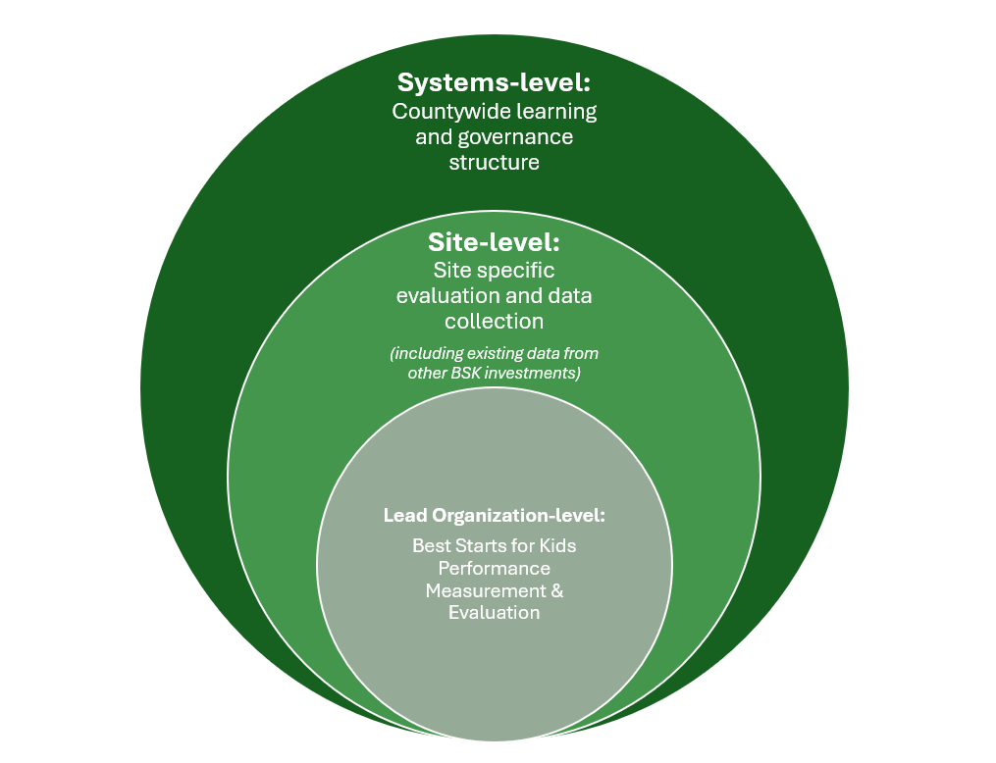

- Data Collection and Reporting

Data collection types detailed in the evaluation plan may include:

- Individual-Level Data
When appropriate for the program model, individual-level data will be reported by the funded program and will typically be reported semiannually.

Individual-level data elements may include individual demographics (including age, gender, race/ethnicity, and zip codes), basic information about services provided, survey information from regular times during program participation (for example at program entry and exit), and individual outcomes. Individual-level data is typically reported through King County’s Client Outcomes Reporting Engine, also known as CORE.

- Aggregate-Level Data
When appropriate for the program model, aggregate-level data will be reported by the funded program and will typically be reported quarterly.

Aggregate-level data may include demographics (including age, gender, race/ethnicity, and zip codes), basic information about services provided, and outcome information of those services.

- Qualitative Data
When appropriate for the program model, qualitative data (such as from focus groups, open-ended surveys and questionnaires, and interviews) may be reported by the funded program.

- Narrative Reports
Funded organizations will also submit annual narrative reports to share information about successes, challenges, system change efforts and other requested information.

- Public Records Act

- Washington State Public Records Act (RCW 42.56) requires public organizations in Washington to promptly make public records available for inspection and copying unless they fall within the specified exemptions contained in the Act or are otherwise privileged.

- All submitted proposals and RFx materials become public information and may be reviewed by anyone requesting to do so at the conclusion of the RFx, negotiation, and award process. This process is concluded when a signed contract is completed between the County and the selected applicant.

- Proposals submitted under this RFx shall be considered public documents and with limited exceptions, proposals that are recommended for contract award will be available for inspection and copying by the public.

If a applicant considers any portion of his/her proposal to be protected under the law, the applicant shall clearly identify on the page(s) affected such words as “CONFIDENTIAL,” PROPRIETARY” or “BUSINESS SECRET.” The applicant shall also use the descriptions above in the following table to identify the effected page number(s) and location(s) of any material to be considered as confidential. If a request is made for disclosure of such portion, the County will review the material in an attempt to determine whether it may be eligible for exemption from disclosure under the law. If the material is not exempt from public disclosure law, or if the County is unable to make a determination of such an exemption, the County will notify the applicant of the request and allow the applicant ten (10) days to take whatever action it deems necessary to protect its interests. If the applicant fails or neglects to take such action within said period, the County will release the portion of the proposal deemed subject to disclosure. By submitting a proposal, the applicant assents to the procedure outlined in this paragraph and shall have no claim against the County on account of actions taken under such procedure. Please notify the County of your needs through the Contact Admin tab in Agiloft and reference the table information below.

Type of Exemption | Beginning Page / Location | Ending Page / Location

- American with Disabilities Act

King County complies with the Americans with Disabilities Act (ADA). Applicants may contact the RFx Coordinator to receive materials for this RFx in alternative formats, such as Braille, large print, audio tape, or computer disc.

- Language Accessibility
Upon request, this RFx can be made available in other languages.

https://www.racialequitytools.org/glossary (link from King County site: https://kingcounty.gov/elected/executive/equity-social-justice/tools-resources/Racial-Justice.aspx)

