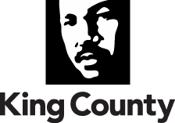

Training Certification Form:

__________________________________________________________________________
(First and Last Name – Please Print)

A member of the _____________________________________________________________
(Name of Board or Commission – Please Print)

Completed the following (Please check all that apply):

- Reviewed “A Summary of King County Board of Ethics” (KC Ord. 9704)
- Reviewed the “King County Public Records Act” training PowerPoint presentation (RCW 42.56 & 40.14)
- Watched the Washington State Attorney General’s “Open Public Meetings Act” 20-minute training video (RCW 42.30)

I hereby certify that the foregoing is true and correct to the best of my knowledge and belief.

Signed and dated by me this ______day of ____________, ______, at _______________, WA.
(day) (month) (year) (city)

________________________________
Signature

Please return the completed form via email to:

Rick Ybarra, Boards & Commissions Liaison
Office of the King County Executive
401 Fifth Avenue, Suite 800
Seattle, WA 98104
Direct Line: 206-263-9651
Email: rick.ybarra@kingcounty.gov

