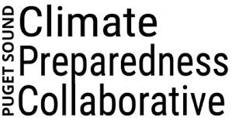**Small Communities Cohort Program FAQ**

The following Frequently Asked Questions (FAQ) provide information regarding the Puget Sound Climate Preparedness Collaborative’s new Small Communities Cohort Program. This document will be updated as needed to include additional questions. Not seeing your question answered here? Contact the Collaborative at [pscpc@kingcounty.gov](mailto:pscpc@kingcounty.gov).

### **What is the Puget Sound Climate Preparedness Collaborative?**

The [Puget Sound Climate Preparedness Collaborative](https://kingcounty.gov/en/dept/executive/governance-leadership/climate-office/partnerships-collaborations/puget-sound-climate-preparedness-collaborative), referred to here as the Collaborative, is a network of more than 30 local and county governments, Tribes, regional agencies, and other organizations in the Puget Sound basin working together to build community, economic, and environmental resilience to the impacts of climate change.

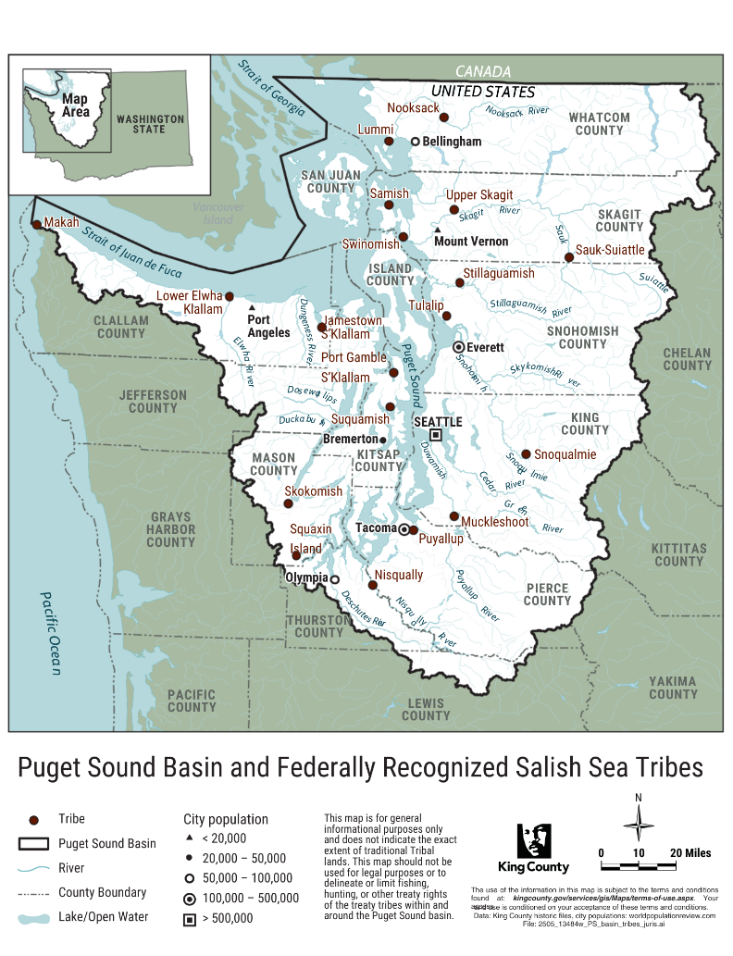

Figure 1. Map of the Puget Sound Basin and Federally Recognized Salish Sea Tribes. Locations on the map are for geographic reference only.

In 2024, the Collaborative was awarded a three-year, $2 million Climate Resilience Regional Challenge grant from the National Oceanic and Atmospheric Administration (NOAA) to expand climate adaptation learning, collaboration, and technical support opportunities for Puget Sound jurisdictions and Tribes. Grant-funded work, which includes creation of the Small Communities Cohort Program, began in spring 2025. See Figure 1 for a map of the Puget Sound basin.

### **What is the Small Communities Cohort Program?**

The Small Communities Cohort Program is designed to support community-identified climate preparedness projects in nine to 12 smaller and less-resourced jurisdictions and Tribes in the Puget Sound region. For the purposes of the program:

* Smaller jurisdictions are jurisdictions (e.g., cities, towns, or villages and unincorporated areas) with a population of 50,000 or less.
* Less-resourced jurisdictions are jurisdictions with a significant percentage of cost-burdened households, populations earning less than 200 percent of the poverty level, households receiving public assistance, and/or households earning low median household incomes. Applicants are not required to identify this information when applying.
* All federally recognized Salish Sea Tribes and Tribal organizations are considered smaller and less resourced.

Staffing for the program is provided by the Collaborative at no cost to participating communities. Staffing resources include three Small Communities Cohort Program Fellows, each of whom will support project work in three to four communities. Program Fellows will be based at King County or other assigned locations and supervised by Collaborative staff; participating communities are not required to host the Fellows. Limited consulting funds are provided to support additional technical or capacity needs. Technical assistance from NOAA support staff may also be available, depending on the requested need. **Projects must be completed by June 30, 2027.** *This program is contingent on the continued availability of obligated federal funds.*

### **Who is eligible for the program?**

The Collaborative will prioritize applications from the following in the Puget Sound basin:

* Local jurisdictions (i.e., cities, towns, villages) with a population of 50,000 or less,
* Counties with an unincorporated area population of 50,000 or less,
* Federally recognized Tribes, and
* Tribal organizations.

Less-resourced medium-sized jurisdictions and counties (population between 50,001 and 100,000) are also encouraged to apply and will be considered based on program demand and capacity.

The following are not eligible as lead applicants but can participate on projects led by eligible public or Tribal applicants: non-governmental organizations, community-based organizations, universities/academics, private businesses, neighborhood groups, and local jurisdictions or counties with unincorporated populations greater than 100,000.

### **What kinds of projects are supported by the program?**

Eligible projects are broadly defined as projects that reduce climate risks and/or increase community resilience to climate change impacts. Projects may include:

* Conducting climate change vulnerability assessments;
* Developing and/or implementing climate action plans, programs, or specific climate actions;
* Pre-planning or project scoping;
* Integrating climate change into existing local plans and practices; and/or
* Community engagement and outreach.

Projects must be completed by June 30, 2027, have clear deliverables and outcomes, and advance climate preparedness objectives within the community. Multiple smaller projects can be submitted by an applicant as a package provided the projects can be completed within the allowed time. A final project scope and timeline will be co-developed with selected project applicants.

### **What if I’m not sure about my project idea?**

Applicants are encouraged to submit a proposal even if project idea(s) are not fully formed or scoped. Collaborative staff are available to answer questions about potential project ideas prior to submitting an application. Additional support for refining project ideas will be provided if selected for further review after submittal. See “What happens if my project is selected?” for more information.

### **Am I required to have a climate action plan to participate?**

A climate action plan is not required to participate in the Small Communities Cohort Program. The program is designed for communities *at any stage of climate action* and can either build upon current work or serve as a launchpad for new efforts. Communities that are early in their climate preparedness work or need assistance with getting work started are particularly encouraged to apply.

### **What are the benefits of participating?**

The Small Communities Cohort Program provides support for completing local climate preparedness projects in the form of shared staffing support, consulting support (limited), and technical support from NOAA (depending on the requested need). Participants in the Cohort will also have access to peer learning opportunities and climate resources from the Collaborative, NOAA, and peer communities.

### **What is expected of participants, and does it cost anything to participate?**

There is no fee for participating in the Small Communities Cohort Program. Participating communities are expected to:

* Be actively engaged in project development and implementation.
* Provide at least one staff point-of-contact who can meet regularly with their assigned Fellow and serve as a project liaison and advocate for information requests and other project needs. The amount of time required for support will vary over time based on project tasks and workflow. For general planning purposes, assume an average of 2-4 hours/week in point-of-contact staff support.
* Have organization approval and support for the project. Participating organizations will be asked to sign a Memorandum of Agreement confirming organizational and staff support for the work once the project scope is finalized.

Participating communities are not required to host Program Fellows.

### **What happens if my project is selected?**

After reviewing applications, qualified applicants will be contacted to schedule a follow-up conversation. These discussions are an opportunity to further develop proposed project idea(s), ask questions, craft a final scope of work, and identify potential technical support needs. Project work is anticipated to begin approximately six weeks after the first selected candidate call, depending on how quickly a Memorandum of Agreement is signed or other scheduling needs. The final Cohort will include between nine and twelve communities.

### **How do I apply?**

Project applications should be submitted by email to [pscpc@kingcounty.gov](mailto:pscpc@kingcounty.gov).

### **Where can I get more information?**

For additional questions, please email [pscpc@kingcounty.gov](mailto:pscpc@kingcounty.gov).