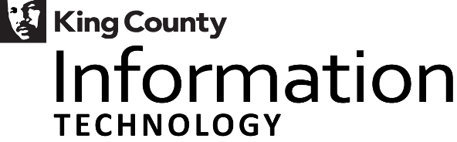

King County, Washington
Strategic Technology Plan 2013 – 2015

2016 Update

April 2016
Table of Contents

2016 Strategic Technology Plan Update 1
King County’s Strategic Technology Plan 1
Measuring Progress 1
Overall Results 2
Strategic Technology Indicators Chart 3
Results by Technology Objective 4
eGovernment 4
Mobility 4
Technology Modernization 4
IT Service Improvements (Maturity) 4
Appendix A – King County Strategic Technology Enterprise Plan–Updated April 2014 5
Appendix B – Strategic Technology Indicators by Objective 6
Appendix C – Table of Acronyms 25

2016 Strategic Technology Plan Update
In 2012/13, the Department of Information Technology, also known as KCIT, developed and published the Strategic Technology Plan 2013 – 2015 which provides strategic direction regarding King County’s information technology (IT). The plan identifies the most appropriate technology objectives needed to focus IT on delivering business value to our customers. The Strategic Technology Plan (STP) is publicly available on the King County website at: http://www.kingcounty.gov/business/oirm/governance/strategicservices/strategicreports.aspx.
King County Code 2.16.0757(A) requires the submittal of an annual update to the STP. This report provides an update on progress made since the inception of the plan. The strategic plan has been endorsed by the Strategic Advisory Council (SAC) and adopted by the King County Council.
A new strategic technology plan is being drafted to cover the 2016-2018 timeframe. A full strategic planning process was utilized to align our technology strategy with the County’s current and future business needs. This has included input and guidance from our Strategic Advisory Council, which includes elected officials from all branches of King County government as well as external industry expert advisors. In addition, business and information technology leaders throughout county government participated in formulating future direction. Performing an environmental scan that includes King County’s strategic and line of business plans as well as information technology industry trends has also helped to set the stage for the technology strategies needed to carry us effectively forward through 2018.

King County’s Strategic Technology Plan
KCIT is committed to increasing the value that technology brings to our internal business partners and to King County’s many and diverse external customers. This means ensuring that the accomplishment of our information technology strategies positions and empowers our partners to accomplish their goals as stated in the King County Strategic Plan as well as in tactical and operational line of business and agency plans. It also means that we can respond quickly with our partners to changing business needs and new technology opportunities that can add value to business operations leading to service improvements for our customers.

We believe this is best accomplished through open, transparent, efficient, effective, and service-focused planning and operational activities. See Appendix A - Strategic Technology Enterprise Plan for a one page summary of strategic efforts contained within the Strategic Technology Plan 2013 – 2015. This summary illustrates how KCIT services align with customers as well as technology domains. It also shares strategic initiatives across several years in all of our service areas. This provides context for how our efforts fit together to help meet our technology and business strategic goals and objectives.

Measuring Progress
Measuring strategic progress is based on looking at movement towards long-term goals that have been identified for strategic technology indicators. There are 30 indicators that align with the four technology objective areas defined in the Strategic Technology Plan. Five of these indicators are focused on information assurance and securing our information technology environment. This reflects not only the strategic importance King County places on securing protected information and business processes but also the needed integration of security concepts in all that we do.

Overall Results
As is the case with any long-range plan, changes that occur over time will influence the value, priority, and feasibility of different components of the plan. Each of the 30 indicators is at a different stage in progressing towards long-term goals. Some indicators have yet to define how progress will be measured. Others have determined baselines and long-range targets. Still others are now measuring progress towards targets.

In this year’s update, minor changes to the strategic outcome measures have occurred as a natural part of evolving the measures to be meaningful and drive desired results over time. For the measures still being defined, progress has not yet enabled fully defining measures that clearly align with goals to effectively drive outcomes.

Chart 1 – Strategic Indicator Progress below summarizes the progress-to-date for all strategic technology indicators. The legend for the table describes the icons that are utilized to provide a visual status update for each indicator. In addition, Appendix B – Strategic Technology Indicators by Objective provides more detail for each indicator including expected benefits that the indicator aligns with, a chart to show progress over time, and notes on progress, obstacles impacting progress, and additional information where appropriate.

Progress related to eGovernment, mobility, maturity, and technology modernization of infrastructure have all made significant advancements. Progress related to modernizing applications has been slower, but has also seen substantial positive progress.

Of the 30 indicators
- three exceed long-range targets
- twenty-three are making positive progress at or above expected levels
- two are making progress, but at a rate slower than initially expected
- two are working towards defining appropriate measures

Strategic Technology Indicators Chart

eGovernment | Mobility | Technology Modernization - Applications | Technology Modernization - Infrastructure | IT Service Improvement (Maturity)
Website vulnerabilities reduced over time | Percent of mobile devices under active management | Percent of applications having identified appropriate data sensitivity classification | Security scorecard shows continuous improvement over time | Percent of Information Assurance (IA) roadmap items that are completed
Percent of business services transacted online | Increased wireless usage | Application counts by type | Percent of worksites with wireless access | Percent of services with defined methodology/ best practice
Web customer satisfaction (resident survey) | Number employees with Unified Communications (UC) capabilities | Increased usage of Office 365 (O365) platform (PaaS) | Application counts by hosting platform (mainframe, server, SVE, VPC, public cloud) | Percent of projects involving technology accomplishing expected benefits
Effectiveness of online messaging and responses | Percent county owned devices that conform to Workstation Service standards / built with standard image | Service Oriented Architecture (SOA) utilization | Percent of county owned server devices running current preferred Operating System (OS) standard | Number of current technology roadmaps
Utilization of open data | Percent of applications delivered through a browser or mobile interface | Percent utilizing standard components | Percent data center square footage that is utilized by county verses lease tenants | Number IT services with service roadmaps
Expand internal participation in providing open data | Percent of overall computing that occurs in a cloud (virtual) environment | Percent of applications conforming with application data standards | Percent of systems receiving full, end-to-end monitoring | Track and report the ratio/mix of KCIT positions

Legend - Strategic Technology Initiative Status




Actuals measured but progress slower than expected
Actuals measured and progress meets or exceeds expectations
Actuals meet or exceed long-range (2023) targets
Measurement process not yet fully defined


Security Focused Indicator

Chart 1 - Strategic Indicator Progress

Results by Technology Objective
The following sections of this report describe overall progress related to each technology objective and highlight significant areas of progress and/or areas of increased focus.

eGovernment
The eGovernment objective has identified six indicators, five of which are making expected progress towards their target goals.

These indicators show that the experience of our residents continues to improve when interacting with us electronically. It’s taking less time to find what they are looking for on our website and they also can access our information on their preferred device more. In addition, more information is being shared through electronic subscriptions – with almost 1 in 7 residents signing up. Social media also continues to provide more targeted information, with a 44 percent growth (down from 51% percent last year) in all social media page views in 2015.

The remaining outcome with below expected progress is around system vulnerabilities. New Payment Card Industry (PCI) requirements have added a significant number of new vulnerabilities. Continued focus is needed to reduce vulnerabilities knowing that new threats are being developed more rapidly than in the past. Maintaining a strong vulnerabilities posture is critical. Also critical is our continued progress towards systems that utilize only standard components thereby reducing the exponential effect on vulnerabilities that multiple technologies can cause.

Some of the near-term areas of focus elicited from a recent event include:
- Ensure that anti-virus is on ALL endpoints.
- Accelerate consolidation of the endpoint security management console to align with KCIT’s service structure. This applies to workstations and servers and will improve standardization.
- Select, architect and implement advanced threat protection. Advanced Threat Protection systems accelerate identification and containment of malware attacks.
- Engage a local consultant to perform forensic incident response analysis.
- Eliminate any unnecessary open network shares and eliminate drive mappings. Network shares provide users and systems access to resources. Drive mappings give these resources an alphabetical designation.
- Address storage of files on local drives through accelerating the adoption of OneDrive for all file storage and the migration of .PST (email storage) files to network archives.
- Identify a process and/or system to ensure 3rd party applications are patched.
- Review and update policies and standards and ensure compliance.
- Block web advertisements. This was attempted when the original URL filter was implemented. Political pressure from agencies such as the County Council and others removed the blocking due to a change in the user experience.
- Decommission legacy remote access platforms (SSL/VPN, Go to My PC – no longer available as of April 1)
- Improve communication processes during an information security incident.

Mobility
All six strategic technology indicators for mobility are meeting or exceeding expected progress towards their goals.

Full Unified Communications (UC) capabilities have been deployed to all appropriate employees. This service includes both enterprise voice services as well as Skype for Business collaboration tools. Mobile Device Management (MDM) has also made great strides by fully rolling out to both managed and personally owned devices. Also important to mobility is increased usage of both private and public clouds to make applications available from anywhere. This includes the refreshing of the employee focused intranet onto a cloud platform, as well as our document collaboration capabilities. When combined effectively with mobile device management, employees can now access their work documents electronically from any location using their work or personal devices. As society continues to increase use of phones and tablets in their personal lives, these updates are important steps to empowering our workforce to be more productive, while also ensuring we are effectively stewarding the information we are responsible for. Significant progress has also occurred in the move to virtual servers, from only 25 percent at the start of 2014 to around 60 percent today.

Technology Modernization
The technology modernization objective has 12 strategic technology indicators identified, six that are application focused, and six that are infrastructure focused. Of these, all six infrastructure and four application indicators are at or exceeding expected progress. Major accomplishments include the decommissioning of our mainframe platform, the significant increase in utilization of our hybrid cloud services, standard cloud collaboration tools available to all employees, and a robust network that now transports voice messages and has the foundation in place for significant increases in wireless traffic.

There are still two indicators that have not yet been defined as they are awaiting our application rationalization strategy, which is currently under construction. Enterprise data classification and Identity and Access Management (IAM) will both be key components of our rationalization strategy going forward.

IT Service Improvements (Maturity)
The IT service improvements objective has six strategic technology indicators identified, five of which are making expected progress towards their target goals. Operational alignment efforts have completed with all KCIT staff now aligned by service rather than by customer. We expect this to have a positive impact on both customer service and service efficiency over time. Processes within each service are also maturing as we implement various on-going improvement efforts. Progress has been slowed in addressing our Information Assurance (IA) roadmap due to the inability to fund next steps in the roadmap including a broader employee education effort.

Appendix A – King County Strategic Technology Enterprise Plan–Updated April 2014
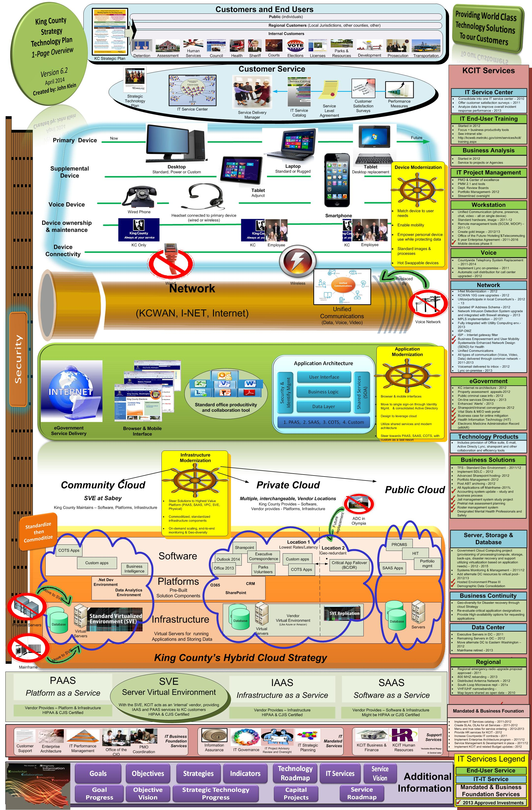

Appendix B – Strategic Technology Indicators by Objective

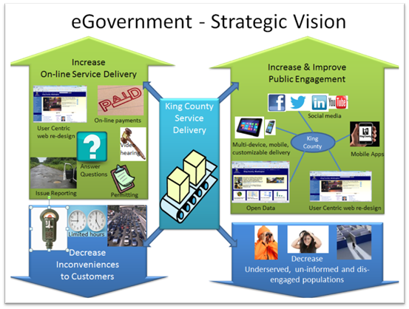

Technology Objective: eGovernment
Improve service delivery to and interaction with King County customers by leveraging web and related social media technologies.
- Improved citizen value and satisfaction when transacting business with King County
- Improved access to King County services
- Increased citizen participation in government
- Greater transparency of government operations

Indicators | Benefit | Chart or progress | Highlights/progress | Hurdles
Website vulnerabilities reduced over time. | Information Assurance – Ensure online transactions are safe and secure. |  | 100 vulnerabilities was initially selected as a good long term goal given the many unknowns that continue to appear as threats. As we learn more about the volume of vulnerabilities over time and increase our understanding of statistical significance, this is proving to be a good stretch target. While KCIT made steady progress in Q3 and Q4 to reduce our web environment vulnerabilities, new PCI vulnerabilities requirements have led to a significant increase in vulnerabilities. On the positive side, our continued progress towards standardizing our environment helps to harden it and reduces the exponential effect that multiple technologies can have on vulnerabilities. Our Chief Information Security and Privacy Officer expects to see a significant decrease in vulnerabilities by Q2 2016. | New PCI requirements
Percent of business services transacted online. | Increases online delivery of King County business services to the public. | 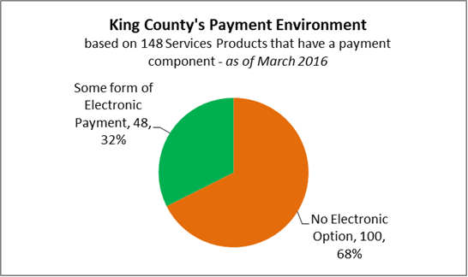 | As stated in last year’s metric, we have broadened this indicator to financial transactions throughout the County and their utilization of online payment options. This information is based upon research performed by the e-payments project. Currently, there are 48 services that accept online payments. This is roughly 32 percent of the different types of financial transactions that occur throughout the County. | A consistent payment process that can be used across different types of services.  Prioritization by business leaders of e-payments as a valuable option towards reducing costs while also improving convenience and access for residents.
Web customer satisfaction. | Ease of Use - Improve the public’s ability to easily find and transact the business services they are interested in. | 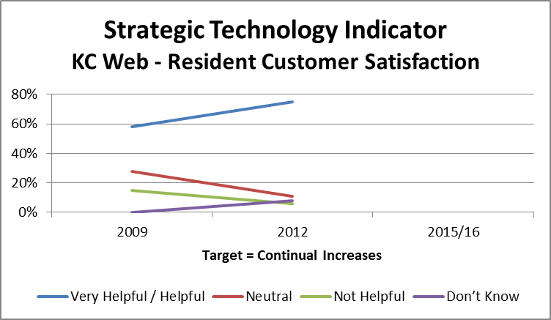 | In 2012, King County’s website was 19 percent above the national average for resident satisfaction. A new resident survey has not been conducted since then.  However, King County has re-architected our web framework since then making it easier to navigate and use on a broader range of consumer devices. | Due to the related expense and effort required, resident surveys are not conducted every year.  Inability for various agencies and departments to convert their web content into the current enterprise standard which would lead to a more consistent user experience as well as more accessible and usable information across our website.
Effectiveness of online messaging and responses. | Increase and improve public engagement using social media. | 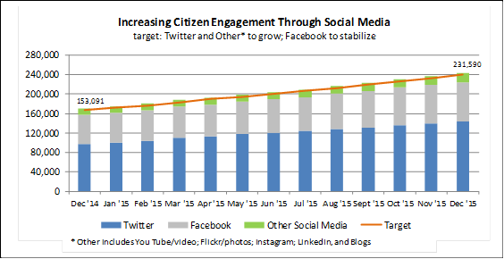  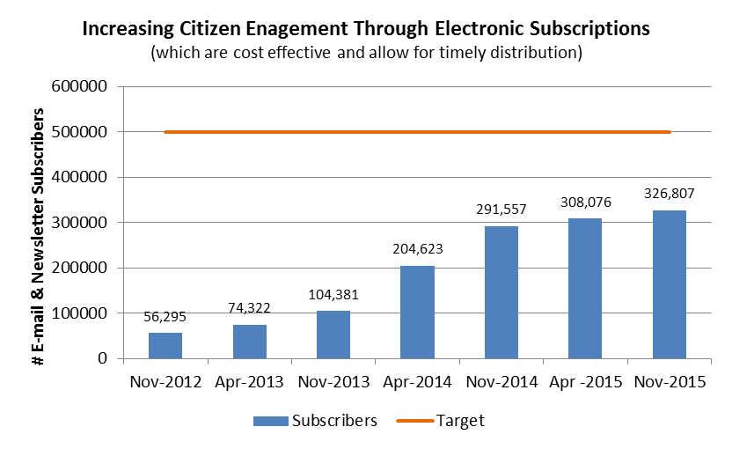 | Online communications continue to increase. Our usage of the GovDelivery tool for online subscription services continues to grow rapidly, with 1 out of 7 residents subscribing. Some relevant statistics include:  Social media stats:  · 180+ total social media pages (up from 141 last year)  · 257,000 fans and followers (up from 174,349)  · 44 percent growth in 2015 across all social media pages (down from 51 percent)  · 26 blogs totaling 300,000 page views in 2015 (up from 14)  · 56 Facebook pages (up from 46)  · 45 Twitter (up from 37)  · 26 video feeds (up from 17)  · 13 Flickr photo galleries (up from 11)  Email/text messages across King County  · 330,000 total subscribers reaching 1 in 7 county residents (up from 1 in 9 last year)  · 11 percent growth in 2015 (down from 60 percent)  · 500+ different topics that people can subscribe to  · In 2015, we sent 12.3 million emails and 5.1 million text messages (up from 9.6 and 3.8 respectively) | We are finding that increased social media accounts don’t directly correlate with increased civic engagement or interaction. We are placing more focus on technologies that appear to be increasing engagement and involvement, such as Twitter. Language is also important and initial translation of some adds to increase awareness has generated significant positive response.
Utilization of open data. | Increase openness of information by publishing county data (that is not private/protected) for public consumption. | 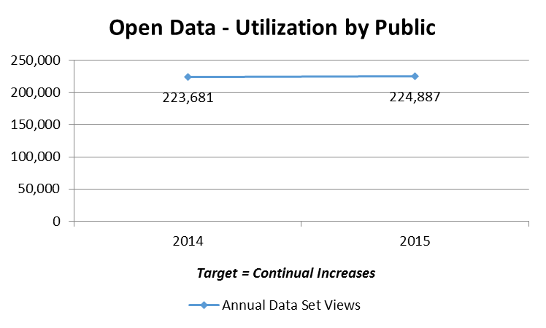 | Growth of page views was relatively flat in 2015. A change in reporting process/tools makes it difficult to compare this data with prior information. It has also caused us to look at whether page views are a valid way to measure utilization, as usage is trending towards applications (Like One Bus Away) that aren’t reflected within page views.  Initial data sets were first made available to the public in October of 2010. | Some departments/agencies have protected information that should not be shared​openly with the public due to the sensitivity of the information involved.
Expand internal participation in providing open data. | Increase openness of information by publishing county data (that is not private/protected) for public consumption. | 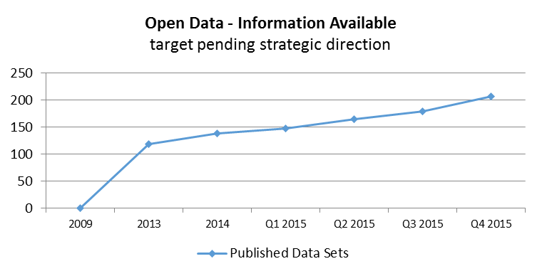 | There are currently over 200 data sets that are posted for public use on King County’s open data website. This number includes charts, applications, calendars and forms. A change in reporting process/tools also makes these numbers difficult to compare to prior data, though we are able to see more historical information than with utilization which isn’t retained as long. Initial data sets were first made available to the public in October of 2010. | Some departments/ agencies have protected information that cannot be shared openly with the public due to the sensitivity of the information involved.

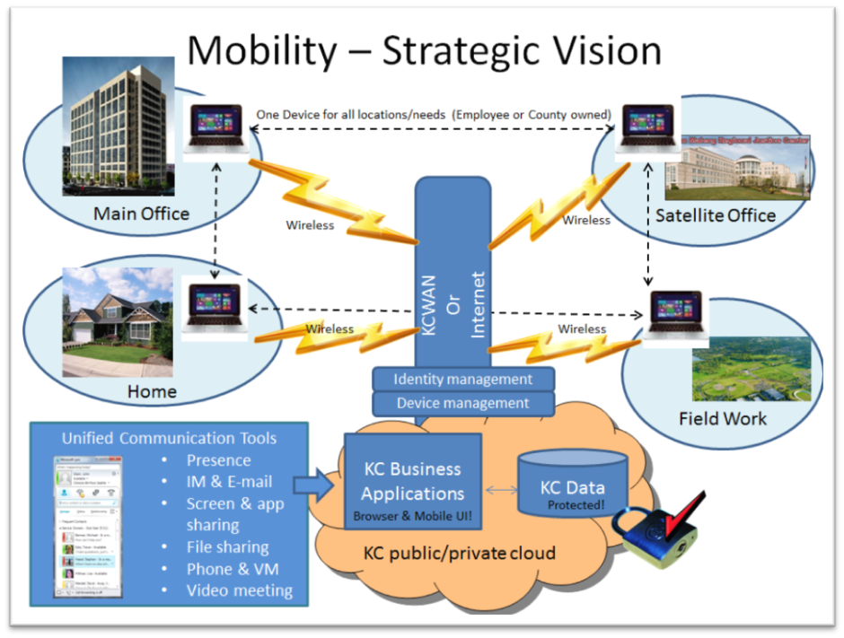
Technology Objective: Mobility
Free employees and citizens to interact and transact business when and where most appropriate and convenient.
- Increased business and IT productivity
- Re-designed business processes geared towards customer service and overall efficiency
- Reduced costs related to staff moves
- More collaborative, open, dynamic office space and working environments

Indicators | Benefit | Chart or progress | Highlights/progress | Hurdles
Percent of mobile devices under active management. | Information Assurance – Ensure that protected information is not at risk due to increased use of mobile end-point devices. |  | A Mobile Device Management (MDM) system was piloted and implemented in late 2014. Options for implementation were based upon policy decisions involving business leaders focused on enabling their staff to be productive with mobile and personal devices, balanced between protecting sensitive data and complying with public disclosure and other transparency needs. Based on pilot results, the full program was rolled out countywide in early 2015.  Measurement was performed on all county owned devices. Significant progress has been made through 2015, with 91 percent of devices managed in January 2016, this includes all county owned devices except for those in agencies that were granted exceptions - Council and PAO.  Personally owned devices are no longer granted access unless they fully comply with our mobile device management policy and supporting systems – which means they are now 100 percent compliant! | If King County data resides on a device, then device management is needed to protect that data. If no data makes it to a device (as is the case with some applications like OWA - the Internet accessible version of the Outlook email application, browser based apps, and O365 SharePoint), then device management may not be needed.  Many employees are reluctant to have their personal devices subject to King County policy. In those cases, employees can elect not to register their device. This choice will limit the type of access to information that they are allowed which includes only use those tools which do-not place data onto their devices, such as OWA as mentioned above.
Increasing wireless usage. | Wireless – allow untethered movement within and between work-sites, improving productivity and collaboration while reducing office move costs. | 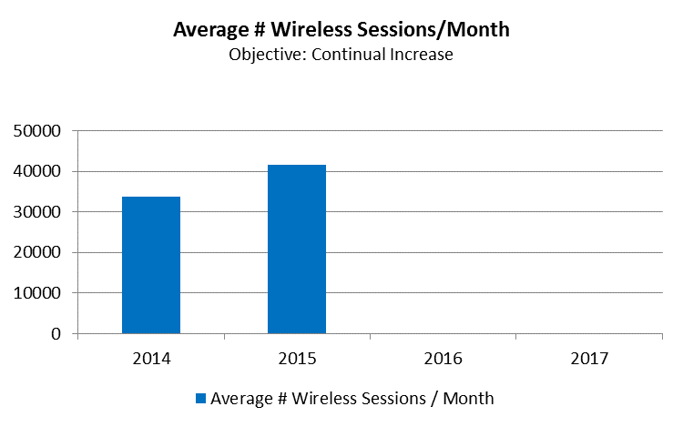 | The average number of wireless sessions per month continues to increase steadily despite the lack of expansion to additional locations. When this happens, we expect to see volume jump as new sites are introduced with the wireless expansion project.  In anticipation of increasing needs around employee mobility, standard equipment for all staff has been updated from a desktop to a laptop. This will provide the same capabilities, while empowering mobility and enabling the future elimination of re-wiring in buildings once all devices can operate over secure wireless connections | The wireless expansion upgrade project was approved for the 2015 budget. After fully designing the solution needed to extend wireless to all buildings, a significant increase in cost was identified. Prior to proceeding, options are being explored and discussed on how to best move forward.
Number of employees with UC capabilities. | Unified Communications (UC) – Extend UC capabilities to all King County staff to increase and improve communication channels and tools available to them. | 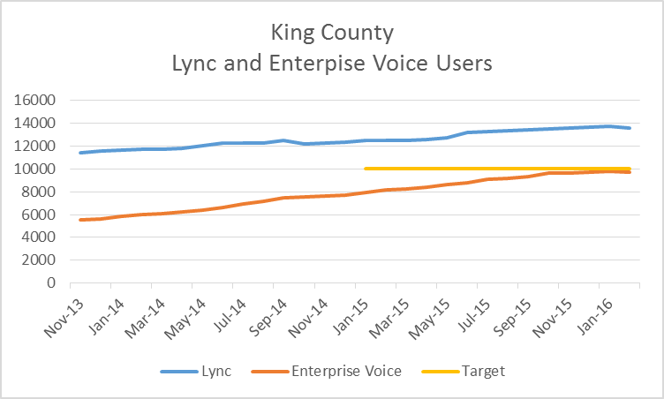 | The roll-out of unified communications (UC) is now complete and has extended to all staff where appropriate for both Skype for Business (formerly called Lync) and Enterprise voice.  Some clean-up efforts continue to decommission older telephony equipment to save additional costs.
Percent county owned devices that conform to Workstation Service standards / built with standard image | End-point standardization: Primary device – Keep employees more productive by reducing end-point device failure and maintenance. | 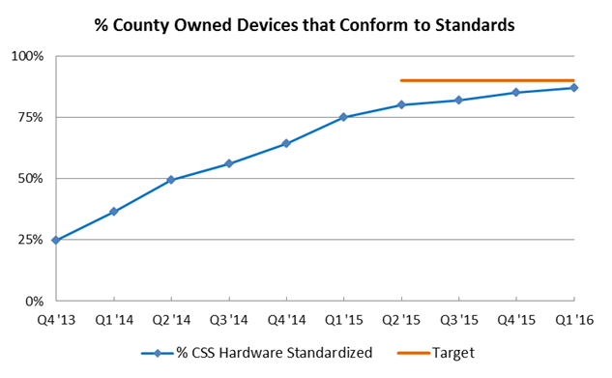 | We continue to progress in increasing the standardization of our end-point devices. Currently 87 percent have been standardized. When we complete our migration towards leased (rather than purchased) devices which are on a 4 year replacement cycle in 2016, we should be at or above the targeted 90 percent. | The speed at which this can occur is limited by the current equipment that is already deployed. For that reason, attainment of this goal is timed to coincide with the equipment replacement schedule which is targeted to replace all equipment every four years.
Percent IT applications delivered through a browser or mobile interface. | Browser/Mobile interface – Applications that run in a browser can be accessed by any device capable of running a browser, and typically are easily accessible via the Internet. Mobility interfaces (for smaller screen size) are also easily available through modern application technologies. |  | We have made significant progress in updating our application inventory to contain current and actionable information. The overall number of applications has changed as we have improved our processes around maintaining the application portfolio and clarifying the definition of an application.  We have started to increase the number of mobile applications - from 1 in 2014 to 8 at the end of 2015 – as we see demand for these types of services beginning to be recognized and valued by our customers. In addition, over half of our applications have a browser or mobile interface making them mobile and available from many locations.  An application rationalization strategy is currently being developed as an enterprise architecture initiative that will provide guidance for how existing legacy applications will be modernized. A future state application architecture will help developed to best determine when to create mobile and browser based interfaces as applications are rationalized. | An application modernization plan is needed for each system in order to better project future compliance. A modernization plan will take significant effort to create.  A 2015/16 proposed project for application modernization was not approved. The Business Solutions Service within KCIT is now addressing application rationalization as part of its on-going practices.
Percent of overall computing that occurs on the cloud (either internal – SVE, or external – VPC). | Cloud Computing – Executing applications on the cloud means that they can be accessible by any device at any time from any location that can access the Internet. | 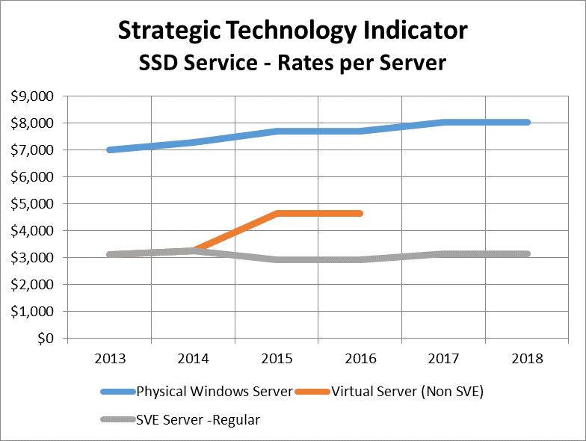 | Moving a significant amount of the County’s applications from physical servers to virtual servers in our Server Virtual Environment (SVE) has already enabled KCIT to provide a significant price reduction for the compute portion of an application’s costs. 2017/18 rates have been determined and show this trend has stabilized but continues to provide significant cost incentive to move from physical to virtual computing. Going forward, we anticipate that some of our compute will be moving off of our SVE and onto our virtual private cloud – Amazon Web Services (AWS) over the next several years as we rationalize our applications to take advantage of this opportunity when it makes sense based on the applications needs (such as rapid scaling up or down to meet user volumes). The rates also indicate that non-standard virtual servers are no longer offered and existing instances are being migrated off of that platform over time when appropriate.  In addition to compute, we have seen significant value from storing data on our virtual private cloud. It is more available and fault tolerant there in addition to costing much less – 2017-18 rates show an 11 percent reduction over 2016 rates! | How quickly we are able to rationalize our application portfolio with determine how quickly we are able to utilize our virtual private cloud for computing resources.  There is also resistance from current users to moving off of 'other virtual' platforms and onto the SVE (Server Virtual Environment) or VPC.

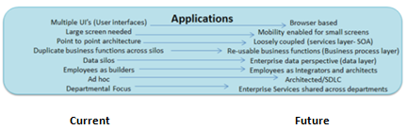
Technology Objective: Technology Modernization – Applications
Enable business solutions that are flexible, timely, and dependable by pro-actively evolving modern application technologies and processes.
- Speed to implement business process changes is faster
- Total Cost of Ownership (TCO) for computing is reduced through efficiencies, standardization, re-use and the ability to meter and rapidly scale resources up or down as needed
- Increased service quality due to increased standardization and reduced downtime
- Reduced risk due to increased redundancy, geographic diversity, and commoditized, on-demand scaling of needed assets

Indicators | Benefit | Chart or progress | Highlights/progress | Hurdles
Percent of applications having identified appropriate data sensitivity classifications. | Information Assurance – Utilize a security scorecard to identify and track progress in improving our security posture for the most critical and vulnerable components of our systems platforms. | 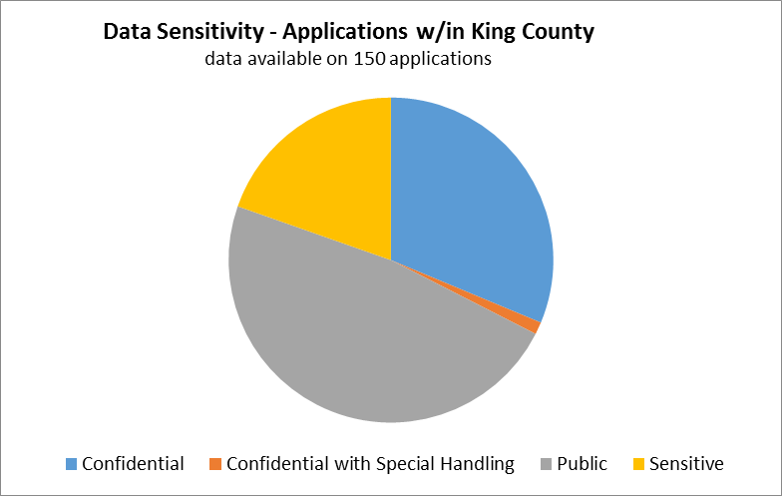 | In 2014, updated data classification standards were approved that align with Washington state standards and that will be used in determining which applications move to which hosting platforms (cloud) – based on their compliance with data sensitivity needs. The standard classifications are: Public, Sensitive, Confidential, and Confidential requiring special handling.  In 2015, we began to update our portfolio with this additional sensitivity information. To date, 150 applications have been updated with over half containing information that should not be made available to the general public.  We still track applications containing the following data:  - Payment Card Industry (PCI)  - Personally Identifiable Information (PII)  - Criminal Justice Information Systems (CJIS)  - Health Insurance Portability and Accountability Act (HIPAA)  - Other confidential data | We are looking to make portfolio updates a standard part of our change management process in order to ensure a more accurate and current portfolio
Application counts by type | Platform steering – Encourage system solutions to use the lowest cost/highest functionality platform, reducing TCO while maintaining service standards and needed business functionality. | 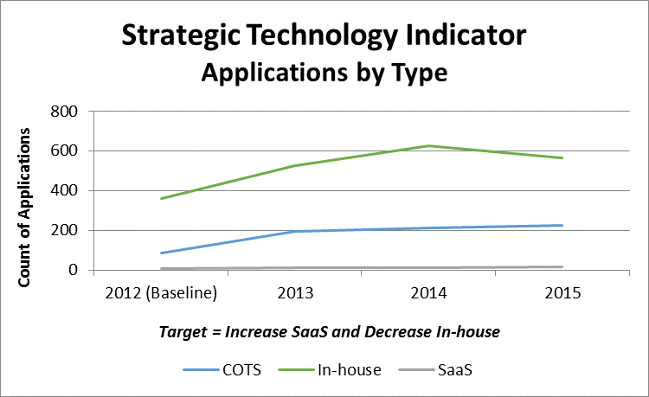 | An updated definition for applications has been created and implemented in order to accurately track applications in our portfolio. Based on updates to our portfolio, we have seen minor increases in COTS and SAAS applications with reductions in in-house applications in alignment with our strategic direction.  As our rationalization approach is adopted across our application services, we should see increased movement in this direction. | Need to establish an application rationalization program is needed.
Percent of county departments and agencies converting intranet sites to 0365. | PAAS - Office 365 – Migrate to an office productivity platform and tools to improve the general office productivity business functions that surround communications and document creation. | 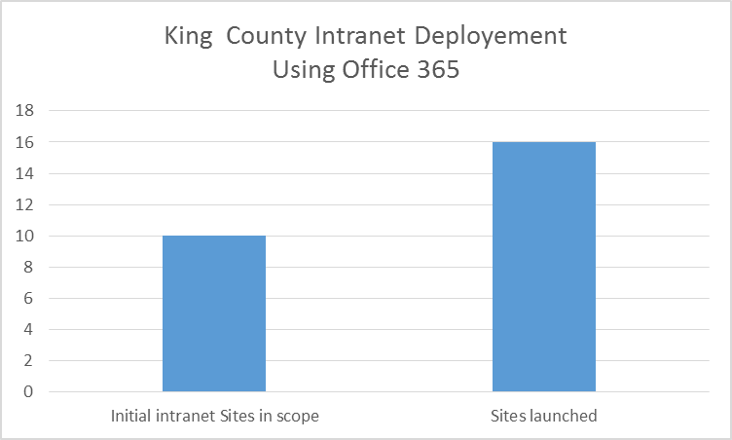 | This metric was changed in 2015 to better reflect platform activity for O365 during the strategic plan reporting period. KCIT’s O365 focus has been centered on SharePoint and migration to its government cloud platform which KC has helped Microsoft to evolve in support of HIPAA and CJIS requirements. By focusing on this area, we are able to generate more value for our customers by re-establishing the County’s intranet - a critical tool for employee engagement and empowerment. The chart to the left shows the County’s results towards launching departments and agencies on the new intranet platform. An additional benefit from this migration has been the implementation of single-sign on for King County’s SharePoint environment. | Some Agencies and departments opted out of the project deliverables and were provided access to the information needed to self-migrate should they so choose in the future.
SOA service utilization rate. | SOA (Service Oriented Architecture) – The main benefit of SOA is to allow simultaneous use and easy mutual data exchange between programs of different vendors without additional programming or making changes to the services. These services are also reusable, resulting in lower development and maintenance costs and providing more value once the service is developed and tested. Having reusable services readily available also results in quicker time to market. |  | We currently have not created the SOA design for our desired modern applications. Until a design is created, we will refrain from determining how success will be measured. In general, this indicator should help to understand how quickly our application portfolio is being modernized. | SOA is a key component of application rationalization. A high level strategy for application modernization is needed prior to implementing an enterprise SOA design to be used by future modern applications.
Percent applications utilizing standard components. | Application architecture- A common application architecture increases system supportability and flexibility while reducing time to implement and fix. | 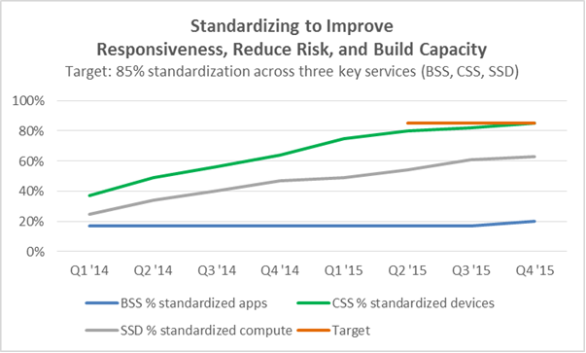 | Applications that currently utilize standard languages and data bases were 20 percent at the end of 2015. This is a slight increase over prior quarters and is indicative that new design review processes are starting to have an impact. However, our portfolio tracking for this component is still maturing and there are a significant number of applications that don’t yet have this tracked in our portfolio. We expect that turning our focus to application rationalization as part of our on-going approach is starting to improve not just the portfolio but the increased usage of standard components within our applications.  As expected, end-point devices have been the quickest component of a system to standardize, followed by our computing infrastructure. Because applications depend on both of these, they have been slowest to standardize but will attain our increased focus going forward. | There are currently 56 different versions of application languages our production environment. There are also 26 versions of multiple types of data bases.  Of these, eight languages/versions and four data base are considered modern and define the standard that should be migrated to.
Percent of applications conforming to application data standards. | Data architecture – Consistent usage and sharing of data improves quality, re-use, and protection while reducing cost and errors. |  | How this indicator is measured will depend on the tools/information available once we have identified our data standards. Significant progress in this area occurred in the second half of 2015 with the hiring of an enterprise data architect who has subsequently created a draft data management strategy that addresses our approach to creating data standards. | Now that an Enterprise Data architect has been hired, we need to re-focus significant application staff into solution architect roles that focus on data design, modeling, and standards

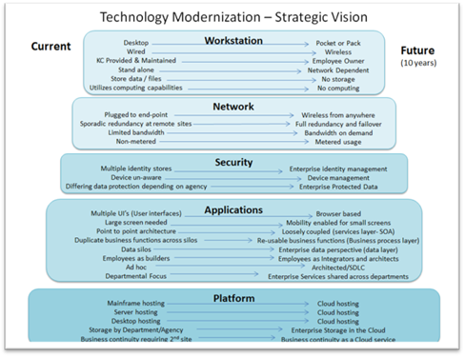
Technology Objective: Technology Modernization – Infrastructure
Empower flexible system solutions by providing current technology platforms, components and frameworks on which applications can operate and continuously improve.
- Speed to implement business process changes is faster
- Total Cost of Ownership (TCO) for computing is reduced through efficiencies, standardization, re-use and the ability to meter and rapidly scale resources up or down as needed
- Increased service quality due to increased standardization and reduced downtime
- Reduced risk due to increased redundancy, geographic diversity, and commoditized, on-demand scaling of needed assets

Indicators | Benefit | Chart or progress | Highlights/progress |  | Hurdles
Security operational scorecard shows continuous improvement over time. | Information Assurance – Utilize a security scorecard to identify and track progress in improving our security posture for the most critical and vulnerable components of our systems platforms. | 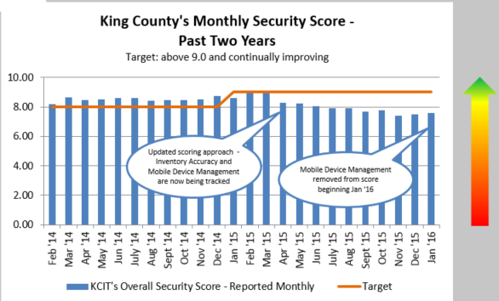 |  |   This metric increased its target in 2015 from a composite score of 8 to 9 based on a full year of meeting the target and wanting to increase our overall drive for improvements. In addition to changing the target, additional scope was added to the scorecard for new challenges in the areas of inventory and mobile device management in an attempt to increase the focus in those areas that need it.  By the end of 2015, we are now able to remove MDM from the scorecard as we have essentially attained desired device compliance in this area for both county owned and personally owned devices. This IT approach of utilizing stretch goals will continue to cause us to look for ways to improve and not become complacent. | Continue to update the areas covered by the scorecard to retain focus on new and most significant security risks across our information technology environment.
Percent of worksites with wireless access | Network – Provide a robust, redundant, wireless network as a key foundational base to all future system solutions.  Ensure proactive upgrades maintain the network’s currency as all other services will increasingly depend more heavily on network capabilities in the future. |  | Minor progress has continued as identified on the chart and in anticipation of the wireless expansion upgrade project – which should have a significant impact as it is rolled out over the next few years. |  | The design phase of the wireless expansion project identified significant cost increases over initial funding requests and is working with sponsorship to determine appropriate approach forward given increased costs.
Application counts by hosting platform (Mainframe, server, SVE, VPC, public cloud) | Cloud platforms – Utilize a suite of cloud platforms (hybrid community/public/private environments) to drive customer behavior to the most cost effective environment. | 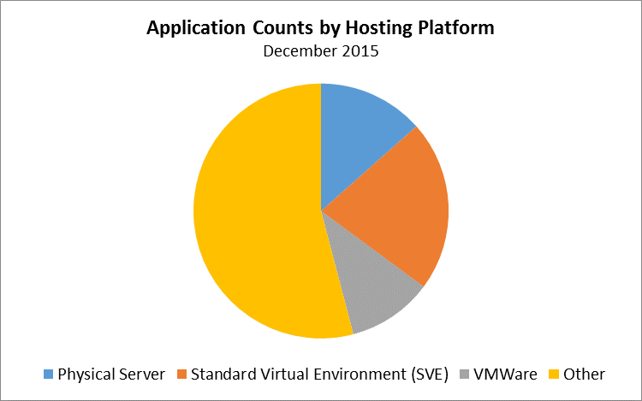 | With our application portfolio improvements, we are now able to present the breakdown of where applications reside within our hybrid cloud environment. The most significant migration in 2015 was to re-deploy all remain applications hosted on our mainframe to a new platform within the standard virtual environment, enabling us to turn off and decommission the costly mainframe platform.  Going forward, we expect application rationalization will migrate applications away from physical servers and VMware towards SVE and AWS. |  | Operationalizing the need for application rationalization will take understanding and support from our many application customers.
Percent of county owned servers running current preferred OS standard. | Standard Operating System – Standardize on Windows as the operating system (OS) for county owned devices, leading to improved systems integration and enabled functionality. |  | We continue to migrate servers off of physical and non-standard virtual servers and towards SaaS, SVE and eventually AWS which are standard. There has been a focused effort to fully eliminate servers that continue to run on the Windows 2003 platform due to security risks related to its obsolescence and lack of vendor support. |  | The Virtual Private Cloud (VPC) is now available, however, we need to create surrounding processes to make it easier to access in a consistent way that fosters cost effective usage.
Percent data center cabinet space that is utilized by the County verses regional tenants. | Data Center – Minimize data center footprint through virtual/cloud hosting in order to reduce cost and enable increased regional partnerships through co-location. | 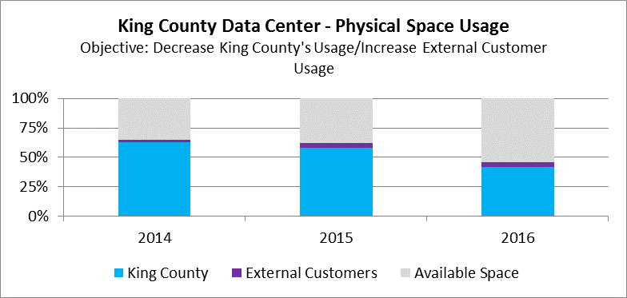 | Through significant process improvement, we have been very successful at dramatically shrinking the square footage needed in the data center to effectively support King County’s overall computing needs. Major successful improvement efforts have included:  - Decommissioning the mainframe and related printer after migrating all systems to the virtual server environment.  - Moving tape back-ups to the cloud, enabling the removal of large tape libraries and equipment  - On-going virtualization of physical servers.  - Less need for on-site office space as we perform more monitoring and maintenance activities remotely.  As our needed footprint has shrunk, we have attempted to re-sell that available space to other organizations needing top tier data center space. Unfortunately, this strategy has not been very successful as most potential tenants are moving to commercial cloud hosting options. As a result, we have changed our strategy and are now looking at how to change our long-term lease to reduce the costs related to the un-used space while continuing to shrink our needed data center footprint. |  | Lease re-structuring.
Percent of systems receiving full, end-to-end monitoring. | Systems Management – The ability to monitor and perform preventative maintenance across entire systems (end-to-end) regardless of where they are located/operating improves the ability to maintain, repair, and improve business systems holistically. | 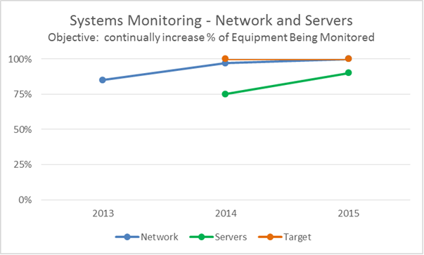 | Our long-term targets for 2023 include:  - 100 percent of network elements being monitored  - 100 percent of systems being monitored (not including end-points)  - 100 percent of services monitored have operational response plans for major alerts  Network monitoring is now fully implemented and has started into the refinement process to improve the results from monitoring.  Servers being monitored has increased to 90 percent and includes 1018 servers. A more robust monitoring tool for servers is also being used on 275 servers including some of our most critical ones. A plan to migrate all servers to this more robust tool is targeted for 2016. |  | Application monitoring is still difficult given our non-standard environment and aging application technologies.

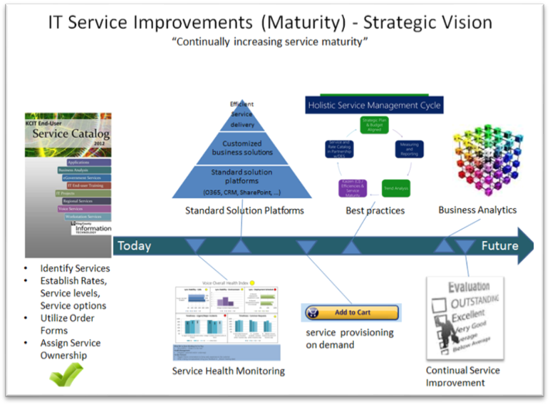
Technology Objective: IT Service Improvements (Maturity)
Increase the value to customers from IT services by maturing our service delivery processes and improving our services to better anticipate and match customer needs and expectations.
- Increased IT customer choice and greater knowledge/ transparency of IT services through improved provisioning, performance dialogues, satisfaction surveys and other practices improving customer satisfaction and engagement
- Strategic alignment of IT services with future customer needs
- Reduced cost of existing services through low cost options in comparison to industry standard offerings, continual service improvements, increased re-use and sharing of solutions, and improved integration across solutions
- Faster delivery of service fixes, changes, improvements and new service introduction through Continual Improvements (CI)

Indicators | Benefit | Chart or progress | Highlights/progress | Hurdles
Percent of IA roadmap items that are completed. | Information Assurance (IA) – Complete an information assurance service roadmap to improve overall understanding, prioritization, and results related to information assurance. | 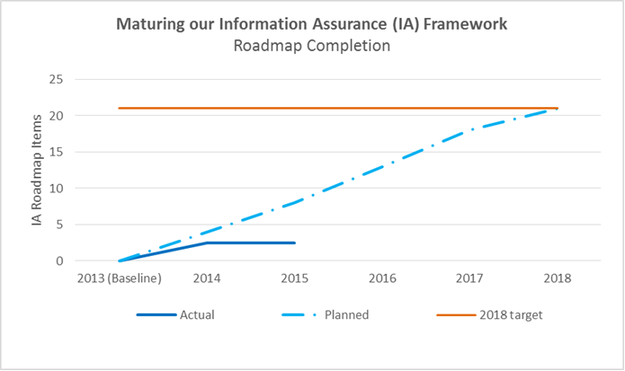 | Significant progress against our information assurance roadmap did not occur in 2015 due to the lack of funding for training and other planned program activities. Existing IA resources have focused on maintaining the current environment. | Progress is slower than expected due to the inability to fund security projects as part of the budget process.
IT customer satisfaction rating. | Service Catalog – A catalog ensures open and transparent communication with customers about the services that are provided as well as the options available to them in order to maximize value received. | 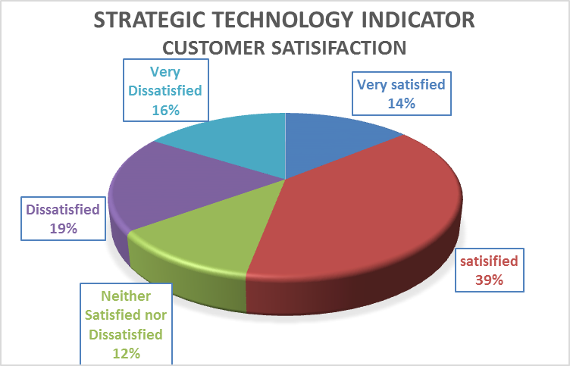 | This indicator was removed last year. The customer satisfaction score from the last survey conducted with the Business Management Council has been retained at left for your reference. | Significant changes in how KCIT interacts with customers are expected as we re-define our SDM role to be customer focused and strategic, removing much of their current line responsibilities. Because of these changes, we will be re-assessing how we track customer satisfaction.
Percent of services with defined methodology/best practice. | Industry best practices – Each service will adopt a methodology or industry best practice by which their service is operated in order to take advantage of the knowledge and learnings of others providing similar services. | 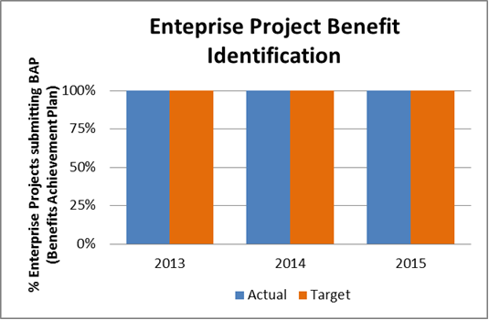 | Most of our IT services our now following a methodology framework or best practice. Expansion and improvement of our operations methodology (utilizing ITIL) has seen significant progress on 2015 with multiple process owners identified and empowered to improve their processes utilizing in-house ITIL expertise to guide and train staff appropriately. | Partial implementation is the norm as full implementation will either be accomplished after fully aligning our services; or, as is the case with some of the larger methodologies like ITIL, component by component.
Percent of IT investments where KCIT is the business sponsors that accomplish a majority of expected benefits. | Benefits realization – Each investment that we make in a service should identify expected and accomplished benefits in order to continually improve our planning skills, to improve the decisions made surrounding investments, and to better inform customers of the potential for beneficial impacts to their services. | 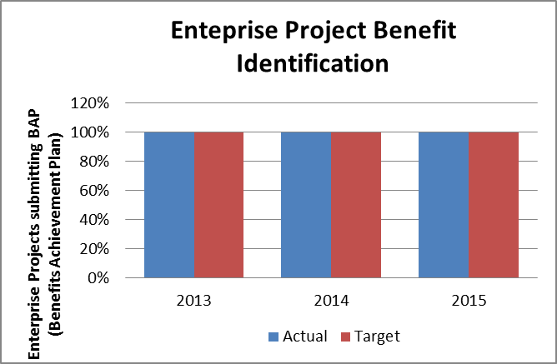  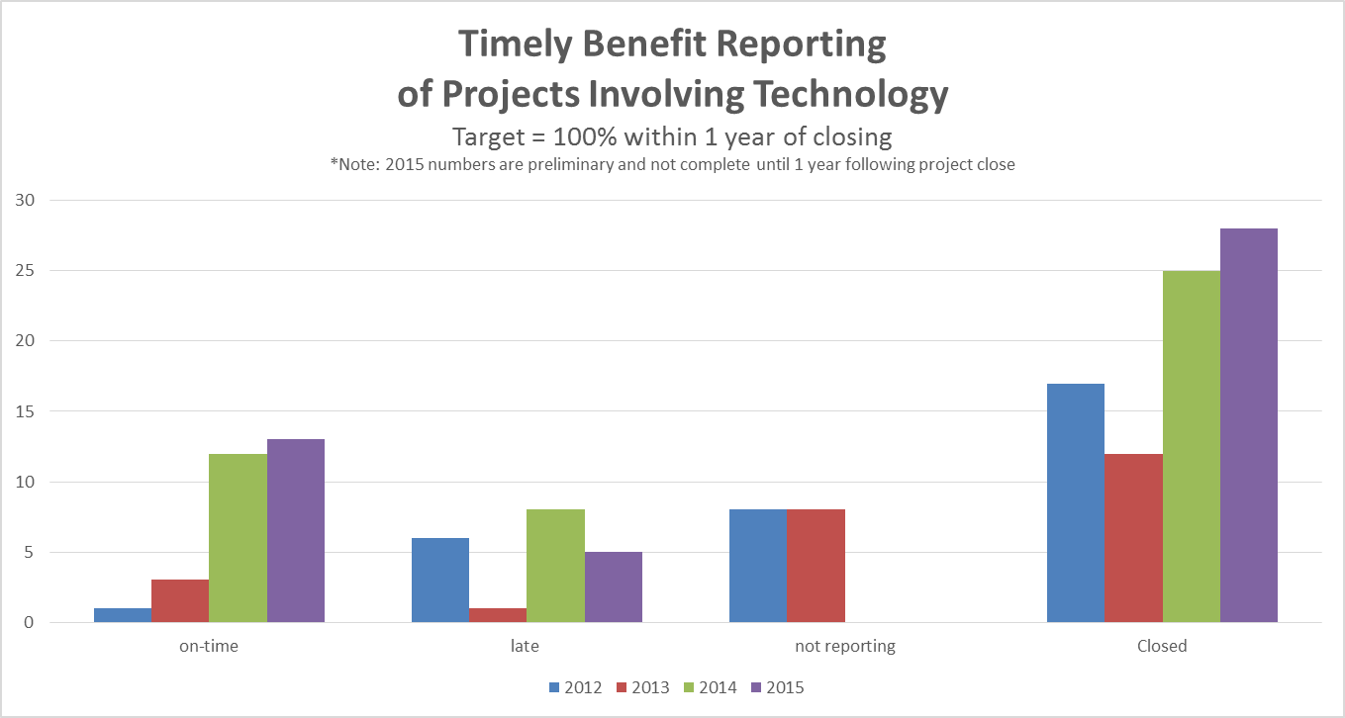 | We have identified 3 progressive measurements as we mature the benefits realization process.  - Percent of Benefit Achievement Plans (BAP's) completed and submitted for active enterprise projects,  - Enterprise projects reporting results against BAPs within one year of scope complete according to close-out report,  - Percent of results accomplished compared to expected as reported (this measure is now reported by PSB as is required by code).  Our long-term goals for each of these areas are 100 percent, 100 percent, and 110 percent respectively. Currently, all enterprise projects have created and submitted BAPS, fully accomplishing the first metric, and consistent with last year’s progress.  For the second metric, we are making progress towards submitting benefit achievement reports in a more timely and consistent way. This can be seen by the on-time component of the graph. Late and non-reporting projects are getting less frequent. For 2015, because there is a 1 year lag in how we measure this metric, 2015 numbers are preliminary until the end of 2016.  We will not report on the 3rd metric which targets achievement of planned benefits. PSB is now responsible for submitting a report on benefits achievement. | PSB is now reporting on the achievement of projects involving IT.
Number of current technology roadmaps. | Enterprise Architecture – Utilizing enterprise architecture helps business leaders and technicians make better decisions by aligning to principles, standards, toolsets, and best practices identified within the County for multiple domain areas. | 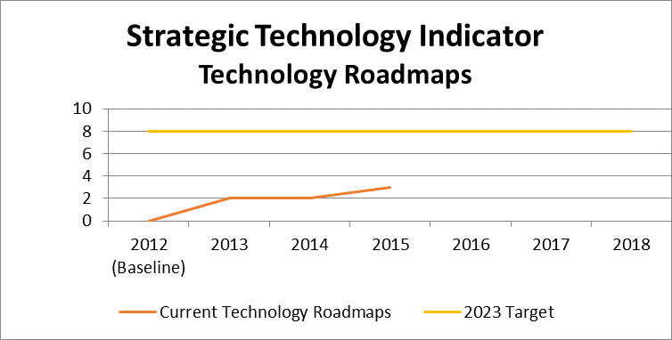 | Several new standards and a new roadmap for Unified Communications (UC) were introduced in 2015 as part of the architecture review process. New roadmaps will continue to be added in 2016 – receiving focus in the application and data area as part of application rationalization efforts and our data focused strategic objective.
Number of IT services with service roadmaps. | Line of Business (LOB) Planning – Pro-actively identifying and planning for future customer needs as well as for environmental changes enables improved service delivery over time and a better TCO approach. | 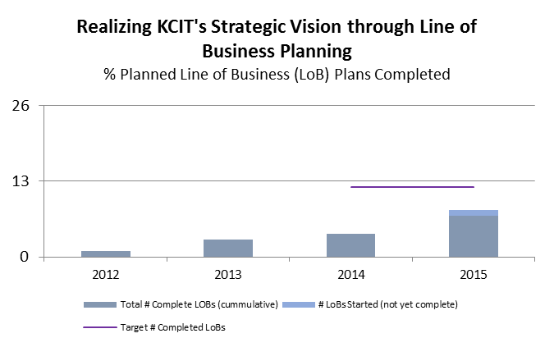 | 2015 saw significant effort to complete line of business plans for most services. Operations completed all efforts including plans for each service. Regional services also completed their LOB plans as did the eGov service.  The combination of PSB analysts and KCIT service delivery managers to facilitate planning worked effectively.  All action items identified in the plans are being monitored by leadership to ensure strategic progress according to the plans. | There is limited organizational capacity to complete this work as we are in the process of shifting from an operational to a strategic orientation.
Ratio/mix of KCIT positions. | Employee Skill Sets – Grow staff skills to implement, support, and maintain modern technology solutions.  Expected future needs will shift towards increased integration (as opposed to custom built solutions) leading to increased need for architecture, analysis, business process, project management vendor management, and especially communication skill sets. | 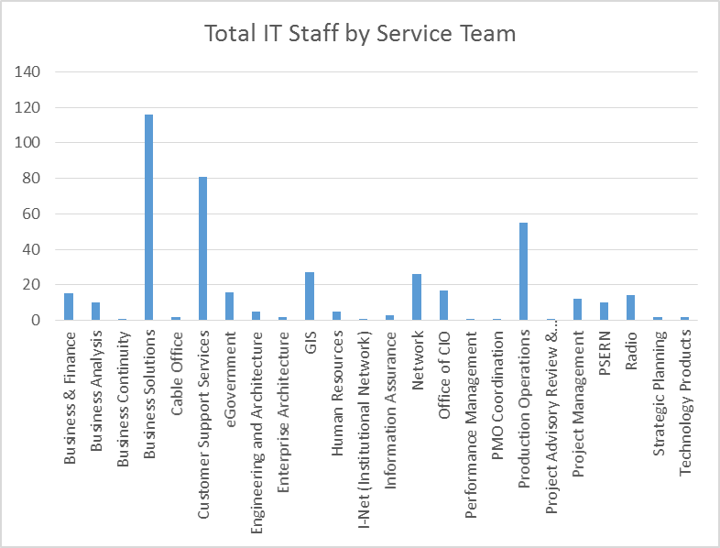  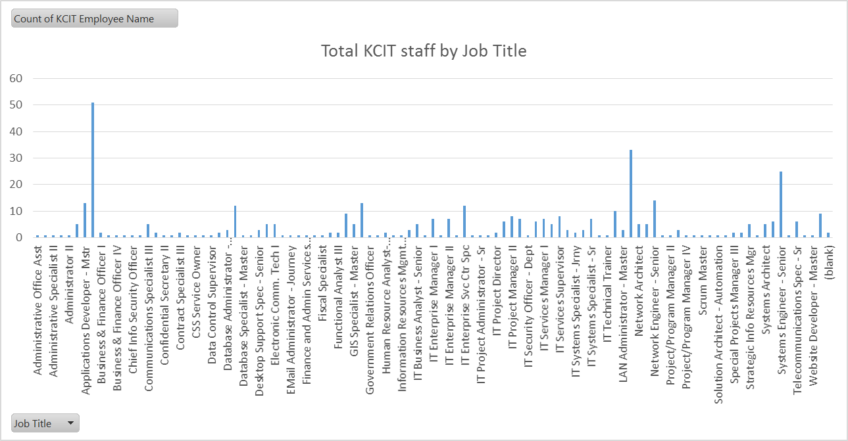 | This indicator doesn’t have any targets other than to initially increase the awareness for how our roles and skill sets are evolving over time.  The two charts show how our staff aligns with our services as well as how many staff are in each of the many job titles used within KCIT. | Shifting of our resources may have an impact on our labor agreements over time.

Appendix C – Table of Acronyms
Acronym | Full Spelling
AWS | Amazon Web Services
BAP | Benefit Achievement Plan
BEUM | Business Empowerment and User Mobility
BMC | Business Management Council
BSS | Business Solutions Service
BYOD | Bring Your Own Device
CFO | Chief Financial Officer
CI | Continuous Improvement
CIO | Chief Information Officer
CIP | Capital Improvement Project
CJIS | Criminal Justice Information System
COTS | Commercial-Off-the-Shelf
CRM | Constituent Relationship Management
CSS | Customer Support Service (formerly workstation service)
EA | Enterprise Architecture
EHR | Electronic Health Record
ESB | Enterprise Service Bus
ESJ | Equity and Social Justice
GIS | Geographical Information System
HIPAA | Health Insurance Portability and Accountability Act
HIT | Health Information Technology
HR | Human Resources
IA | Information Assurance
IAM | Identify and Access Management
IAAS | Infrastructure-as-a-Service
IM | Instant Messaging
I-Net | Institutional Network
IP | Intellectual Property
ITIL | Information Technology Infrastructure Library
IT | Information Technology
KCIT | Department of Information Technology, also known as King County Information Technology
KCSP | King County Strategic Plan
KCWAN | King County Wide Area Network
LOB | Line of Business
MDM | Mobile Device Management
NG 911 | Next Generation 911
O365 | Office 365 – Microsoft’s cloud offering for SharePoint service
OS | Operating System
OWA | Outlook Web Access
PAAS | Platform-as-a-Service
PAO | Prosecuting Attorney’s Office
PCI | Payment Card Industry
PH | Public Health
PII | Personally Identifiable Information
PMO | Project Management Office
PSB | Performance, Strategy and Budget
SAAS | Software-as-a-Service
SAC | Strategic Advisory Council
SCOC | Strengths, Constraints, Opportunities, and Challenges
SDLC | Solution Delivery Lifecycle
SME | Subject Matter Expert
SOA | Service Oriented Architecture
SVE | Standard Virtual Environment – King County’s ‘Private Cloud’
SSD | Server, Storage and Database
SSL/VPN | Secure Sockets Layer/ Virtual Private Network
SSO | Single Sign-On
STP | Strategic Technology Plan
TCO | Total Cost of Ownership
TMB | Technology Management Board
UC | Unified Communications
VM | Voice Mail
VPC | Virtual Private Cloud
WAP | Wireless Access Point

