STRATEGIC INFORMATION
TECHNOLOGY PLAN 2024 – 2027

2025 Update

April 30, 2026

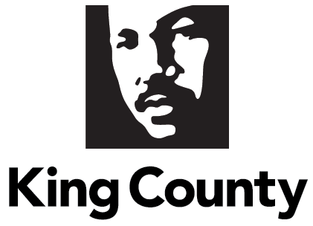

Contents

I. Contents 2
II. King County Code 3
III. Executive Summary 4
IV. Background 5
Department Overview: 5
Key Context: 9
King County’s Technology Governance Structures: 10
Report Methodology: 12
V. Report Requirements 15
KCC 2A.380.200.B.1 - A vision statement for the coordination of technology management and investment across the county; 15
KCC 2A.380.200.B.2 - A description of the current environment strengths, weaknesses, opportunities, and challenges for individual planning issue areas 16
KCC 2A.380.200.B.3 - A list of recommended objectives, with descriptions 17
KCC 2A.380.200.B.4 - The approach to achieve the desired outcomes for each strategic objective 19
KCC 2A.380.200.B.5 - The accomplishments towards meeting objectives from previous approved strategic plans, when objectives have not been met, and a discussion of the obstacles towards meeting those objectives 28
Overview of Key 2025 Accomplishments 28
Progress by Goal Area 31
Goal 1 - Increase Mission Impact 31
Goal 2 - Reduce Cybersecurity and Enterprise Risk 33
Goal 3 - Improve Resident and Stakeholder Experience 36
Goal 4 - Develop People and Teams 38
Goal 5 – Drive Productivity and Cost Optimization 40
KCC 2A.380.200.B.6 – Appendices supporting the recommended objectives; and 44
KCC 2A.380.200.B.7 - Appendix defining the appropriate strategic performance metric(s) for each recommended objective in the plan 44
VI. Conclusion 44
VII. Appendices 46
Appendix A – All Strategic Goals, Objectives, and Initiatives 46
Appendix B – Projects Completed in 2025 70
Appendix C – Approved Project List on 12/31/25 73

King County Code

2A.380.200.B Technology business plan - strategic information technology plan.
Beginning in 2019, and every fourth year thereafter, the chief information officer shall prepare a strategic information technology plan for council adoption by motion. The strategic information technology plan, and the motion for adoption of the plan, shall be transmitted to council by December 31 of the year it is prepared, with annual updates provided by April 30 starting in the year two of the four-year plan. The plan should include, for the subsequent four calendar years:
- A vision statement for the coordination of technology management and investment across the county;
- A description of the current environment, strengths, weaknesses, opportunities, and challenges for individual planning issue areas;
- A list of recommended objectives, with description;
- The approach to achieve the desired outcomes for each strategic objective;
- The accomplishments towards meeting objectives from previous approved strategic plans, when objectives have not been met, and a discussion of the obstacles towards meeting those objectives;
- Appendices supporting the recommended objectives; and
- Appendix defining appropriate strategic performance metric or metrics for each recommended objective in the plan. (Ord. 19654 § 6, 2023: Ord. 18802 § 1, 2018: Ord. 18432 § 8, 2016).

Executive Summary

This report provides the annual update for 2025 of the County’s Strategic Information Technology Plan 2024-2027 (SITP) required by King County Code 2A.380.200. It describes progress made in 2025 and highlights potential future changes to the plan. This report provides a status report on King County’s accomplishments towards achieving the five goals defined in the SITP, with a corresponding set of initiatives which are discreet and measurable bodies of work.

This status update report describes the progress of each of the 83 strategic initiatives supporting the SITP 2024-2027, with aligned and prioritized capital IT investments supporting the five goal areas. Key indicators achieved in 2025 include:

Table 1 – Key Accomplishment Metrics
Metric | 2024 | 2025 | Change 2024-2025
Number of strategic IT initiatives completed | 4 | 11 | 7 or 175% increase in completed initiatives
Capital IT projects completed (over $100,000) | 14 | 24 | 10 or 71.4 % increase in completed capital projects
Completed IT projects with end of project review score | 81.5% | 89% | 9.2% increase in median end of project reviews from prior year

In addition to the 11 initiatives completed in 2025, another 45 strategic IT initiatives are currently underway. In total, 37 initiatives are currently scheduled to be completed in 2026.

Continuously refining strategy is an IT industry best practice. As anticipated, timelines and deliverables for the initiatives identified in the SITP 2024-2027 are adjusted in this report to reflect the progress, learnings, issues, and other factors impacting a digital environment. For full transparency, all changes from the 2025 SITP Update are noted in this report. New initiatives are also added to the strategy portfolio in 2025 and are denoted in the progress report section of this document. The SITP strategic goals and objectives are also updated for clarity and focus for IT customers and staff.

Improvements to King County IT Investment Process made in 2024 continue to demonstrate benefits. The Business Management Council, the advisory body that recommends IT investments, uses a set of 10 weighted criteria to compare and prioritize projects to better reduce King County’s overall technical debt and align with goals in the SITP 2024-2027. , This means that existing projects that need additional appropriation and new technology projects are evaluated together. This holistic look at all projects continues to improve King County’s ability to determine what funding and staffing resources are needed and available to deliver quality IT solutions on time.

The state of King County’s information technology is described in the SITP 2024-2027 using strengths, weaknesses, opportunities, and challenges (SWOC) analysis. While overall findings from the SWOC assessment have not changed significantly in 2025, enterprise technology is becoming increasingly complex to manage because of its distributed, interconnected, and fast-changing aspects.

- High future costs occur by postponing IT upgrades and replacements. The increasing maintenance costs of carrying King County’s technical debt reduces the resources available for innovation, and risks weakening the County’s security posture.
- Limited data-sharing agreements or clear rules for sharing data between agencies. Data silos, pockets of disconnected, non-standardized data owned by separate agencies, make it difficult to know where community needs or impacts are greatest.
- Opportunities to create efficiencies by leveraging enterprise platforms, reducing the hundreds of applications currently supported, and automating manual workflows with improved data tools and artificial intelligence (AI).

Background

Department Overview:
The King County Department of Information Technology (KCIT) supports King County government functions and employees, other regional governments, and the public through a wide array of technology services. The County’s Chief Information Officer (CIO) serves as the department director. KCIT delivers enterprise wide, along with executive branch specific, technology solutions. The County’s legislative and judicial branches, along with separately elected-led agencies, contract with KCIT or hire their own staff to deliver agency-specific information technology solutions that are built on enterprise infrastructure and platforms.

Within adopted budgets, KCIT plans, operates, and supports the County’s IT infrastructure. Primarily, this involves maintaining and modernizing the County’s robust technology portfolio. Technology is a vital component of every King County department’s business operation. KCIT supports more than 25,000 laptops, radios, mobile devices, audio/visual (AV) equipment, and other critical IT hardware. County employees rely on over 550 software applications (apps) to conduct their daily work and deliver services to the public. KCIT supports secure and efficient digital workplaces by managing the County’s:
- Infrastructure and cloud technologies
- Network and wi-fi at County facilities
- Software applications, databases, and data visualization tools
- Employee computers, mobile devices, and other IT equipment
- Communication platforms and AV equipment
- Information security
KCIT also oversees countywide resources such as the employee intranet platform and the County’s public website kingcounty.gov. King County’s website receives over 13 million visitors annually, making it the County’s virtual “front door” and the principal means for the public to engage with County departments services and information.

Additionally, KCIT provides regional services supporting other local government agencies. This includes:
- 911 emergency call handling system;
- Radio subscriber services that include radio installation, mobile radio maintenance services, warranty services, programming, and parts and accessories;
- Geographic information system (GIS) mapping; and
- Institutional network (I-Net), a fiberoptic network that provides high-speed data, voice, and video communications to approximately 300 public facilities including schools, libraries, and government agencies.
KCIT supports the digital services provided by other agencies and offers a handful of services directly to the public, such as cable and broadband internet advocacy for improved access and infrastructure and 911 community education.

On January 6, 2025, an acting CIO was appointed by the Executive and confirmed by the Council, with the appointment extended throughout the year. During 2025, KCIT’s leadership team was restructured to better position the department and King County to successfully take on the significant challenges of keeping pace with the rapid advancement of technology.

Notably, in 2025, legislation formally establishing the Chief Information Security Officer (CISO) in KCC, was passed by the Council. Ordinance 20012 identifies the scope and duties of the position, which reports to the CIO.

Figure 1 – KCIT by the Numbers - 2025
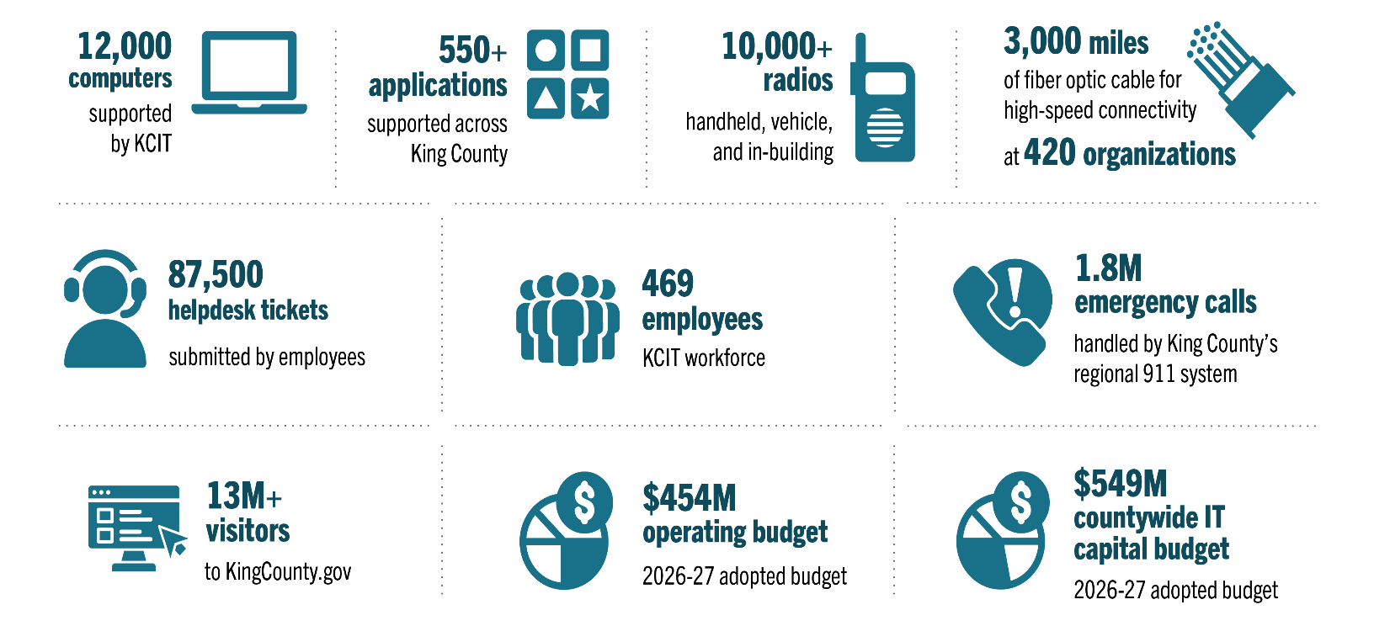

Figure 2 – KCIT Map
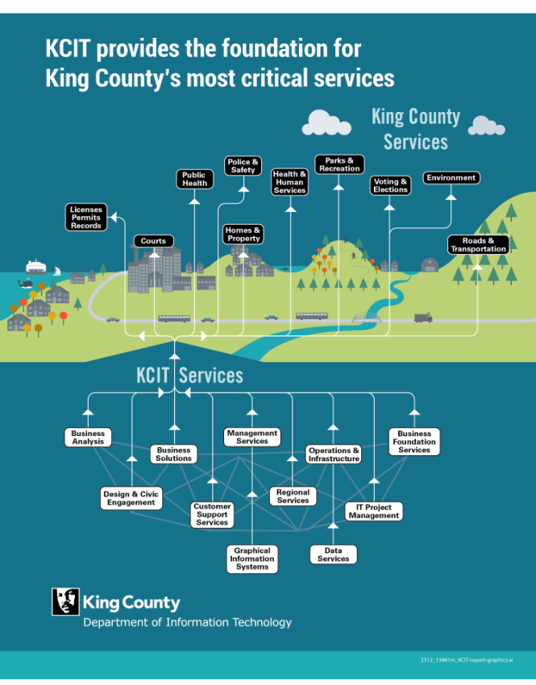

Key Context:
King County is home to some of the world's largest tech companies including Microsoft and Amazon. This county’s technologically adept population has high expectations for King County to deliver innovative technology solutions and seamless online customer service experiences. At the same time, the gap between those who have access to the internet, skills, and devices, and those who do not have access remains. This gap is known as the digital divide., Community members rely on information technology to connect with King County services such as bus scheduling, tax payments, public health appointments, legal proceedings, and more. In response, digital equity has been added to King County’s determinants of equity.

Due to the County’s return to office requirements, most King County employees began to work in-person or in hybrid remote/in-person environments in 2025 and more are expected to work in office in 2026. Even with a growing number of employees returning to works sites several days a week, digital tools continue to be heavily utilized by the County workforce.

The constant stream of new tools, platforms, and methodologies require King County to stay vigilant and discerning when making technology investment decisions. Such a dynamic environment demands the agility and foresight to select technologies that not only meet current needs but also have the scalability and adaptability to accommodate future requirements. Keeping pace with emerging trends, ensuring compatibility with existing systems, and funding are all key factors for KCIT.

As previously reported in SITPs, King County faces significant challenges funding technology solutions and services due to the severely limited General Fund, making it necessary to pursue creative approaches and innovative strategies to meet technology needs despite financial constraints. With revenues restricted and technology costs rising, King County must carefully evaluate technology investments to ensure they support strategic initiatives and operational priorities. These investments require ongoing maintenance and upgrades.

Developed in 2025, a new IT investment prioritization model is designed to focus capital investments on technology modernization, with the goal of replacing outdated systems with modern, cost-effective and sustainable alternatives and eliminating duplicate systems, boosting efficiency. This model depends on expanded data about the technology ecosystem and leverages an enterprise architecture portfolio tool to help guide funding decisions more effectively. King County plans to fully implement the model in early 2026, once it collects enough data to apply it to the entire technology portfolio.

Additionally, King County uses the same modern tool and data-driven approach from the prioritization model to strengthen strategic IT goal tracking and improve IT strategy adoption. Balancing technological progress with fiscal responsibility remains essential for optimizing operations and delivering effective public services.
Cybersecurity concerns also loom large as governments increasingly become targets for sophisticated cyber threats. Ransomware attacks on government entities continue, including against libraries, schools, hospitals, and law enforcement. These attacks hamper regular business practices for days – or even weeks, with serious financial and operational impacts. King County leadership plays a crucial role in prioritizing defensive technologies that mitigate risks, while continuing to cultivate a culture of cybersecurity awareness among employees across the organization.

It is essential that King County deploys and uses artificial intelligence (AI) responsibly. To this end, the CIO approved a countywide AI policy on November 25, 2025. The purpose of the policy is to ensure secure, privacy-protecting, legal, and responsible AI deployment and establishes requirements for AI system acquisition and use across the County. systems, use cases, and readiness.

King County’s Technology Governance Structures:
King County’s technology strategies and funding proposals are developed with input and oversight from four IT advisory bodies. In 2001, Ordinance 14155 instituted a King County information technology governance structure, establishing four committees to advise KCIT as it performs the duties described in King County Code (KCC) 2A.380.300-330, as summarized below in Table 2.

Table 2. IT Governance Committees
Group Name & Membership  per Ordinance 14155 | Duties per Ordinance 14155
Strategic Advisory Council (SAC)  The voting members shall be the executive, two representatives of the King County council’s choosing, the sheriff, the prosecuting attorney, the assessor, the chief information officer, the presiding judge of the superior court, the presiding judge of the district court, the director of elections and the chief information officer. The nonvoting advisory members shall be up to eight external advisors from the private sector to be selected by both the chair and the chief information officer, each to serve a two-year term, and up to two external advisors from the public sector to be selected by the chair and the chief information officer, each to serve a two-year term. | The strategic advisory council shall act in an advisory capacity to the executive in developing long-term strategic objectives and planning and implementing for information technology deployment countywide.  The strategic advisory council shall:  - Develop and recommend strategic objectives for information technology deployment countywide;  - Review information technology proposals for their alignment with adopted strategic objectives;  - Review and endorse the information technology strategic plan and all updates to it;  - Review policy-related transmittals to the county council that are proposed by the executive for large countywide information technology projects; and  - If necessary, review and endorse information technology standards, policies and guidelines recommended by the chief information officer for countywide adoption.
Business Management Council (BMC)  The members shall be the chief information officer and each agency’s deputy director or business manager, designated by the agency’s director, who is familiar with that agency’s business and operations and has authority to commit resources and speak with the authority of the agency when participating in business management council meetings. | The business management council shall act in an advisory capacity to the county’s chief information officer in carrying out duties related to developing short-term, mid-term and strategic objectives for information technology countywide, in recommending information technology proposals for funding and in developing standards, policies and guidelines for implementation.  The business management council shall:  - Review information technology proposals made by individual members, groups of members or ad hoc committees;  - Assess short-term, mid-term strategic value and risk of information technology proposals;  - Assess alignment of information technology proposals with agency technology plans and adopted strategic objectives;  - Recommend information technology proposals for funding and for inclusion in the information technology strategic plan;  - Review and endorse proposed information technology standards, policies and guidelines and recommend to the chief information officer for countywide adoption; and  - Review operations management issues as needed.
Technology Management Board (TMB)  The members shall be the chief information officer, each agency’s information technology director or manager, designated by the agency's director, who is familiar with the agency's technology needs and operations and information technology service delivery managers for executive branch departments. | The board shall act in an advisory capacity to the county's chief information officer on technical issues including policies and standards for information security, applications, infrastructure and data management.  The technology management board shall:  - Review the strategic objectives recommended by the strategic advisory council and assess issues related to the ability of the technology infrastructure to support them;  - Review the business objectives and information technology proposals recommended by the business management council and assess issues related to compliance with the county's technology standards and policies and the impact to the technology infrastructure required to support them;  - Develop or review information technology program proposals that support the strategic and business objectives of the county;  - Develop or review technology program proposals that promote the efficient operation and management of technology infrastructure, applications and data;  - Recommend technology program proposals for funding and for inclusion in the information technology strategic plan; and  - Review and endorse information technology standards, policies and guidelines for countywide use. Information technology standards, policies and guidelines with business implications shall be referred to the business management council for endorsement for countywide use.
Project Review Board (PRB)  The members of the project review board shall be the chief information officer, the deputy county executive, the director of the office of performance, strategy and budget and the director of the department of executive services.  The chief information officer shall serve as the chair of the project review board.  An ad hoc project review team may be convened to focus on specific projects as determined to be necessary by the project review board. Each ad hoc project review team shall include the project’s sponsoring agency director. An ad hoc project review team shall report its findings to the project review board. | All information technology projects shall participate in an oversight process established by the project review board and the chief information officer. The board shall act in an advisory capacity to the chief information officer in:  - Endorsing project management methodology for countywide use;  - Implementing the project management oversight including, but not limited to, review of information technology project status, plans, risk and progress and approval of incremental release of project funding;  - Recommending budgetary changes, suspension or general shutdown of approved information technology projects; and  - Recommending independent quality assurance reviews.

In accordance with KCC, the 2024-2027 SITP was developed according to the recommendations of the Strategic Advisory Council, the Business Management Council, and the Technology Management Board. The 2024-2027 plan was transmitted to the King County Council on September 17, 2024, and adopted January 7th, 2025, via Motion 16719 This report is an update to the adopted 2024-2027 SITP.

Report Methodology:
This report provides the annual update for 2025 of the SITP required by King County Code. Progress on goals is captured into two sections: a portfolio overview of all capital projects and projects under Project Review Board oversight and IT initiatives, and a breakdown by each strategic goal.

Measuring progress on IT Capital Projects - King County measures three key performance indicators (KPIs) related to capital IT projects and projects under PRB oversight. Project performance is measured for overall progress toward the strategic goals and objectives stated in the Strategic Information Technology Plan 2024-2027:

KPI #1: Project Closure Rates – measures the number of projects closed and the median time taken to complete projects.

KPI #2: Project Benefits – measures project alignment with the strategic technology goals as defined in the Strategic Information Technology Plan 2024-2027. It also measures alignment with benefit achievement reporting as identified in each project’s benefit achievement plan. Four benefit categories are used to measure this alignment at a portfolio level. Benefit achievement (BA) categories include:

- BA Category 1 – External Service Benefits: These projects are focused on improving the quality or quantity of services provided to the public. This includes improved quality of service, such as faster response times and better access to services. In 2025, five projects were completed that achieved these benefits.
- BA Category 2 – Internal Service Benefits: These projects are focused on improving internal operations, including the quality or quantity of internal services. In 2025, six projects were completed that achieved these benefits.
- BA Category 3 – Maintaining Service at Current Levels: This category is achieved by projects that either replace or upgrade older technology, reduce the risk of system failures, or provide regulatory compliance. In 2025, twelve projects were completed that achieved this benefit.
- BA Category 4 – Reduced Cost or Cost Avoidance to Produce Services: This category describes projects that reduce or avoid costs to King County. In 2025, one project was completed that achieved these benefits. Therefore, the category is not included in the charts below.
KPI #3: End of Project Review – measures IT projects under Project Review Board oversight which are those with budget of greater than or equal to $250,000 at completion in a more qualitative way than the project benefits KPI.

End of project reviews are required for all technology projects using a capital fund and/or costing more than $250,000. Business and technology stakeholders complete separate evaluations with set criteria; projects are scored within three areas: project value, as determined by the project’s sponsor (see sample Image 1); project management, as determined by the managing organization; and how well the project followed PRB oversight requirements, as determined by PRB support staff.
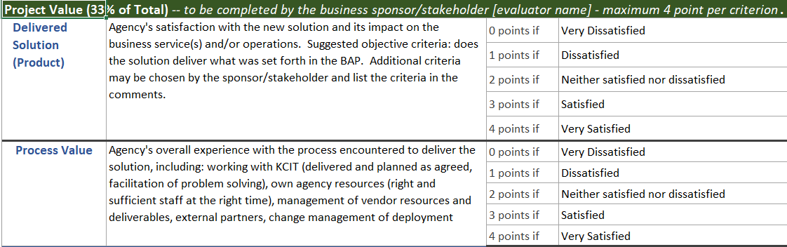
Table 3 – Methodology for Completed Project Value Assessment

Projects with a combined score below the 75 percent success threshold must undergo a post-closure review to determine lessons learned and to improve future project deliveries. The data from end of project reviews is useful for evaluating future investments and assessing King County’s project delivery practices over time.

Measuring Progress on Strategic IT Initiatives
This report measures the strategic initiatives started and completed compared to what was planned, in alignment with Appendix B – Information Technology Strategic Performance Metrics in the SITP 2024-2027and as updated in this document. This report also updates strategic initiatives for:
- Changes to active or planned initiatives
- New initiatives deemed critical to accomplishing strategic IT goals and objectives
- Completed strategic initiatives
Maintaining the currency and focus of the portfolio of strategic initiatives improves delivery of strategic goals and objectives over time. In 2024, King County implemented an enterprise architecture portfolio tool called LeanIX. This tool tracks strategic initiative status through monthly status updates from the owners of each strategic initiative. These status updates are reviewed periodically with KCIT leadership to validate progress and adjust if and where needed. This continuous improvement is an IT industry best practice. , By fully leveraging LeanIX, King County significantly improves strategy deployment for IT.

Goals, objectives, and initiatives are updated as part of annual updates to keep the strategic IT plan current and relevant, with estimations continuously improved to reflect learnings discovered throughout the process.

In addition to the initiatives identified in the SITP 2024-2027, new initiatives continue to be identified that are critical to accomplishing strategic objectives and goals going forward. These initiatives are identified when status updates reveal additional or new needs related to accomplishing objectives and goals. Once identified and approved by IT leadership, new initiatives are included in the portfolio tracking tool and, in this report, and are tracked as strategic initiatives going forward in future annual updates.

The status of strategic goals, objectives, and initiatives are assessed by their designated owner monthly for initiatives and at least quarterly for goals and objectives. The CIO has overall responsibility for the creation of the SITP 2024-2027 as well as the execution of IT initiatives and projects to accomplish that plan. As such, the CIO delegates the responsibility for accomplishing each goal, objective, and initiative. This enables the leader closest to and/or most responsible for what needs to be done to provide more accurate and timely updates.

The SITP strategic goals and objectives are modified since the 2024 report, as discussed later in this document. Changes to initiatives are included in the Progress by Goal Areas section of this report. There, the initiatives for each goal and objective are identified including updated progress and changes for that initiative since the last update. A full list of initiative is also detailed in Appendix A - Table 37 for easy reference.

Of the 83 strategic IT initiatives, 24 remain unchanged from the 2025 report; 36 have number changes due to re-aligning to the updated goals and objectives; five have number changes and wording/scope changes; and 18 are added as new. Current goals, objectives, and initiatives are maintained in the strategy portfolio tool, LeanIX. Specific reports within LeanIX are used to populate this report.

Report Requirements

KCC 2A.380.200.B.1 - A vision statement for the coordination of technology management and investment across the county;

No update or change to the vision statement occurred in 2025. The vision identified in King County’s Strategic Information Technology Plan 2024-2027 remains, as noted below. The next SITP will include an updated vision statement.

As stewards of public resources, KCIT facilitates a technology ecosystem that optimizes the use of digital tools, data, and infrastructure. This SITP reflects a vision where technology enables operational efficiency as well as equity for all residents.

The coordination of technology management and investments proposed in this SITP align with the Executive’s Best Run Government priority. Technology is integral to King County’s day-to-day business operations and customer service delivery. Leveraging technology can help King County enhance revenue collection, improve efficiency, and strengthen fiscal transparency and accountability behind the scenes – as is the case with proposed replacement of the County’s tax assessment and payment system. Delivering effective online services can also directly improve mobility, health-service delivery, public safety, and social outcomes for community members. Within the last four years, King County has implemented a number of online services including remote jury duty via video conferencing, a multilingual website with AI chatbots answering frequently asked questions, and a wide range of online applications such as domestic violence protection orders, reduced transit fares, senior property tax exemptions, and more. This SITP calls for further technology modernizations that are essential to realize the efficiencies and user-friendly services embodied by Best Run Government.

Underpinning this strategic vision is King County’s dedication to digital equity – the idea that the benefits of technology are accessible to all communities. Sustaining vibrant communities includes removing barriers that prevent King County’s low-income and rural residents from full and equitable digital engagement. In the future, proposed digital inclusion initiatives will seek to bridge the digital divide and empower underserved populations, while strategic investments in cybersecurity and data governance will safeguard the privacy of residents.

This vision entails a holistic approach to technology management that promotes interoperability, innovation, and resilience – ensuring the County remains at the forefront of digital transformation. This coordinated approach to technology management will foster greater collaboration across County departments. It will minimize redundancy and drive efficiency, further transforming the County into a more technologically advanced and interconnected community that enables every resident to thrive.

KCC 2A.380.200.B.2 - A description of the current environment strengths, weaknesses, opportunities, and challenges for individual planning issue areas

The strengths, weaknesses, opportunities, and challenges from the Strategic Information Technology Plan 2024-2027 have not changed.

Table 4 - SITP 2024 – 2027 SWOC Table

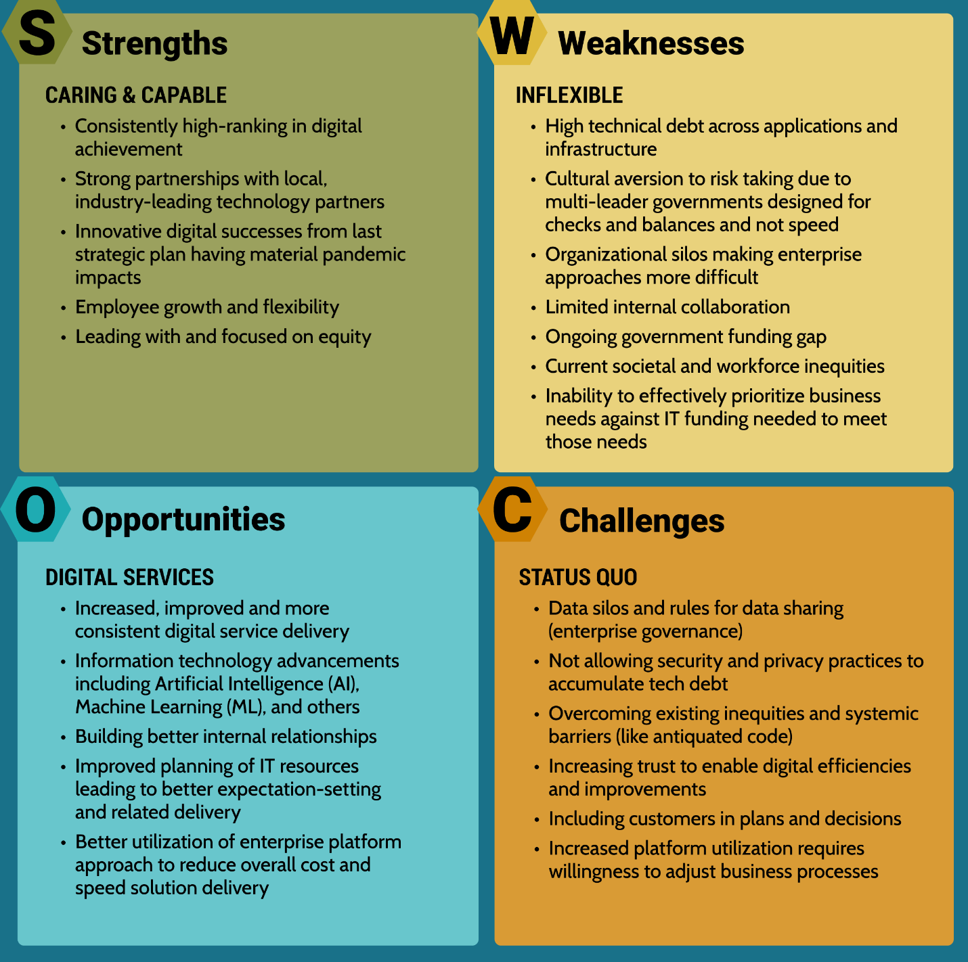

KCC 2A.380.200.B.3 - A list of recommended objectives, with descriptions

Below are the updated 2025 SITP goals. The SITP strategic goals and objectives are updated for clarity and focus for IT customers and staff.

Figure 3 – 2025 Updated SITP Goals
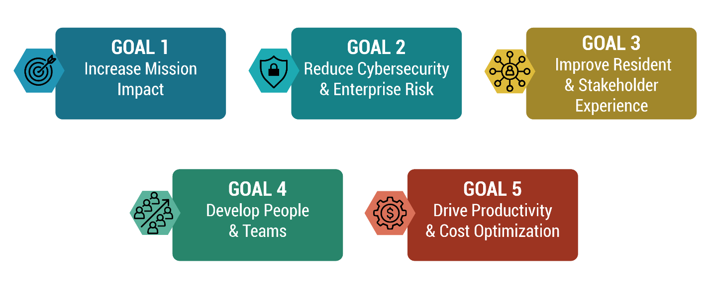
Table 5 below provides a side by side comparison of the 2024 and 2025 goals along with the rationale for the change to the goal.

Table 5 - Table of Updated and Previous Strategic IT Goals
Updated Goal | Updated Description | Previous Goal | Previous Description | Rationale for Update
Goal 1 - Increase Mission Impact | We leverage data and technology to create impactful outcomes and drive informed decision-making. | A Digitally Equitable KC | Enable a digital King County that offers equitable access, opportunities, and outcomes for all community members | Clarify role of IT to support achieving meaningful results with technology and data.
Goal 2 - Reduce Cybersecurity and Enterprise Risk | We secure technology systems, physical infrastructure assets, and data to mitigate risk and maintain public trust. | Continuously Improve Digital Security and Privacy | Continuously Improve Digital Security and Privacy. | Focus on risk reduction with clearer terminology.
Goal 3 - Improve Resident and Stakeholder Experience | We partner to deliver modern, innovative services that are user-centric, trusted, and accessible. | Consistent Online Services Experience | Enable a digital King County through responsible and managed investment in digital capabilities that deliver consistent online services experience to the external community. | Streamline and clarify; center users in IT service delivery and elevates accessibility.
Goal 4 - Develop People & Teams | We support a County workforce that is digitally capable and adaptable to change. | A Data-Driven King County | Expand the availability, use, and power of data and analytics to advance a data-driven King County. | Recognize the important human element of a data-focused, digitally capable County.
Goal 5 - Drive Productivity & Cost Optimization | We maximize the value and longevity of technology investments for effective, reliable, and resilient operations. | Drive IT Excellence | Drive Information Technology effectiveness and operational excellence | Explicit focus on cost and productivity. Shifting focus to measurable outcomes, aligning to benchmarks, managing technology investments as a portfolio.

KCC 2A.380.200.B.4 - The approach to achieve the desired outcomes for each strategic objective

This section provides detail for each of the five information technology goals, including objectives designed to achieve the goal. A corresponding set of initiatives which are discrete and measurable bodies of work representing the work to be completed for each objective is also included. Changes to objectives since the last report are identified and described in Table 6. A full list of all goals, objectives, and initiatives is included as appendix A of this report.

Table 6 - Table of Updated Strategic IT Objectives
Updated Objective | Updated Description | Previous Objective | Previous Description | Basis for Update
Obj 1.1 - Support Broadband and Digital Equity | Support efforts to build a Washington state broadband and digital equity plan that addresses unserved/underserved populations. | Obj 1.3 - Support Broadband and Digital Equity | Support efforts to build a Washington state broadband and digital equity plan that addresses unserved/underserved populations. | Renumber; no substantive change.
Obj 1.2 - Targeted Accelerator Initiatives | Identify and invest in initiatives that provide high benefits to our partners and customers relative to the projected costs. | Obj 1.2 - Remove Potential Bias | Facilitate the use of tools and measures that remove potential bias from information technology initiatives. | Changed objective to group efforts more aligned with mission impacting efforts. Potential Bias was removed as it is better covered in objective 5.4 AI efforts.
 |  | OBJ 1.4 - Data-Driven Equity | Be data-driven when making decisions regarding equitable access and standards across the county. | Removed as this is similar to other equity and data efforts.
Obj 2.1 - Centralize and streamline identity management | Centralize and streamline identity management at King County. | Obj 2.1 - Centralize and streamline identity management | Centralize and streamline identity management at King County. | No Change
Obj 2.2 - Ensure privacy & security of information assets. | Ensure the privacy and security of information assets. | Obj 2.2 - Ensure privacy & security of information assets. | Ensure the privacy and security of information assets. | No Change
Obj 2.3 - Automate Threat detection capability. | Automate King County's threat detection capability. | Obj 2.3 - Automate Threat detection capability. | Automate King County's threat detection capability. | No Change
Obj 2.4 - Increase Speed of Information Security and Privacy Deployment | Increase the speed of information security and privacy strategy adoption and deployment in the County. | Obj 2.4 - Increase Speed of S&P Deployment | Increase the speed of information security and privacy strategy adoption and deployment in the County. | No Change
Obj 3.1 – One Stop Portal Experience | Design and implement a portal experience for the community that serves as a 'one-stop shop' for needed services and information. | Obj 3.1 - 'One-Stop' Portal Experience | Design and implement a portal experience for the community that serves as a 'one-stop shop' for needed services and information. | No Change
Obj 3.2 - Focus on the Customer | Involve customers earlier and more often and empower them to solve their own problems where appropriate. | New |  | Added to increase the focus on customer experience and involvement needed to accomplish goal 3.
Obj 3.3 - Lead Digital Accessibility | Lead the standardization of accessibility and language across all communication channels with the community. | Obj 1.1 - Lead Digital Accessibility | Lead the standardization of accessibility and language across all communication channels with the community. | No Change except re-aligned with goal 3 and updated numbering.
Obj 4.1 - Invest in People | Ensure that we prioritize employees through:  - Continued skill development in both their current and desired career progression  - Tools that enable effective communication, productivity, and wellness  - A positive, supporting, and caring work environment, culture, and experience where all are included | Obj 4.1 - Enterprise Data Governance Strategy & Roadmap. | Implement an enterprise data governance strategy and roadmap. | Updated to align with goal 4 to develop people and teams and target the associated investments needed to accomplish that goal. Data governance is removed as it has been mostly accomplished through its initiatives with any remaining work continuing under other objectives.
 |  | Obj 4.2 - Increase use of data in Focus Areas | Increase the transparency, availability, and use of data relevant to specific areas of focus to be determined, across the County (equity, quality of services, etc.) | Removed as an objective to coincide with the change in goal 4. Data usage continues to receive focus under initiatives in several more focused areas.
Obj 5.1 - Accelerate legacy modernization | Reduce technical debt in existing systems through modernization. Also put policies and processes in place to ensure avoidance of increasing technical debt in all systems through on-going maintenance and upgrades when needed. | Obj 5.1 - Accelerate legacy modernization | Accelerate legacy modernization | No Change. Added detail to description.
Obj 5.2 - Faster IT Service Delivery | Reduce the time from inception to delivery of quality solutions while improving status communications with partners & customers. | Obj 5.3 - IT Services Portfolio Focused on Enterprise Value | Deliver a strategic information technology services portfolio that focuses on enterprise value | Increased specificity to improve communication and intent and re-numbered.
Obj 5.3 - Improve Internal IT Controls | Increase the accuracy, understanding, and usage of internal control systems to improve operational and strategic awareness. | Obj 5.4 - IT Asset Management Practice | Create an information technology asset management practice to reduce risk, manage cost, and improve service. | Broadened asset management to include other internal controls areas.
Obj 5.4 - Leverage AI | Leverage Artificial Intelligence throughout King County's workforce and services to increase productivity and quality while ensuring safe and equitable use. | Obj 3.2 - AI Strategy & Roadmap | Develop a formal Artificial Intelligence (AI) strategy and roadmap for King County. | Increased the specificity of wording for better clarity, re-numbered, and re-aligned with goal 5.
OBJ 5.5 - Leverage Financial Controls | Utilize automation, best practices and proven tools to improve cost effective IT service delivery. | Obj 5.5 - Evolve Project Oversight & Management | Evolve the project oversight and management functions to reduce administrative burden, improve project outcomes, and increase the percentage of on-time project completion. | Broadened to additional areas of financial control in addition to project oversight.
 |  | Obj 5.2 - Implement Enterprise Architecture (EA) | Finalize and implement the Enterprise Architecture (EA) | Dropped due to being vague and hard to communicate. Strategic initiatives continue in support of other objectives.

Figure 4 – Goal One and Objectives
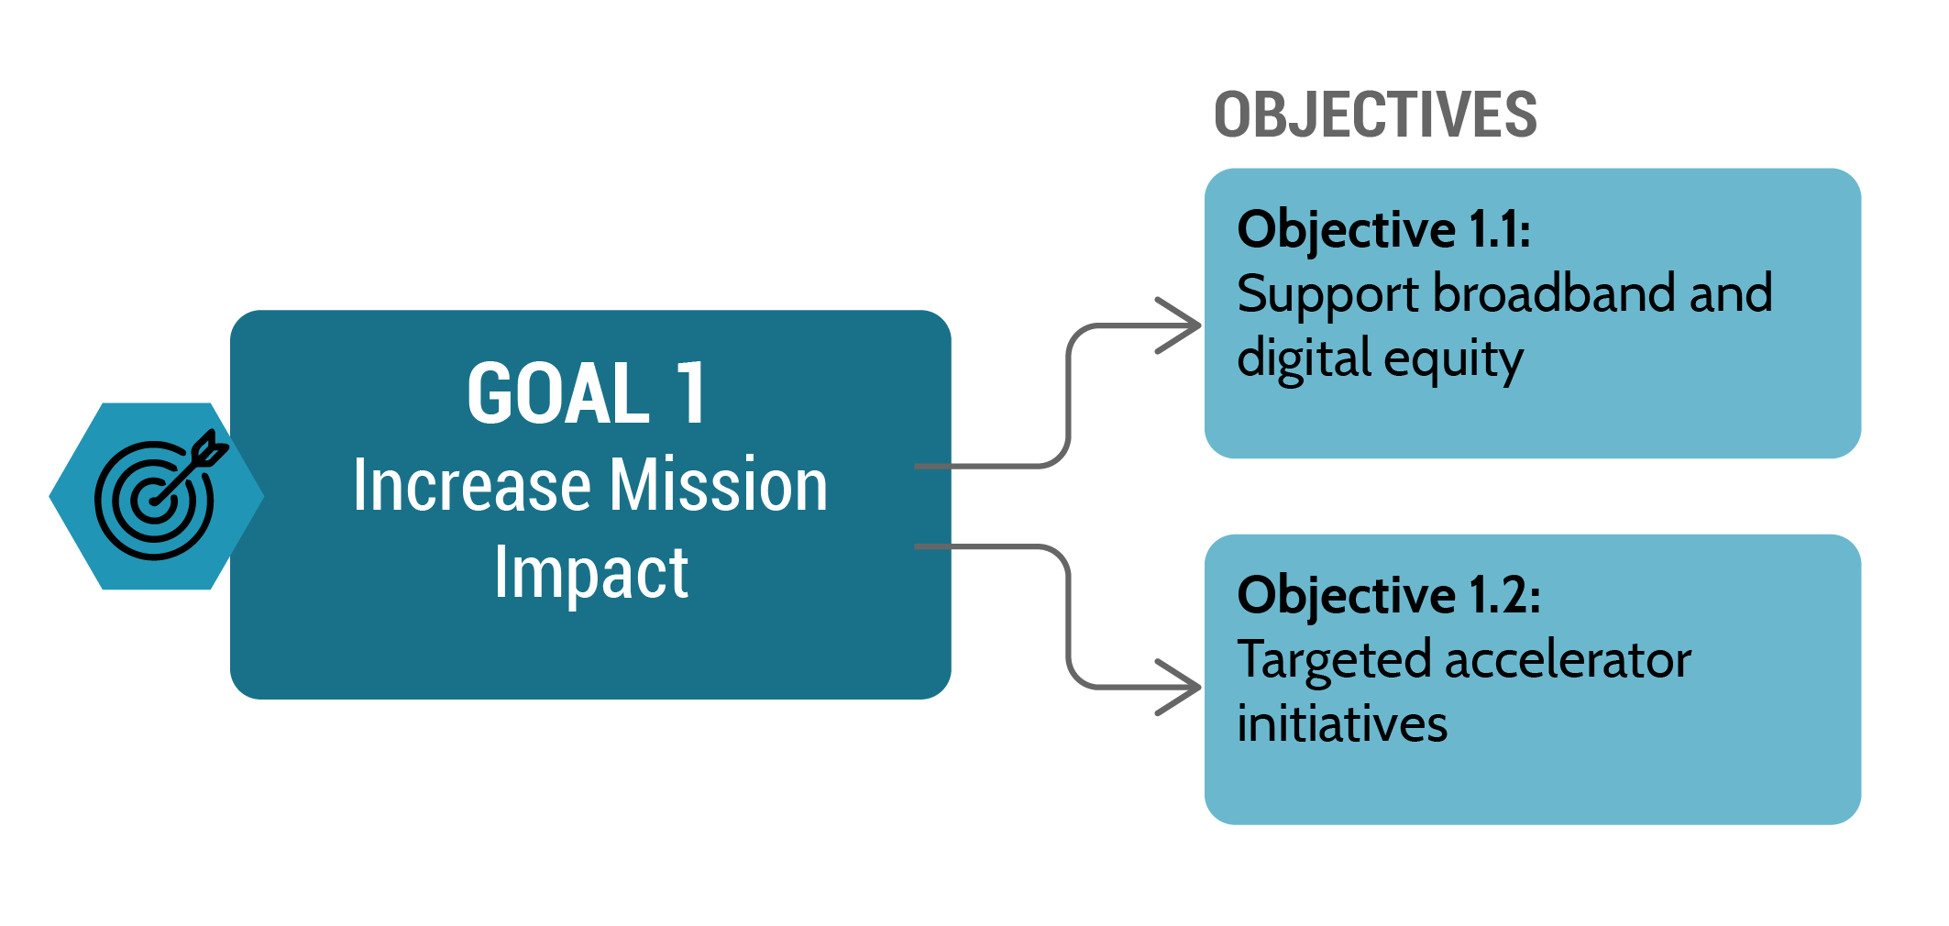

Goal 1: King County leverages information technology to deliver services and meet statutory and policy obligations, supporting all branches of government to maximize results. Because technology can have a profound impact on most aspects of County service delivery, IT has the potential to significantly improve the results delivered to the public and internally. This updated goal recognizes that data and technology should be leveraged to expand mission impact and produce meaningful results.

One key area supporting mission accomplishment digital equity. Fast and reliable broadband internet is an essential public utility people need to effectively work from home, conduct personal business (like banking or online payments), or access critical resources such as telemedicine, educational resources, or online government services. King County continues to partner with other governments and private industry to improve internet access and affordability.

Digital equity goes beyond internet connectivity. King County is working to further equitable access to vital information and services by standardizing accessibility across all communications channels – including the public website for desktop and mobile visitors, social media, apps, phone calls, and video conferencing. Clear analysis using more robust reporting tools helps leaders identify and mitigate potential bias from technology initiatives and make data-informed decisions.

Accelerator initiatives are initiatives that impact current and future mission delivery, helping to maximize long-term results and value. One example of an accelerator initiative is a data hub, where relevant, timely data is available to employees for analysis and decision making. DNRP recently launched a data hub to consolidate and analyze scientific data much faster and in a more straightforward way than without the data hub. This helps DNRP staff better measure changes to the environment, and be more data driven in their recommendations.

Other examples include improved metric identification, tracking, and reporting tools like dashboards and early investment analytic processes like equity impact reviews that seek to increase the impacts of investments on equity conditions either in the community or in the workplace.

Figure 5 – Goal 2 and Objectives
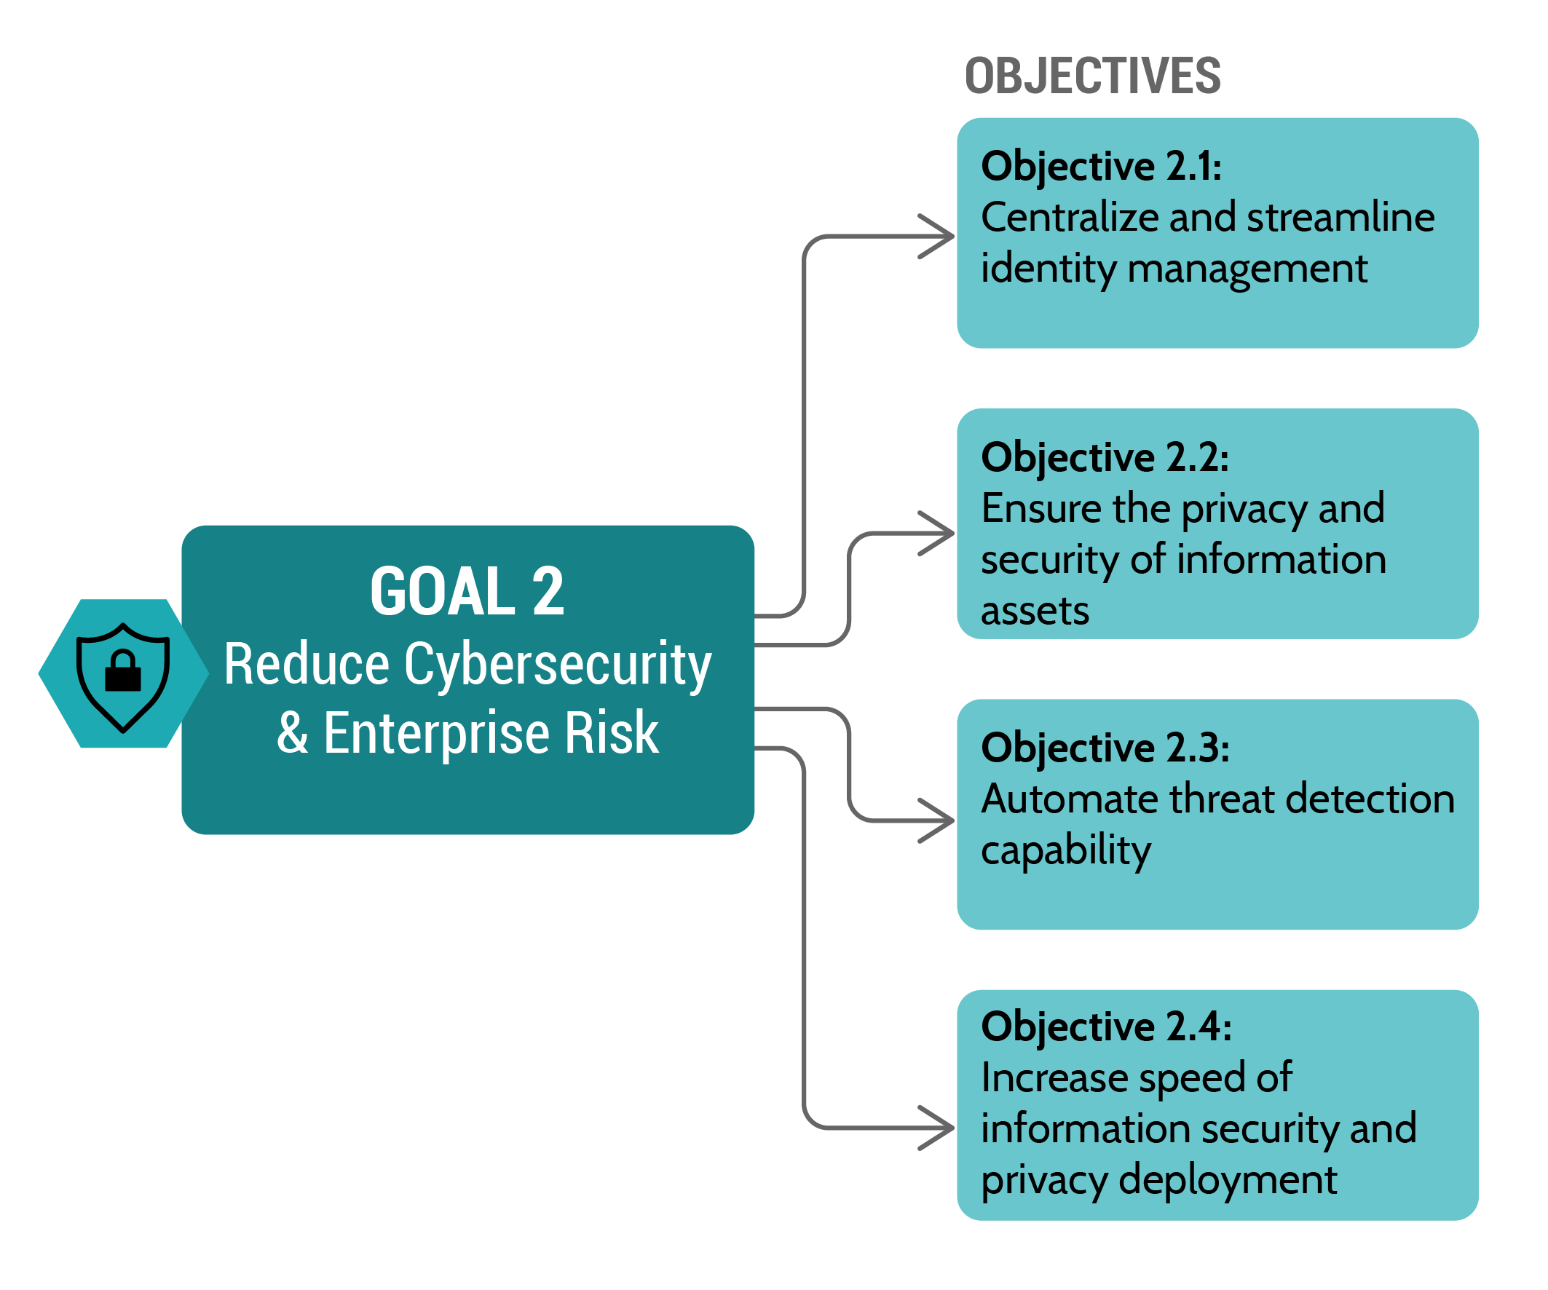
Goal 2: The goal of continuously enhancing digital security and privacy is foundational to King County's resilience, credibility, and the fulfillment of its duty to safeguard the public interest in an increasingly digital world. This goal is updated to explicitly focus on reducing risk and maintaining public trust by securing systems, physical infrastructure assets, and data.

Security and data privacy continue to be of paramount importance, as cyberattacks on governments continue. In an era marked by rapid technological advancements and an ever-growing reliance on digital infrastructure, it is imperative to continuously improve the County’s digital security and privacy. The escalating frequency and sophistication of cyber threats pose a direct and substantial risk to the confidentiality, integrity, and availability of sensitive information.

Data breaches can have far-reaching consequences, including significant community and individual harm, severe financial losses, and overall loss of trust in government services. It’s for these reasons that King County must continue with an unwavering commitment to the security and privacy of the organization.

Figure 6 - Goal 3 and Objectives
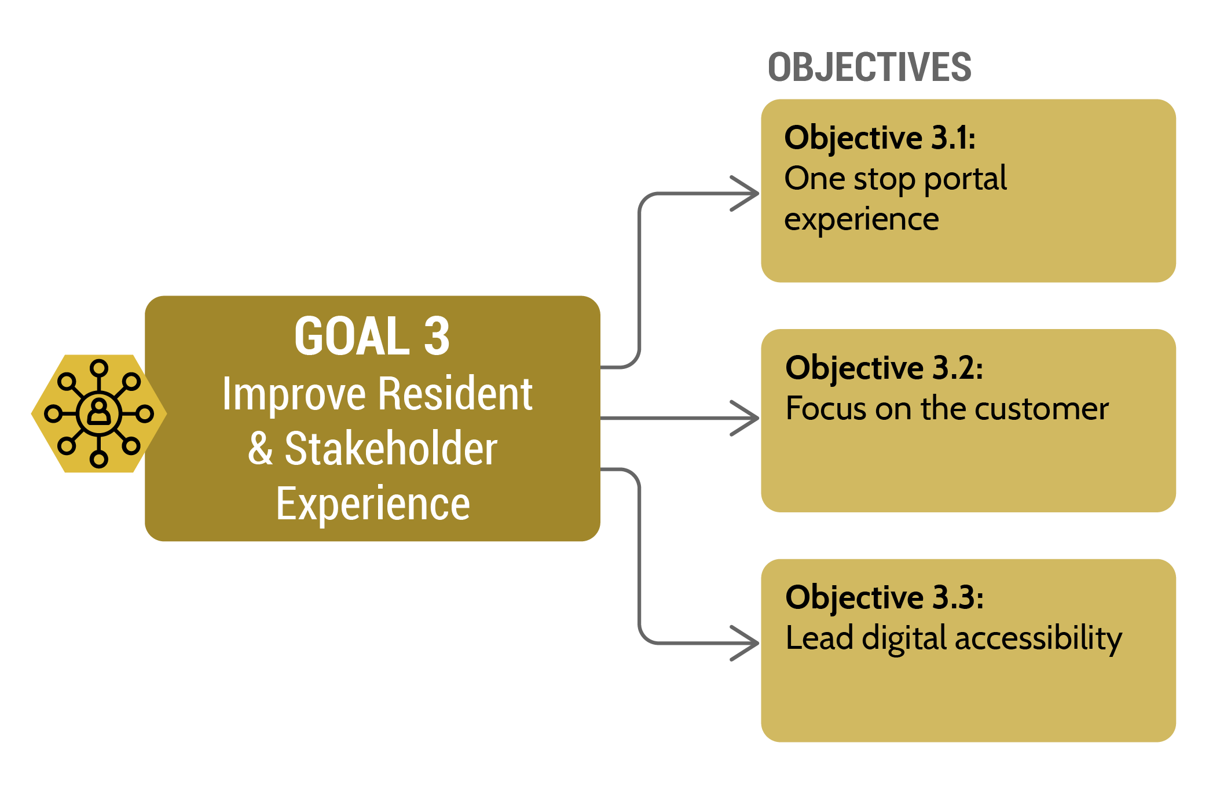Goal 3: People expect seamless online services. Improving King County’s user experience is not just a matter of digital convenience - removing barriers to digital services promotes inclusivity and enhances access to critical services. This updated goal focuses on improving the user experience to deliver modern, innovative services that are user centric, trusted, and accountable.

The SITP’s vision of a centralized portal for all public services is a “one-stop-shop” approach that quickly connects people with the right resources. The initiatives outlined in pursuit of this goal ensure that the public can easily and equitably access online government services, information, and resources. The strategic investment in digital capabilities enables King County to bridge the gap between essential services and the public’s access to them, fostering a more connected community.

Figure 7 – Goal 4 and Objectives

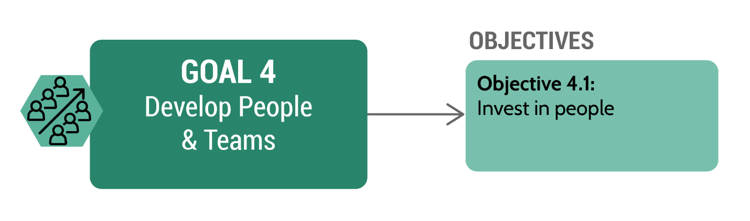
Goal 4: This updated goal focuses on the County’s most important asset, people, through developing and supporting a County workforce that is digitally capable and adaptable to change. This is especially critical given the increasing pace of technological change.

The progress around building data capacity has surfaced the need for investment in and development of staff and teams throughout KCIT and across the County to be able to more effectively identify and analyze data appropriately. While most of the existing strategic initiatives focused on data efforts will continue through to completion in support of objectives under other goals, updating this goal enables and increased focus on investments for enhancing data capabilities for King County staff. The increased focus on skills development will help all King County employees to not only better leverage the new data capabilities, but also other new and powerful technology advances like artificial intelligence, low and no-code environments, expanded digital access tools (including increased digital accessibility for broader user capabilities, multi-lingual access, and multi-channel availability), and customer experience platforms among other areas.

Figure 8 – Goal 5 and Objectives
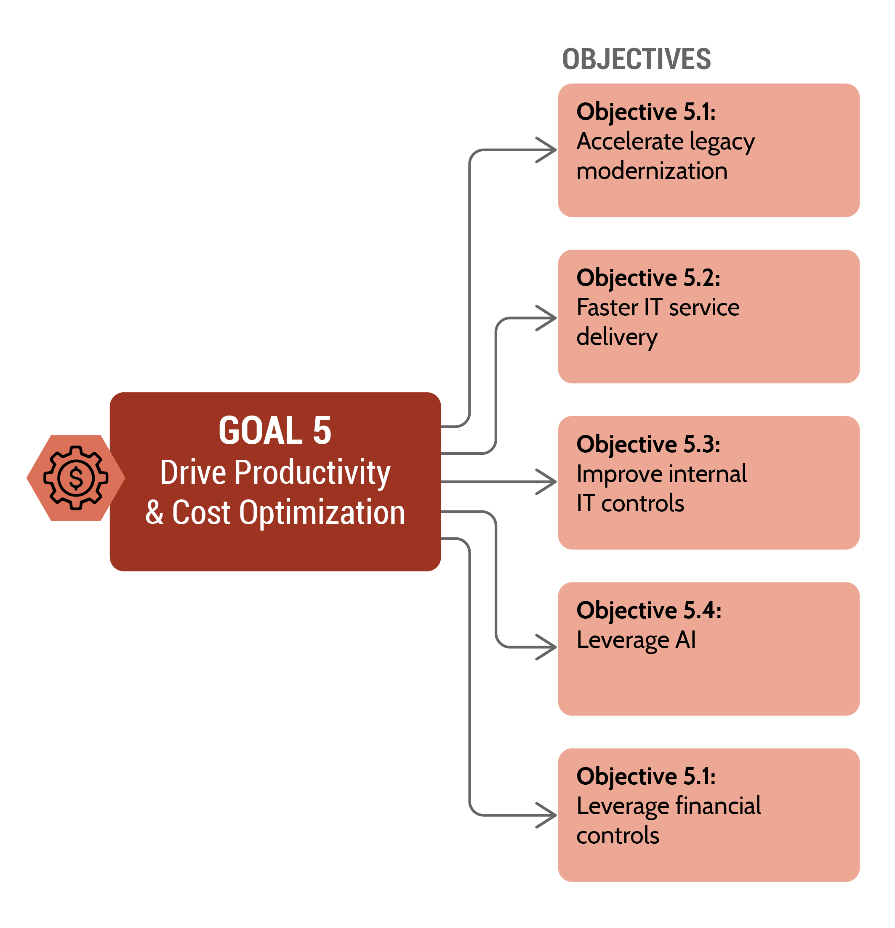

Goal five is updated to focus explicitly on cost and productivity, maximizing value and longevity of technology investments for effective, reliable, and resilient operations.

The objectives in this SITP are intended to help deliver technology solutions that expand King County’s culture of continuous improvement. With a focus on improving effectiveness and optimize costs, the SITP aims to modernize aging legacy equipment – King County’s “technical debt” – and reduce the number of redundant applications.

Two objectives are added to this goal area targeting AI and financial IT controls. Each is anticipated to significantly impact King County’s ability to drive productivity and optimize costs in the County’s digital ecosystems. Notably, while enterprise architecture (EA) remains a critically important foundational aspect IT work, it is removed as a standalone objective because it indirectly supports other efforts and objectives.

The initiatives supporting this goal lay the groundwork for a resilient information technology environment that enhances service delivery and ensures the responsible stewardship of resources.

KCC 2A.380.200.B.5 - The accomplishments towards meeting objectives from previous approved strategic plans, when objectives have not been met, and a discussion of the obstacles towards meeting those objectives

Overview of Key 2025 Accomplishments

King County strives to invest in technology that drives real change for communities. There are currently 83 strategic initiatives supporting King County’s Strategic Information Technology Plan as identified in Table 7. Of those, 18 were added to those identified in the 2025 Update. Of the 83 initiatives, 11 were completed in 2025, in addition to the four completed in 2024, as indicated in Table 8 and Table 9. In addition to the completed initiatives, an additional 45 initiatives were actively being worked on at the end of 2025. The remaining 23 initiatives are scheduled to start in 2026 or later.
Table 7 – Initiative Status by Goal

Table 9 - Initiatives by Year
Table 8 - Completed Initiatives by Goal

A list of all initiatives is provided in the progress report section of this report, grouped by goal area. Timelines and deliverables for each initiative are adjusted to reflect the current progress, learnings, issues, business changes, and other factors that typically impact a digital environment, following IT industry best practice to continuously improve and refine strategy. For transparency, all changes from the last update to the SITP are noted in the tables supporting each goal. New initiatives are shown in the strategy portfolio and are noted in the progress report section of this document, as well as the full list of initiatives in appendix A. Similar updates are expected in future years to stay current, relevant, and effective in addressing strategic IT goals.

In 2025, King County delivered 24 capital or operating IT projects each with a budget equal to or greater than $100,000. The median duration for completing these projects was 2.20 years (see Figure 9). Alignment with and contribution towards meeting a strategic IT goal are two of the key factors in evaluating, prioritizing, and approving each of these projects.

Figure 9 – Number of Closed Capital or Operating Projects with budget equal to or greater than $100,000 by Year

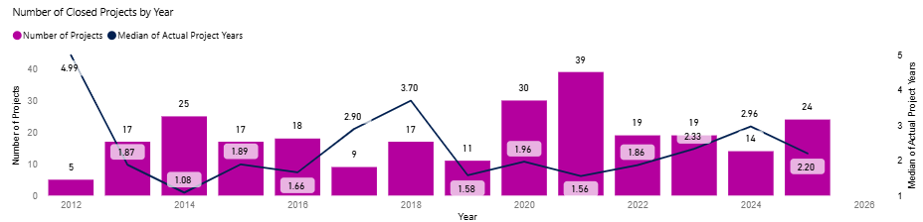

As detailed in the Report Methodology section, King County measures project success using three KPIs: project closures, project benefits, and end-of-project review scores.

Figure 10 demonstrates how the 24 capital projects and operating IT projects with budget equal or greater than $100,000 completed in 2025 aligned with both the five IT goal areas and the prescribed “primary benefit” categories used to measure project success. (For a complete description of project benefit categories, please see the Report Methodology section.) Figure 11 illustrates the same information but for projects that are active, on hold, or not yet started.

Figure 10 – Total project counts and budgets by Strategic Technology Objectives and Primary Benefit Achievement Categories for IT projects with budget $100K or greater, closed in 2025
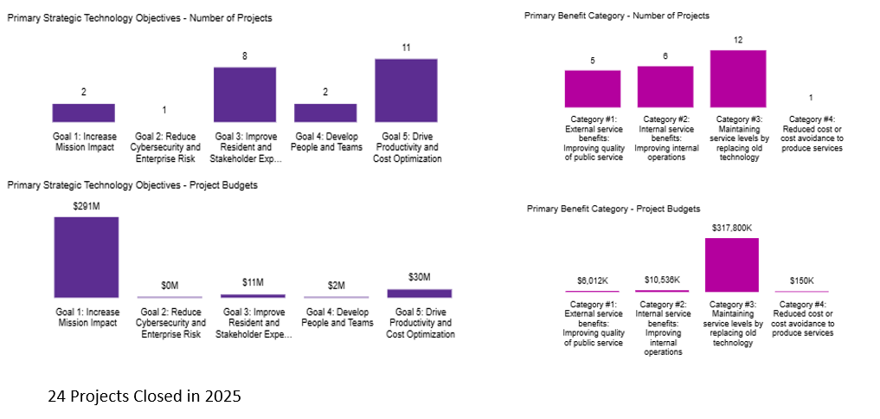

Figure 11 – Total project counts and budgets by Strategic Technology Objectives and Primary Benefit Achievement Categories for approved projects still active, on hold, or not yet started

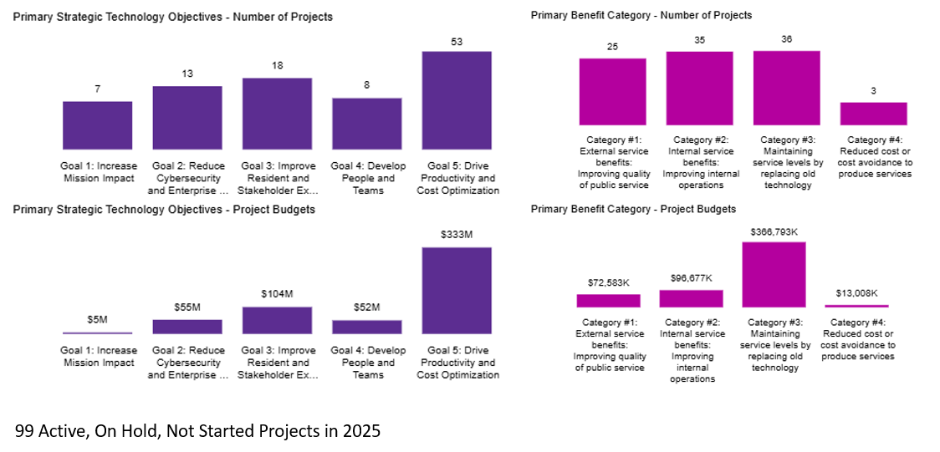
In 2025, the median end of project review scores increased to 89 percent. This is an increase from the prior year of 9.2 percent, which is within the expected variation of scores from project to project and year to year. End of project reviews for all completed projects are listed in the tables below. KCIT uses end of project reviews to continuously improve delivery of IT projects.

Progress by Goal Area
The following sections of this report show progress made in 2025 of each strategic goal and objective and include information related to supporting strategic initiatives and capital projects.

Goal 1 - Increase Mission Impact
Tables 10 and 11 reflect a current snapshot of the list of strategic initiatives supporting each objective for goal one. Keeping these strategic initiatives current helps drive viability given changes in the IT landscape that include business needs, technology availability, and resource planning. This list will be used in the next annual update to generate metrics as defined in appendix B of the SITP 2024-2027. These tables identify changes to an initiative’s description or dates compared to the original initiative list in the SITP 2024-2027. They also provide information on the status of each effort as last reflected in the portfolio management tool by the initiative’s owner. Overall, goal one saw four strategic initiatives completed in 2025 in addition to the two that completed in 2024, five were still active at the end of 2025, with four planned to start in 2026.

Table 10 – Obj 1.1 - Support broadband and digital equity
Obj 1.1 - Support Broadband and Digital Equity
Initiative | Planned Start | Actual Start | Percent Complete | Planned Complete
1.1.1 - Fiber Grants | 2024-01-01 | On Time | 85% | 2026-12-31
1.1.2 - Broadband and Digital Equity as a Determinant of Equity | 2024-01-01 | On Time | 100% | Completed on 2024-03-31
1.1.3 - Digital Equity Funding Framework | 2024-01-01 | On Time | 100% | Completed on 2025-01-08
1.1.4 - Broadband and Digital Equity Dashboard | 2024-01-01 | On Time | 100% | Completed on 2024-10-09
1.1.5 - BEAD Funding | 2024-10-01 | On Time | 50% | 2028-12-31
1.1.6 - Equity Metrics | 2025-01-01 | On Time | 100% | Completed on 2025-02-01
1.1.7 - KCIT ESJ Policy | 2025-06-20 | On Tme | 50% | 2026-12-31

Table 11- Obj 1.2 - Targeted accelerator initiatives
Obj 1.2 - Targeted accelerator initiatives
Initiative | Planned Start | Actual Start | Percent Complete | Planned Complete
1.2.1 - Data Hub Investment 2025 | 2024-01-01 | On Time | 100% | Completed on 2025-12-31
1.2.2 - EIR Expansion | 2024-04-01 | Early | 55% | 2027-04-01
1.2.3 - EIR Process Maturity | 2025-01-01 | Early | 100% | Completed on 2025-08-14
1.2.4 - Enable Self-Service Data Analytics | 2026-04-01 | Not Started | 0% | 2027-12-31
1.2.5 - Data Dashboards for Areas of Focus | 2025-06-01 | 2025-12-01 | 25% | 2028-12-31
1.2.6 - Data Hub Investments 2026 | 2026-01-01 | NEW -Not Started | 0% | 2026-12-31
1.2.7 - Enterprise Data Investments 2026 | 2026-01-01 | New - Not Started | 0% | 2026-12-31
1.2.8 - Enterprise 211 Crisis Connections Data | 2026-01-01 | New - Not Started | 0% | 2026-12-31

In 2025, King County completed two Increase Mission Impact focused projects with one project spending over $250,000 or using capital funds and under Project Review Board oversight. The end-of-project evaluation for that one project is shown in table 13. See Appendix B for further project details.

Table 12 - Goal one completed end of project review for one project completed in 2025, over $250,000 and using capital funds
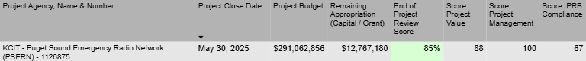

In addition to the two projects that closed in 2025, seven additional capital IT projects or projects with budget equal or greater than $100,000 supporting this goal were active, not started, or on hold and did not complete in 2025 as listed in Table 13. The total project budget for those efforts totaled over $5.2 million. See Appendix C for further project details.

Table 13- Active IT l projects with budget over $100K at the end of 2025 that support goal one
Goal 1 - Increase Mission Impact
Project Name | Status | Total Project Budget
DPH EHS Residential Lead Monitoring | On Hold | $ 425,347.00
DPH School Based Health Center Data Hub | Active | $ 660,193.00
DPH Sexual Health Clinic Partner Notification | Active | $ 555,259.00
DPH/DNRP - Access and Outreach Database | Active | $ 1,251,269.00
KCIT - Copilot Chat AI Readiness | Active | $ 425,280.00
DNRP SWD Haz Waste Services | Not Started | $ 1,656,073.00
KCIT - Data Lakehouse | Not Started | $ 247,770.00
Total for Goal 1: |  | $5,221,191.00

Goal 2 - Reduce Cybersecurity and Enterprise Risk
Tables 14 through 17 list the 2025 strategic initiatives supporting each of the objectives for goal two. The tables identify changes to an initiative’s description or dates compared to the original initiatives listed in the SITP 2024-2027. It also provides information on the status of the effort as last reflected in the portfolio management tool by the initiative’s owner. Overall, one strategic initiative was completed in 2025 in addition to two that were completed/cancelled in 2024. Additionally, 18 were active at the end of 2025 with four planned to start in 2026.

Table 14 - Obj 2.1 - Centralize and streamline identity management
Obj 2.1 - Centralize and streamline identity management
Initiative | Planned Start | Actual Start | Percent Complete | Planned Complete
2.1.1 - AD Consolidation | 2024-01-01 | On Time | 10% | 2026-09-30
2.1.2 - Identity Platform | 2026-01-01 | Not Started | 0% | 2026-12-31
2.1.3 - Vendor Access Policy | 2024-01-01 | Early | 75% | 2026-12-31
2.1.4 - Public User IAM Policy | 2024-01-01 | Cancelled | 100% | Cancelled on 2024-12-31
2.1.5 - Login.KC Upgraded to MFA | 2025-07-01 | Early | 9% | 2027-02-04

Table 15- Obj 2.2 - Ensure privacy & security of information assets
Obj 2.2 - Ensure privacy & security of information assets
Initiative | Planned Start | Actual Start | Percent Complete | Planned Complete
2.2.1 - Enterprise Information Classification | 2025-01-01 | On Time | 10% | 2026-12-31
2.2.2 - PII Inventory | 2025-01-01 | On Time | 1% | 2027-12-31
2.2.3 - Data Loss Prevention Strategy | 2025-01-01 | On Time | 1% | 2026-12-31
2.2.4 - Reduce high Vulnerability Response Time | 2024-01-01 | On Time | 100% | Completed On 2024-12-31
2.2.5 - Reduce high vulnerability response v2 | 2025-01-01 | On Time | 100% | Completed On 2025-12-31
2.2.6 - Ray Baum Act Compliance | 2023-01-03 | On Time | 70% | 2026-05-29
2.2.7 - Distributed Antenna Systems servicing | 2024-04-01 | On Time | 95% | 2026-06-30
2.2.8 - Radio Preventative Maintenance | 2024-04-01 | On Time | 49% | 2027-12-31
2.2.9 - Deliver BC Plan | 2024-04-01 | On Time | 35% | 2026-12-31
2.2.10 - BC Program Established | 2025-06-22 | On Time | 60% | 2026-06-30

Table 16 - Obj 2.3 - Automate Threat detection capability
Obj 2.3 - Automate Threat detection capability
Initiative | Planned Start | Actual Start | Percent Complete | Planned Complete
2.3.1 - SIEM Tuning | 2024-01-01 | On Time | 78% | 2026-12-31
2.3.2 - Security Incident Response Plan | 2024-01-01 | On Time | 1% | 2026-12-31
2.3.3 - Threat Detection Roadmap | 2025-04-01 | On Time | 5% | 2026-06-30
2.3.4 - Information Asset Inventory | 2025-01-01 | On Time | 10% | 2027-12-31
2.3.5 - Enable Data Classification | 2026-03-02 | NEW - Not Started | 0% | 2027-12-31

Table 17 - Obj 2.4 – Increase speed of information security and privacy deployment.
Obj 2.4 – Increase speed of information security and privacy deployment
Initiative | Planned Start | Actual Start | Percent Complete | Planned Complete
2.4.1 - 'Right Size' Security and Privacy (S&P) Headcount | 2024-01-01 | On Time | 21% | 2027-12-31
2.4.2 - S&P Shared Responsibility Program | 2025-01-01 | Not Started | 0% | 2027-03-31
2.4.3 - Reduce S&P Response Time | 2024-01-01 | On Time | 4% | 2026-12-31
2.4.4 - S&P Committee | 2025-01-01 | Not Started | 0% | 2026-06-31
2.4.5 - Data Office Creation | 2024-01-01 | On Time | 25% | 2026-12-31

IT Projects - Closed in 2025
In 2025, King County completed one Reduce Cybersecurity and Enterprise Risk focused project with spending over $250,000 or using capital funds. The end-of-project evaluation for this project is shown in table 19.

Table 18 - Goal two project success score for project completed in 2025, over $250,000 and/or using capital funds

IT Projects - Active in 2025
In 2025, 13 capital IT projects or projects had budgets greater than $100,000 supporting this goal that were active, not started, or on hold, and did not complete in 2025. The combined project budgets for these efforts is $54.8 million. Table 20 shows each of these projects with the total project budget. See Appendix C for further details.

Table 19 - Active IT projects with budget of $100K or greater, at the end of 2025 that support goal two
Goal 2 - Reduce Cybersecurity and Enterprise Risk
Project Name | Status | Total Project Budget
FMD KCCF Security Video Network | Not Started | $ 519,600.00
DNRP SWD SCADA Security Upgrades | Active | $ 2,562,905.00
Enterprise CyberSecurity - Data Classification | Not Started | $ 789,501.00
Enterprise CyberSecurity - GRC, and Privacy | Not Started | $ 500,000.00
Enterprise CyberSecurity - Sentinel Optimization | Not Started | $ 511,495.00
Enterprise IT Asset Management | Not Started | $ 2,076,842.00
KCIT - Tableau Public Architectural Direction | Active | $ 157,128.00
KCIT AD Consolidation | Active | $ 2,787,509.00
KCIT Identity Governance and Admin Solutions | Active | $ 474,000.00
KCIT MFA for Login.KC | Active | $ 1,960,000.00
PCI Compliance Assessment and Remediation | Not Started | $ 816,043.00
Upgrade Transit Radio Network 2027 | Not Started | $ 40,800,000.00
KCSO CJIS Network Upgrade | Active | $ 812,586.50
Total for Goal 2: |  | $54,767,586.50

Goal 3 - Improve Resident and Stakeholder Experience
Tables 20 through 22 list the 2025 strategic initiatives supporting each of the objectives for goal three. The tables identify changes to initiative descriptions or changes to dates compared to initiatives listed in the SITP 2024-2027. The tables provide information on the status of the effort as last reflected in the portfolio management tool by the owner of the initiative. Overall, one strategic initiative was completed in 2025, with seven active at the end of 2025, and seven more planned to start in 2026 or 2027.

Table 20 - Obj 3.1 – One Stop Portal Experience
Obj 3.1 – One Stop Portal Experience
Initiative | Planned Start | Actual Start | Percent Complete | Planned Complete
3.1.1 - Public Identity Access Point Inventory | 2025-04-01 | On Time | 5% | 2026-03-31
3.1.2 - Omnichannel portal | 2027-01-01 | Started Early | 60% | 2028-03-31
3.1.3 - Enterprise CRM | 2025-04-01 | On Time | 2% | 2026-12-31
3.1.4 - PTAS (Property Tax Assessment System) | 2025-07-18 | On Time | 8% | 2028-06-30

Table 21 - Obj 3.2 - Focus on the Customer
Obj 3.2 - Focus on the Customer
Initiative | Planned Start | Actual Start | Percent Complete | Planned Complete
3.2.1 - Open Data Best Practices | 2026-01-01 | Not Started | 0% | 2028-12-31
3.2.2 - Open Data Strategy & Roadmap | 2026-01-01 | Not Started | 0% | 2028-12-31
3.2.3 - Low and No-Code Governance | 2025-06-20 | On Time | 70% | 2027-12-31
3.2.4 - User-Centered Digital Transformation | 2026-06-01 | Not Started | 0% | 2028-12-31

Table 22 - Obj 3.3 - Lead Digital Accessibility
Obj 3.3 - Lead Digital Accessibility
Initiative | Planned Start | Actual Start | Percent Complete | Planned Complete
3.3.1 - Public Input on IT | 2027-01-01 | Not Started | 0% | 2027-12-31
3.3.2 - Digital Accessibility Compliance - Program | 2024-01-01 | On Time | See below projects that comprise this program | 2027-12-31
3.3.2.1 Training for Digital Accessibility | 2024-01-31 | On Time | 100% | Completed on 2025-12-31
3.3.2.2 Audit & Plan for Digital Accessibility | 2025-06-01 | Not Started | 0% | 2026-06-31
3.3.2.3 Remediation for Digital Accessibility | 2026-01-01 | Not Started | 0% | 2026-12-31
3.3.2.4 Ongoing Governance for Digital Accessibility | 2026-01-01 | Not Started | 0% | 2026-12-31
3.3.3 - Communication Channel Strategy | 2024-04-01 | On Time | 60% | 2026-06-30

IT Projects - Closed in 2025
In 2024, King County completed eight Improve Resident and Stakeholder Experience project with four projects spending over $250,000 or using capital funds and under Project Review Board oversight. The end-of-project evaluations for those projects are shown below.

Table 23 - Success scores for projects completed in 2025 over $250,000 supporting goal 3
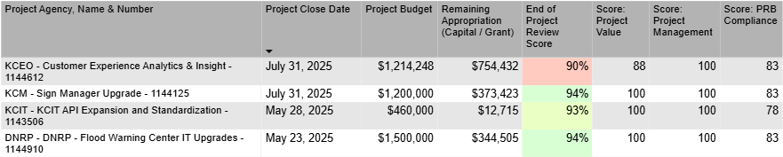

IT Projects - Active in 2025
In addition to the eight projects that closed in 2025, 18 capital IT projects or projects with budget equal to or greater than $100,000 supporting this goal were active and did not complete in 2025. The total project budget for those efforts totaled over $103 million. Shown in table 24 are each of these projects with the total project budget. See Appendix C for further details.

Table 24 - Active IT capital projects at the end of 2025 that support Goal 3
Goal 3 - Improve Resident and Stakeholder Experience

Project Name | Status | Total Project Budget
DES FBOD Treasury Countywide Electronic Payment Processor | Active | $ 1,819,627.00
DES RALS Trans Cntrl Dispatch | Active | $ 1,675,000.00
DLS - Permitting- SaaS Software Replacement | Not Started | $ 1,172,000.00
DNRP CRM Standards and Reporting | Not Started | $ 578,501.00
DPH EMS Emergency Medical Dispatch Strategic Initiative | Not Started | $ 1,073,340.00
EMS Online SI STRIVE Implementation | Active | $ 2,987,541.00
DPH IT EHS Envision Replacement | Active | $ 5,571,295.00
KCIT - ADA Compliance Remediation | Not Started | $ 500,000.00
KCIT Enhanced Wireless - Customer Requests | Active | $ 553,489.00
Access Customer Eligibility | Active | $ 1,200,000.00
Advanced Service Management | Active | $ 4,800,000.00
Customer Response Application | Not Started | $ 9,000,000.00
Demand Response Operations Management Framework | Not Started | $ 1,200,000.00
MTD RideshareOnline.com Enhancements Phase 2 | Not Started | $ 249,265.00
ORCA Enhancements | Active | $ 5,400,000.00
ORCA Replacement | Active | $ 57,537,785.00
Real-Time Improvements Project | Active | $ 2,219,832.00
Vanpool Improvements | Not Started | $ 6,000,000.00
Total for Goal 3: |  | $103,537,675.00

Goal 4 - Develop People and Teams

Table 25 lists the 2025 strategic initiatives supporting the objective for goal four. The table identifies changes to an initiative’s description or dates compared to the original initiatives listed in the SITP 2024-2027. It also provides information on the status of the effort as last reflected in the portfolio management tool by the initiative’s owner. No strategic initiatives were completed in 2025 or 2024 for goal four; two were active at the end of 2025, with one planned to start in 2026. More initiatives are expected to be added during 2026 as this goal was only recently updated to focus on people and teams.

Table 25 - Obj 4.1 - Invest in People.
Obj 4.1 - Invest in People
Initiative | Planned Start | Actual Start | Percent Complete | Planned Complete
4.1.1 - Future Staffing Needs Initiative | 2026-06-01 | Not Started | 0% | 2027-01-31
4.1.2 - Implementation of Equitable Hiring Practices | 2025-06-20 | On Time | 60% | 2027-01-31
4.1.3 - Implement Actions to Address Employee Survey | 2025-06-20 | On Time | 5% | 2026-12-31

IT Projects - Closed in 2025
In 2025, King County completed two “Develop People and Teams” projects with one of those projects spending over $250,000 or using capital funds and under Project Review Board oversight. The end of project evaluation for that project is shown in table 26.

Table 26 - Success scores for projects completed in 2025 over $250,000 supporting goal 4
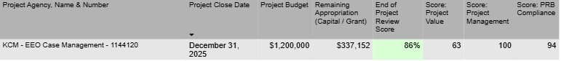

IT Projects - Active in 2025
In addition to the two projects that closed in 2025, eight capital IT projects or projects with budget equal or greater than $100,000 supporting this goal were active and did not complete in 2025. The total project budget for those efforts totaled almost $52 million. Listed in table 27 are each of these projects with the total project budget. See Appendix C for further details.

Table 27 - Active IT projects at the end of 2025 that support goal four
Goal 4 – A Data Driven King County
Project Name | Status | Total Project Budget
DNRP - SWD Workforce Management System | Active | $ 1,558,582.00
HASTUS Tuning | Active | $ 1,200,000.00
Operator Electronic Pick | Not Started | $ 5,820,000.00
Pre-trip Inspection | Active | $ 6,000,000.00
Security TCC Pilot | Active | $ 2,400,000.00
TDC FAC ACCESS VIDEO SYS REPL | Active | $ 5,854,713.00
TDC Video Management System | Active | $ 23,237,189.00
KCSO Payroll Reengineering | Active | $ 6,154,099.00
Total for Goal 4: |  | $ 52,224,583.00

Goal 5 – Drive Productivity and Cost Optimization
Tables 28 through 32 list the 2025 strategic initiatives supporting each of the objectives for goal five. The tables identify changes to an initiative’s description or dates compared to the original initiatives listed in the SITP 2024-2027. They also provide information on the status of the effort as last reflected in the portfolio management tool by the owner of the initiative.

Overall, five strategic initiatives were completed in 2025 in addition to the zero that completed in 2024. Additionally, thirteen were worked on and active at the end of 2025 with seven planned to start in 2026.

Table 28 - Obj 5.1 - Accelerate legacy modernization
Obj 5.1 - Accelerate legacy modernization
Initiative | Planned Start | Actual Start | Percent Complete | Planned Complete
5.1.1- Cloud Strategy | 2024-01-01 | On Time | 100% | Completed On 2025-04-01
5.1.2 - Tech Debt Reduction | 2024-01-01 | On Time | 10% | 2027-12-31
5.1.3 - Conference Room Modernization | 2024-01-01 | On Time | 100% | Completed on 2025-01-31
5.1.4 - Enterprise Architecture Framework | 2024-01-01 | On Time | 20% | 2026-06-30
5.1.5 - Business Capabilities - Platform consolidation | 2024-01-01 | On Time | 45% | 2026-03-31
5.1.6 - Enterprise Solutions / Platforms | 2026-01-01 | Not Started | 0% | 2028-12-31
5.1.7 - API Transition | 2024-01-01 | On Time | 100% | Completed on 2025-06-11
5.1.8 - ERP Strategy & Roadmap | 2024-04-01 | 2025-03-09 | 15% | 2027-01-29
5.1.9 - KCIT Shared Device Telephony Solution | 2025-07-03 | On Time | 31% | 2026-12-31

Table 29 - Obj 5.2 - Faster IT Service Delivery
Obj 5.2 - Faster IT Service Delivery
Initiative | Planned Start | Actual Start | Percent Complete | Planned Complete
5.2.1 - AI Investment Framework | 2025-01-01 | On Time | 80% | 2026-03-01
5.2.2 - AI Governance Model | 2025-01-01 | On Time | 100% | Completed On 2025-12-31
5.2.3 - AI Up-Skill | 2025-01-08 | On Time | 30% | 2027-12-31
5.2.4 - Technology Investment to Business Priority Alignment | 2025-01-01 | On Time | 100% | Completed On 2025-08-27
5.2.5 - KCIT Service Catalog | 2026-01-01 | Not Started | 0% | 2027-12-31
5.2.6 - Innovation Culture | 2026-01-01 | Not Started | 0% | 2027-12-31

Table 30 - Obj 5.3 - Improve Internal IT Controls
Obj 5.3 - Improve Internal IT Controls
Initiative | Planned Start | Actual Start | Percent Complete | Planned Complete
5.3.1- Operational Metrics & KPI's | 2025-07-13 | On Time | 22% | 2026-12-31
5.3.2 - Neurons Migration | 2024-06-18 | On Time | 74% | 2026-05-31
5.3.3 - Data Asset Inventory | 2026-07-01 | Started Early | 2% | 2028-12-31
5.3.4- Asset Inventory | 2026-04-01 | Started Early | 10% | 2028-03-31
5.3.5 - KCIT Governance Updates | 2025-02-18 | Started Early | 6% | 2026-12-31
5.3.6 - KCIT Resource Planning | 2025-04-01 | Not started | 0% | 2026-09-30

Table 31 - Obj 5.4 - Leverage AI
Obj 5.4 - Leverage AI
Initiative | Planned Start | Actual Start | Percent Complete | Planned Complete
5.4.1 - Enable Countywide AI Governance | 2026-01-01 | Not started | 0% | 2026-12-31
5.4.2 - Launch AI Enablement Processes | 2026-01-01 | Not started | 0% | 2026-12-31

Table 32 - Obj 5.5 - Leverage Financial Controls
Obj 5.5 - Leverage Financial Controls
Initiative | Planned Start | Actual Start | Percent Complete | Planned Complete
5.5.1 - Use ITFM automation to increase productivity | 2025-07-01 | On Time | 10% | 2026-12-31
5.5.2 - Contract best practices: CLM365 Implementation | 2026-01-01 | Not started | 0% | 2026-12-31

IT Projects - Closed in 2025
In 2025, King County completed 11 Drive Productivity and Cost Optimization projects, with seven spending over $250,000 or using capital funds and under Project Review Board oversight. End of project evaluations for these projects are shown in table thirty-three. One project has an end of review evaluation in progress.

Table 33- Success scores for projects completed in 2025 over $250,000 supporting goal five.
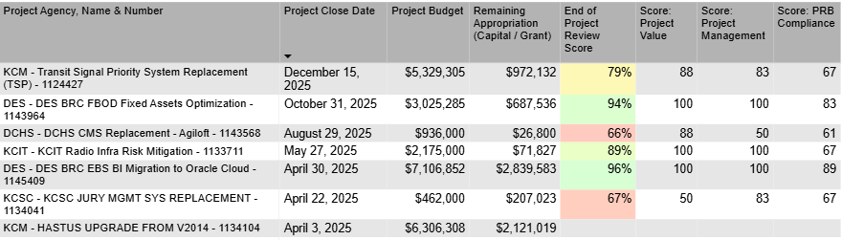

IT Projects - Active in 2025
In addition to the eleven projects that closed in 2025, 53 capital IT projects or projects with budget equal or greater than $100,000 supporting this goal were active, not started, on hold, and did not complete in 2025. The total project budget for these projects totaled over $333 million. Listed in table 34 are the projects with total project budget. See Appendix C for further details.

Table 34 - Active IT capital projects at the end of 2025 that support goal five.
Project Name | Status | Total Project Budget
DCHS Behavioral Health Care Coordination Platform | Active | $ 6,139,040.00
DES - Inquest CMS Implementation | Active | $ 223,070.00
DES BRC EBS Application Upgrade | Active | $ 12,184,095.00
DES - Comprehensive Facilities Asset Management (CFAM) | Active | $ 1,500,000.00
DHR SkillSurvey - Reference Checking to go out for RFP | Active | $ 196,896.00
DJA Data Warehouse | Active | $ 1,918,516.00
DJA Systems Replacement Project | Active | $ 8,426,832.00
DLS - Road Services Roadworks 2025 Upgrade | Not Started | $ 199,794.00
RSD Maintenance Mgmt System Replacement | Active | $ 1,075,000.00
DNRP Parks - Lucity - SeeClickFix Integration | Active | $ 196,688.00
DNRP SWD - Permit Compliance Program | Active | $ 442,944.00
DNRP WTD - CUES Spider Automatic Data Transfer Solution | Active | $ 119,898.00
DNRP WTD Data Storage Intake | Active | $ 237,840.00
DNRP WTD ECMS Portal | On Hold | $ 220,145.00
DNRP WTD Flow Monitoring Data Management and Analysis Application Update | Active | $ 218,709.00
WTD CMMS UPGRADE | Active | $ 11,865,472.00
WTD PIMS/CROMERR REPLACEMENT | Active | $ 3,290,696.00
DPD Case Management System Replacement | Active | $ 7,072,949.00
DPH Infolinx Upgrade or Replacement | Active | $ 616,347.00
JHS Electronic Medication Administration Record | Active | $ 1,503,665.00
DPH Health Sciences Data Exchange Engine | Active | $ 211,549.00
KCIT POTS Line Replacement Project | Not Started | $ 4,510,680.00
911 Platform Modernization | Active | $ 21,575,655.00
ASCEND: Advancing Secure Cloud-enabled Design | Active | $ 187,056.00
KCIT - 2025 King County High-Resolution Aerial Imagery Acquisition Project | Active | $ 140,736.00
KCIT - New Outlook Deployment | On Hold | $ 233,000.00
KCIT - PMO Work Management Implementation | On Hold | $ 944,700.00
KCIT - Ray Baum Act Compliance | Active | $ 4,893,760.00
KCIT RCECC Diverse Fiber Path | Not Started | $ 1,944,800.00
KCIT Shared Device Telephony Solution | Active | $ 3,648,000.00
Laboratory Information Management System (LIMS) Modernization | Active | $ 4,567,475.00
Property Tax Administration System (PTAS) 2025 | Active | $ 131,103,596.00
AssetWorks M5 2024 Upgrade | Active | $ 355,755.00
Copilot PC Upgrades Eqmt Replacement | Not Started | $ 6,871,680.00
Energy Monitoring (Trolley) - not under PRB oversight | Active | $ 2,400,000.00
HASTUS Upgrade from 2022 Version | Not Started | $ 6,267,773.00
INIT Streetcar | Active | $ 858,000.00
MTD - CAD/AVL System Replacement Planning | Not Started | $ 1,200,000.00
MTD - Capital - 1134260 Trolley SCADA Replacement | Active | $ 819,837.00
MTD - Capital - 1134261 Building Management System (BMS) Review | On Hold | $ 102,547.00
MTD - Capital - FA - 1139367 - Interim/ Tukwila Base Electrification - Network | Active | $ 343,334.00
MTD - Tukwila Base - Vertical Lift Inventory System | Active | $ 109,328.00
Network Architecture Upgrade - Eqmt Replacement | Not Started | $ 4,440,000.00
TDC Asset Management System Replacement | Active | $ 27,382,326.00
TDC TCC Phone System | Active | $ 3,333,000.00
TDC Zero Emissions Charge Management Technology | Active | $ 14,469,490.00
WebTools Upgrade | Active | $ 5,400,000.00
Yard Management | Active | $ 4,800,000.00
KCSO AFIS LIMS Replacement | Active | $ 676,000.00
KCSO AFIS Livescan Replacement | Active | $ 920,000.00
KCSO Computer Aided Dispatch System Replacement | Active | $ 17,833,953.00
PAO - CJIS Data Hub with Esri Enterprise | Active | $ 106,972.00
Total for Goal 5: |  | $333,309,598

KCC 2A.380.200.B.6 – Appendices supporting the recommended objectives; and

KCC 2A.380.200.B.7 - Appendix defining the appropriate strategic performance metric(s) for each recommended objective in the plan

See Appendices A-C. See also King County’s Strategic Information Technology Plan 2024-2027 for details about strategic metric reporting.

Conclusion

The SITP 2024-2027 directly addresses King County’s immediate technological needs and actively establishes a foundation for a future-ready, resilient digital infrastructure. By embracing a culture of continuous improvement and responsibly investing in emerging technologies, King County positions itself to continue to deliver efficient, citizen-centric services while skillfully navigating the complexities of the evolving digital landscape.

Future iterations of this report will reflect updated goals, initiatives, investments and respective metrics demonstrating impact.

Appendices

Appendix A – All Strategic Goals, Objectives, and Initiatives

This appendix provides a full list of all strategic goals in table 35, all strategic objectives in table 36, and all strategic initiatives in table 37. These lists were exported from the portfolio management tool and include the lifecycle status for each item on the list. Lifecycle status values and their meaning include:
- Plan or Phase-in = Approved with a future starting date
- Active = Currently in progress
- End of Life = Completed

Table 35- Appendix A - List of strategic IT goals
Goal Name | Description | Lifecycle
Goal 1 - Increase Mission Impact | We leverage data and technology to create impactful outcomes and drive informed decision-making. | active
Goal 2 - Reduce Cybersecurity and Enterprise Risk | We secure technology systems, physical infrastructure assets, and data to mitigate risk and maintain public trust. | active
Goal 3 - Improve Resident and Stakeholder Experience | We partner to deliver modern, innovative services that are user-centric, trusted, and accessible. | active
Goal 4 - Develop People & Teams | We develop a county workforce that is digitally capable and adaptable to change. | active
Goal 5 - Drive Productivity & Cost Optimization | We maximize the value and longevity of technology investments for effective, reliable, and resilient operations. | active

Table 36 - Appendix A - List of strategic IT objectives
Objective Name | Description | Lifecycle
Obj 1.1 - Support Broadband and Digital Equity | Support efforts to build a Washington state broadband and digital equity plan that addresses unserved/underserved populations. | active
Obj 1.2 - Targeted 'Accelerator' Initiatives | Identify and invest in initiatives that provide high benefits to our partners and customers relative to the projected costs. This includes (but is not limited to) leveraging an ideation process that accepts all ideas, vets those ideas rapidly for feasibility and potential value (benefit - cost), and formulates an approach for leadership approval where high value exists. | active
Obj 2.1 - Centralize and streamline identity management | Centralize and streamline identity management at King County. | active
Obj 2.2 - Ensure privacy & security of information assets. | Ensure the privacy and security of information assets. | active
Obj 2.3 - Automate Threat detection capability. | Automate King County's threat detection capability. | active
Obj 2.4 - Increase Speed of IS&P Deployment | Increase the speed of information security and privacy strategy adoption and deployment in the County. | active
Obj 3.1 - 'One-Stop' Portal Experience | Design and implement a portal experience for the community that serves as a 'one-stop shop' for needed services and information. | active
Obj 3.2 - Focus on the Customer | Involve customers earlier and more often and empower them to solve their own problems where appropriate. | active
Obj 3.3 - Lead Digital Accessibility | Lead the standardization of accessibility and language across all communication channels with the community. | active
Obj 4.1 - Invest in People | Ensure that we prioritize employees through:  - Continued skill development in both their current and desired career progression  - Tools that enable effective communication, productivity, and wellness  - A positive, supporting, and caring work environment, culture, and experience where all are included | active
Obj 5.1 - Accelerate legacy modernization | Reduce technical debt in existing systems through modernization. Also put policies and processes in place to ensure avoidance of increasing technical debt in all systems through on-going maintenance and upgrades when needed. | active
Obj 5.2 - Faster IT Service Delivery | Reduce the time from inception to delivery of quality solutions while improving status communications with partners & customers. | active
Obj 5.3 - Improve Internal IT Controls | Increase the accuracy, understanding, and usage of internal control systems to improve operational and strategic awareness | active
Obj 5.4 - Leverage Artificial Intelligence (AI) | Leverage Artificial Intelligence throughout King County's workforce and services to increase productivity and quality while ensuring save and equitable use. | active
OBJ 5.5 - Leverage Financial Controls | Utilize automation, best practices and proven tools to improve cost effective IT service delivery. | active
Table 37 - Appendix A - List of Strategic IT Initiatives, with lifecycle state, start (active) date, complete date, and changes from prior SITP Update.
Strategic Initiative Name | Description | Lifecycle State | Start (active) Date | Complete Date | As Reported in Last Update | Changes from Last Update
1.1.1 - Fiber Grants | Complete two WSBO funded public private partnership infrastructure grants with Ziply Fiber. | Active | 2024-01-01 | 2026-12-31 | 1.3.1 - Fiber Grants | Number Only
1.1.2 - Broadband and Digital Equity as a Determinant of Equity | Engage with the office of PSB the OERSJ to include broadband and digital equity as a new determinant of equity. | Completed | 2024-01-01 | 2024-03-31 |  | Number Only
1.1.3 - Digital Equity Funding Framework | Establish a framework for tracking digital equity funding opportunities. | Completed | 2024-01-01 | 2025-12-31 | 1.3.3 - Digital Equity Funding Framework | Number Only
1.1.4 - Broadband and Digital Equity Dashboard | Establish broadband and digital equity measurements and repeatable data sources to enable dashboard reporting. | Completed | 2024-01-01 | 2024-10-09 | 1.3.4 - Broadband and Digital Equity Dashboard | Number Only
1.1.5 - BEAD Funding | Identify private ISP's to partner with on BEAD project areas and secure funding to build infrastructure to unserved and underserved locations in King County. | Active | 2024-01-01 | 2026-12-31 | 1.3.5 NEW - BEAD Funding | Number Only
1.1.6 - Equity Metrics | Establish metrics that track the outcomes of equity impact processes intended to eliminate bias. | Completed | 2024-01-01 | 2024-03-31 | 1.2.1 - Equity Metrics | Number Only
1.1.7 - KCIT ESJ Policy | Draft and approve KCIT ESJ Policy which will formalize the EIR process and training guidelines | Active | 2024-01-01 | 2025-12-31 |  | New in 2025
1.2.1 - Data Hub Investment 2025 | Strategically invest in data hubs and intelligence tools to identify where needs for services are the greatest. | Completed | 2024-01-01 | 2025-12-31 | 1.4.1 - Data Hub Investment | Number Only
1.2.2 - EIR Expansion | Expand Equity Impact Reviews (EIRs) to include Information Technology (IT) lines of service. | Active | 2024-04-01 | 2027-04-01 | 1.2.2 - EIR Expansion | No Change
1.2.3 - EIR Process Maturity | Standardize, digitize, and make transparent the Equity Impact Review (EIR) process and use for 95% of County projects. | Completed | 2025-01-01 | 2025-08-14 | 1.2.3 - EIR Process Maturity | No Change
1.2.4 - Enable Self-Service Data Analytics | Enable self-service data analytics capabilities and expand data literacy across County agencies. | Not Started | 2026-04-01 | 2027-12-31 | 4.1.2 - Enable Self-Service Data Analytics | Number Only
1.2.5 - Data Dashboards for Areas of Focus | Identify, year over year, the area(s) of focus, provision the work to gather, analyze, and present data, and provision dashboards that present relevant metrics regarding the area of focus. | Active | 2025-12-01 | 2028-12-31 | 4.2.1 - Data Dashboards for Areas of Focus | Number Only
1.2.6 - Data Hub Investments 2026 | Billable data hub, warehouse, lakehouse investments planned for 2026 | Active | 2026-01-01 | 2026-12-31 |  | New in 2025
1.2.7 - Enterprise Data Investments 2026 | Support enterprise data hub, warehouse, lakehouse investment that expand enterprise services and mature KCIT’s data-driven culture. | Active | 2026-01-01 | 2026-12-31 |  | New in 2025
1.2.8 - Enterprise 211 Crisis Connections Data | Optimize costs by developing an enterprise data source that streamlines business processes and allows for services to be connected to resident needs more efficiently. | Active | 2026-01-01 | 2026-12-31 |  | New in 2025
2.1.1 - AD Consolidation | Complete Active Directory (AD) consolidation, migrating all users and workstations into the KC domain. | Active | 2024-01-01 | 2026-09-30 | 2.1.1 - AD Consolidation | No Change
2.1.2 - Identity Platform | Procure an enterprise identity governance platform to centralize and streamline identity management across King County. | Active | 2026-01-01 | 2027-12-31 | 2.1.2 - Identity Platform | No Change
2.1.3 - Vendor Access Policy | Design and implement a policy and plan for vendor access to servers and data that recognizes the breadth of usage scenarios. | Active | 2024-01-01 | 2026-12-31 | 2.1.3 - Vendor Access Policy | No Change
2.1.4 - Public User IAM Policy | Develop an identity management policy for public users (non-County employees) who interact with King County digital assets. | Cancelled 2024 | NA | NA | 2.1.4 - Public User IAM Policy | No Change
2.1.5 - Login.KC Upgraded to Multi-Factor Authentication (MFA) | Upgrade Login.KC to MFA to reduce security risk to KC ecosystem by securing external login process to jail bookings and related functions from external partner orgs | Active | 2025-07-01 | 2027-02-04 | 2.1.5 NEW - Login.KC Upgraded to MFA | Number and wording
2.2.1 - Enterprise Information Classification | Implement an enterprise information classification strategy as it applies to Azure Information Protection (AIP) labeling, data loss prevention (DLP), and other similar functions. | Active | 2025-01-01 | 2026-12-31 | 2.2.1 - Enterprise Information Classification | No Change
2.2.10 - BC Program Established | Establish a complete Business Continuity program with updated CooP, Buisness Impact Analysis, and all the artifacts/documentation, operationalizing the program including regular training for different roles, regular test plans and schedule, and yearly audit of Buisness Impact Analysis. | Active | 2025-06-22 | 2026-06-30 | 5.3.8 NEW - BC Program Established | Number and wording
2.2.2 - PII Inventory | Inventory Personally Identifiable Information (PII) countywide through a system of record at the software and data level. | Active | 2025-01-01 | 2027-12-31 | 2.2.2 - PII Inventory | No Change
2.2.3 - Data Loss Prevention Strategy | 2.2.3 - Implement a data loss prevention strategy to control access and transmission of sensitive data across King County. | Active | 2025-01-01 | 2026-12-31 | 2.2.3 - Data Loss Prevention Strategy | No Change
2.2.4 - Reduce high Vulnerability Response Time | Reduce response time to remediate high vulnerabilities by 20%. | Completed | 2024-01-01 | 2024-12-31 | 2.2.4 - Reduce high Vulnerability Response Time | No Change
2.2.5 - Reduce high vulnerability response v2 | Reduce response time to remediate high vulnerabilities by an additional 20% on top of accomplishments in 2.2.4. | Completed | 2025-05-01 | 2025-12-30 | 2.2.5 NEW - Reduce high vulnerability response v2 | No Change
2.2.6 - Ray Baum Act Compliance | This project will bring King County in compliance with the Ray Baum Act which requires agencies, that project Voice over IP (VoIP) telephony services, to provide detailed location information to the Public Safety Answering Point (PSAP) for all 911 calls. The project includes performing detailed audit and documentation of network ports and wireless connectivity, re-patching and re-labeling switch ports and patch panels to identify advanced location information, such as "NW Quadrant of 7th floor SW corner" and configuring the network hardware to identify/report each port and wireless device with their location information at each King County facility/location where we provide VoIP phone service. | Active | 2023-01-03 | 2026-05-29 | 5.1.4 NEW - Ray Baum Compliance | Number and wording
2.2.7 - Distributed Antenna Systems servicing | Comply with regulatory requirements for Distributed Antenna Systems by creating long-term support model for KC DAS | Active | 2024-04-01 | 2026-06-30 | 5.4.3 - Distributed Antenna Systems servicing | Number Only
2.2.8 - Radio Preventative Maintenance | Implement radio subscriber Preventative Maintenance (PM) service to the entire King County region for both internal and external public safety agencies. | Active | 2024-01-01 | 2027-12-31 | 5.4.2 - Radio Preventative Maintenance | Number Only
2.2.9 - Deliver BC Plan | Deliver Business Continuity (BC) plan that is maintainable and testable. | Active | 2024-01-01 | 2026-12-31 | 5.3.4 - Deliver BC Plan | Number Only
2.3.1 - SIEM Tuning | Invest 5,000 hours in further tuning of Sentinel, KCIT's Security Information and Event Management platform, to develop an automated threat detection capability. | Active | 2024-01-01 | 2026-12-31 | 2.3.1 - SIEM Tuning | No Change
2.3.2 - Security Incident Response Plan | Develop a robust, countywide security incident response plan that aligns with the Cybersecurity and Infrastructure Security Agency best practices for local government entities. | Active | 2024-01-01 | 2026-12-31 | 2.3.2 - Security Incident Response Plan | No Change
2.3.3 - Threat Detection Roadmap | Analyze and develop a 3-year roadmap for threat detection capability within the security operations center for King County. | Active | 2025-04-01 | 2026-06-30 | 2.3.3 - Threat Detection Roadmap | No Change
2.3.4 - Information Asset Inventory | Partner with agencies to catalog/classify/secure/share information assets using a consistent approach that adheres to asset management, data security, and information classification policies. | Active | 2025-01-01 | 2027-12-31 | 4.1.1 - Information Asset Catalog | Number Only
2.3.5 - Enable Data Classification | In partnership with the Security & Privacy division, deliver a solution that streamlines the process of labeling and classifying data and provides ongoing reporting and quality monitoring for the data classification project. | Phase-in | 2026-03-02 | 2027-12-31 |  | New in 2025
2.4.1 - 'Right Size' S&P Headcount | Achieve a team member count and structure that appropriately reflects the critical role and responsibilities of the security and privacy team for the County. | Active | 2024-01-01 | 2027-12-31 | 2.4.1 - 'Right Size' S&P Headcount | No Change
2.4.2 - S&P Shared Responsibility Program | Develop a shared responsibility program with County agencies to inform, educate, and obtain consensus regarding regarding efforts to protect information and assets. | Active | 2025-01-01 | 2027-03-31 | 2.4.2 - S&P Shared Responsibility Program | No Change
2.4.3 - Reduce S&P Response Time | Reduce response time to critical security and privacy incidents by 10%. | Active | 2024-01-01 | 2026-12-31 | 2.4.3 - Reduce S&P Response Time | No Change
2.4.4 - S&P Committee | Develop a security and privacy committee with representation from County agencies for centralized decision-making and communications regarding efforts to protect information and assets. | Active | 2025-01-01 | 2026-06-30 | 2.4.4 - S&P Committee | No Change
2.4.5 - Data Office Creation | Establish a Data Office with Chief Data Officer and enterprise data governance council. | Active | 2024-01-01 | 2026-12-31 | 4.1.3 - Data Office Creation | Number Only
3.1.1 - Public Identity Access Point Inventory | Inventory all identity-associated entry points for those we serve and develop a plan and timeline to centralize their access via the portal.  Bolster application portfolio to identify which applications are accessed by the public and which capability the application is providing. This will help influence decisions associated with the one-stop portal. | Active | 2025-04-01 | 2026-03-31 | 3.1.1 - Public Identity Access Point Inventory | No Change
3.1.2 - Omnichannel portal | Build an omnichannel portal for interactions between King County agencies and those they serve. | Phase In | 2027-01-01 | 2028-03-31 | 3.1.2 - Omnichannel portal | No Change
3.1.3 - Enterprise CRM | 1 - Develop a countywide strategy for Customer Relationship Management (CRM), 2 - Inventory, 3 - Design, 4 - develop a roadmap for the reduction of redundant CRM systems. | Active | 2025-04-01 | 2026-12-31 | 3.1.3 - Enterprise CRM | No Change
3.1.4 - PTAS (Property Tax Assessment System) | The intent of the Property Tax Administration System (PTAS) modernization effort is to implement a tax administration solution that utilizes a modern data and technology architecture to support future business needs, goals, and objectives in a multiple agency environment. | Active | 2025-07-18 | 2028-06-30 |  | New in 2025
3.2.1 - Open Data Best Practices | Develop a set of open data best practices and a community of practice across the county to focus on useability, quality, and consistency. | Phase In | TBD | 2029-12-31 | 4.1.5 - Open Data Best Practices | Number Only
3.2.2 - Open Data Strategy & Roadmap | Refine and execute the open data strategy and associated roadmaps. | Phase In | TBD | 2028-12-31 | 4.1.6 - Open Data Strategy & Roadmap | Number Only
3.2.3 - Low and No-Code Governance | Implement low and no code policy, processes and on-going governance | Active | 2025-06-20 | 2027-12-31 |  | New in 2025
3.2.4 - User-Centered Digital Transformation | Drive User-Centered Digital Transformation: Shift the engagement with visual design and digital development principles earlier in the project planning processes to improve customer experiences, ensure proper usability and accessibility standards, and reduce project timelines & overages | Active | 2025-06-20 | TBD |  | New in 2025
3.3.1 - Public Input on IT | Create a process that allows the public to provide feedback on tools that directly support their customer service experience. | Phase In | 2027-01-01 | 2027-12-31 | 1.1.1 - Public Input on IT | Number Only
3.3.2 - Digital Accessibility Compliance - Program | Ensure that all public-facing web technologies meet the Web Content Accessibility Guidelines (WCAG), making digital services more accessible to all.  This initiatives acts at a program level and has multiple initiatives rolling up to this one. See the 'children' in the relations explorer for initiatives currently in the program. | Active | 2024-01-01 | 2027-12-31 | 1.1.2 - Digital Accessibility Compliance - Program | Number Only
3.3.2.1 Training for Digital Accessibility | Develop and deliver accessibility training to all KCIT staff and those in the enterprise who will benefit. | Completed | 2025-01-31 | 2025-12-31 | 1.1.2.1 NEW - Training for Digital Accessibility | Number Only
3.3.2.2 Audit & Plan for Digital Accessibility | Asses the current state of ADA compliance for KC's digital services - both internal and external facing - and create a plan to move to full compliance. | Active | 2025-06-01 | 2026-06-31 | 1.1.2.2 NEW - Audit & Plan for Digital Accessibility | Number Only
3.3.2.3 Remediation for Digital Accessibility | Establish a system of record for all ADA technical debt (product/platform, quality of current compliance, etc.) for internal and external-facing experiences.  Define a rubric for prioritizing work to be completed (number of users, internal/external, seasonality of use, etc.)  Establish a regular cadence for progress reporting  Define a common approach and Enterprise Standard for validation and quality testing for each platform (heuristics, ownership & responsibility within KCIT, etc.) | Active | 2026-01-01 | 2026-12-31 | 1.1.2.3 NEW - Remediation for Digital Accessibility | Number Only
3.3.2.4 Ongoing Governance for Digital Accessibility | Outcomes for this effort include:  * identify all touchpoints across the KCIT product/project delivery process where ADA should be included  * establish clear roles for all aspects of governance  * promote compliance for all digital experiences offered by King County  * operationalize the process | Active | 2025-06-01 | 2026-12-31 | 1.1.2.4 NEW -Ongoing Governance for Digital Accessibility | Number Only
3.3.3 - Communication Channel Strategy | Define County supported communication channels -where/ how they are utilized and the languages that each supports. | Active | 2024-04-01 | 2026-06-30 | 1.1.3 - Communication Channel Strategy | Number Only
4.1.1 - Future Staffing Needs Initiative | Future Staffing Needs Initiative | Active | 2026-06-01 | 2027-01-31 |  | New in 2025
4.1.2 - Implementation of Equitable Hiring Practices | Continuous Improvement of KCIT's Hiring Practices | Active | 2025-06-20 | 2027-01-31 |  | New in 2025
4.1.3 - Implement Actions to Address Employee Survey |  | Active | 2025-06-20 | 2026-12-31 |  | New in 2025
5.1.1 - Cloud Strategy | 5.1.1 - Develop a resilient and scalable hybrid cloud strategy that addresses evolving technology needs and generates flexible cost models tied to business investments. | Completed | 2024-01-01 | 2025-03-31 | 5.1.1 - Cloud Strategy | No Change
5.1.2 - Tech Debt Reduction | Identify systems and hardware technical debt, and introduce debt reduction planning into lifecycle management. | Active | 2024-04-01 | 2027-12-31 | 5.1.2 - Tech Debt Reduction | No Change
5.1.3 - Conference Room Modernization | 5.1.3 - Modernize conference room technologies and implement ongoing maintenance practices. | Completed | 2024-01-01 | 2025-01-31 | 5.1.3 - Conference Room Modernization | No Change
5.1.4 - Enterprise Architecture Framework | Develop and maintain a consistent Enterprise Architecture framework for aligning technology investments with Information Technology and business objectives.  Leading to Better decision-making regarding IT investments by considering business context (capabilities, value stream, process). | Active | 2024-01-01 | 2026-06-30 | 5.2.1 - Enterprise Architecture Framework | Number Only
5.1.5 - Business Capabilities - Platform consolidation | Identify business capabilities served by disparate technology solutions and draft a strategy for the reduction of redundancies. | Active | 2024-01-01 | 2026-03-31 | 5.3.1 - Business Capabilities - Platform consolidation | Number Only
5.1.6 - Enterprise Solutions / Platforms | Reduce the number of unique configurations of hardware and software through the use of enterprise-enabled solutions. | Active | 2026-01-01 | 2028-12-31 | 5.3.2 - Enterprise Solutions / Platforms | Number Only
5.1.7 - API Transition | Complete the transition to Application Programming Interfaces (APIs), platforms, and reusable services that reduce effort and accelerate delivery. | Completed | 2024-01-01 | 2025-06-11 | 5.3.3 - API Transition | Number Only
5.1.8 - ERP Strategy & Roadmap | Update the enterprise resource planning (ERP) strategy and roadmap. | Active | 2025-03-09 | 2027-01-29 | 5.3.7 - ERP Strategy & Roadmap | Number Only
5.1.9 - KCIT Shared Device Telephony Solution | This project will replace the Teams Shared Devices (physical phones) installed in more than 170+ King County and partner locations. This project would plan, design and implement the necessary infrastructure to replace all the devices. This budget includes the associated cost for the voice platform, new physical phones, a Project Manager, a Change Manager and 3 TLT’s. This project will not target the Microsoft Teams client. Voice, meeting, and chat functionality will not be impacted and will remain as is. | Plan | 2025-07-03 | 2026-12-31 |  | New in 2025
5.2.1 - AI Investment Framework | Establish an AI investment framework based on King County's principles of True North. | Active | 2025-01-01 | 2026-03-31 | 3.2.1 - AI Investment Framework | Number Only
5.2.2 - AI Governance Model | Draft and formalize an AI governance model including a standards engagement toolkit to support the established AI ecosystem. | Completed | 2024-01-01 | 2025-12-31 | 3.2.2 - AI Governance Model | Number Only
5.2.3 - AI Up-Skill | Identify the new skills needed by employees to use AI in the business setting. | Active | 2025-01-08 | 2027-12-31 | 3.2.3 - AI Up-Skill | Number Only
5.2.4 - Technology Investment to Business Priority Alignment | Ensure alignment of business priorities with technology investments and enterprise/County values. This alignment will be ensured when each IT project proposed and approved is evaluated and approved by the countywide business leaders who can conduct that work based on their knowledge and understanding of their agency priorities and the County's values in the context of prioritizing all IT proposals for funding. | Completed | 2025-01-01 | 2025-08-27 | 5.5.3 - Technology Investment to Business Priority Alignment | Number and wording
5.2.5 - KCIT Service Catalog | Lead partnership in developing and delivering a Service Catalog for external use (agency awareness of KCIT applications, systems, and services) as well as internal use (leverage central source of truth for application, system, and service capabilities to drive processes and automation across KCIT & King County-wide services). | Active | 2026-01-01 | 2027-12-31 | 5.3.5 - KCIT Service Catalog | Number and wording
5.2.6 - Innovation Culture | Build a culture of responsible innovation to support the development and testing of new concepts. | Active | 2025-02-13 | 2027-12-31 | 5.3.6 - Innovation Culture | Number Only
5.3.1- Operational Metrics & KPI's | What: Operational Metrics & KPI's WHY: | Active | 2025-07-13 | 2026-12-31 | New | New in 2025
5.3.2 - Neurons Migration | Cherwell is King County's ITSM and ticketing platform. The platform is owned, and primarily used, by KCIT with other agencies/departments building on the functionality as well. The platform is reached its end of life and project commits to migrating the functionality and the data within Cherwell to Neurons ITSM. | Active | 2024-06-18 | 2026-05-31 |  | New in 2025
5.3.3 - Complete Data Asset Catalog | Catalog and map data assets. | Active | 026-03-01 | 2028-12-31 | 4.1.4 - Complete Data Asset Catalog | Number Only
5.3.4- Asset Inventory | Develop an inventory of assets (physical and virtual) and a corresponding strategy for their ongoing maintenance and lifecycle management. | Phase In | 2026-04-01 | 2028-03-31 | 5.4.1 - Asset Inventory | Number Only
5.3.5 - KCIT Governance Updates | Refine the KCIT governance function to increase efficiencies and reduce administrative burden. This could include various sub-initiatives focused on operations of SAC, BMC, TMB and PRB, and KCIT Records Management/Public Records Requests. Potentials for further stakeholder evaluation are: 1) Document current processes 2) Review used Tools and Systems and identify opportunities to modernize. 3.) Specific to BMC: Review of submitted conceptual IT proposals via on-line form to replace the current manual spreadsheets with an on-line tool to summarize BMC scores, ranks proposals based on scores and creates the prioritized list. 4) Explore options for all IT project proposals for BMC reviews; first complete intake for cost estimates. 5) Leverage conceptual review proposals information submitted in an on-line form to be leveraged/ passed into a full budget proposal form that would need to be build. 6) Other as identified by the stakeholders. | Active | 2026-01-06 | 2026-12-31 | 5.5.1 - KCIT Governance | Number Only
5.3.6 - KCIT Resource Planning | Implement resource planning within KCIT to facilitate project intake, project prioritization, project planning, and project oversight. | Active | 2025-07-01 | 2026-09-30 | 5.5.2 - KCIT Resource Planning | Number Only
5.4.1 - Enable Countywide AI Governance | Develop people and teams, drive productivity, and put boots on the ground by actively contributing to AI governance and AI center of excellence efforts. solutions. | Active | 2026-01-01 | 2026-12-31 |  | New in 2025
5.4.2 - Launch AI Enablement Processes | Develop and launch processes that speed up the decision-making process, enabling increased deployments of responsible, risk managed AI solutions. | Active | 2026-01-01 | 2026-12-31 |  | New in 2025
5.5.1 - Use ITFM automation to increase productivity | Leverage ITFM automation to boost productivity by streamlining financial processes, minimizing manual effort, and accelerating data-driven decision-making through standardized, real-time reporting. | Active | 2025-07-01 | 2026-12-31 |  | New in 2025
5.5.2 - Contract best practices: CLM365 Implementation | Implement the CLM365 application in 2026 to strengthen contract lifecycle management by streamlining workflows, centralizing documentation, and ensuring compliance with county policies and regulatory standards. Through automation and improved transparency, CLM365 will drive greater efficiency, accountability, and consistency across all contracting processes. | Active | 2026-01-05 | 2026-12-31 |  | New in 2025

Appendix B – Projects Completed in 2025

In 2025, 24 projects were completed. Completed projects include all projects under PRB oversight including capital and operating IT projects with budget greater than $100K.
Table 38 - Appendix B - projects completed in 2025.
Strategic Technology Goal | Project Name | Status | Project Close Date | Total Project Budget
Goal 1: Increase Mission Impact | Puget Sound Emergency Radio Network (PSERN) | Closed | 5/30/2025 | $ 291,062,856.00
Goal 1: Increase Mission Impact | DAJD Resident GED Testing | Closed | 9/30/2025 | $ 104,754.00
Goal 2: Reduce Cybersecurity and Enterprise Risk | KCIT Vendor Access Management | Closed | 3/31/2025 | $ 291,613.00
Goal 3: Improve Resident and Stakeholder Experience | Real Time Information System Replacement (not under PRB oversight) | Closed | 3/31/2025 | $ 6,600,000.00
Goal 3: Improve Resident and Stakeholder Experience | KCIT API Expansion and Standardization | Closed | 5/28/2025 | $ 460,000.00
Goal 3: Improve Resident and Stakeholder Experience | Customer Experience Analytics & Insight | Closed | 7/31/2025 | $ 1,214,248.00
Goal 3: Improve Resident and Stakeholder Experience | DNRP - Flood Warning Center IT Upgrades | Closed | 5/23/2025 | $ 1,500,000.00
Goal 3: Improve Resident and Stakeholder Experience | DES - RALS ArchivesSpace | Closed | 1/31/2025 | $ 128,801.00
Goal 3: Improve Resident and Stakeholder Experience | Sign Manager Upgrade | Closed | 7/31/2025 | $ 1,200,000.00
Goal 3: Improve Resident and Stakeholder Experience | KCIT ADA Training | Closed | 4/30/2025 | $ 229,850.00
Goal 3: Improve Resident and Stakeholder Experience | KCIT Digital ADA Compliance | Closed | 12/31/2025 | $ 150,000.00
Goal 4: Develop People and Teams | EEO Case Management | Closed | 12/31/2025 | $ 1,200,000.00
Goal 4: Develop People and Teams | DHR - Voice of Employee (VOE) - (not under PRB oversight) | Closed | 1/31/2025 | $ 406,270.00
Goal 5: Drive Productivity and Cost Optimization | Transit Signal Priority System Replacement (TSP) | Closed | 12/15/2025 | $ 5,329,305.00
Goal 5: Drive Productivity and Cost Optimization | KCIT Radio Infra Risk Mitigation | Closed | 5/27/2025 | $ 2,175,000.00
Goal 5: Drive Productivity and Cost Optimization | KCSC JURY MGMT SYS REPLACEMENT | Closed | 4/22/2025 | $ 462,000.00
Goal 5: Drive Productivity and Cost Optimization | HASTUS UPGRADE FROM V2014 | Closed | 4/3/2025 | $ 6,306,308.00
Goal 5: Drive Productivity and Cost Optimization | DCHS CMS Replacement - Agiloft | Closed | 8/29/2025 | $ 936,000.00
Goal 5: Drive Productivity and Cost Optimization | KCSO Body-Worn Camera and In Car Video Systems Project (not under PRB oversight) | Closed | 1/21/2025 | $ 4,000,000.00
Goal 5: Drive Productivity and Cost Optimization | DES BRC FBOD Fixed Assets Optimization | Closed | 10/31/2025 | $ 3,025,285.00
Goal 5: Drive Productivity and Cost Optimization | KCSO CAD Replacement Planning | Closed | 1/15/2025 | $ 239,801.00
Goal 5: Drive Productivity and Cost Optimization | DNRP WTD GraniteNet SaaS Deployment | Closed | 4/25/2025 | $ 138,406.00
Goal 5: Drive Productivity and Cost Optimization | DES BRC EBS BI Migration to Oracle Cloud | Closed | 4/30/2025 | $ 7,106,852.00
Goal 5: Drive Productivity and Cost Optimization | DPH-Prevention KCMEO CT Scanner | Closed | 9/30/2025 | $ 230,700.00
Total Budget of Closed Projects: |  |  |  | $334,498,049.00

Appendix C – Approved Project List on 12/31/25
Table 39 - Appendix C - approved project list on 12/31/2025.
Strategic Technology Goal | Agency | Project Name | Status | Total Project Budget
Goal 1: Increase Mission Impact | DPH | DPH EHS Residential Lead Monitoring | On Hold | $ 425,347.00
Goal 1: Increase Mission Impact | DPH | DPH School Based Health Center Data Hub | Active | $ 660,193.00
Goal 1: Increase Mission Impact | DPH | DPH Sexual Health Clinic Partner Notification | Active | $ 555,259.00
Goal 1: Increase Mission Impact | DPH | DPH/DNRP - Access and Outreach Database | Active | $ 1,251,269.00
Goal 1: Increase Mission Impact | KCIT | KCIT - Copilot Chat AI Readiness | Active | $ 425,280.00
Goal 1: Increase Mission Impact | KCIT | DNRP SWD Haz Waste Services | Not Started | $ 1,656,073.00
Goal 1: Increase Mission Impact | KCIT | KCIT - Data Lakehouse | Not Started | $ 247,770.00
Goal 2: Reduce Cybersecurity and Enterprise Risk | DES | FMD KCCF Security Video Network | Not Started | $ 519,600.00
Goal 2: Reduce Cybersecurity and Enterprise Risk | DNRP | DNRP SWD SCADA Security Upgrades | Active | $ 2,562,905.00
Goal 2: Reduce Cybersecurity and Enterprise Risk | KCIT | Enterprise CyberSecurity - Data Classification | Active | $ 789,501.00
Goal 2: Reduce Cybersecurity and Enterprise Risk | KCIT | Enterprise CyberSecurity - GRC, and Privacy | Active | $ 500,000.00
Goal 2: Reduce Cybersecurity and Enterprise Risk | KCIT | Enterprise CyberSecurity - Sentinel Optimization | Active | $ 511,495.00
Goal 2: Reduce Cybersecurity and Enterprise Risk | KCIT | Enterprise IT Asset Management | Active | $ 2,076,842.00
Goal 2: Reduce Cybersecurity and Enterprise Risk | KCIT | KCIT - Tableau Public Architectural Direction | Active | $ 157,128.00
Goal 2: Reduce Cybersecurity and Enterprise Risk | KCIT | KCIT AD Consolidation | Active | $ 2,787,509.00
Goal 2: Reduce Cybersecurity and Enterprise Risk | KCIT | KCIT Identity Governance and Admin Solutions | Active | $ 474,000.00
Goal 2: Reduce Cybersecurity and Enterprise Risk | KCIT | KCIT MFA for Login.KC | Active | $ 1,960,000.00
Goal 2: Reduce Cybersecurity and Enterprise Risk | KCIT | PCI Compliance Assessment and Remediation | Not Started | $ 816,043.00
Goal 2: Reduce Cybersecurity and Enterprise Risk | KCM | Upgrade Transit Radio Network 2027 | Active | $ 40,800,000.00
Goal 2: Reduce Cybersecurity and Enterprise Risk | KCSO | KCSO CJIS Network Upgrade | Active | $ 812,586.50
Goal 3: Improve Resident and Stakeholder Experience | DES | DES FBOD Treasury Countywide Electronic Payment Processor | Active | $ 1,819,627.00
Goal 3: Improve Resident and Stakeholder Experience | DES | DES RALS Trans Cntrl Dispatch | Active | $ 1,675,000.00
Goal 3: Improve Resident and Stakeholder Experience | DLS | DLS - Permitting- SaaS Software Replacement | Not Started | $ 1,172,000.00
Goal 3: Improve Resident and Stakeholder Experience | DNRP | DNRP CRM Standards and Reporting | Not Started | $ 578,501.00
Goal 3: Improve Resident and Stakeholder Experience | DPH | DPH EMS Emergency Medical Dispatch Strategic Initiative | Not Started | $ 1,073,340.00
Goal 3: Improve Resident and Stakeholder Experience | DPH | EMS Online SI STRIVE Implementation | Active | $ 2,987,541.00
Goal 3: Improve Resident and Stakeholder Experience | DPH | DPH IT EHS Envision Replacement | Active | $ 5,571,295.00
Goal 3: Improve Resident and Stakeholder Experience | KCIT | KCIT - ADA Compliance Remediation | Not Started | $ 500,000.00
Goal 3: Improve Resident and Stakeholder Experience | KCIT | KCIT Enhanced Wireless - Customer Requests | Active | $ 553,489.00
Goal 3: Improve Resident and Stakeholder Experience | KCM | Access Customer Eligibility | Active | $ 1,200,000.00
Goal 3: Improve Resident and Stakeholder Experience | KCM | Advanced Service Management | Active | $ 4,800,000.00
Goal 3: Improve Resident and Stakeholder Experience | KCM | Customer Response Application | Not Started | $ 9,000,000.00
Goal 3: Improve Resident and Stakeholder Experience | KCM | Demand Response Operations Management Framework | Not Started | $ 1,200,000.00
Goal 3: Improve Resident and Stakeholder Experience | KCM | MTD RideshareOnline.com Enhancements Phase 2 | Not Started | $ 249,265.00
Goal 3: Improve Resident and Stakeholder Experience | KCM | ORCA Enhancements | Active | $ 5,400,000.00
Goal 3: Improve Resident and Stakeholder Experience | KCM | ORCA Replacement | Active | $ 57,537,785.00
Goal 3: Improve Resident and Stakeholder Experience | KCM | Real-Time Improvements Project | Active | $ 2,219,832.00
Goal 3: Improve Resident and Stakeholder Experience | KCM | Vanpool Improvements | Not Started | $ 6,000,000.00
Goal 4: Develop People and Teams | DNRP | DNRP - SWD Workforce Management System | Active | $ 1,558,582.00
Goal 4: Develop People and Teams | KCM | HASTUS Tuning | Active | $ 1,200,000.00
Goal 4: Develop People and Teams | KCM | Operator Electronic Pick | Not Started | $ 5,820,000.00
Goal 4: Develop People and Teams | KCM | Pre-trip Inspection | Active | $ 6,000,000.00
Goal 4: Develop People and Teams | KCM | Security TCC Pilot | Active | $ 2,400,000.00
Goal 4: Develop People and Teams | KCM | TDC FAC ACCESS VIDEO SYS REPL | Active | $ 5,854,713.00
Goal 4: Develop People and Teams | KCM | TDC Video Management System | Active | $ 23,237,189.00
Goal 4: Develop People and Teams | KCSO | KCSO Payroll Reengineering | Active | $ 6,154,099.00
Goal 5: Drive Productivity and Cost Optimization | DCHS | DCHS Behavioral Health Care Coordination Platform | Active | $ 6,139,040.00
Goal 5: Drive Productivity and Cost Optimization | DES | DES - Inquest CMS Implementation | Active | $ 223,070.00
Goal 5: Drive Productivity and Cost Optimization | DES | DES BRC EBS Application Upgrade | Active | $ 12,184,095.00
Goal 5: Drive Productivity and Cost Optimization | DES | DES - Comprehensive Facilities Asset Management (CFAM) | Active | $ 1,500,000.00
Goal 5: Drive Productivity and Cost Optimization | DHR | DHR SkillSurvey - Reference Checking to go out for RFP | Active | $ 196,896.00
Goal 5: Drive Productivity and Cost Optimization | DJA | DJA Data Warehouse | Active | $ 1,918,516.00
Goal 5: Drive Productivity and Cost Optimization | DJA | DJA Systems Replacement Project | Active | $ 8,426,832.00
Goal 5: Drive Productivity and Cost Optimization | DLS | DLS - Road Services Roadworks 2025 Upgrade | Not Started | $ 199,794.00
Goal 5: Drive Productivity and Cost Optimization | DLS | RSD Maintenance Mgmt System Replacement | Active | $ 1,075,000.00
Goal 5: Drive Productivity and Cost Optimization | DNRP | DNRP Parks - Lucity - SeeClickFix Integration | Active | $ 196,688.00
Goal 5: Drive Productivity and Cost Optimization | DNRP | DNRP SWD - Permit Compliance Program | Active | $ 442,944.00
Goal 5: Drive Productivity and Cost Optimization | DNRP | DNRP WTD - CUES Spider Automatic Data Transfer Solution | Active | $ 119,898.00
Goal 5: Drive Productivity and Cost Optimization | DNRP | DNRP WTD Data Storage Intake | Active | $ 237,840.00
Goal 5: Drive Productivity and Cost Optimization | DNRP | DNRP WTD ECMS Portal | On Hold | $ 220,145.00
Goal 5: Drive Productivity and Cost Optimization | DNRP | DNRP WTD Flow Monitoring Data Management and Analysis Application Update | Active | $ 218,709.00
Goal 5: Drive Productivity and Cost Optimization | DNRP | WTD CMMS UPGRADE | Active | $ 11,865,472.00
Goal 5: Drive Productivity and Cost Optimization | DNRP | WTD PIMS/CROMERR REPLACEMENT | Active | $ 3,290,696.00
Goal 5: Drive Productivity and Cost Optimization | DPD | DPD Case Management System Replacement | Active | $ 7,072,949.00
Goal 5: Drive Productivity and Cost Optimization | DPH | DPH Infolinx Upgrade or Replacement | Active | $ 616,347.00
Goal 5: Drive Productivity and Cost Optimization | DPH | JHS Electronic Medication Administration Record | Active | $ 1,503,665.00
Goal 5: Drive Productivity and Cost Optimization | DPH | DPH Health Sciences Data Exchange Engine | Active | $ 211,549.00
Goal 5: Drive Productivity and Cost Optimization | KCIT | KCIT POTS Line Replacement Project | Not Started | $ 4,510,680.00
Goal 5: Drive Productivity and Cost Optimization | KCIT | 911 Platform Modernization | Active | $ 21,575,655.00
Goal 5: Drive Productivity and Cost Optimization | KCIT | ASCEND: Advancing Secure Cloud-enabled Design | Active | $ 187,056.00
Goal 5: Drive Productivity and Cost Optimization | KCIT | KCIT - 2025 King County High-Resolution Aerial Imagery Acquisition Project | Active | $ 140,736.00
Goal 5: Drive Productivity and Cost Optimization | KCIT | KCIT - New Outlook Deployment | On Hold | $ 233,000.00
Goal 5: Drive Productivity and Cost Optimization | KCIT | KCIT - PMO Work Management Implementation | On Hold | $ 944,700.00
Goal 5: Drive Productivity and Cost Optimization | KCIT | KCIT - Ray Baum Act Compliance | Active | $ 4,893,760.00
Goal 5: Drive Productivity and Cost Optimization | KCIT | KCIT RCECC Diverse Fiber Path | Not Started | $ 1,944,800.00
Goal 5: Drive Productivity and Cost Optimization | KCIT | KCIT Shared Device Telephony Solution | Active | $ 3,648,000.00
Goal 5: Drive Productivity and Cost Optimization | KCIT | Laboratory Information Management System (LIMS) Modernization | Active | $ 4,567,475.00
Goal 5: Drive Productivity and Cost Optimization | KCIT | Property Tax Administration System (PTAS) 2025 | Active | $ 131,103,596.00
Goal 5: Drive Productivity and Cost Optimization | KCM | AssetWorks M5 2024 Upgrade | Active | $ 355,755.00
Goal 5: Drive Productivity and Cost Optimization | KCM | Copilot PC Upgrades Eqmt Replacement | Not Started | $ 6,871,680.00
Goal 5: Drive Productivity and Cost Optimization | KCM | Energy Monitoring (Trolley) - not under PRB oversight | Active | $ 2,400,000.00
Goal 5: Drive Productivity and Cost Optimization | KCM | HASTUS Upgrade from 2022 Version | Not Started | $ 6,267,773.00
Goal 5: Drive Productivity and Cost Optimization | KCM | INIT Streetcar | Active | $ 858,000.00
Goal 5: Drive Productivity and Cost Optimization | KCM | MTD - CAD/AVL System Replacement Planning | Not Started | $ 1,200,000.00
Goal 5: Drive Productivity and Cost Optimization | KCM | MTD - Capital - 1134260 Trolley SCADA Replacement | Active | $ 819,837.00
Goal 5: Drive Productivity and Cost Optimization | KCM | MTD - Capital - 1134261 Building Management System (BMS) Review | On Hold | $ 102,547.00
Goal 5: Drive Productivity and Cost Optimization | KCM | MTD - Capital - FA - 1139367 - Interim/ Tukwila Base Electrification - Network | Active | $ 343,334.00
Goal 5: Drive Productivity and Cost Optimization | KCM | MTD - Tukwila Base - Vertical Lift Inventory System | Active | $ 109,328.00
Goal 5: Drive Productivity and Cost Optimization | KCM | Network Architecture Upgrade - Eqmt Replacement | Not Started | $ 4,440,000.00
Goal 5: Drive Productivity and Cost Optimization | KCM | TDC Asset Management System Replacement | Active | $ 27,382,326.00
Goal 5: Drive Productivity and Cost Optimization | KCM | TDC TCC Phone System | Active | $ 3,333,000.00
Goal 5: Drive Productivity and Cost Optimization | KCM | TDC Zero Emissions Charge Management Technology | Active | $ 14,469,490.00
Goal 5: Drive Productivity and Cost Optimization | KCM | WebTools Upgrade | Active | $ 5,400,000.00
Goal 5: Drive Productivity and Cost Optimization | KCM | Yard Management | Active | $ 4,800,000.00
Goal 5: Drive Productivity and Cost Optimization | KCSO | KCSO AFIS LIMS Replacement | Active | $ 676,000.00
Goal 5: Drive Productivity and Cost Optimization | KCSO | KCSO AFIS Livescan Replacement | Active | $ 920,000.00
Goal 5: Drive Productivity and Cost Optimization | KCSO | KCSO Computer Aided Dispatch System Replacement | Active | $ 17,833,953.00
Goal 5: Drive Productivity and Cost Optimization | PAO | PAO - CJIS Data Hub with Esri Enterprise | Active | $ 106,972.00
Goal 5: Drive Productivity and Cost Optimization | PAO | PAO Civil Matter Case Mgmt Sys | Active | $ 3,010,000.00
Total Portfolio Budget: |  |  |  | $549,060,656

Link to King County Code Section 2A.380.200.B: https://aqua.kingcounty.gov/council/clerk/code/05_Title_2A.htm
The term ‘objective’ is used interchangeably with ‘goal’ throughout this strategic plan, consistent with information technology strategy nomenclature. ‘Goal’ tends to refer to the higher-level objectives.
Link to Keep Your Strategy and Execution on Track to Deliver Success: https://www.gartner.com/document-reader/document/4020025?ref=solrAll&refval=458287346
Link to 2026-2027 IT Investment Process Guidance: https://kc1.sharepoint.com/sites/EXEC-BUDGET/IT-Investments/Shared%20Documents/Forms/AllItems.aspx?id=%2Fsites%2FEXEC-BUDGET%2FIT-Investments%2FShared%20Documents%2FIT-Investments-Guidance%2F2026-27%20IT%20Investment%20Process%20Guidance%2Epdf&parent=%2Fsites%2FEXEC-BUDGET%2FIT-Investments%2FShared%20Documents%2FIT-Investments-Guidance
As defined in the SITP 2024-2207, “technical debt” refers to the future costs incurred by postponing IT upgrades and replacements. The increasing maintenance costs of carrying King County’s technical debt reduces the resources available for innovation, and risks weakening the County’s security posture.
Link to 10 weighted criteria: https://www.bing.com/search?q=agile+approach+to+change&gs_lcrp=EgRlZGdlKgcIABBFGMIDMgcIABBFGMIDMgcIARBFGMIDMgcIAhBFGMIDMgcIAxBFGMIDMgcIBBBFGMIDMgcIBRBFGMIDMgcIBhBFGMIDMgcIBxBFGMID0gELNTY2MzExNmowajSoAgiwAgE&FORM=ANAB01&PC=U531
Link to King County Code Section 2A.380.200.B: https:/aqua.kingcounty.gov/council/clerk/code/05_Title_2A.htm
On March 9, 2026, the acting CIO was formally appointed as CIO by the King County Council.
King County Ordinance 20012
Link to 2020 King County Broadband Access Study: https://cdn.kingcounty.gov/-/media/king-county/depts/kcit/documents/202002-broadband-access-study.pdf?rev=2bbe2aad09d7442f93435a3bf710bbc0&hash=F19909B19694D50E537BEDD5B6A89B75
Link to King County Determinants of Equity – Digital Equity: https://storymaps.arcgis.com/collections/7ea68c94642141a7810c0129ed76e86a?item=1
Link to Digital Equity as a determinant of equity in King County: https://storymaps.arcgis.com/collections/7ea68c94642141a7810c0129ed76e86a
St. Paul, Minn., Systems Come Back Online After Cyber Attack. www.govtech.com/security/st-paul-minn-systems-come-back-online-after-cyber-attack
4A.200.030.E of KCC code: ‘Each technology capital project seeking expenditure authority shall also include a benefit achievement plan describing how the proposed technology investment will produce an improvement or savings in county services; how the improvement or savings will be measured; how much improvement or savings is expected; and when the improvement or savings is likely to be achieved.’
Link to the SITP 2024-2027: https://cdn.kingcounty.gov/-/media/king-county/depts/kcit/documents/sitp-2024-2027.pdf?rev=60b54cd570ab49f6a45194eb0e547071&hash=2AF5BE4BE0B487481BBE67CF6EA4EB41
Link to Lean IX: https://kingcounty.leanix.net/workspace/workspace-selection?relativeUrl=%2F
Link to Keep Your Strategy and Execution on Track to Deliver Success: https://www.gartner.com/document-reader/document/4020025?ref=solrAll&refval=458287346
Link to Agile Change Management: Overview, Principles, Best Practices (2025): https://whatfix.com/blog/agile-change-management/
Link to King County Determinants of Equity – Digital Equity: https://storymaps.arcgis.com/collections/7ea68c94642141a7810c0129ed76e86a?item=2
Link to 2020 “King County Broadband Access Comprehensive Report,” p. 396: https://cdn.kingcounty.gov/-/media/king-county/depts/kcit/documents/202002-broadband-access-study.pdf?rev=2bbe2aad09d7442f93435a3bf710bbc0&hash=F19909B19694D50E537BEDD5B6A89B75
Link to Keep Your Strategy and Execution on Track to Deliver Success: https://www.gartner.com/document-reader/document/4020025?ref=solrAll&refval=458287346
Prior Date was 12-31-2025
This initiative was counted as completed in last year’s update since it was completed before the report was submitted. Going forward in this and future reports, only those initiatives completed in the year addressed by the report are included in that year’s totals. An adjustment has been made to the tables in this report to count this initiative as completed in 2025 and not 2024.
Prior Date was 2025-12-31
Prior Date was 2025-09-30
Prior Date was 2025-06-30
Prior date was 2025-06-30
Prior date was 2026-03-31
Prior date was 2025-12-31
This Strategic Initiative was added in 2025
This Strategic Initiative was added in 2025
Prior date was 2025-12-31
Prior date was 2025-12-31
Prior date was 2025-05-30
Prior date was 2025-12-31
Prior date was 2025-12-31
Prior Date was 2024-01-01
Prior date was 2026-01-01
Prior date was 2028-12-31
Prior date was 2025-12-31
Link to King County Strategic Information Technology plan 2024-2027 Link: https://cdn.kingcounty.gov/-/media/king-county/depts/kcit/documents/sitp-2024-2027.pdf?rev=60b54cd570ab49f6a45194eb0e547071&hash=2AF5BE4BE0B487481BBE67CF6EA4EB41

