Notice of Application
(Type 2 Decision)
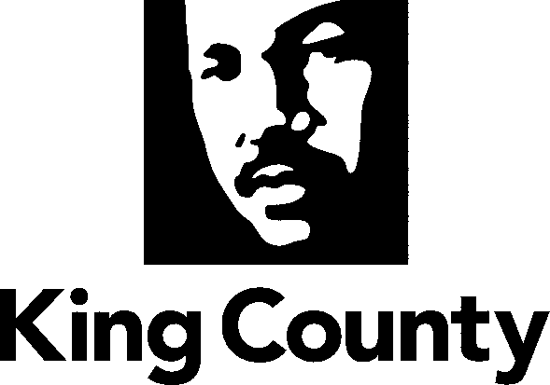
Permitting Division
Department of Local Services
919 SW Grady Way, Suite 300
Renton, WA 98057
206-296-6600
https://kingcounty.gov/depts/local-services/permits

Project Name: Fall City Floating File No.: TEMP24-0006

Applicant: Simon Briant Permitting Project Manager: Fereshteh Dehkordi
simon.briant@fallcityfloating.com Telephone No.: (206) 477-8479
E-mail: fdehkordi@kingcounty.gov

Date Application Filed: May 22, 2024
Date Determined Complete: May 22, 2024
Date of Mailing: June 11, 2024

Project Location: On the Northwest intersection of Fall City Carnation Road SE and Neal Road SE
Parcel 152407-9097

Project Description: Temporary parking associated with recreational use of park and river tubing activity from June to September.
Permits requested in this application: Temporary Use Permit

Relevant documents are available online at www.kingcounty.gov/permits/, or at the address above.

Consistency with applicable County plans and regulations: This proposal will be reviewed for compliance with all applicable King County Codes, including Roads Standards, Surface water Design Manual, Zoning, Grading and Critical Areas Codes.

Other permits not included in this application, known at this time:

The Department of Local Services, Permitting Division will issue a decision on this application following a 21-day public comment period which ends July 2, 2024. Written comments on this application must be submitted to Permitting Division at the address above. A public hearing is not required for this application prior to the Permitting Division’s decision. However, the decision may be appealed to the King County Hearing Examiner, who would conduct an appeal hearing prior to making a decision on the appeal. Details of the appeal process will be included in the notice of decision.
Any person wishing additional information on this proposed project should contact the Project Manager at the phone number or e-mail listed above. You may review the application and any documents or studies in our Snoqualmie office, or at www.kingcounty.gov/permits/.

NOTE: To request this information in alternative formats for people with disabilities, please call 206-296-6600 or TTY Relay: 711.

If you wish to receive a copy of the Permitting Division’s Report and Decision on this application, complete and return the portion below to the Department of Local Services, Permitting Division at the address listed above.

= = = = = = = = = = = = = = = = = = = = = = = = = = = = = = = = = = = = = = = = = = = = = = = = = = = = = = = = =
Please send me notification of any official notices concerning this application. (Please print clearly)

File No.:TEMP24-0006_______________

Name: ___________________________________ Telephone: ____________________________________

Email: _________________________________________________________________________________

Address: (optional): _______________________________________________________________________
Notifications will be sent via email unless hard copy is requested

