Aid called? Aid should be called if strangulation occurred regardless of signs or symptoms.

- Method and/or (how was victim strangled)

One Hand-R One Hand-L Two Hands Forearm

Knee/Foot Chokehold Manual Ligature

Other (explain)

- Is the suspect right or left handed? Right Left

- Please estimate how long you were strangled.

Minutes seconds Multiple times? Yes No

Estimate Pressure Used (check one) 1 2 3 4 5 6 7 8 9 10
(1 = weak – 10 = extremely strong)

- Suffocated? Yes No Minutes Seconds What was used?

- What did the suspect say during strangulation/suffocation?

- What did the victim say during the strangulation?

- Describe suspect’s demeanor during strangulation/suffocation.

- Describe suspect’s face during strangulation/suffocation.

- What made the suspect stop?

- Victim’s thoughts during strangulation/suffocation?

- Has the suspect strangled/suffocated you before? Yes # No

- Did you attempt to physically stop the strangulation? Yes No If yes, please describe:

- Were you shaken simultaneously while being strangled? Yes No

QUESTIONS TO ASK VICTIM

SYMPTONS | DURING | AFTER | VOICE CHANGES | SWALLOWING CHANGES
Unable to breath |  |  | Painful to speak | Neck tenderness
Difficult to breath |  |  | Unable to speak | Trouble swallowing
Physical pain |  |  | Other | Painful to swallow
Rapid breathing |  |  |  | Neck pain
Shallow breathing |  |  |  | Other
Coughing up blood
Vomiting/dry heaving |  |  | Explain other:
Dizziness
Headache
Feel faint
Disoriented

- Loss of consciousness? Yes No Not sure

Unexplained injury?

- Any change or loss of hearing during/after strangulation/suffocation? Yes No

- Any change or loss of vision during/after strangulation/suffocation? Yes No

- How did your body/head feel during /after strangulation/suffocation?

Describe

- Did the victim urinate defecate feel the urge to do one or both?

DEPUTY/OFFICER’S OBSERVATIONS

FACE | EYES AND EYELIDS | NOSE | EARS
Red or flushed | Petechiae to R eye | Petechiae | Petechiae on ear(s)
Petechiae | Petechiae to L eye | Scratch(es)/abrasion(s) | Bleeding from ear(s)
Scratch(es)/abrasion(s) | Petechiae to R eyelid | Swelling | Bruising/discoloration/  petechiae behind  ear(s)
Sweating | Petechiae to L eyelid | Other | Swelling
Bruising | Blood in eyeball(s) |  | Other
Other | Other
MOUTH | UNDER CHIN | CHEST | SHOULDERS
Swollen tongue | Scratch(es)/abrasion(s) | Scratch(es)/abrasion(s) | Scratch(es)/abrasion(s)
Swollen lip(s) | Laceration(s) | Laceration(s) | Laceration(s)
Scratch(es)/abrasion(s) | Bruise(s) | Bruise(s) | Bruise(s)
Petechial in palate | Fingernail impression(s) | Other | Other
Other | Other
NECK |  | HEAD | VOICE
Redness | Petechiae | Petechiae on scalp or  head | Raspy/hoarse voice
Finger mark(s) | Swelling | Hair pulled | Coughing
Fingernail impression(s) | Tenderness/pain | Bump(s) | Whispering
Bruise(s) | Scratch(es)/abrasion(s) | Laceration(s)
Ligature mark(s) |  | Scratch(es)/abrasion(s)

***PLEASE TAKE PHOTOGRAPHS***

Diagram ALL injuries on the victim

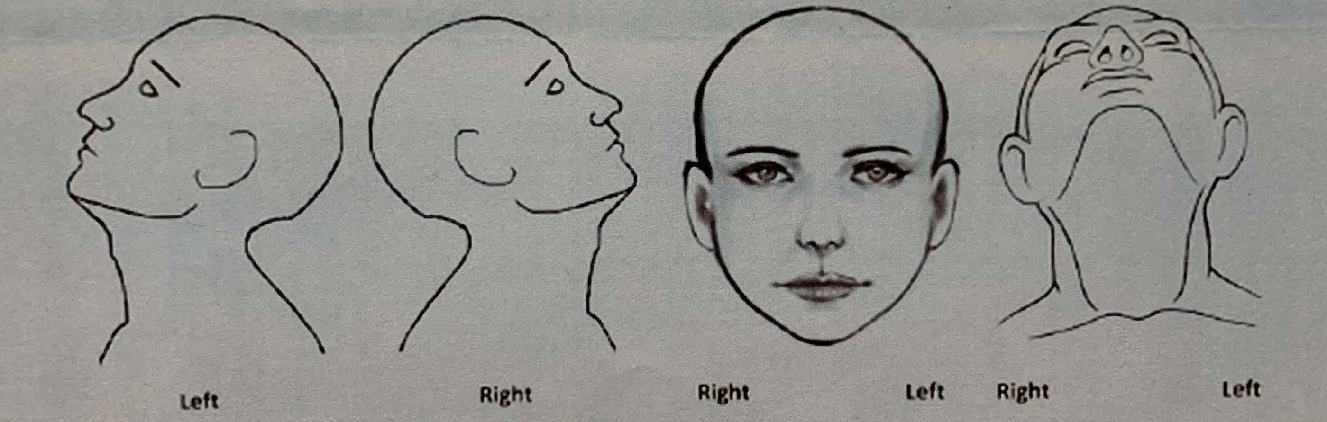

Describe any other injuries or symptoms

DEPUTY/OFFICER CHECKLIST

☐ If strangled/suffocated with object(s), photograph object(s) and collect for evidence.

☐ Document where the object(s) was/were found in the report.

☐ Determine if jewelry was worn by either party (rings, necklaces, watches, etc.) Photograph/look for pattern and photograph.

☐ If defecation or urination in clothes, collect clothes as evidence.

☐ If victim vomited, take a photo of vomit.

☐ Advise on future symptoms (headaches, throat/neck pain, etc.) Advise victim that they should be with somebody, and should not be alone for 24 hours.

Who will be with you? Contact number:

☐ PHOTOGRAPH suspect: hands, arms, face, chest and any areas where suspect states any injuries/contact occurred.

