Future Life Plan
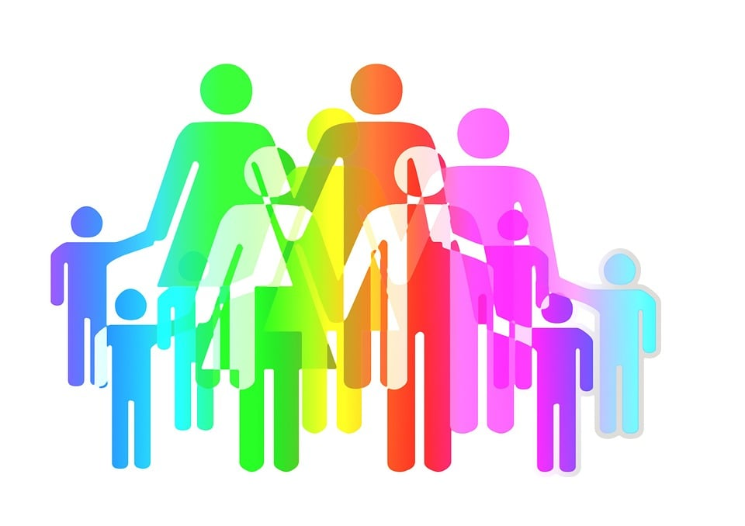
As you come to the end of your dependency case, you may want to think about and plan how you want your future life to be for you and your family. Creating a “Future Life Plan,” helps you recognize the positive changes you have made in your life, how you’re maintaining it, and the supports you’ll need to maintain it.
Also, a “Future Life Plan,” can help you outline your goals and desired outcomes. Writing down your goals, being specific, noting the dates and times of when you hope to reach your goals, helps to solidify them in your mind.
“A goal is just a dream, without a plan.” (Antoine de Saint-Exupery)

Family and Parenting:
Things I’m Maintaining | How am I Maintaining it | Supports I Need to Maintain it

Goal:________________________________________________________________________________
_____________________________________________________________________________________
Start Date:________________ End Date:________________
Financial:
Things I’m Maintaining | How am I Maintaining it | Supports I Need to Maintain it

Goal:________________________________________________________________________________
_____________________________________________________________________________________
Start Date:________________ End Date:________________
Housing:
Things I’m Maintaining | How am I Maintaining it | Supports I Need to Maintain it

Goal:________________________________________________________________________________
_____________________________________________________________________________________
Start Date:________________ End Date:________________
Problem Solving:
Things I’m Maintaining | How am I Maintaining it | Supports I Need to Maintain it

Goal:________________________________________________________________________________
_____________________________________________________________________________________
Start Date:________________ End Date:________________
Medical/Dental:
Things I’m Maintaining | How am I Maintaining it | Supports I Need to Maintain it

Goal:________________________________________________________________________________
_____________________________________________________________________________________
Start Date:________________ End Date:________________
Social/Recovery Connections:
Things I’m Maintaining | How am I Maintaining it | Supports I Need to Maintain it

Goal:________________________________________________________________________________
_____________________________________________________________________________________
Start Date:________________ End Date:________________
Transportation:
Things I’m Maintaining | How am I Maintaining it | Supports I Need to Maintain it

Goal:________________________________________________________________________________
_____________________________________________________________________________________
Start Date:________________ End Date:________________

