

REVENUE MANUAL

2025

King County

Office of Performance, Strategy and Budget

Office of Economic and Financial Analysis

The purpose of the King County Revenue Manual is to document and memorialize significant revenue sources that support and sustain King County government. It is intended to serve as a resource for County staff and elected officials, other government agencies within King County, and the public.

For each of the revenues presented here, the revenue manual identifies and provides details about sources, uses, collection and legal authority. It also presents a fiscal history in both graphical and numeric form.

The Office of Performance, Strategy and Budget (PSB) has direct oversight of the manual and collaborates with the Office of Economic and Financial Analysis (OEFA) and other County agencies in its development and publication.

TABLE OF CONTENTS

Section 1 – Overview of Major Revenue Categories 1

Section 2 – Property Tax-Based Revenue Sources 4

Introduction

Detailed Analysis of Property Tax-Based Revenue Sources

Current Expense Levy

Mental Health and Developmental Disabilities Levy

Veteran’s Aid Levy

Automated Fingerprint Identification (AFIS) Levy

Parks Levy

Veteran’s and Human Services Levy

Puget Sound Emergency Radio Network

Best Start for Kids

Crisis Care Centers

Emergency Medical Services (EMS) Levy

Conservation Futures Levy

Unincorporated Areas/Roads Levy

Flood District Levy

Marine Levy

Transit Levy

Unlimited Tax General Obligation (UTGO) Bond Levy

Hospital Property Tax Levy

Section 3 – Sales Tax-Based Revenue Sources 41

Introduction

Detailed Analysis of Sales Tax-Based Revenue Sources

Local Basic and Option (1%)

Criminal Justice

Mental Illness and Drug Dependency (MIDD)

Transit

Health Through Housing

Doors Open Tax

Hotel-Motel Tax

Extended Lodging Tax

Cannabis Excise Tax

Section 4 – Other Revenue Sources 64

Introduction

Detailed Analysis of Other Revenue Sources

Solid Waste Disposal Charges

Wastewater Treatment Revenues

Real Estate Excise Tax (REET 1) Revenues

Motor Vehicle Fuel Tax

E-911 Excise Tax

Transit Fares

Rental Car Sales Tax

Gambling Tax

# Section 1 - Overview of Major Revenue Categories

**Revenues**

King County receives many different types of revenues. These include tax revenues, charges for services, grants, interest earnings and others. Figure 1 provides a breakdown of the types of revenues received for the overall county in 2024, totaling $6.2 billion.

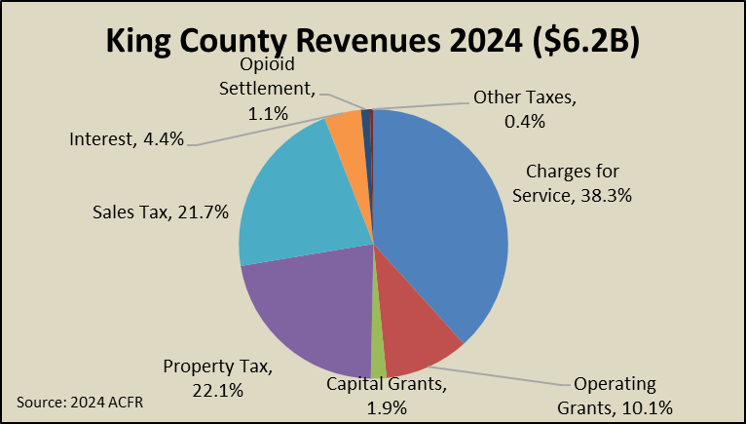

**Figure 1. Source of County Revenues-Countywide**

As can be seen, on a countywide basis, charges for services make up the largest source of revenues for King County. These include revenues the county receives from providing services like wastewater treatment, solid waste disposal, airport facilities and transit. The next two categories are property and sales taxes which together make up 43.8% of countywide revenues. These include all property tax levies in the county levy including the non-voted regular levy, the levy lid lifts and levies for transportation, marine, conservation futures, bond redemption, along with the emergency medical services and the roads levy. Sales taxes are made up of the local option sales tax, the metro transit sales tax, and those for mental health, housing, cultural access, and criminal justice. Grants make up approximately 12% of revenues and include both capital and operating grants. Miscellaneous other taxes and interest revenue make up the remainder of county revenues.

Figure 1 indicates revenues for the county, but King County also accounts for the goods and services it provides in two different sub-classifications, governmental activities and business activities. These sub-classifications are important since they highlight a very different revenue structure depending on the type of service.

Government activities are those that are recognized as basic government services like policing, courts, elections, and human services. Figure 2 indicates the revenue composition for King County’s governmental activities, which totaled $3.79 billion in 2024.

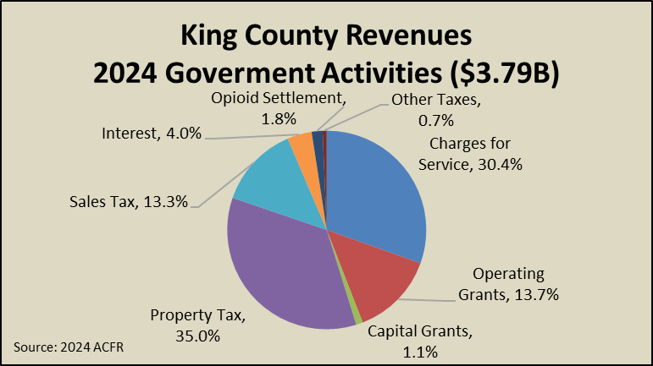

**Figure 2. Source of County Revenues-Government Activities**

Service charges are still the largest single source of revenues at 30.4%. However, if taxes are aggregated, they make up a larger share (48.3%) of general government revenues. Capital and operating grants make up about 14.8% of general government funding. Interest revenue amounted to 4% of government revenue. Opioid Settlement funds were 1.8%in 2024.

Figure 3 on the following page indicates revenues for business type activities, which totaled $2.41 billion in 2024. As mentioned, business-type activities are those intended to recover all or a significant portion of their costs through user fees and charges to external users of goods and services. Included are the operation of the County’s public transportation system, wastewater treatment facilities, solid waste disposal, airport and other services. Also included is the operation of the King County Marine District.

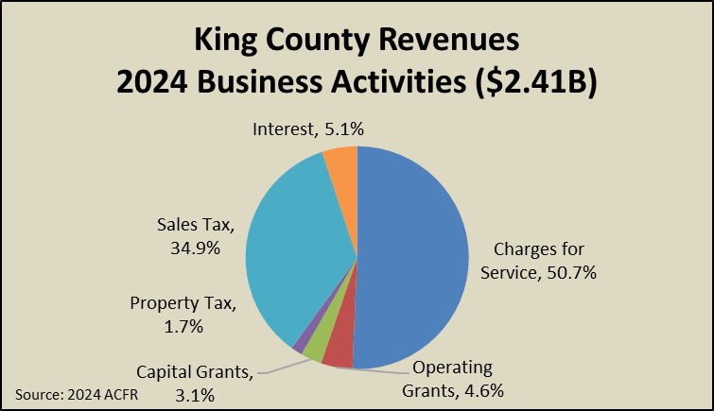

**Figure 3. Source of County Revenues-Business Activities**

As can be seen from Figure 3, 50.7% of revenues for business-type activities came from service charges and 34.9% from sales taxes. This sales tax revenue is the 0.9% tax levied countywide in support of metro transit. Transit also receives a small amount of property taxes which makes up about 1.8% overall. The remaining revenues are interest which for 2024 totaled 5.1% and grants totaled 7.7%.

The revenues the county receives have very specific processes and requirements. The remainder of this manual includes detailed information on selected revenue sources for King County. This includes specific property tax revenues along with the sales tax levies and hotel tax revenues. Also, information is provided on solid waste disposal charges, wastewater fees, real estate excise tax (REET 1) revenues, motor vehicle fuel taxes, Emergency 911 (E-911) excise taxes, rental car, gambling, cannabis, and transit fares.

# Section 2 - Property Tax-Based Revenue Sources

Property taxes are the County’s largest tax revenue source and the largest single source of revenues for the County’s General Fund and Roads Fund. Property tax levies are authorized in the Revised Code of Washington (RCW) for general or specific purposes and are either regular or excess levies. Regular levies are those the county is authorized to levy for specific purposes. Excess levies require voter approval. The RCW’s define specific limits on levies and describe what the levies can be used for. For example, the statute authorizing the Conservation Futures levy (RCW 84.34.230) allows the county to impose up to a six and one-quarter cent per one thousand dollar of assessed value levy for the purpose of “acquiring futures and other rights and interests in real property….” The key RCW’s relevant for understanding King County property tax revenues are RCW 84.52 and RCW 84.55.

The County collects property taxes through the regular levy, additional countywide levies for transportation, conservation futures and bond redemption, the unincorporated areas levy, the emergency medical services levy and others. The following funds receive property tax collections in King County:

**Levies and Destination Funds for King County Property Taxes**

|  |  |
| --- | --- |
| **Levy** | **Fund(s)/Destination** |
| County Regular Levy (non-voted)  -Current Expense  -Development Disabilities/ Mental Health  -Veteran’s Aid | General Fund  Developmental Disabilities/Mental Health  Veterans Relief Services |
| County Regular Levy (voted)  -Parks  -AFIS  -Veteran’s  -PSERN  -Best Start for Kids  -Crisis Care Centers | Parks, Open Space and Trails Levy  Automated Fingerprint Identification  Veterans, Seniors and Vulnerable Populations Levy  Puget Sound Emergency Radio Network Levy  Best Starts for Kids Levy  Crisis Care Centers |
| County Hospital | County Hospital |
| Transportation | Transit |
| Conservation Futures | Conservation Futures Sub-Fund |
| Bond Fund-Unlimited | Unlimited Bond Redemption |
| Unincorporated Areas/Roads Levy | County Roads |
| Emergency Medical Services Levy | Emergency Medical Services |
| Marine Levy | Marine operating |
| King County Flood Levy | King County Flood District |

In general, the levy amount for each levy is set on an annual basis and incremented annually by a limit factor and the value of add-ons. Add-ons include new construction, changes in state assessed utility values, annexed parcels, etc. The limit factor for most levies is 1.01[1] (meaning the levy can be increased by 1% each year) but exceptions are allowed for levies approved by voters. The value of new construction in the county from August 1 of the prior year to July 31 of the assessment year is allowed to be counted as part of the property tax levy and is valued at the previous year’s levy rate. The change in the value of state assessed utility value is valued similarly and provided by the Washington State Department of Revenue (DOR). Some levies (the levy lid lifts) have limit factors that are based on the rate of inflation. The table below describes the limit factors for King County levies:

**King County Levy Limit Factors**

|  |  |
| --- | --- |
| **Levy** | **Limit Factor** |
| Current Expense, Human Services/ Mental Health, Veteran’s Aid, Conservation Futures, Emergency Medical Services, Transit, UAL/Roads, Marine, PSERN, AFIS, Crisis Care Centers, County Hospital | One plus the lesser of the June-to-June implicit price deflator for personal consumption (IPD) or 1%. If the IPD is less than 1%, Council may pass legislation finding substantial need and then 1% may be used (limit factor = 1.01). |
| Parks | One plus the King County rate of inflation plus the population index or 1%, whichever is greater |
| Veterans, Seniors and Vulnerable Populations | One plus 3.5% |
| Best Start for Kids | One plus 3%. |
| King County Flood | One plus the lesser of the June-to-June implicit price deflator for personal consumption (IPD) or 1%. If the IPD is less than 1%, the district may pass legislation finding substantial need and then 1% may be used (limit factor = 1.01). |
| Unlimited Tax General Obligation Bond (UTGO) | Not limited |

King County levies a regular tax (non-voter approved) on all taxable real and personal property within its boundaries. Real property includes land, buildings and improvements, and personal property refers to assets used in the operation of a business, as well as materials used in the operation of a commercial, industrial or agricultural enterprise. Property tax is applied based on assessed value (AV) of the property and the levy rate. The King County Assessor is responsible for determining the value of real and personal property within King County and applying the appropriate levies to individual parcels. The amount of property tax levied is based on the fair market value of the property being taxed. The property tax rate is an amount of tax per $1000 of assessed value (AV), also referred to as the levy rate.

In 2025, the rate for the countywide levy was $1.36182 per $1,000 of assessed value on total taxable property valuation of $873,376,861,846 and the regular levy rate for county roads[2] was $1.30780 on taxable property valuation of $79,133,465,416 yielding levy amounts of $1,368,176,511 and $102,167,925 respectively.[3]



Besides limitations on the growth rate of levy amounts, levies are also subject to maximum levy rate values and aggregate limits. For the countywide levy, the maximum limit is $1.80. For the unincorporated areas levy, the maximum is set at $2.25. From 2012 to 2016, the unincorporated areas levy was at its maximum levy rate and so the levy amount each year was determined by the level of unincorporated assessed value. From 2017 to 2025, the rate fell below $2.25.

In addition, there are aggregate limits that affect levy amounts. The state applies several limits on property tax levy rates, including a $5.90 limit on aggregate regular levy rates assessed by counties/cities and smaller taxing districts and a constitutional property tax limit of one percent of the true and fair value of the property.[4]

**Property Tax Limitations in King County**

|  |  |
| --- | --- |
| **Aggregate Limit** | **Levies** |
| $5.90 limitation | County regular levies  City (incorporated) or Roads (Unincorporated)  Library District  Fire Districts  Hospital Districts  Park and other junior districts  Flood District |
| 1% Constitutional Limit | All $5.90 components above  State  Sound Transit (ST3)  EMS  Conservation Futures  Marine  Transit levy  County Hospital |

Under normal economic conditions, property taxes are a relatively stable source of revenue. Base property tax revenues are usually predictable rising via the applicable limit factor each year. However, incremental increases due to new construction fluctuate with the economy. During the recession of 2007-2009, with the downturn in the housing market, both property values and new construction declined, which had an impact on revenues the County took in from property taxes. Since recovering from the Great Recession, King County has seen positive year over year growth in total countywide assessed value for a decade from 2014 through 2023. During this booming period, home prices accelerated, and new construction activity contributed to faster levy growth. In 2023, the local housing market saw declines in home prices of more than 5% but in 2024 home prices grew again. Even though 2024 AV dropped, the 2025 assessed value grew by 4.8% countywide and the unincorporated AV grew by nearly 12%. New construction growth countywide was also negative year-over-year in 2025 at -9.6% but the unincorporated portion of King County saw new construction activities rise significantly by more than 21% from 2024 even with high interest rates throughout the year.



**Property Taxes – Current Expense (CX)**

|  |  |  |
| --- | --- | --- |
| **Revenue Description** |  | Ad valorem tax based upon the assessment of the taxable value of property in King County for the purpose of funding the general purposes of county government. |
|  |  |  | |
| **Legal Authorization for Collection:** |  | Revised Code of Washington; RCW 36.40.090, RCW 36.33.010, RCW 84.52.042, RCW 84.52.052 | |
|  |  |  | |
| **Fund:** |  | 000000010 | |
| **Account Numbers:** |  | 31111 (Real Property), 31112 (Private Property), 31113 (Real Property – Delinquent), 31114 (Private Property – Delinquent), 31119 (Ad Valorem Tax Refunds) | |
|  |  |  | |
| **Source:** |  | King County property owners | |
| **Use:** |  | General purposes of county government | |
|  |  |  | |
| **Fee Schedule/Rate:** |  | $0.49695 per thousand dollars AV [2025 Levy Rate] | |
| **Method of Payment:** |  | Property owner pays King County Treasurer online or by personal or business check. | |
| **Frequency of Collection:** |  | First half taxes are due April 30. Second half taxes are due Oct. 31. (RCW 84.56.020). | |
| **Exemptions:** |  | Numerous exemptions exist based on type, ownership, use, or status of property. See http://www.kingcounty.gov/sites/Assessor/TaxpayerAssistance/TaxRelief.aspx | |
| **Enacted / Expiration:** |  | Tax assessed annually by King County Department of Assessments.  1945 / No expiration | |
| **Revenue Collector:** |  | King County Treasurer | |
| **Distribution:**  **Limit Factor:**  **Restrictions:**  **Budgeting:**  **Forecast:** |  | King County Treasurer  1.01 (1% increase)  The CX levy together with other components of the countywide levy may not exceed $1.80 per thousand dollars of assessed value, and together with other levies must not exceed the $5.90 limit for local property taxes and the 1% state constitutional limit.  Amount is budgeted in account 31111 (account 31112 set at 0). Delinquencies and refunds are budgeted separately.  Provided by the King County Office of Economic and Financial Analysis (OEFA). | |
|  |  |  | |

**Fiscal History**

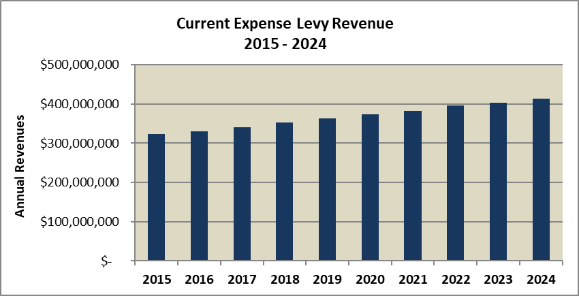



Data Sources: King County EBS – Accounts 31111, 31112 as of 5-1-25

CX revenues have been increasing year on year. In 2024, the County collected more than $413,000,000 in revenues from the current expense property tax levy. The CX levy amount generally increases at the rate of one percent per year plus the value of new construction. From 2009 to 2012, total property tax revenues increased by an average of 2.10 percent. In 2013, revenues increased by more than 10 percent. This growth was largely due to a one-time change in how property tax revenues used for debt service were levied. Prior to 2013, property taxes dedicated to debt service were levied separately in a bond redemption levy. In 2013, that practice was discontinued and property taxes to be used for debt service were levied as part of the CX levy, significantly increasing the total levy amount.

The CX levy rate has been decreasing annually until 2024 when it increased but decreased once again in 2025. The table below indicates the levy rates over the most recent ten-year period:



As can be noted, the levy rates decreased from $0.79209/$1,000 AV in 2016 to $0.49695 in 2025. These levy rates decreased as assessed value grew, although the levy rate increased in 2024 as AV decreased that year.

# Property Taxes – Mental Health and Developmental Disabilities

|  |  |  |
| --- | --- | --- |
| **Revenue Description** |  | Ad valorem tax based upon the assessment of the taxable value of property in King County for the purpose of providing additional funds for the coordination and provision of community services for persons with developmental disabilities or mental health needs. |
|  |  |  | |
| **Legal Authorization for Collection:** |  | Revised Code of Washington RCW 71.20.100, 71.20.110 | |
|  |  |  | |
| **Fund:** |  | 000001070, 000001120 | |
| **Account Numbers:** |  | 31111 (Real Property), 31112 (Private Property), 31113 (Real Property – Delinquent), 31114 (Private Property – Delinquent), 31119 (Ad Valorem Tax Refunds) | |
|  |  |  | |
| **Source:** |  | King County property owners | |
| **Use:** |  | Funding community services for persons with developmental disabilities or mental health needs | |
|  |  |  | |
| **Fee Schedule/Rate:** |  | $0.00923 per thousand dollars AV [2025 Levy Rate] | |
| **Method of Payment:** |  | Property owner pays King County Treasurer online or by personal or business check. | |
| **Frequency of Collection:** |  | First half taxes are due April 30. Second half taxes are due Oct. 31. (RCW 84.56.020). | |
| **Exemptions:** |  | Numerous exemptions exist based on type, ownership, use, or status of property. See <http://www.kingcounty.gov/sites/Assessor/TaxpayerAssistance/TaxRelief.aspx> | |
| **Enacted / Expiration:** |  | Tax assessed annually by King County Department of Assessments.  1967 / No expiration | |
| **Revenue Collector:** |  | King County Treasurer | |
| **Distribution:**  **Limit Factor:**  **Restrictions:**  **Budgeting:**  **Forecast:** |  | King County Treasurer  1.01 (1% increase)  The Mental Health levy alone may not exceed $0.025/$1000 AV, and together with other components of the countywide and other property tax levies may not exceed the $5.90/$1000 AV limit for local property taxes and the 1% state constitutional limit.  Total amount is budgeted in account 31111 (all other accounts set at 0).  Provided by the King County Office of Economic and Financial Analysis (OEFA). | |
|  |  |  | |

**Fiscal History**

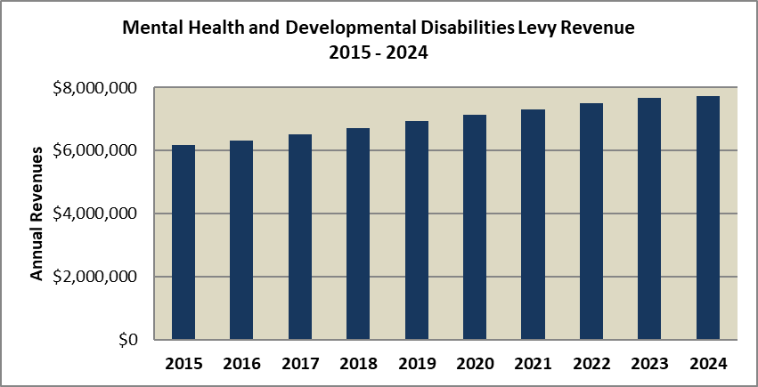



Data Sources: King County EBS – Accounts 31111, 31112, 31113, 31114, 31119 as of 5-23-25

Totals will be less than the Certified Levy due to the inclusion delinquencies.

Mental Health and Developmental Disabilities revenues have increased each year since 2012. Revenues for Mental Health and Developmental Disabilities amounted to approximately $7.7 million in 2024, an increase of 0.82% from 2023.

The Mental Health and Developmental Disabilities levy rate increased each year between 2009 and 2013, while remaining well below the $0.025/$1000 AV threshold. Increasing property values allowed for a reduction in the levy rate for 2014 and continuing reductions in 2015 through 2023. The table below indicates past and current Mental Health and Developmental Disabilities levy rates:



As can be noted, the levy rates decreased from $0.01499/$1,000 AV in 2016 to a low of $0.00883 in 2023 and rose 7% to $0.00945 in 2024 as AV decreased. Again, the rate decreased to $0.00923 in 2025.

# Property Taxes – Veteran’s Aid Levy

|  |  |  |
| --- | --- | --- |
| **Revenue Description** |  | Ad valorem tax based upon the assessment of the taxable value of property in King County for the purpose of creating an assistance fund for the relief of honorably discharged veterans and the indigent wives, husbands, widows, widowers, and minor children of such indigent or deceased veterans. |
|  |  |  | |
| **Legal Authorization for Collection:** |  | Revised Code of Washington; RCW 73.08.080 | |
|  |  |  | |
| **Fund:** |  | 000001060 | |
| **Account Numbers:** |  | 31111 (Real Property), 31112 (Private Property), 31113 (Real Property – Delinquent), 31114 (Private Property – Delinquent), 31119 (Ad Valorem Tax Refunds) | |
|  |  |  | |
| **Source:** |  | King County property owners | |
| **Use:** |  | Assisting honorably discharged veterans | |
|  |  |  | |
| **Fee Schedule/Rate:** |  | $0.00411 per thousand dollars AV [2025 Levy Rate] | |
| **Method of Payment:** |  | Property owner pays King County Treasurer online or by personal or business check. | |
| **Frequency of Collection:** |  | First half taxes are due April 30. Second half taxes are due Oct. 31. (RCW 84.56.020). | |
| **Exemptions:** |  | Numerous exemptions exist based on type, ownership, use, or status of property. See <http://www.kingcounty.gov/sites/Assessor/TaxpayerAssistance/TaxRelief.aspx> | |
| **Enacted / Expiration:** |  | Tax assessed annually by King County Department of Assessments.  1888 / No expiration | |
| **Revenue Collector:** |  | King County Treasurer | |
| **Distribution:**  **Limit Factor:**  **Restrictions:**  **Budgeting:**  **Forecast:** |  | King County Treasurer  1.01 (1% increase)  The Veteran’s Aid levy rate is limited to no less than $0.01125/$1000 AV and no greater than $0.27/$1000 AV. It may be lowered to less than the $0.01125 minimum if the fund balance exceeds the amount represented by the minimum levy rate. The levy together with other components of the countywide property tax levy and other levies may not exceed the $5.90/$1000 AV limit for local property taxes and the 1% state constitutional limit.  Total amount is budgeted in account 31111 (all other accounts set at 0).  Provided by the King County Office of Economic and Financial Analysis (OEFA). | |

**Fiscal History**

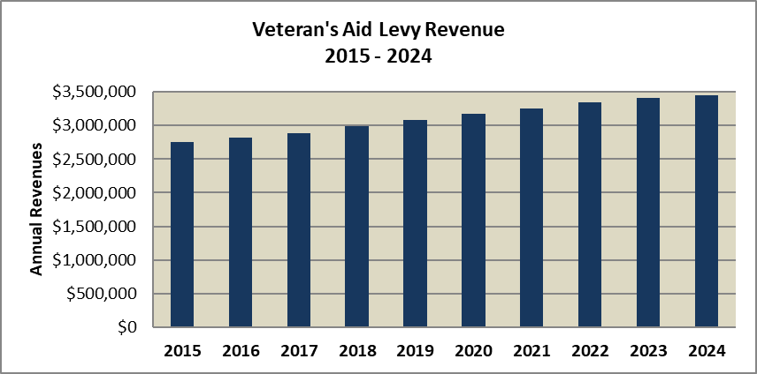



Data Sources: King County EBS – Accounts 31111, 31112, 31113, 31114, 31119 as of 5-1-25

Totals will be less than the Certified Levy due to the inclusion of delinquencies.

Veteran’s Aid revenues have increased each year since 2012. Revenues in 2024 equaled $3.449 million, a 0.95% increase over 2023.

The Veteran’s Aid levy rate increased each year from 2009 through 2013 to maintain operating revenues around $2.5 million per year as assessed values declined. Increasing property values allowed for a reduction in the rate in years 2014 through 2023, before a slight increase in 2024. The table below indicates past and current Veteran’s Aid levy rates:



As can be noted, the levy rates decreased from $0.00668/$1,000 AV in 2016 to a low of $0.00393/$1,000 AV in 2023 and then increased 7% to $0.00421 in 2024. The rate dropped a little to $0.00411 in 2025.

# Property Taxes – Automated Fingerprint ID Levy (AFIS)

|  |  |  |
| --- | --- | --- |
| **Revenue Description** |  | Ad valorem tax based upon the assessment of the taxable value of property in King County for the purpose of funding the continued operation of the regional automated fingerprint identification system (AFIS) and related technologies and services. |
|  |  |  | |
| **Legal Authorization for Collection:** |  | Revised Code of Washington; RCW 84.55.050, KC Ord. No. 18674 | |
|  |  |  | |
| **Fund:** |  | 000001220 | |
| **Account Numbers:** |  | 31111 (Real Property), 31112 (Private Property), 31113 (Real Property – Delinquent), 31114 (Private Property – Delinquent), 31119 (Ad Valorem Tax Refunds) | |
|  |  |  | |
| **Source:** |  | King County property owners | |
| **Use:** |  | Operation of the regional automated fingerprint identification system | |
|  |  |  | |
| **Fee Schedule/Rate:** |  | $0.00275 per thousand dollars AV [2026 Levy Rate] | |
| **Method of Payment:** |  | Property owner pays King County Treasurer online or by personal or business check. | |
| **Frequency of Collection:** |  | First half taxes are due April 30. Second half taxes are due Oct. 31. (RCW 84.56.020). | |
| **Exemptions:** |  | Numerous exemptions exist based on type, ownership, use, or status of property. See <http://www.kingcounty.gov/sites/Assessor/TaxpayerAssistance/TaxRelief.aspx> | |
| **Enacted / Expiration:** |  | Tax assessed annually by King County Department of Assessments.  1987 / 2024 / Levy Renewed in 2025 | |
| **Revenue Collector:** |  | King County Treasurer | |
| **Distribution:**  **Limit Factor:**  **Restrictions:**  **Budgeting:**  **Forecast:** |  | King County Treasurer  1.01 (1% increase)  The AFIS levy together with other components of the countywide and other property tax levies may not exceed the $5.90/$1000 AV limit for local property taxes and the 1% state constitutional limit.  Total amount is budgeted in account 31111 (all other accounts set at 0).  Provided by the King County Office of Economic and Financial Analysis (OEFA). | |
|  |  |  | |

**Fiscal History**

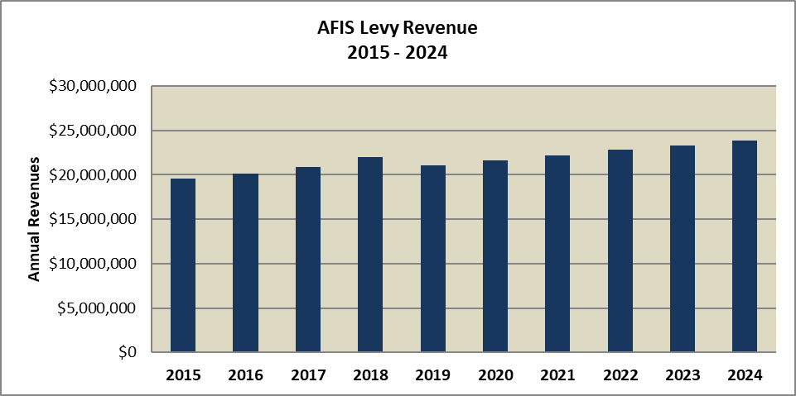



Data Sources: King County EBS – Accounts 31111, 31112, 31113, 31114, and 31119 as of 5-1-25

Totals will be less than the Certified Levy due to the inclusion delinquencies.

Automated Fingerprint Identification System revenues had been decreasing year over year until 2013, when a new voter-approved levy went into effect. The new levy resulted in a more than 64% jump in revenues, from just over $11 million in 2012 to over $18 million in 2013 and 2014. Revenues increased each year beyond that through 2018, before declining slightly in 2019. It resumed annual increases from 2020-2024. The final year of collection was 2024.

During the previous levy cycle, running from 2007 to 2012, AFIS had a sizable fund balance that allowed the County to decrease the levy amounts. The current levy plan, covering 2019 through 2024, set an initial levy rate of $0.035/$1000 assessed value with subsequent annual increases tied to a one percent increase. The table below indicates past and current levy rates:



As can be noted, the levy rates decreased from $0.05069/$1,000 AV in 2015 to a low of $0.02681 before increasing to $0.02905 in 2024 because of declining assessed values. This levy has been renewed by voters in April 2025 so the levy will resume in 2026 with an initial levy rate of $0.0275/$1000 AV.

# Property Taxes – Parks Levy

|  |  |  |
| --- | --- | --- |
| **Revenue Description** |  | Ad valorem tax based upon the assessment of the taxable value of property in King County for the purpose of maintaining and operating King County's parks system; improving parks, recreation and mobility by acquiring open space and continuing to develop regional trails; repairing, replacing and improving local parks and trails in King County's cities; funding environmental education, maintenance, conservation and capital programs at the Woodland Park Zoo. |
|  |  |  | |
| **Legal Authorization for Collection:** |  | Revised Code of Washington; RCW 84.55.050, KC Ord. No. 17568 | |
|  |  |  | |
| **Fund:** |  | 000001451/1452 (through 2013); 000001453 (2014 and beyond) | |
| **Account Numbers:** |  | 31111 (Real Property), 31112 (Private Property), 31113 (Real Property – Delinquent), 31114 (Private Property – Delinquent), 31119 (Ad Valorem Tax Refunds) | |
|  |  |  | |
| **Source:** |  | King County property owners | |
| **Use:** |  | Maintaining and operating the County parks system | |
|  |  |  | |
| **Fee Schedule/Rate:** |  | $0.19748 per thousand dollars AV [2025 Levy Rate] | |
| **Method of Payment:** |  | Property owner pays King County Treasurer online or by personal or business check. | |
| **Frequency of Collection:** |  | First half taxes are due April 30. Second half taxes are due Oct. 31. (RCW 84.56.020). | |
| **Exemptions:** |  | Numerous exemptions exist based on type, ownership, use, or status of property. See <http://www.kingcounty.gov/sites/Assessor/TaxpayerAssistance/TaxRelief.aspx> | |
| **Enacted / Expiration:** |  | Tax assessed annually by King County Department of Assessments.  2004 / 2025 | |
| **Revenue Collector:** |  | King County Treasurer | |
| **Distribution:**  **Limit Factor:**  **Restrictions:**  **Budgeting:**  **Forecast:** |  | King County Treasurer  One plus the King County rate of inflation plus the population index or 1%, whichever is greater.  The Parks Operating levy together with other components of the countywide and other property tax levies may not exceed the $5.90/$1000 AV limit for local property taxes and the 1% state constitutional limit.  Total amount is budgeted in account 31111 (all other accounts set at 0).  Provided by the King County Office of Economic and Financial Analysis (OEFA). | |
|  |  |  | |

**Fiscal History**

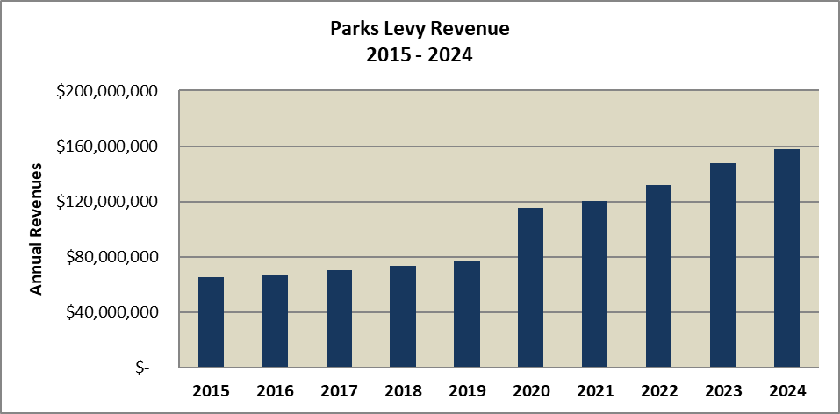



Data Sources: King County EBS – Accounts 31111, 31112, 31113, 31114, 31119 as of 5-1-25

Totals will be less than the Certified Levy due to the inclusion delinquencies.

Parks property tax funding from 2008-2013 was provided by two separate levies: the Parks Operating levy and the Open Space and Trails levy. Both levies had the same levy amounts and rates and increased each year from 2009 through 2013, with increases tied to the annual percentage change in the Consumer Price Index. In 2013, King County voters approved a levy lid lift to replace both the expiring levies at $0.1877 for 2014. As a result, in 2014, the County collected more than $62.5 million in revenues from the parks operating property tax levy, a 52.37% increase from 2013, attributable to a new, higher levy rate. The new parks levy rate also increased by the percentage change in the CPI in years 2015 to 2019. In 2019, King County voters renewed the levy at $0.1832/$1000 assessed value for the first year for a period of six years. Subsequently, another large increase occurred in 2020 with the adoption of the new, higher levy rate. Revenues have more than doubled between 2015 and 2024.

The table below indicates past and current Parks Operating levy rates:



As can be noted, the levy rates decreased from $0.159995/$1,000 AV in 2016 to $0.12926 in 2019 before increasing to $0.18320 in 2020 with the passage of the renewed levy. Since the levy passed, the rate has decreased a little to a low of $0.17143 in 2023 and increased again in 2024 and 2025 to $0.19748. The levy is up for renewal in 2025 at a rate of $0.2443/$1000 AV.

# Property Taxes – Veterans, Seniors, and Human Services Levy

|  |  |  |
| --- | --- | --- |
| **Revenue Description** |  | Ad valorem tax based upon the assessment of the taxable value of property in King County for the purpose of enabling the provision of human services such as affordable and supportive housing, mental health counseling, employment assistance and other essential regional health and human services for veterans, seniors, and other vulnerable populations of King County. |
|  |  |  | |
| **Legal Authorization for Collection:** |  | Revised Code of Washington RCW 84.55.050, KC Ord. No. 18555 | |
|  |  |  | |
| **Fund:** |  | 000001143 | |
| **Account Numbers:** |  | 31111 (Real Property), 31112 (Private Property), 31113 (Real Property – Delinquent), 31114 (Private Property – Delinquent), 31119 (Ad Valorem Tax Refunds) | |
|  |  |  | |
| **Source:** |  | King County property owners | |
| **Use:** |  | Housing and supportive services for veterans and seniors, as well as other individuals in need | |
|  |  |  | |
| **Fee Schedule/Rate:** |  | $0.10030 per thousand dollars AV [2025 Levy Rate] | |
| **Method of Payment:** |  | Property owner pays King County Treasurer online or by personal or business check. | |
| **Frequency of Collection:** |  | First half taxes are due April 30. Second half taxes are due Oct. 31. (RCW 84.56.020). | |
| **Exemptions:** |  | Numerous exemptions exist based on type, ownership, use, or status of property. See <http://www.kingcounty.gov/sites/Assessor/TaxpayerAssistance/TaxRelief.aspx> | |
| **Enacted / Expiration:** |  | Tax assessed annually by King County Department of Assessments.  2006 / 2029 | |
| **Revenue Collector:** |  | King County Treasurer | |
| **Distribution:**  **Limit Factor:**  **Restrictions:**  **Budgeting:**  **Forecast:** |  | King County Treasurer  One plus 3.5%  The Veteran’s and Human Services levy together with other components of the countywide and other property tax levies may not exceed the $5.90/$1000 AV limit for local property taxes and the 1% state constitutional limit.  Total amount is budgeted in account 31111 (all other accounts set at 0).  Provided by the King County Office of Economic and Financial Analysis (OEFA). | |
|  |  |  | |

**Fiscal History**

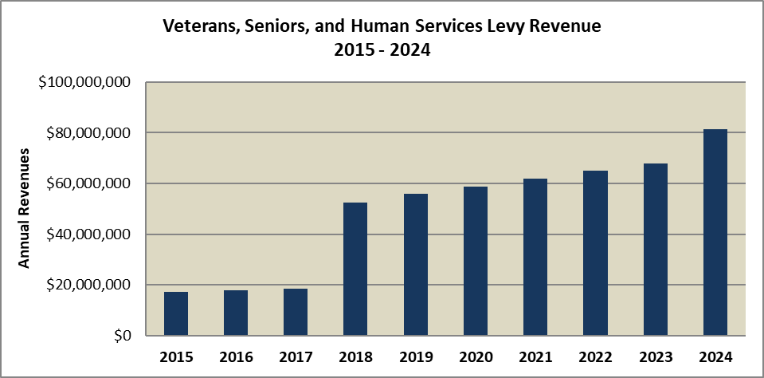



Data Sources: King County EBS – Accounts 31111, 31112, 31113, 31114, 31119 as of 5-1-25

Totals will be less than the Certified Levy due to the inclusion delinquencies.

Veteran’s and Human Services levy historically collected between $13 million and $18.5 million before 2017, when voters approved a renewal and substantial expansion of the levy. As a result, revenues in 2018 increased 184% over 2017 and have increased each year since. The levy was renewed again in 2023, and the levy amount increased 19.5% to $81.3 million in 2024.

The previous levy had a voter-approved initial levy rate of $0.05/$1000 assessed value in 2012, with increases in the levy amount in subsequent years of the greater of 1% or the percentage increase in the Consumer Price Index, up to a maximum of 3%. The levy passed in 2017 doubled the initial rate to $0.10/$1000 in 2018. The most recent levy renewal maintains that rate as the base rate, with 3.5% increases annually. The table below indicates past and current levy rates:



As can be noted, the levy rates decreased from $0.04219/$1,000 AV in 2016 to $0.3964 in 2017. In 2017, voters approved a new levy for Veterans, Seniors, and Human Services. And collection of the levy began in 2018 at a rate of $0.10/$1,000 AV, before declining to $0.07879 in 2023 due to rapid assessed value growth. The levy was renewed in 2024 at $0.100/$1,000 AV and will increase slightly in 2025.

# Property Taxes – Puget Sound Emergency Radio Network

|  |  |  |
| --- | --- | --- |
| **Revenue Description** |  | Ad valorem tax based upon the assessment of the taxable value of property in King County for the purposes of paying the capital, transition and financing costs for the Puget Sound emergency radio network (PSERN) project. |
|  |  |  | |
| **Legal Authorization for Collection:** |  | Revised Code of Washington RCW 84.55.050, KC Ord. No. 17993 | |
|  |  |  | |
| **Fund:** |  | 000001511 | |
| **Account Numbers:** |  | 31111 (Real Property), 31112 (Private Property), 31113 (Real Property – Delinquent), 31114 (Private Property – Delinquent), 31119 (Ad Valorem Tax Refunds) | |
|  |  |  | |
| **Source:** |  | King County property owners | |
| **Use:** |  | Raising funds to pay the capital, transition and financing costs for the Puget Sound emergency radio network project. | |
|  |  |  | |
| **Fee Schedule/Rate:** |  | $0.04476 per thousand dollars AV [2024 Levy Rate] | |
| **Method of Payment:** |  | Property owner pays King County Treasurer online or by personal or business check. | |
| **Frequency of Collection:** |  | First half taxes are due April 30. Second half taxes are due Oct. 31. (RCW 84.56.020). | |
| **Exemptions:** |  | Numerous exemptions exist based on type, ownership, use, or status of property. See <http://www.kingcounty.gov/sites/Assessor/TaxpayerAssistance/TaxRelief.aspx> | |
| **Enacted / Expiration:** |  | Tax assessed annually by King County Department of Assessments.  2016 / 2024 | |
| **Revenue Collector:** |  | King County Treasurer | |
| **Distribution:**  **Limit Factor:**  **Restrictions:**  **Budgeting:**  **Forecast:** |  | King County Treasurer  1.01 (1% increase)  The PSERN levy together with other components of the countywide and other property tax levies may not exceed the $5.90/$1000 AV limit for local property taxes and the 1% state constitutional limit.  Total amount is budgeted in account 31111 (all other accounts set at 0).  Provided by the King County Office of Economic and Financial Analysis (OEFA). | |
|  |  |  | |

**Fiscal History**

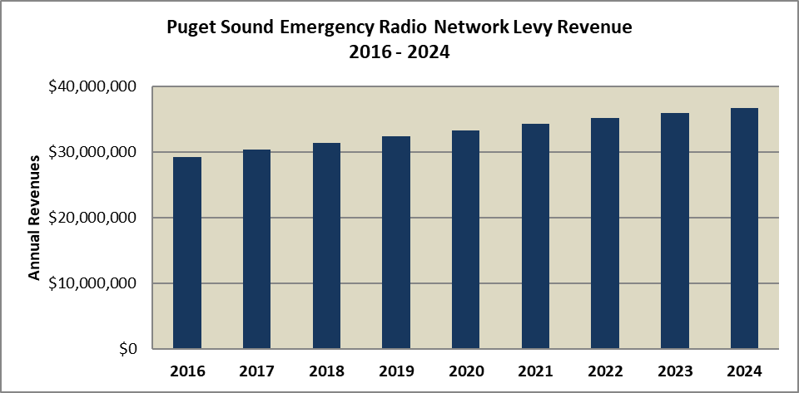



Data Sources: King County EBS – Accounts 31111, 31112, 31113, 31114, 31119 as of 5-1-25

Totals will be less than the Certified Levy due to the inclusion delinquencies.

PSERN was a new levy in 2016 that generated $29.2 million in revenue its first year, before increasing each year thereafter through 2024. The levy rate has decreased from the initial levy rate of $0.07000/$1000 assessed value to a low of $0.04131 in 2023 due to rapid growth in assessed value. In 2024, the last year of collection, the rate increased 8% to $0.04476 from 2023. This levy is now expired.



# Property Taxes – Best Start for Kids

|  |  |  |
| --- | --- | --- |
| **Revenue Description** |  | Ad valorem tax based upon the assessment of the taxable value of property in King County for the purpose of funding prevention and early intervention strategies to improve the health and well-being of children, youth and their communities in King County. |
|  |  |  | |
| **Legal Authorization for Collection:** |  | Revised Code of Washington RCW 84.55.050, KC Ord. No. 19351 | |
|  |  |  | |
| **Fund:** |  | 000001480 | |
| **Account Numbers:** |  | 31111 (Real Property), 31112 (Private Property), 31113 (Real Property – Delinquent), 31114 (Private Property – Delinquent), 31119 (Ad Valorem Tax Refunds) | |
|  |  |  | |
| **Source:** |  | King County property owners | |
| **Use:** |  | Funding prevention and early intervention strategies to improve the health and well-being of children, youth and communities in King County. | |
|  |  |  | |
| **Fee Schedule/Rate:** |  | $0.17959 per thousand dollars AV [2025 Levy Rate] | |
| **Method of Payment:** |  | Property owner pays King County Treasurer online or by personal or business check. | |
| **Frequency of Collection:** |  | First half taxes are due April 30. Second half taxes are due Oct. 31. (RCW 84.56.020). | |
| **Exemptions:** |  | Numerous exemptions exist based on type, ownership, use, or status of property. See <http://www.kingcounty.gov/sites/Assessor/TaxpayerAssistance/TaxRelief.aspx> | |
| **Enacted / Expiration:** |  | Tax assessed annually by King County Department of Assessments.  2016 / 2027 | |
| **Revenue Collector:** |  | King County Treasurer | |
| **Distribution:**  **Limit Factor:**  **Restrictions:**  **Budgeting:**  **Forecast:** |  | King County Treasurer  One plus 3.0%  The Best Start for Kids levy together with other components of the countywide and other property tax levies may not exceed the $5.90/$1000 AV limit for local property taxes and the 1% state constitutional limit.  Total amount is budgeted in account 31111 (all other accounts set at 0).  Provided by the King County Office of Economic and Financial Analysis (OEFA). | |
|  |  |  | |

**Fiscal History**

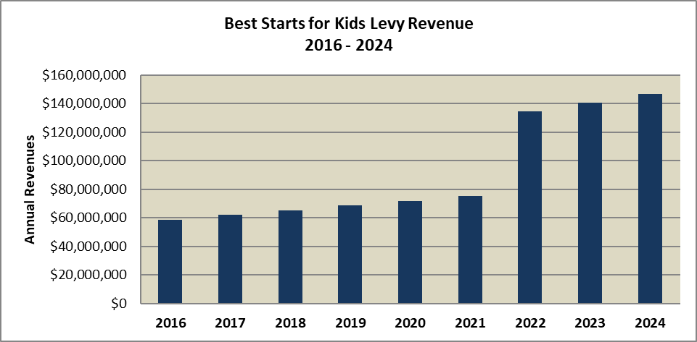



Data Sources: King County ARMS & EBS – Accounts 31111, 31112, 31113, 31114, 31119 as of 5-1-25

Totals will be less than the Certified Levy due to the inclusion delinquencies.

BSK was a new levy in 2016 that generated $58.5 million in revenue its first year, increasing each year thereafter. The levy was renewed in 2021. After the 2021 renewal, the BSK revenue increased 78.6% to $134.5 million. The levy rate decreased from the initial levy rate of $0.14000/$1000 assessed value in 2016 to $0.11554 in 2021 when the initial levy expired. The second levy rate of $0.19000 began in 2022 andthe rate has since decreased from its initial amount due to rising assessed values, to a low rate of $0.16297 in 2023 and rising 10% to $0.17992/$1000 AV in 2024 before declining slightly in 2025 to $0.17959.



# Property Taxes – Crisis Care Centers

|  |  |  |
| --- | --- | --- |
| **Revenue Description** |  | Ad valorem tax based upon the assessment of the taxable value of property in King County for the purpose of funding a county-wide network of five crisis care centers, restoring and expanding mental health residential treatment beds, and strengthening the community behavioral health workforce. |
|  |  |  | |
| **Legal Authorization for Collection:** |  | Revised Code of Washington RCW 84.55.050, KC Ord. No. 19572 | |
|  |  |  | |
| **Fund:** |  | 000001460 | |
| **Account Numbers:** |  | 31111 (Real Property), 31112 (Private Property), 31113 (Real Property – Delinquent), 31114 (Private Property – Delinquent), 31119 (Ad Valorem Tax Refunds) | |
|  |  |  | |
| **Source:** |  | King County property owners | |
| **Use:** |  | Funding a network of five crisis care centers. | |
|  |  |  | |
| **Fee Schedule/Rate:** |  | $0.14197 per thousand dollars AV [2025 Levy Rate] | |
| **Method of Payment:** |  | Property owner pays King County Treasurer online or by personal or business check. | |
| **Frequency of Collection:** |  | First half taxes are due April 30. Second half taxes are due Oct. 31. (RCW 84.56.020). | |
| **Exemptions:** |  | Numerous exemptions exist based on type, ownership, use, or status of property. See <http://www.kingcounty.gov/sites/Assessor/TaxpayerAssistance/TaxRelief.aspx> | |
| **Enacted / Expiration:** |  | Tax assessed annually by King County Department of Assessments.  2024 / 2032 | |
| **Revenue Collector:** |  | King County Treasurer | |
| **Distribution:**  **Limit Factor:**  **Restrictions:**  **Budgeting:**  **Forecast:** |  | King County Treasurer  Maximum of 1.01 (1% increase)  The Crisis Care Centers levy together with other components of the countywide and other property tax levies may not exceed the $5.90/$1000 AV limit for local property taxes and the 1% state constitutional limit.  Total amount is budgeted in account 31111 (all other accounts set at 0).  Provided by the King County Office of Economic and Financial Analysis (OEFA). | |
|  |  |  | |

**Fiscal History**

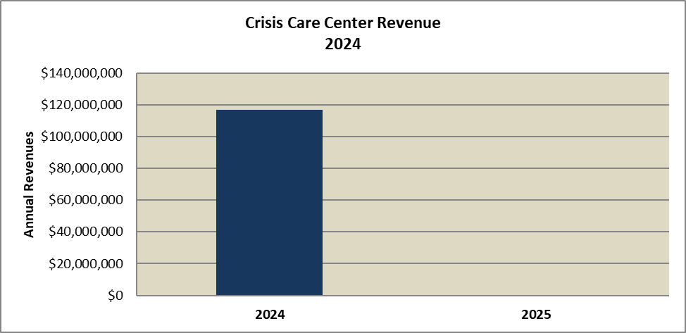



Data Sources: King County ARMS & EBS – Accounts 31111, 31112, 31113, 31114, 31119 as of 5-1-25

Totals will be less than the Certified Levy due to the inclusion delinquencies.

Crisis Care Centers began collection in 2024, taking in $116.9 million. After an initial levy rate of $0.14500/$1000 AV in 2024, the rate dropped to $0.1497 in 2025.



# Property Taxes – Emergency Medical Services Levy

|  |  |  |
| --- | --- | --- |
| **Revenue Description** |  | Ad valorem tax based upon the assessment of the taxable value of property in King County for the purpose of providing emergency medical services. |
|  |  |  | |
| **Legal Authorization for Collection:** |  | Revised Code of Washington; RCW 84.52.069, KC Ord. No. 17598 | |
|  |  |  | |
| **Fund:** |  | 000001190 | |
| **Account Numbers:** |  | 31111 (Real Property), 31112 (Personal Property), 31113 (Real Property – Delinquent), 31114 (Personal Property – Delinquent), 31119 (Ad Valorem Tax Refunds) | |
|  |  |  | |
| **Source:** |  | King County property owners | |
| **Use:** |  | Providing emergency medical services | |
|  |  |  | |
| **Fee Schedule/Rate:** |  | $0.22146 per thousand dollars AV [2025 Levy Rate] | |
| **Method of Payment:** |  | Property owner pays King County Treasurer online or by personal or business check. | |
| **Frequency of Collection:** |  | First half taxes are due April 30. Second half taxes are due Oct. 31. (RCW 84.56.020). | |
| **Exemptions:** |  | Numerous exemptions exist based on type, ownership, use, or status of property. See <http://www.kingcounty.gov/sites/Assessor/TaxpayerAssistance/TaxRelief.aspx> | |
| **Enacted / Expiration:** |  | Tax assessed annually by King County Department of Assessments.  1980 / 2025 | |
| **Revenue Collector:** |  | King County Treasurer | |
| **Distribution:**  **Limit Factor:**  **Restrictions:**  **Budgeting:**  **Forecast:** |  | King County Treasurer. Revenues are split between the county and the City of Seattle based on Seattle/non-Seattle assessed value.  1.01 (1% increase)  The Emergency Medical Services levy alone may not exceed $0.50/$1000 AV and together with other components of the countywide property tax levy may not exceed the 1% state constitutional limit.  Total amount is budgeted in account 31111 (all other accounts set at 0).  Provided by the King County Office of Economic and Financial Analysis (OEFA). | |
|  |  |  | |

**Fiscal History**

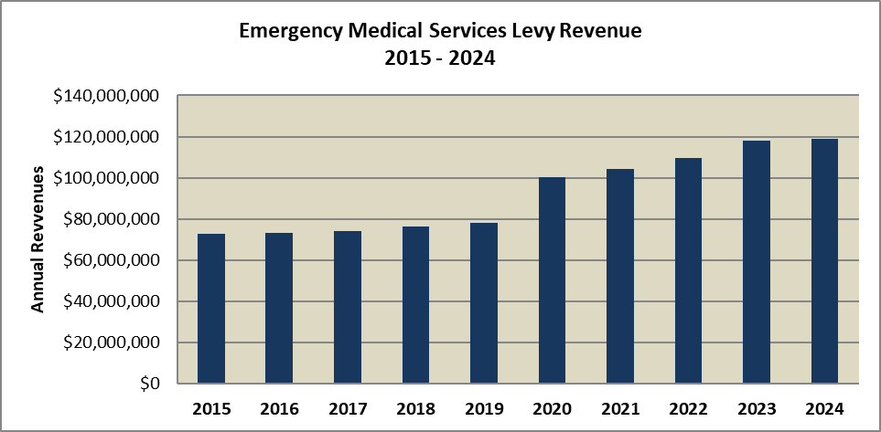



Data Sources: King County EBS – Accounts 31111, 31112, 31113, 31114, 31119 as of 5-1-25

Totals will be less than the Certified Levy due to the inclusion delinquencies.

The Emergency Medical Services revenues have increased each year. The EMS levy is an ongoing 6-year lid lift that has been approved by voters several times in recent history. The levy was passed in 2002, with an initial levy of $0.25 cents per $1000 of assessed value, again in 2008 at $0.30 cents. $0.33 cents in 2014, $0.265 cents in 2020, and will be on the ballot for renewal again in 2025 at a rate of $0.25/$1000 AV.

In 2014, a new levy rate of $0.335/$1000 assessed value was implemented, replacing the previous levy which was limited to $0.30/$1000. The levy ran through 2019. A new levy passed in 2019 set the initial rate at $0.265/$1000 assessed value. The table below indicates past and current levy rates:



As can be noted, the levy rate declined in years 2015 through 2019. The new levy rate of $0.26500 began in 2020 and declined to a low of $0.20922 in 2023. The levy rate increased in 2024 due to a drop in AV before declining a little to $0.22146 in 2025.

# Property Taxes – Conservation Futures Levy

|  |  |  |
| --- | --- | --- |
| **Revenue Description** |  | Ad valorem tax based upon the assessment of the taxable value of property in King County for the purpose of acquiring futures and other rights and interests in real property and for maintaining and operating any property acquired with these funds. |
|  |  |  | |
| **Legal Authorization for Collection:** |  | Revised Code of Washington; RCW 84.34.230, RCW 84.34.210, RCW 84.34.220 | |
|  |  |  | |
| **Fund:** |  | 000003151 | |
| **Account Numbers:** |  | 31117 (Conservation Future Levy – Current), 31119 (Ad Valorem Tax Refunds) | |
|  |  |  | |
| **Source:** |  | King County property owners | |
| **Use:** |  | Purchasing open space and development rights | |
|  |  |  | |
| **Fee Schedule/Rate:** |  | $0.06248 per thousand dollars AV [2025 Levy Rate] | |
| **Method of Payment:** |  | Property owner pays King County Treasurer online or by personal or business check. | |
| **Frequency of Collection:** |  | First half taxes are due April 30. Second half taxes are due Oct. 31. (RCW 84.56.020). | |
| **Exemptions:** |  | Numerous exemptions exist based on type, ownership, use, or status of property. See <http://www.kingcounty.gov/sites/Assessor/TaxpayerAssistance/TaxRelief.aspx> | |
| **Enacted / Expiration:** |  | Tax assessed annually by King County Department of Assessments.  1983 / No expiration | |
| **Revenue Collector:** |  | King County Treasurer | |
| **Distribution:**  **Limit Factor:**  **Restrictions:**  **Budgeting:**  **Forecast:** |  | King County Treasurer  1.01 (1% increase)  The Conservation Futures levy may not exceed $0.0625/$1000 AV and the levy together with other components of the countywide and other property tax levies must not exceed the 1% state constitutional limit.  Budgeted outside EBS.  Provided by the King County Office of Economic and Financial Analysis (OEFA). | |
|  |  |  | |

**Fiscal History**

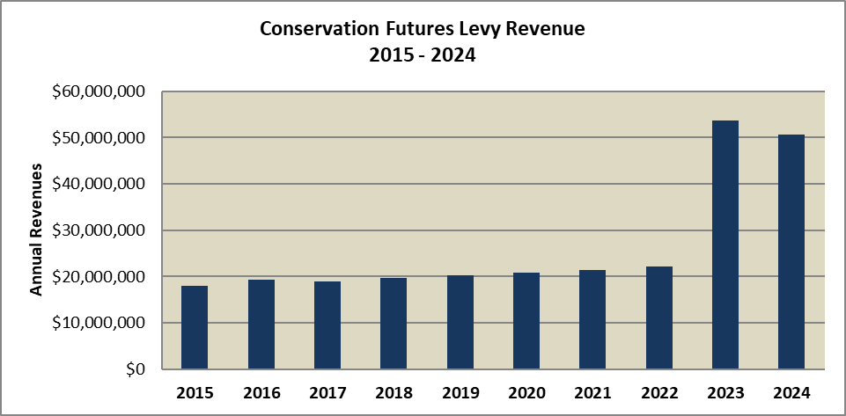



Data Sources: King County EBS – Accounts 31117 and 31119; Funds 3151, 8400, and 8401 as of 5-1-25

The Conservation Futures levy has been collected since 1982. Revenues in recent years remained somewhat stable, with levy amounts between $16 million and $22 million per year through 2022. In 2022, voters approved a doubling of the levy through a lid lift, resulting in a 142.8% increase in revenues in 2023, to $53.6 million. Revenues decline 5.7% in 2024 due to decreases in assessed value as the levy rate was at its statutory maximum.

The Conservation Futures levy rate decreased each year before passage of the levy lid lift, restoring the original $0.06250/$1000 AV rate. The table below indicates past and current levy rates:



As can be noted, the levy rate decreased from $0.04445/$1,000 AV in 2016 to $0.03117 in 2022 before the new levy rate passed. Note, that since this is a new levy rate in 2023 and assessed values went down in 2024, the levy rate of $0.06250/$1,000 AV rate remained at that level through 2024 before declining to $0.06248 in 2025.

# Property Taxes – UAL/Roads Levy

|  |  |  |
| --- | --- | --- |
| **Revenue Description** |  | Ad valorem tax based upon the assessment of the taxable value of property in unincorporated King County for the purpose of establishing, laying out, constructing, altering, repairing, improving and maintaining county roads, bridges and wharves in unincorporated King County. |
|  |  |  | |
| **Legal Authorization for Collection:** |  | The county legislative authority may levy an ad valorem property tax for the purpose of building or maintaining county transportation systems (RCW 36.82.040, RCW 84.52.043, RCW 84.52.052) | |
|  |  |  | |
| **Fund:** |  | 000001030 | |
| **Account Numbers:** |  | 31111 (Real Property), 31112 (Personal Property), 31113 (Real Property – Delinquent), 31114 (Personal Property – Delinquent), 31119 (Ad Valorem Refunds) | |
|  |  |  | |
| **Source:** |  | Property owners in Unincorporated King County | |
| **Use:** |  | Building or maintaining roads, bridges and wharves in Unincorporated King County | |
|  |  |  | |
| **Fee Schedule/Rate:** |  | $1.30780 per thousand dollars AV [2025 Levy Rate] | |
| **Method of Payment:** |  | Property owner pays King County Treasurer online or by personal or business check. | |
| **Frequency of Collection:** |  | First half taxes are due April 30. Second half taxes are due Oct. 31. (RCW 84.56.020). | |
| **Exemptions:** |  | Numerous exemptions exist based on type, ownership, use, or status of property. See <http://www.kingcounty.gov/sites/Assessor/TaxpayerAssistance/TaxRelief.aspx> | |
| **Enacted / Expiration:** |  | Tax assessed annually by King County Department of Assessments.  1937 / No expiration | |
| **Revenue Collector:** |  | King County Treasurer | |
| **Distribution:**  **Limit Factor:**  **Restrictions:**  **Budgeting:**  **Forecast:** |  | King County Treasurer  1.01 (1% increase)  The UAL/Roads levy rate may not exceed $2.25/$1,000 of assessed value and together with other components of the countywide and other property tax levies may not exceed the $5.90/$1000 AV limit for local property taxes and the 1% state constitutional limit.  Total amount is budgeted in account 31111 (all other accounts set to 0).  Provided by the King County Office of Economic and Financial Analysis (OEFA). | |

**Fiscal History**

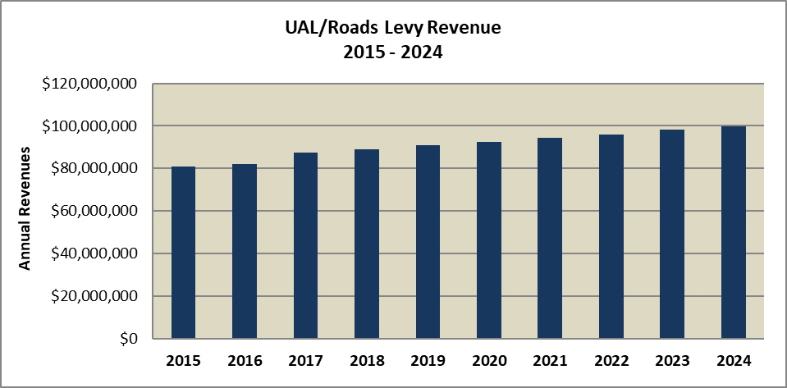



Data Sources: King County EBS – Accounts 31111, 31112, 31113, 31114, 31119 as of 5-1-25

Totals will be less than the Certified Levy due to the inclusion delinquencies.

The UA/Roads levy is imposed in the unincorporated areas of King County. Due to dropping residential property values and large annexations, UA/Road’s revenues decreased substantially from 2012 and 2013, with 2013 being the low point in revenue. During this period the Roads levy rate reached its maximum rate of $2.25/$1000, which meant levy collections were directly impacted by changes to the area’s assessed value. The last major annexation was in 2016 (Klahanie) which had a negative fiscal impact on Roads levy revenues as the levy was still capped at its maximum rate of $2.25. Since then, strong growth in the unincorporated area property values has led to lower levy rates, and steady growth in Roads levy revenues. In 2025 the roads levy generated $99.8 million.

The table below indicates the levy rates:



As can be noted, the levy rate has decreased from the $2.25/$1,000 AV maximum in 2016 to a low of $1.24031 in 2023 and increasing 15% to $1.43195 in 2024 before declining in 2025 to $1.3078.

# Property Taxes – Flood District Levy

|  |  |  |
| --- | --- | --- |
| **Revenue Description** |  | Ad valorem tax based upon the assessment of the taxable value of property in King County for the purpose of helping to control flooding. |
|  |  |  | |
| **Legal Authorization for Collection:** |  | Revised Code of Washington; RCW 86.12.010 | |
|  |  |  | |
| **Fund:** |  | 000001561/000003571 | |
| **Account Numbers:** |  | 33833 (Inter-Governmental Payments) | |
|  |  |  | |
| **Source:** |  | King County property owners | |
| **Use:** |  | Operate and maintain flood control projects | |
|  |  |  | |
| **Fee Schedule/Rate:** |  | $0.09757 per thousand dollars AV [2025 Levy Rate] | |
| **Method of Payment:** |  | Property owner pays King County Treasurer online or by personal or business check. | |
| **Frequency of Collection:** |  | First half taxes are due April 30. Second half taxes are due Oct. 31. (RCW 84.56.020). | |
| **Exemptions:** |  | Numerous exemptions exist based on type, ownership, use, or status of property. See <http://www.kingcounty.gov/sites/Assessor/TaxpayerAssistance/TaxRelief.aspx> | |
| **Enacted / Expiration:** |  | Tax assessed annually by King County Department of Assessments.  2008 / No expiration | |
| **Revenue Collector:** |  | King County Treasurer | |
| **Distribution:**  **Limit Factor:**  **Restrictions:**  **Budgeting:**  **Forecast:** |  | King County Treasurer  1.01 (1% increase)  The Flood District levy alone may not exceed $0.50/$1000 AV. The levy together with other components of the countywide and other property tax levies may not exceed the $5.90/$1000 AV limit for local property taxes and the 1% state constitutional limit.  Total amount goes to the King County Flood District and is budgeted as part of 33833 Flood Control Reimbursement in fund 000001561.  Provided by the King County Office of Economic and Financial Analysis (OEFA). | |
|  |  |  | |

**Fiscal History**

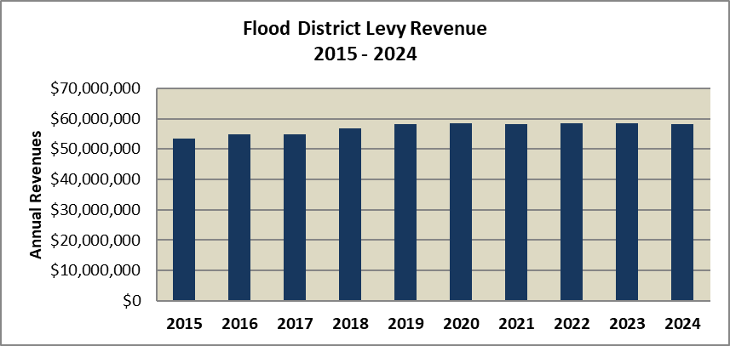



Data Sources: King County EBS – Accounts 17212 and 17214 as of 6-12-25

Flood district revenues increased substantially between 2012 and 2014, with increasing levy rates offsetting lower assessed values. Revenues for 2014 amounted to approximately $51.9 million, an increase of 25.86% over 2013. Since then, revenues have increased in most years, with a slight decline in 2021 and 2024, but remaining around $58 million per year.

Levy rates for the Flood District steadily decreased year over year from 2016 through 2023 in response to increased County assessed value. The rate increased slightly in 2024 to offset a decline in assessed value. In 2025, the levy rate increased back up to $0.09757 as the Flood District was projecting a revenue shortfall as it begins a 6-year Capital Improvement Plan. The table below indicates past and current Flood District levy rates:



# Property Taxes – Marine Levy

|  |  |  |
| --- | --- | --- |
| **Revenue Description** |  | Ad valorem tax based upon the assessment of the taxable value of property in King County for the purpose of providing passenger only ferry service |
|  |  |  | |
| **Legal Authorization for Collection:** |  | Revised Code of Washington; RCW 36.54.130 | |
|  |  |  | |
| **Fund:** |  | 000004591 | |
| **Account Numbers:** |  | 31111 (Real Property), 31112 (Personal Property), 31113 (Real Property – Delinquent), 31114 (Personal Property – Delinquent), 31119 (Ad Valorem Refunds) | |
|  |  |  | |
| **Source:** |  | King County property owners | |
| **Use:** |  | Passenger-only ferry service | |
|  |  |  | |
| **Fee Schedule/Rate:** |  | $0.00828 per thousand dollars AV [2025 Levy Rate] | |
| **Method of Payment:** |  | Property owner pays King County Treasurer online or by personal or business check. | |
| **Frequency of Collection:** |  | First half taxes are due April 30. Second half taxes are due Oct. 31. (RCW 84.56.020). | |
| **Exemptions:** |  | Numerous exemptions exist based on type, ownership, use, or status of property. See <http://www.kingcounty.gov/sites/Assessor/TaxpayerAssistance/TaxRelief.aspx> | |
| **Enacted / Expiration:** |  | Tax assessed annually by King County Department of Assessments.  2008 / No expiration | |
| **Revenue Collector:** |  | King County Treasurer | |
| **Distribution:**  **Restrictions:**  **Budgeting:**  **Forecast:** |  | King County Treasurer  The Marine levy may not exceed $0.075/$1000 AV. The levy together with other components of the countywide and other property tax levies may not exceed the 1% state constitutional limit.  Total amount is budgeted in account 31111.  Provided by the King County Office of Economic and Financial Analysis (OEFA). | |
|  |  |  | |

**Fiscal History**

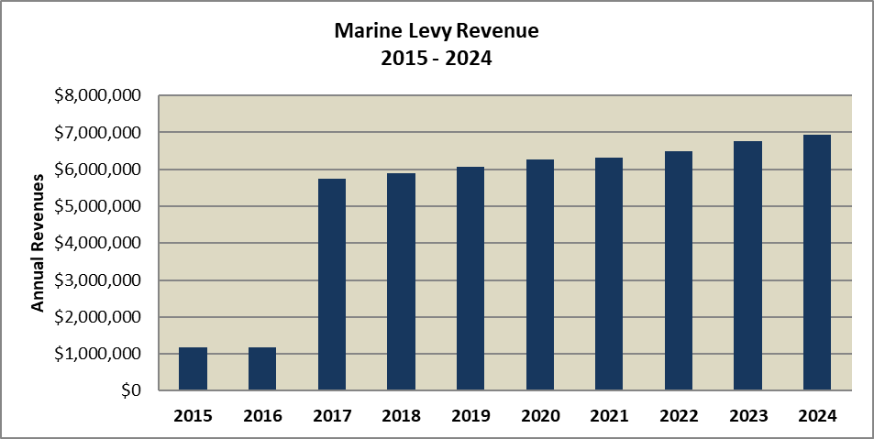



Data Sources: King County EBS – Accounts 31111, 31112, 31113, 31114, and 31119 as of 5-1-25

Totals will be less than the Certified Levy due to the inclusion delinquencies.

Marine levy revenues decreased drastically in 2010 when most of the revenues were reallocated to transit. From 2010 through 2016, revenue amounts were rather stable. In 2017, the Marine levy rate was substantially increased, with the Transit levy being decreased proportionally to offset the increase. Revenues in 2017 were nearly four times higher than in 2016, with a total of $5.7 million collected. In 2024, this amount was up to $6.9 million.

Prior to the rate cut and reallocation in 2010, the Marine levy rate was approximately $0.05/$1000 AV. The levy reallocation caused the Marine levy rate to drop by over 90%. In 2017, the levy rate increased. The table below indicates past and current Marine levy rates:



As can be noted, the levy rates decreased to a low of $0.00279 in 2016. The new rate for 2017 jumped to $0.01229 before decreasing in 2018-2023, with a slight increase in 2024 due to lower assessed values and 2025 was slightly lower at $0.00828.

# Property Taxes – Transit Levy

|  |  |  |
| --- | --- | --- |
| **Revenue Description** |  | Ad valorem tax based upon the assessment of the taxable value of property in King County for the purpose of expanding transit on State Route 520 and other transit-related purposes |
|  |  |  | |
| **Legal Authorization for Collection:** |  | Revised Code of Washington RCW 84.52, RCW 39.67.020 | |
|  |  |  | |
| **Fund:** |  | 000004641 | |
| **Account Numbers:** |  | 31111 (Real Property) 31112 (Personal Property) 31113 (Real Property – Delinquent) 31114 (Personal Property – Delinquent) 31119 (Ad Valorem Refunds) | |
|  |  |  | |
| **Source:** |  | King County property owners | |
| **Use:** |  | Expansion of transit along State Route 520 and other transit-related purposes | |
|  |  |  | |
| **Fee Schedule/Rate:** |  | $0.03939 per thousand dollars AV [2025 Levy Rate] | |
| **Method of Payment:** |  | Property owner pays King County Treasurer online or by personal or business check. | |
| **Frequency of Collection:** |  | First half taxes are due April 30. Second half taxes are due Oct. 31. (RCW 84.56.020). | |
| **Exemptions:** |  | Numerous exemptions exist based on type, ownership, use, or status of property. See <http://www.kingcounty.gov/sites/Assessor/TaxpayerAssistance/TaxRelief.aspx> | |
| **Enacted / Expiration:** |  | Tax assessed annually by King County Department of Assessments.  2010 / No expiration | |
| **Revenue Collector:** |  | King County Treasurer | |
| **Distribution:**  **Limit Factor:**  **Restrictions:**  **Budgeting:**  **Forecast:** |  | King County Treasurer  1.01 (1% increase)  The Transit levy alone may not exceed $0.075/$1000 AV and together with other components of the countywide property tax levy may not exceed the 1% state constitutional limit.  Total amount is budgeted in account 31111 (all other accounts set at 0).  Provided by the King County Office of Economic and Financial Analysis (OEFA). | |
|  |  |  | |

**Fiscal History**

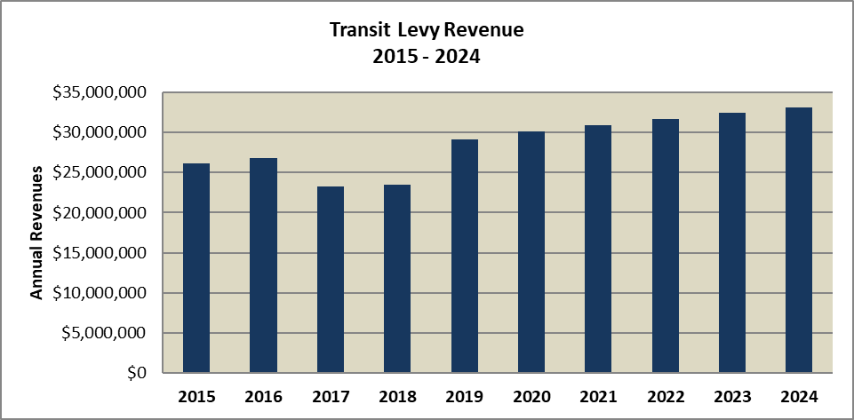



Data Sources: King County EBS – Accounts 31111, 31112, 31113, 31114, 31119 as of 5-1-25

Totals will be less than the Certified Levy due to the inclusion delinquencies.

The transit levy was introduced in 2010 through the reallocation of transportation levy dollars from ferries to transit. Initially, $0.065 of the marine levy was reallocated to transit, with $.01 dedicated to improving transit across State Route 520 and the remainder allocated to other transit-related purposes. Transit revenues collected through the property tax levy increased from 2010 to 2012 but then dipped slightly in 2013 as the levy hit the statutory maximum levy rate. Revenues increased in years 2014 through 2016 in line with improving property valuations. In 2017, the reallocation of some of the marine levy funds was reversed, resulting in a 13% decrease in revenues. In 2019, Metro undertook a sizable route expansion and increased its levy rate and collections to fund the growth. By 2024, the levy revenue was $33.1 million.

While the initial levy rate was set at $0.065/$1000 assessed value in 2010, the rate increased in both 2011 and 2012 because of declining property values and reached a peak rate of $0.075/$1000 in 2012 and remained there until 2014. Strengthening property values allowed for a reduction in the levy rate for 2015 and a further reduction in 2016. In 2017, a portion of Transit levy revenue was reallocated back to the Marine levy. The table below indicates past and current levy rates:

As can be noted, the levy rate decreased each year from 2019 through 2023 before increasing in 2024 due to falling assessed value and the rate decreased again in 2025 to $0.03939.

# Property Taxes – UTGO Bond Levy

|  |  |  |
| --- | --- | --- |
| **Revenue Description** |  | Ad valorem tax based upon the assessment of the taxable value of property in King County for the purpose of financing capital improvements through the issuance of Unlimited Tax General Obligation Bonds. |
|  |  |  | |
| **Legal Authorization for Collection:** |  | Local governments are authorized to issue UTGO Bonds pursuant to Article  7, Section 2(b) of the Washington Constitution and laws of the state of Washington (including, but not limited to, chapters 39.36, 39.46 and 84.52 RCW). | |
|  |  |  | |
| **Fund:** |  | 000008500 | |
| **Account Numbers:** |  | 31111 (Real Property), 31112 (Personal Property), 31113 (Real Property – Delinquent), 31114 (Personal Property – Delinquent), 31119 (Ad Valorem Refunds) | |
|  |  |  | |
| **Source:** |  | King County property owners | |
| **Use:** |  | Financing capital improvements | |
|  |  |  | |
| **Fee Schedule/Rate:** |  | $0.02204 per thousand dollars AV [2025 Levy Rate] | |
| **Method of Payment:** |  | Property owner pays King County Treasurer online or by personal or business check. | |
| **Frequency of Collection:** |  | First half taxes are due April 30. Second half taxes are due Oct. 31. (RCW 84.56.020). | |
| **Exemptions:** |  | Numerous exemptions exist based on type, ownership, use, or status of property. See <http://www.kingcounty.gov/sites/Assessor/TaxpayerAssistance/TaxRelief.aspx> | |
| **Enacted / Expiration:** |  | Tax assessed annually by King County Department of Assessments.  1895 /No expiration | |
| **Revenue Collector:** |  | King County Treasurer | |
| **Distribution:**  **Restrictions:**  **Limit Factor:**  **Budgeting:**  **Forecast:** |  | King County Treasurer  Voter approval is required to issue the debt supported by the UTGO Bond levy, but the annual levy is otherwise unlimited.  The levy is not limit factor limited.  Total amount is budgeted in account 31111 (all other accounts set at 0).  Provided by the King County Office of Economic and Financial Analysis (OEFA). | |
|  |  |  | |

**Fiscal History**

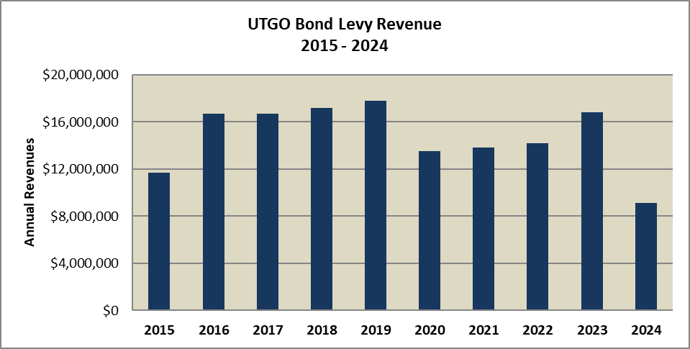



Data Sources: King County EBS – Accounts 31111, 31112, 31113, 31114, 31119 as of 5-1-25

Totals will be less than the Certified Levy due to the inclusion delinquencies.

UTGO bond levy revenue changes each year based on required debt service payments in any given year. It declined sharply in 2010 to reflect a reduction in the County’s debt service obligation achieved mostly due to the maturing of outstanding bonds and has generally declined since. An additional refinancing in 2020 allowed for a reduction in the UTGO bond levy rate and associated revenue to $13.5 million but since then the bond revenue has been growing more than 2% in 2021 and 2022. Then in 2023, the bond revenue was increased by 18.9% before declining substantially in 2024 to $9.1 million.

The levy rate has also fallen in most years. The table below indicates the past and current levy rates:



As can be noted, the levy rate has decreased from $0.03981/$1,000 AV in 2016 to $0.02204 in 2025.

# County Hospital Property Tax

|  |  |  |
| --- | --- | --- |
| **Revenue Description** |  | The County is authorized to have an additional property tax for the maintenance, operation and capital expenses of a hospital and to pay the principal and interest on bonds for these purposes. |
|  |  |  |
| **Legal Authorization for Collection:** |  | RCW 36.62.010, 36.62.090, 84.52.043 |
|  |  |  |
| **Fund:** |  | 000001700 |
| **Account Number(s):** |  | 31111 (Real Property), 31112 (Personal Property), 31113 (Real Property – Delinquent), 31114 (Personal Property – Delinquent), 31119 (Ad Valorem Refunds) |
|  |  |  |
| **Source:** |  | King county property owners |
| **Use:** |  | Financing maintenance, operations and capital expenses of a hospital. |
|  |  |  |
| **Fee Schedule:** |  | $0.10 per thousand dollars AV [2025 Levy Rate] |
| **Method of Payment:** |  | Property owner pays King County Treasurer online or by personal or business check. |
| **Frequency of Collection:** |  | First half taxes are due April 30. Second half taxes are due Oct. 31. (RCW 84.56.020). |
| **Exemptions:** |  | Numerous exemptions exist based on type, ownership, use, or status of property. See <http://www.kingcounty.gov/sites/Assessor/TaxpayerAssistance/TaxRelief.aspx> |
| **Enacted / Expiration:** |  | 2025 / No Expiration |
| **Revenue Collector:** |  | King County Treasurer |
| **Distribution:**  **Limit Factor:**  **Restrictions:**  **Budgeting:**  **Forecast:** |  | King County Treasurer  1.01 (1% increase)  The Levy amount may not exceed a rate of $0.20/$1000 AV multiplied by assessed value in 2025 and this levy amount is limited to 1% growth per year in the future, and together with other components of the Countywide property tax levy may not exceed the 1% State constitutional limit  Total amount is budgeted in account 31111 (all other accounts set at 0).  Provided by the King County Office of Economic and Financial Analysis (OEFA). |
|  |  |  |

This additional property tax for a King County hospital was approved in 2024 and began collection in 2025 at a rate of 10 cents per $1,000 assessed value. Additional information on this levy to follow in future editions of this Revenue Manual.

# Section 3 - Sales Tax-Based Revenue Sources

Sales taxes in Washington State are applied on the sales price of tangible personal property and certain services. In general, a taxable retail sale is a sale of tangible personal property but also included are the sale of some services including installing, improving, maintaining, cleaning, altering, constructing, repairing and decorating real and personal property. Other taxable services include amusement and recreational activities, lawn maintenance, physical fitness, lodging for less than 30 days, and telephone service.

During the 2025 legislative session, Engrossed Substitute SB 5814 was passed, and the impacts will be felt greatly in King County. This bill expanded the definition of retail sales and made certain activities subject to the retail sales tax. The change makes the following activities part of the sales tax base beginning October 1, 2025.

- Custom software and customization of prewritten software.

- Custom website design, support, and development services.

- Information technology related training services, technical support, and other services.

- Investigation, security services, security monitoring, armored car services.

- Temporary staffing, excluding temporary staff provided at hospitals.

- In-home advertising services, except for services related to printing, publishing, and

radio and television broadcasting.

- Live Presentations.

Sales taxes are collected by sellers of goods and services and are remitted to the Department of Revenue. Use taxes are paid by the consumer when retail sales tax is not collected by the seller/service provider. Exemptions are provided in law for food, prescription drugs, sales to nonresidents, federal government sales, interstate and foreign sales, certain manufacturers and machinery exemptions, sales to Indian tribes and newspapers.

The sales tax rate varies by jurisdiction based on what sales tax levies are in effect. State law authorizes around 25 different types of local sales and use taxes. In King County, the sales tax rate is generally 10.2% in the urban (RTA) portions of the county and 8.8% in the more rural (non-RTA) sections of King County[5]. The sales and use tax rate within the City of Shoreline was raised to 10.4%, making it the highest sales tax rate in King County. Of this tax, most goes to the state, some to transit agencies and some to local governments. The exact breakdown is shown below.

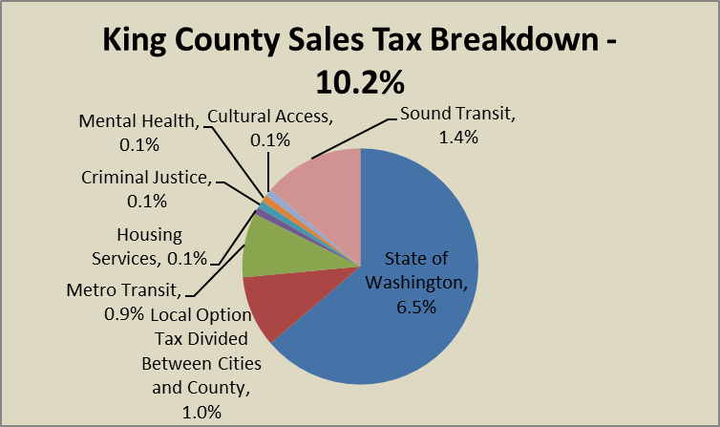

**Figure 4. King County Sales Tax Breakdown, (2025, most RTA areas)**

As can be seen, 6.5% of the 10.2% tax goes to the state, and 1.4% for Sound Transit and 0.9% for Metro Transit.[6] A 1% local option tax is imposed on taxable sales that is remitted to local government. Of that, King County gets the full 1% for sales in the unincorporated county and 0.15% for sales in the incorporated county. The three remaining taxes are each 0.1% of taxable sales and the revenue is used for mental health, criminal justice, and housing purposes. In April 2024, a sales tax increase of 0.1% to fund cultural access will begin collection. All sales taxes are collected by the state and then distributed to the local taxing district. The Washington Department of Revenue is the implementing agency, and they charge 1% of collected sales tax as an administrative fee.

Currently there are six different sales tax levies that are authorized and imposed in King County:

Basic and Option (1%): Since 1970 Washington state law has allowed counties to levy 0.5% sales and use tax. RCW 82.14.030 now allows counties to levy not only a basic 0.5% sales and use tax rate plus an optional tax at rates ranging from 0.1% to 0.5%. The rate in King County is the full 1% with the county receiving the full 1% on unincorporated county sales and 0.15% on sales within incorporated areas. In general, only a small percentage of sales occur in the unincorporated area and most sales that occur are in incorporated areas of the county. The chart below shows the percentage of unincorporated taxable sales in King and various peer counties for 2024.

**Unincorporated Taxable Sales and Use Taxes**

|  |  |  |
| --- | --- | --- |
| County | **Unincorporated Sales (% of Total)** | **Unincorporated Sales and Use (% of Total)** |
| Kitsap | 46.5% | 46.6% |
| Clark | 28.3% | 28.1% |
| Pierce | 25.8% | 25.6% |
| Snohomish | 23.3% | 22.9% |
| Whatcom | 21.1% | 21.7% |
| Skagit | 19.8% | 21.7% |
| Thurston | 19.3% | 19.1% |
| Yakima | 16.6% | 17.4% |
| Spokane | 17.2% | 16.9% |
| Benton | 8.8% | 10.7% |
| King | 4.7% | 4.2% |

Note: Data from WA DOR for 2024, QBR Table.

As can be seen, only about 4.7% of taxable sales in King County occur in the unincorporated areas and this is a substantially lower percentage than other counties in Washington State.

Criminal Justice: In 1990, Washington state provided counties with authority to request voters for approval of a local 0.1% sales tax for criminal justice funding as specified in RCW 82.14.340. The distributions are shared with the cities with 10% going to the county and the rest apportioned to the county and all cities within the county based on population. This tax has generally been declining for the county over time as population shifts from the unincorporated areas to incorporated areas due to population growth and annexations. The figure below shows the percentage breakdown from 2015-2024.

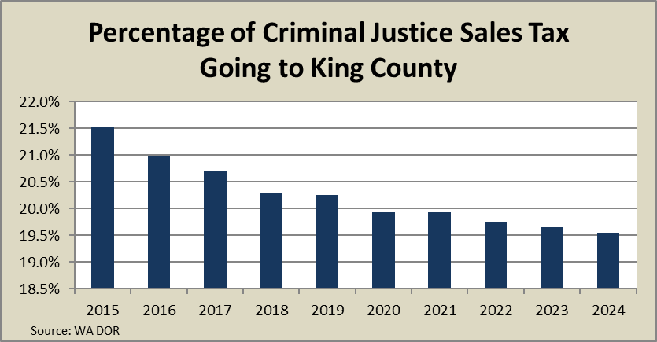

**Figure 5. Percentage of Criminal Justice Sales Tax to King County**

As can be seen, the county’s share has been decreasing over time although it was up a small amount in 2021.

2025 Sales Tax for Criminal Justice – ESSB 2015: A countywide tax of 0.1% was authorized in 2025 for criminal justice funding and will go into effect in October 2025. In July 2025, the King County Council also authorized the 0.1% sales tax for criminal justice. Cities or counties are only eligible to impose this tax if the city or county meets the requirements to receive funding from the Grant program created in ESSB 2015. The moneys from this tax must be used for criminal justice purposes. Criminal justice purposes means activities that substantially assist the criminal justice system, which may include circumstances where ancillary benefit to the civil justice system occurs.

Mental Illness/Drug Dependency: A countywide tax of 0.1% was authorized in 2005 for the funding of programs associated with mental health and drug dependency and went into effect in King County in 2008. This tax is applied countywide with the proceeds devoted to new or expanded county programs for mental health treatment, chemical dependency services and/or therapeutic court services. The MIDD levy was re-authorized in 2016 in King County to extend through 2025. This levy will be re-examined by the Council in fall 2025.

Transit: Since 1971, RCW 82.14.045 authorized the levying of a local sales and use tax to finance local transit systems. The King County rate is 0.9% on all taxable sales, excluding large hotel sales where the rate is 0.6%. This tax is applied countywide and provides a significant amount of funding for metro transit.

Health Through Housing: A countywide tax of 0.1% was authorized in 2021 for the purchase of hotels, motels, and other single room settings for use as emergency and permanent supportive housing for people experiencing chronic homelessness in King County.

Doors Open / Cultural Access Program: A countywide tax of 0.1% was authorized in 2023 for funding equitable access to science, heritage, and the arts in King County. Collection began in April 2024.

DOR distributes the revenue to each jurisdiction monthly with about a two-month lag. Typically, the distribution payments are split out among RTA and non-RTA and taxable sales data among monthly, quarterly and annual filers. Delinquent payments also are provided.



Taxable sales in Washington have been sourced to the destination of the good since 2008. Prior to that, sales were based on the origin of the sale. This change occurred since Washington signed the Streamlined Sales and Use Tax Agreement (SSUTA). This agreement was intended to facilitate sales tax collection from other states, however the change also led to significant changes in revenue distributions for some local jurisdictions. Therefore, the state developed a mitigation program to mitigate for losses experienced by some jurisdictions. King County experienced a significant loss due to this change and therefore the state sent mitigation payments on a quarterly basis for all sales tax levies. The mitigation payments were based on the estimated loss but offset by local sales tax revenue reported to DOR by sellers in other states (“voluntary compliance revenue”) registered through the SSUTA. In 2017, the state legislature enacted Engrossed House Bill 2163 that required out of state sellers meeting certain criteria to begin either collecting and remitting sales and use taxes on all taxable retail sales within the State or to comply with certain sales and use tax notice and reporting provisions.

Local taxes on lodging sales are another type of sales tax that has been received by King County in the past. However, in 2016, RCW 67.28.180 temporarily re-directed this revenue to the State’s stadium and exhibition account through 2020. In 2021, King County began receiving the revenue again. King County receives 2% of all lodging sales within King County except within the City of Bellevue. This tax is credited against the state retail sales tax and so the hotel-motel tax is not an additional tax for consumers. Beginning in 2019, the Convention Center tax was extended to all short-term lodging in King County at a rate of 7% on sales within the City of Seattle and 2.8% in the rest of the county. The tax is levied on lodging premises including vacation rentals and short-term home-shares and the county receives some of the additional revenue.

The following pages provide more specific detail on each sales tax revenue source.

# Local Basic and Option (1%) Sales and Use Tax

|  |  |  |
| --- | --- | --- |
| **Revenue Description** |  | The State authorizes the County to impose a basic 0.5 percent sales and use tax and an optional sales and use tax up to an additional 0.5 percent to obtain revenues for general county purposes. |
|  |  |  |
| **Legal Authorization for Collection:** |  | RCW 82.14.030 |
|  |  |  |
| **Fund:** |  | Prior to 2015, 95.4% of revenues to General Fund (000000010), 4.6% to Children and Family Services (000001421). Beginning in 2015, all revenues go to the GF |
| **Account Number(s):**  **Department** |  | 31310  Finance (GF) and DCHS (C&FS) |
|  |  |  |
| **Source:** |  | Purchasers of goods and some services located within King County |
| **Use:** |  | Unrestricted and may be used for general county purposes. |
|  |  |  |
| **Fee Schedule:** |  | The tax rate for the County’s local and option tax is 1 percent in unincorporated areas and 0.15 percent in incorporated areas. |
| **Method of Payment:** |  | Various |
| **Frequency of Collection:** |  | Paid by purchasers at time of transaction. |
| **Exemptions:** |  | There are numerous sales tax exemptions as described in RCW 82.08 |
| **Enacted / Expiration:** |  | 1970 / No Expiration |
| **Revenue Collector:** |  | Department of Revenue (DOR) |
| **Distribution:**  **Restrictions:**  **Budgeting:**  **Forecast:** |  | If both the County and a city within the County impose the basic tax, the County receives 15 percent of the revenue on taxes from goods purchased within the city. It receives 100 percent of the local tax collected on goods purchased in unincorporated areas of the County.  Tax only applies on applicable goods and services as listed in RCW 82.08 and 82.12  Budgeted in Fund 0010 (and 1421 prior to 2015), Account 31310  Provided by the King County Office of Economic and Financial Analysis (OEFA). |
|  |  |  |

**Fiscal History**

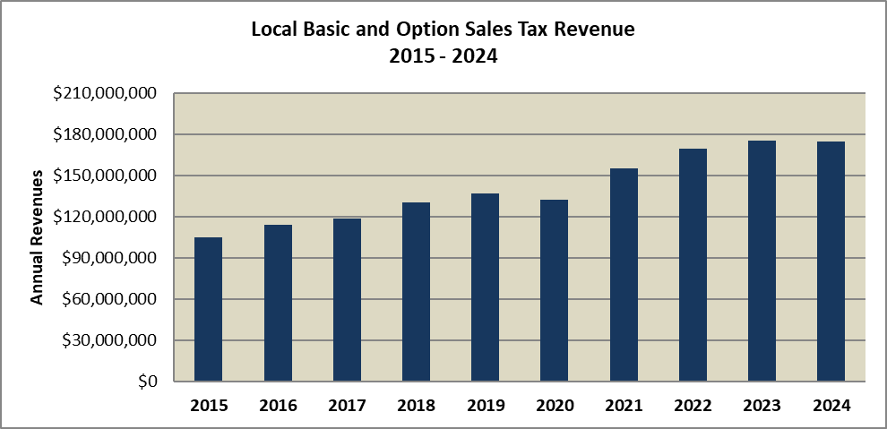



Data Sources: King County EBS – Account 31310 and 33699 as of 5-1-25

Due to the fixed nature of sales taxes being set at 1% of taxable sales, local option sales tax revenue correlates to total taxable sales and is therefore highly sensitive to overall economic conditions, particularly consumer spending. The 2007-2009 Great Recession caused a significant decline in revenues in 2009, but revenues began increasing in 2010 as the economy began to recover. Revenues fell during the COVID-19 pandemic in 2020 before rebounding in 2021 and 2022. 2023 had only moderate sales tax revenue growth of 3% over the prior year. There was a slight decline in 2024 bringing revenues to $174.7 million. The decline in sales tax in 2024 was due to countywide low taxable sales which was an unusual occurrence since King County was not in a recession last year.

# Criminal Justice Sales and Use Tax

|  |  |  |
| --- | --- | --- |
| **Revenue Description** |  | A county-wide 0.1 percent sales tax to be used for criminal justice purposes. |
|  |  |  |
| **Legal Authorization for Collection:** |  | RCW 82.14.340 |
|  |  |  |
| **Fund:** |  | 000000010 |
| **Account Number(s):**  **Department** |  | 31370  Finance |
|  |  |  |
| **Source:** |  | Retail purchases of tangible personal property and certain services and items used in the State that were acquired without being subject to sales taxes |
| **Use:** |  | Criminal justice programs |
|  |  |  |
| **Fee Schedule:** |  | 0.1 percent sales tax |
| **Method of Payment:** |  | Various |
| **Frequency of Collection:** |  | Paid by purchasers at time of transaction. |
| **Exemptions:** |  | There are numerous sales tax exemptions as described in RCW 82.08 |
| **Enacted / Expiration:**  **Special Requirements** |  | 1990 / No Expiration  State revenues from this source are to be used exclusively for criminal justice purposes and cannot replace existing funding. |
| **Revenue Collector:** |  | Washington State Department of Revenue (DOR) |
| **Distribution:**  **Restrictions:**  **Budgeting:**  **Forecast:** |  | Ten percent of the funds collected are distributed to the county, with the remainder allocated to the cities and the county based on population. DOR distributes CJ sales tax revenues monthly with a two-month lag.  The Criminal Justice Sales and Use Tax is limited to 0.1%  Budgeted in Fund 0010, Account 31370  Provided by the King County Office of Economic and Financial Analysis (OEFA). |
|  |  |  |

**Fiscal History**

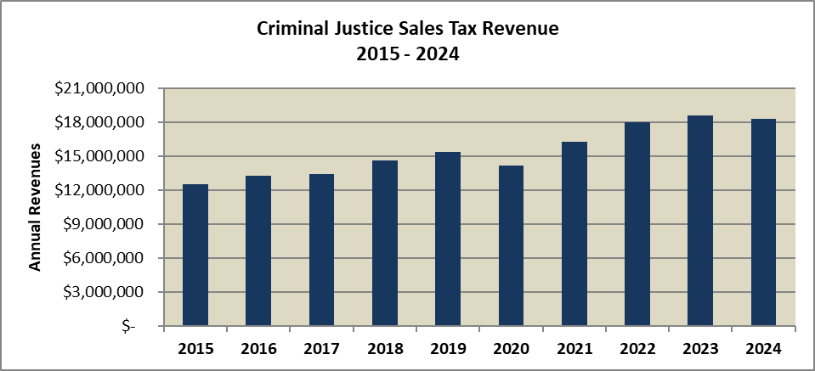



Data Sources: King County EBS – Accounts 31370 and 33699 as of 5-1-25

Criminal justice sales tax revenues have varied from year to year based on the drivers of taxable sales together with the distribution methodology. From 2010 to 2014, revenues increased by an average of 1.4 percent with a notable decrease in 2012. This is partly due to changes in the distribution of population within the county due to annexations. Another notable decrease occurred in 2020 due to an initial reduction in consumer activity in response to the COVID-19 pandemic. In 2024, the County collected $18.3 million in revenues from state distributions of the County’s portion of criminal justice assistance funding, a 1.6% decrease from 2023 and this was due to lower taxable sales countywide last year.

# Mental Illness and Drug Dependency Sales and Use Tax

|  |  |  |
| --- | --- | --- |
| **Revenue Description** |  | In 2005, the state authorized counties to impose a 0.1 percent sales tax increase to fund mental health and chemical dependency services. The law provided for new or expanded chemical dependency, mental health treatment services and therapeutic court programs. |
|  |  |  |
| **Legal Authorization for Collection:** |  | RCW 82.14.460 |
|  |  |  |
| **Fund:** |  | 000001135 |
| **Account Number(s):**  **Department** |  | 31314  Community and Human Services |
|  |  |  |
| **Source:** |  | Sales and use tax at the rate of 0.1 percent on any taxable event within the County. |
| **Use:** |  | Programs and services include treatment services, case management, and housing that are a component of a coordinated chemical dependency or mental health treatment program or service. |
|  |  |  |
| **Fee Schedule:** |  | 0.1 percent sales tax |
| **Method of Payment:** |  | Various |
| **Frequency of Collection:** |  | Paid by purchasers at time of transaction. |
| **Exemptions:** |  | There are numerous sales tax exemptions as described in RCW 82.08 |
| **Enacted / Expiration:**  **Special Requirements:** |  | First authorized in 2005 / re-authorized in 2016 for the 2017-2025 period  All moneys collected must be used solely for the purpose of providing new or expanded programs and services as provided in this section, with exceptions stipulated in 2009 legislation that allow for a percentage of funding to be used to replace existing funds (supplanting) in the amounts of 30 percent, 20 percent, and 10 percent in 2014, 2015, and 2016, respectively. |
| **Revenue Collector:** |  | Department of Revenue (DOR) |
| **Distribution:**  **Restrictions:**  **Budgeting:**  **Forecast:** |  | DOR distributes MIDD sales tax revenues monthly with a two-month lag.  The Mental Illness and Drug Dependency sales tax is limited to 0.1%.  Budgeted in Fund 1135, Acct 31310  Provided by the King County Office of Economic and Financial Analysis (OEFA). |
|  |  |  |

**Fiscal History**

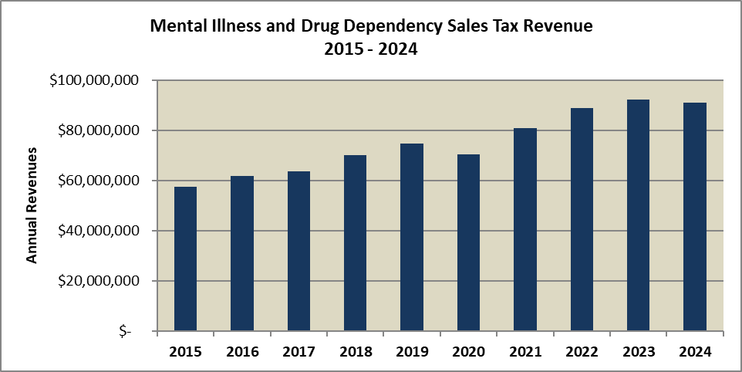

Data Sources: King County ARMS & EBS – Accounts 31310, 31314, 33699 as of 5-1-25

MIDD sales tax revenues have varied from year to year based on the drivers of taxable sales. After a slight decrease in 2010 related to the Great Recession, overall sales tax revenues and thus MIDD revenues began steadily increasing as the economy recovered. Revenues have been growing since due to strong taxable sales growth and only decreased in 2020 due to the COVID-19 pandemic. Since the pandemic, sales tax revenue has been recovering strongly in 2021 and 2022. MIDD sales tax experienced a 3.67% increase in 2023 before a 1.3% decrease in 2024 due to lower taxable sales countywide.

# Transit Sales and Use Tax

|  |  |  |
| --- | --- | --- |
| **Revenue Description** |  | The County levies a county-wide 0.9 percent sales and use tax for public transportation purposes. |
|  |  |  |
| **Legal Authorization for Collection:** |  | RCW 82.14.045 |
|  |  |  |
| **Fund:** |  | 000004641, 000003641, 000004642, 000008430 |
| **Account Number(s):**  **Department** |  | 31310  King County Department of Transportation – Metro Transit Division |
|  |  |  |
| **Source:** |  | Sales and use tax at the rate of 0.9 percent on any taxable event within the County. |
| **Use:** |  | Public transportation purposes, 0.2% restricted to debt service by county policy |
|  |  |  |
| **Fee Schedule:** |  | 0.9 percent sales tax |
| **Method of Payment:** |  | Various |
| **Frequency of Collection:** |  | Paid by purchasers at time of transaction. |
| **Exemptions:** |  | There are numerous sales tax exemptions as described in RCW 82.08  The rate is 0.6% on large lodging establishments. |
| **Enacted / Expiration:**  **Special Requirements:** |  | 1971 / No Expiration  State revenues from this source are to be used exclusively for transportation. |
| **Revenue Collector:** |  | Washington State Department of Revenue (DOR) |
| **Distribution:**  **Restrictions:**  **Budgeting:**  **Forecast:** |  | DOR distributes transportation sales tax revenues monthly with a two-month lag.  The transit sales tax is limited to 0.9%, increased from 0.6% in 2000 to offset the repeal of motor vehicle excise taxes, historically the primary funding source for transit. The rate increased to 0.8% in 2001 and 0.9% in 2007.  Budgeted in Funds 4641, 4642, and 8430; Acct 31310  Provided by the King County Office of Economic and Financial Analysis (OEFA). |
|  |  |  |

**Fiscal History**

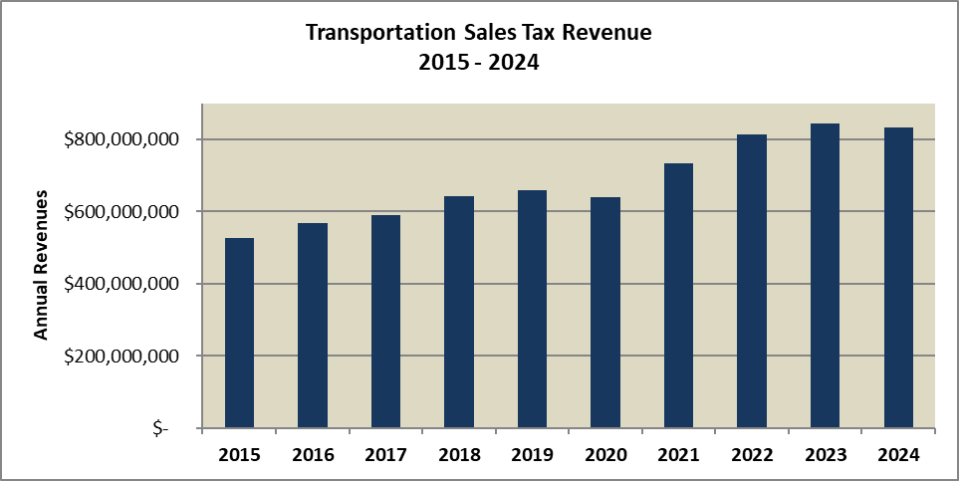



Data Sources: King County EBS – Accounts 31310, 33699 as of 5-1-25

Transit sales and use tax revenues have varied from year to year, fluctuating with overall sales tax collection patterns. Declining sales tax collections during the Great Recession led to decreases in transit revenue in years 2009 and 2010. The economic recovery has resulted in steadily increasing revenues for nearly a decade from 2011 to 2019. The COVID-19 pandemic and its negative impacts on consumer spending resulted in a decrease in sales tax revenues in 2020, before a strong rebound in 2021 and 2022. The sales tax revenue growth was only moderate at 3.8% in 2023 followed by a 1.2% decline in 2024 due to lower taxable sales countywide.

# Health Through Housing Tax

|  |  |  |
| --- | --- | --- |
| **Revenue Description** |  | The County levies a county-wide 0.1 percent sales tax for the purchase of hotels, motels, and other single room settings for use as emergency and permanent supportive housing for people experiencing chronic homelessness in King County. |
|  |  |  |
| **Legal Authorization for Collection:** |  | RCW 82.14.530 |
|  |  |  |
| **Fund:** |  | 000001320 |
| **Account Number(s):**  **Department** |  | 31325  King County Community and Health Services |
|  |  |  |
| **Source:** |  | Sales and use tax at the rate of 0.1 percent on any taxable event within the County. |
| **Use:** |  | Purchase of facilities for use as emergency and supportive housing for people experiencing homelessness |
|  |  |  |
| **Fee Schedule:** |  | 0.1 percent sales tax |
| **Method of Payment:** |  | Various |
| **Frequency of Collection:** |  | Paid by purchasers at time of transaction. |
| **Exemptions:** |  | There are numerous sales tax exemptions as described in RCW 82.08 |
| **Enacted / Expiration:**  **Special Requirements:** |  | 2021 / No Expiration  State revenues from this source are to be used exclusively to help in addressing homelessness. |
| **Revenue Collector:** |  | Washington State Department of Revenue (DOR) |
| **Distribution:**  **Restrictions:**  **Budgeting:**  **Forecast:** |  | DOR distributes transportation sales tax revenues monthly with a two-month lag.  There are numerous restrictions as described in RCW 82.14.530  Budgeted in Funds 1320; Acct 31325  Provided by the King County Office of Economic and Financial Analysis (OEFA). |
|  |  |  |

**Fiscal History**

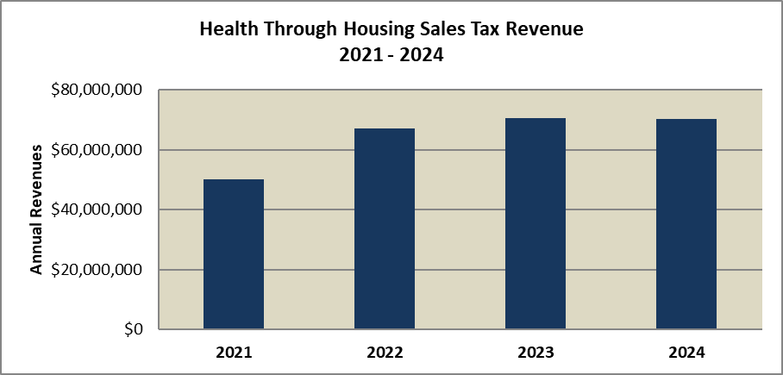



Data Sources: King County ARMS & EBS – Accounts 31310, 33699 as of 5-1-25

The Health Through Housing sales tax began collection in 2021, generating $50.1 million in its first year. Revenues grew each year through 2023 before declining slightly in 2024, to $70.26 million collected. The taxbase for this revenue excludes the cities of Bellevue, Covington, Issaquah, Kent, Maple Valley, North Bend, Renton, and Snoqualmie.

# Doors Open / Cultural Access Program Tax

|  |  |  |
| --- | --- | --- |
| **Revenue Description** |  | The County levies a county-wide 0.1 percent sales tax for the funding of access to science, heritage, and the arts in King County. |
|  |  |  |
| **Legal Authorization for Collection:** |  | RCW 82.14.525, King County Ordinance 19710 |
|  |  |  |
| **Fund:** |  | 000001160 |
| **Account Number(s):**  **Department** |  | 31326  King County Community and Health Services |
|  |  |  |
| **Source:** |  | Sales and use tax at the rate of 0.1 percent on any taxable event within the County. |
| **Use:** |  | To fund equitable access, support programming in public schools, and increase tourism and revenue, and feed the workforce pipeline to the arts and culture sector. |
|  |  |  |
| **Fee Schedule:** |  | 0.1 percent sales tax |
| **Method of Payment:** |  | Various |
| **Frequency of Collection:** |  | Paid by purchasers at time of transaction. |
| **Exemptions:** |  | There are numerous sales tax exemptions as described in RCW 82.08 |
| **Enacted / Expiration:**  **Special Requirements:** |  | 2023 / Expiration 2031  State revenues from this source are to be used exclusively to provide equitable access to cultural organizations. |
| **Revenue Collector:** |  | Washington State Department of Revenue (DOR) |
| **Distribution:**  **Restrictions:**  **Budgeting:**  **Forecast:** |  | DOR distributes transportation sales tax revenues monthly with a two-month lag.  There are numerous restrictions as described in RCW 82.14.525  Budgeted in Funds 1160; Acct 31326  Provided by the King County Office of Economic and Financial Analysis (OEFA). |
|  |  |  |

**Fiscal History**

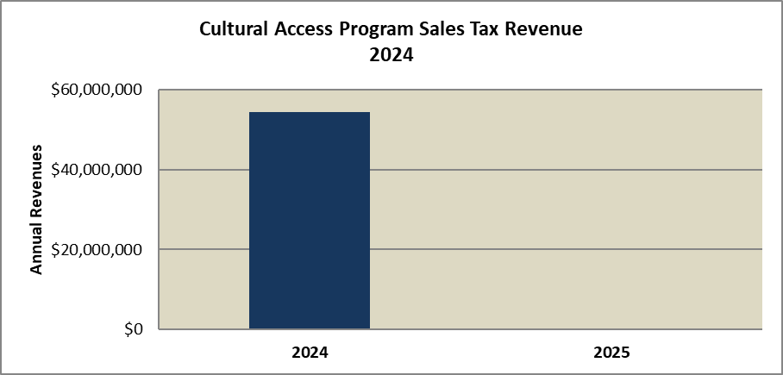



The Doors Open sales tax began collection in April 2024, generating $54.4 million in revenue.

# Hotel/Motel Sales Tax

|  |  |  |
| --- | --- | --- |
| **Revenue Description** |  | An excise tax of two percent on the sale of or charge made for the furnishing of lodging for periods of less than 30 consecutive days. |
|  |  |  |
| **Legal Authorization for Collection:** |  | RCW 67.28.180 |
|  |  |  |
| **Fund:** |  | Funds 000001180 |
| **Account Number(s):**  **Department** |  | Account 31330  Community and Health Services |
|  |  |  |
| **Source:** |  | Sales and use tax at the rate of 2 percent on the amount charged by hotels, motels, rooming houses, private campgrounds, RV parks, and similar facilities for periods of occupancy less than 1 month. |
| **Use:** |  | Funding affordable workforce housing, services for homeless youth, cultural and heritage facilities, and tourism promotion |
|  |  |  |
| **Fee Schedule:** |  | 2.0 percent sales and use tax. Tax is state shared revenue and so does not affect total tax amount to the consumer. |
| **Method of Payment:** |  | Various |
| **Frequency of Collection:** |  | Paid by customers at time of transaction. |
| **Exemptions:** |  | Does not apply to sales of temporary medical housing (RCW 82.08.997) or emergency lodging provided for homeless persons for periods less than 30 days. |
| **Enacted / Expiration:**  **Special Requirements:** |  | 1967 / No Expiration  Revenues are restricted in use. Please see RCW 67.28.1815 and 67.28.080 |
| **Revenue Collector:** |  | Department of Revenue (DOR) |
| **Distribution:**  **Restrictions:**  **Budgeting:**  **Forecast:** |  | DOR distributes hotel/motel tax revenues monthly with a two-month lag.  The Hotel/Motel Tax alone is limited to 2% and together with all other taxes imposed on lodging may not exceed 12% except within the City of Seattle.  Budgeted in Fund 1180, Account 31330  Provided by the King County Office of Economic and Financial Analysis (OEFA). |
|  |  |  |

**Fiscal History**

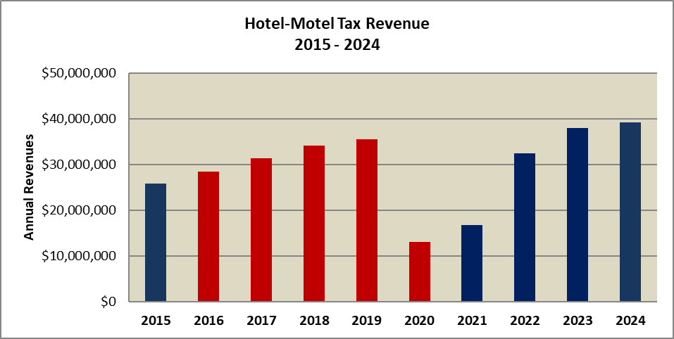



Data Sources: King County EBS – Account 31330 2014-2015 and 2020-2023; WA DOR 2016-2019

* Red bars indicate years in which revenue remained with WA state

This excise tax is more volatile as its base for the tax is just the purchases on lodging, campgrounds, RV parks and campgrounds in King County. This revenue is dependent on tourists to Washington state. Tourism suffered steep declines during the 2007-2009 Great Recession, which was reflected in an over 18% decrease in Hotel/Motel revenues in 2009. As the economy recovered, tourism activity improved, leading to annual increases in revenues until 2013. In 2013, the county was no longer allowed to collect the tax within the City of Bellevue resulting in a revenue decline. However, total Hotel/Motel tax revenues recovered in 2014 amounting to $23.2 million, an 11.8% increase from the previous year before decreasing slightly in 2015. From 2016 through 2020, hotel tax revenues began being deposited in the State’s stadium and exhibition center account. King County began to receive the revenue again in 2021 and 2022, as economic activity in the hospitality sector rebounded from the COVID-19 pandemic. Revenue has increased each year since 2020 and are at $39.3 million in 2025.

# Extended Lodging Tax

|  |  |  |
| --- | --- | --- |
| **Revenue Description** |  | A sales and use tax levied on lodging premises with fewer than 60 units including vacation rentals and short-term home-shares to fund the Washington State Convention and Trade Center and affordable housing programs. |
|  |  |  |
| **Legal Authorization for Collection:** |  | HB 2015 (2017-2018 Session), modifying RCW 36.100.040, RCW 82.08, RCW 67.28 |
|  |  |  |
| **Fund:** |  | 000002460 |
| **Account Number(s):**  **Department** |  | 33607  Community and Health Services |
|  |  |  |
| **Source:** |  | Sales and use tax at the rate of 7 percent within the City of Seattle and 2.8% outside the city on the amount charged by lodging facilities with fewer than 60 units. Payment to King County/PFD does not include home-shares in Seattle. |
| **Use:** |  | To fund the Washington State Convention and Trade Center and affordable housing programs in Seattle and King County. |
|  |  |  |
| **Fee Schedule:** |  | 7.0 percent in the City of Seattle and 2.8 percent outside the city (except Skykomish). |
| **Method of Payment:** |  | Various |
| **Frequency of Collection:** |  | Paid by customers at time of transaction. |
| **Exemptions:** |  | Does not apply to sales of temporary medical housing (RCW 82.08.997) or emergency lodging provided for homeless persons for periods less than 30 days. |
| **Enacted / Expiration:**  **Special Requirements:** |  | 2018 / No Expiration  Revenues are restricted in use. Please see RCW 36.100.040, RCW 67.28.1815 and 67.28.080 |
| **Revenue Collector:** |  | Department of Revenue (DOR) |
| **Distribution:**  **Restrictions:**  **Budgeting:**  **Forecast:** |  | DOR distributes hotel/motel tax revenues monthly with a two-month lag to the PFD. They distribute quarterly to the County.  The Hotel/Motel Tax together with all other taxes imposed on lodging may not exceed 15.6% within the City of Seattle and maximum lodging rates in other jurisdictions consistent with lodging with 60 or more units.  Budgeted in fund 2460, account 33607.  Provided by the King County Office of Economic and Financial Analysis (OEFA). |
|  |  |  |

**Fiscal History**

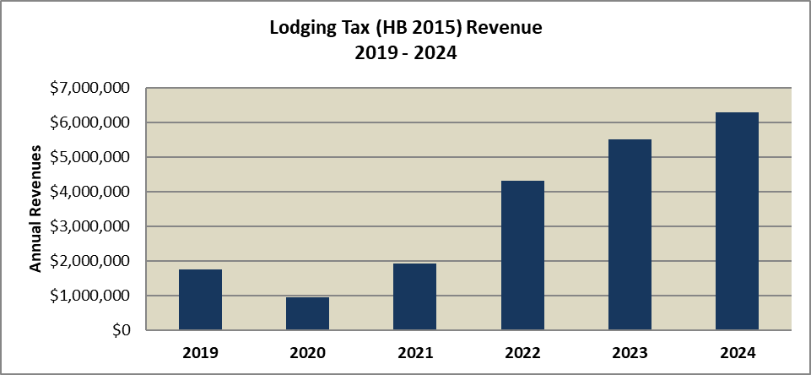



Data Source: Seattle Convention Center Public Facilities District (SCC)

Revenue collection on the Extended Lodging tax began in 2019. The COVID-19 pandemic negatively impacted revenues in 2020, but the recovery beginning in 2021 and 2022 resulted in large increases in revenues. Growth has remained strong, with about $6.3 million collected in 2024.

# Cannabis Excise Tax

|  |  |  |
| --- | --- | --- |
| **Revenue Description** |  | An excise tax of two percent on the sale of or charge made for the furnishing of lodging for periods of less than 30 consecutive days. |
|  |  |  |
| **Legal Authorization for Collection:** |  | RCW 69.50.535 |
|  |  |  |
| **Fund:** |  | Fund 0010 |
| **Account Number(s):**  **Department** |  | Account 33605  Community and Health Services |
|  |  |  |
| **Source:** |  | Excise tax at the rate of 37 percent on the selling price of each retail sale of cannabis concentrates, useable cannabis, and cannabis-infused products. |
| **Use:** |  | Funding education, health care, research, and substance abuse prevention |
|  |  |  |
| **Fee Schedule:** |  | 37 percent excise tax, separate and in addition to general state and local sales and use taxes and is not part of the total retail price to which general state and local sales and use taxes apply. |
| **Method of Payment:** |  | Various |
| **Frequency of Collection:** |  | Paid by customers at time of transaction. |
| **Exemptions:** |  | Does not apply to sales of medical cannabis, as of 6/2024 |
| **Enacted / Expiration:**  **Special Requirements:** |  | Approved by voters in 2012 / No Expiration  Revenues are restricted in use. Please see RCW 69.50.535 |
| **Revenue Collector:** |  | Department of Revenue (DOR) |
| **Distribution:**  **Restrictions:**  **Budgeting:**  **Forecast:** |  | Thirty percent of the tax is distributed to counties, cities and towns. The distributions are based both on a jurisdiction’s proportional share of revenues generated within the jurisdiction as well as based on population. DOR distributes cannabis taxes quarterly.  The Cannabis Excise Tax is currently limited at 37 percent.  Budgeted in Fund 0010, Account 33605  Provided by the King County Office of Economic and Financial Analysis (OEFA). |
|  |  |  |

**Fiscal History**

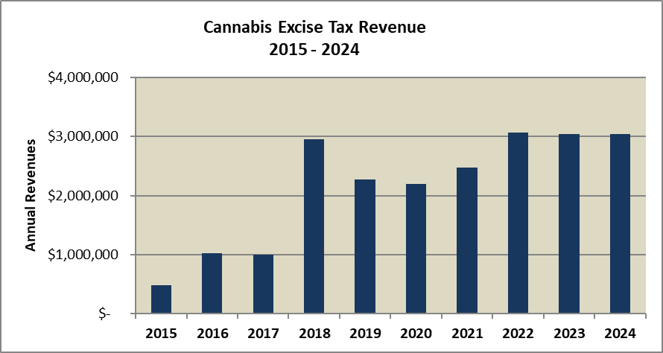



Data Sources: King County EBS

With the legalization of cannabis in 2012, the State of Washington imposed an excise tax on all sales of cannabis products. The WA state LCB levies and collects a 37% excise tax on statewide cannabis sales. 5% of these collections are shared with local jurisdictions based on population size and retail footprint. King County receives approximately 14% of the local share.

The portion of this excise tax which is distributed to King County has seen revenues which rise and fall relative to the sales of cannabis products within King County. In 2015, the statutory burden of the cannabis tax on retail sales shifted from retailers to buyers. This made the tax in addition to the retail sale price, rather than being included in the sale price. The excise tax rate was also increased from 25% to 37% of retail sales. As a result, in 2016 the cannabis tax rate revenue distributed to King County increased 112% to more than $1 million. In 2018, the cannabis excise tax increased year over year by nearly 200% to $2.96 million. Then the revenues to King County fell two years in a row with the COVID pandemic in 2019 and 2020. Since the pandemic, the cannabis tax revenues are now higher than in 2018 with the County portion of the excise tax being around $3 million from 2022 through 2024.

# Section 4 - Other Revenue Sources

The County gets revenues from many other sources besides property and sales taxes. The following are additional revenue sources provided in this manual:

Solid Waste Disposal Fees: The County receives solid waste disposal fees from providing transfer stations, drop boxes and disposal service within the county.

Wastewater Conveyance and Treatment: The County receives wastewater fees for conveying and treating wastewater from many jurisdictions in King County. These fees are used to support the transmission infrastructure along with supporting waste treatment at West Point, Renton, Brightwater and several other locations in King County.

Real Estate Excise Taxes (REET): The County receives excise tax revenue on the sale of real estate in the unincorporated portions of the county. There are two 0.25% taxes (REET 1 and REET 2) which are used for capital projects.

Motor Vehicle Fuel Taxes: These taxes are collected and dispersed from the state for the purpose of road and storm water projects.

E-911: These are line charges on telephone service in King County for the purpose of paying for the emergency response system in King County.

Transit Fares: This is the fare revenue received by transit for transit services.

Rental Car Tax: The County receives revenue from tax levied on rental car transactions.

Gambling Tax: These taxes are levied on gambling activity within the County.

# Solid Waste Disposal Charges

|  |  |  |
| --- | --- | --- |
| **Revenue Description** |  | Fees charged at county transfer facilities and the Cedar Hills Regional Landfill. |
|  |  |  |
| **Legal Authorization for Collection:** |  | RCW 36.58.045; King County Code Title 10 |
|  |  |  |
| **Fund:** |  | 000004040 |
| **Account Number(s):**  **Department:** |  | 34371 (Disposal Charges)  Department of Natural Resources and Parks (Solid Waste) |
|  |  |  |
| **Source:** |  | Commercial companies and self-haulers |
| **Use:** |  | Operations and maintenance of facilities and equipment; education and promotion of waste prevention and recycling; and administrative operating expenses and overhead. |
|  |  |  |
| **Fee Schedule:** |  | Fees vary by hauler type, facility type, waste type, waste quantity and facility type.[7] The basic fee (commercial collection companies and residential and business self-haulers who bring solid waste to the transfer facilities) and the regional direct fee (commercial collection companies hauling to landfill) are both $217.20 per ton. C&D Debris is not being disposed at the King County transfer stations. |
| **Method of Payment:** |  | All service fees collected in cash, check or by credit or debit cards by scale operators at the time of use. |
| **Frequency of Collection:** |  | Time of use or pre-authorized monthly billing |
| **Exemptions:** |  | Provided if engaged in a community litter clean-up campaign (with prior authorization) and in the event of an emergency, as determined by the County executive. |
| **Enacted / Expiration:** |  | 1989 / No Expiration |
| **Revenue Collector:** |  | Charges are collected by the Solid Waste Division, Department of Natural Resources and Parks, and remitted to the King County Treasurer. |
| **Distribution:**  **Restrictions:**  **Budgeting:**  **Forecast:** |  | King County Treasurer  KCC 10.08.040 describes the operation of solid waste facilities.  Total amount is budgeted in account 34371.  Provided by the King County Department of Natural Resources and Parks. |
|  |  |  |

**Fiscal History**

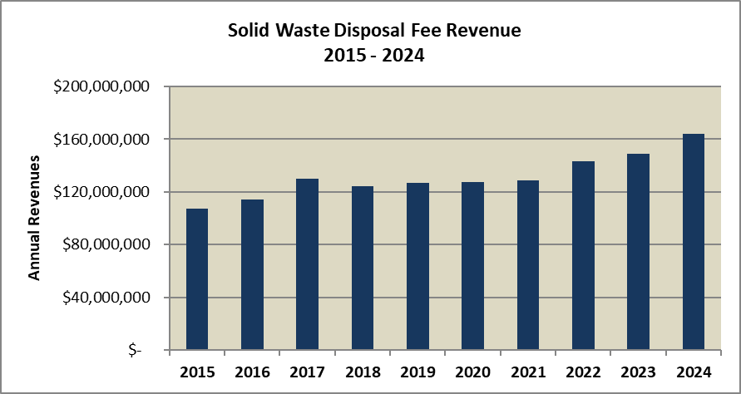



Data Sources: King County EBS – Account 34371 as of 5-1-25

The Solid Waste Division of the Department of Natural Resources and Parks operates eight transfer stations, two rural drop boxes, and the Cedar Hills Regional Landfill serving King County (excluding the cities of Seattle and Milton). Current fees fund operation of the solid waste facilities, support waste prevention and recycling programs, and are used to extend the life of the Cedar Hills Regional Landfill. The division proposes fees using five key inputs: financial, tonnage, revenue, expenditures, and target fund balance. Other factors that affect the division’s determination of user fees include existing and potential inter-local agreements and bond financing. Through 2028, the biggest contributor to solid waste fee increases is expected to be renovations of the urban transfer system.

Solid waste disposal fee revenue fell through 2012 before beginning to increase again in 2013. Revenues peaked in 2017, when the County collected $129.77 million in fees from the disposal of solid waste in King County (excluding Seattle and Milton). Revenues declined slightly in 2018 before increasing again in 2019 through 2024 with revenues hitting $164.1 million last year.

# Wastewater Treatment Revenues

|  |  |  |
| --- | --- | --- |
| **Revenue Description** |  | Under long-term agreements with local sewer agencies in its service area, King County charges each agency a monthly amount for providing wastewater treatment. |
|  |  |  |
| **Legal Authorization for Collection:** |  | RCW 35.58.200; King County Code Chapter 13 |
|  |  |  |
| **Fund:** |  | 000004611 |
| **Account Number(s):**  **Department** |  | 44192 (Sewer Component Agencies Revenue)  Natural Resources and Parks (Wastewater Treatment) |
|  |  |  |
| **Source:** |  | Local sewer agencies in King County |
| **Use:** |  | Wastewater treatment |
|  |  |  |
| **Fee Schedule:** |  | For 2024, $55.11 per month for single-family residences and $55.11 per month for each 750 cubic feet of water used for multifamily, industrial, and commercial customers. |
| **Method of Payment:** |  | Various |
| **Frequency of Collection:** |  | Paid by sewer utility customers monthly. |
| **Exemptions:** |  | While some individual sewer agencies within King County provide discount programs for low-income customers, this does not impact the agencies’ remittances to King County as remittances are based on the number of customers an agency serves. |
| **Enacted / Expiration:** |  | 1957 / No Expiration |
| **Revenue Collector:** |  | Monthly charges are collected by the local sewer agency, then remitted to the King County Treasurer. |
| **Distribution:**  **Restrictions:**  **Budgeting:**  **Forecast:** |  | King County Treasurer  None  Total amount is budgeted in account 44192.  Provided by the King County Wastewater Treatment Division. |
|  |  |  |

**Fiscal History**

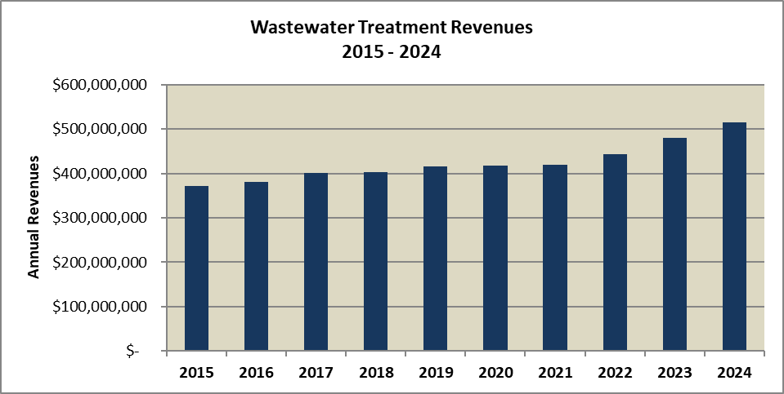



Data Sources: King County EBS – Account 44192 as of 5-1-25

Wastewater treatment revenues have experienced significant increases especially in odd-numbered years, reflecting rate increases imposed in those years, with the only exception being during the pandemic in 2021. The rates and number of customers are listed below.





Revenues have generally been increasing and in 2024, total revenues were approximately $514.6 million with the sewer rates at $55.11. The number of wastewater treatment customers as measured by residential customer equivalents has grown each year, except for 2021 post-pandemic. As of 2024, the number of customers was 778,193 which was above pre-pandemic levels.

# REET 1 Revenues

|  |  |  |
| --- | --- | --- |
| **Revenue Description** |  | The County imposes a real estate excise tax of up to 0.25 percent for the purpose of funding capital projects listed in the capital facilities plan element of the County Growth Management Act plan |
|  |  |  |
| **Legal Authorization for Collection:** |  | RCW 82.46.010 |
|  |  |  |
| **Fund:** |  | 000003681 |
| **Account Number(s):**  **Department:** |  | 31734 (REET 1 Revenue), 31830  Department of Natural Resources and Parks (Parks & Recreation) |
|  |  |  |
| **Source:** |  | Real estate sales within unincorporated King County |
| **Use:** |  | Funding public works capital projects |
|  |  |  |
| **Fee Schedule:** |  | 0.25 percent of the full selling price of real estate purchases within unincorporated King County for REET 1. REET 2 is an identical 0.25% tax. |
| **Method of Payment:** |  | Various |
| **Frequency of Collection:** |  | Paid by purchasers at time of transaction. |
| **Exemptions:** |  | Sales by the County are exempt, but sales to the County are not (RCW 82.45.010) |
| **Enacted / Expiration:** |  | 1982 / No Expiration |
| **Revenue Collector:** |  | King County Treasurer |
| **Distribution:**  **Restrictions:**  **Budgeting:**  **Forecast:** |  | King County Treasurer  The tax rate is limited for each REET 1 and 2 to 0.25 percent  Total amount budgeted outside EBS.  Provided by the King County Office of Economic and Financial Analysis (OEFA). |
|  |  |  |

**Fiscal History**

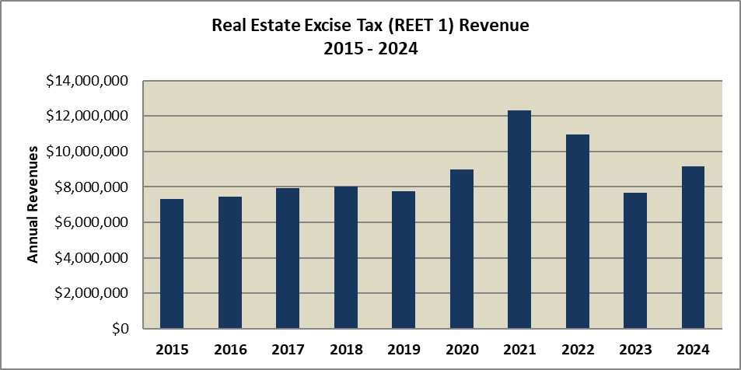



Data Sources: King County EBS – Account 31731 as of 5-1-25

*Includes only REET 1 revenue; REET 2 is also collected in an identical amount

Real estate excise tax revenue is subject to changes in the valuation and sales occurring in the local real estate market in King County. Real Estate Excise tax revenues in 2014 were down from 2013, but 2013 included one very large sale and so revenues were significantly higher than expected. Revenues rebounded significantly 2015 through 2017 and grew slightly in 2018 before declining in 2019. In 2020 and 2021, REET revenues increase significantly on the strength of the local housing market before declining in 2022 and 2023 as the market softened. Housing prices rose the following year helping to raise revenues again in 2024 to $9.2 million.

# Motor Vehicle Fuel Tax

|  |  |  |
| --- | --- | --- |
| **Revenue Description** |  | Excise tax levied on each gallon of motor vehicle fuel sold in the state for transportation purposes; serves as one of the primary sources of road fund revenue for counties. |
|  |  |  |
| **Legal Authorization for Collection:** |  | RCW 82.36 Motor Vehicle Fuel Tax  RCW 46.68.090 (Distribution of statewide fuel taxes)  RCW 46.68.122 (Distribution of amount to counties)  RCW 36.82.020 (County Road fund)  RCW 82.80 (Local option transportation taxes) |
|  |  |  |
| **Fund:** |  | 000001030 |
| **Account Numbers:** |  | 33689 (County Roads State Entitlements) |
|  |  |  |
| **Source:** |  | Sales of motor vehicle and special (diesel) fuel sold in the state and deposited in the state motor vehicle fund and distributed by the state as a shared tax. |
| **Use:** |  | Road purposes with dedicated percentage tied to paths and trails |
|  |  |  |
| **Fee Schedule:** |  | The State levies a tax of 49.4 cents per gallon on motor vehicle and special (diesel) fuel. Funds are collected by the state and distributed to counties monthly based on several allocation factors, including population, road replacement costs and need. A $0.06 increase in the state fuel tax rate will take effect on July 1, 2025. |
| **Method of Payment:** |  | Various |
| **Frequency of Collection:** |  | Time of purchase |
| **Exemptions:** |  | N/A |
| **Enacted / Expiration:** |  | State fuel tax enacted in 1921 / No Expiration |
| **Revenue Collector:** |  | Washington State Department of Licensing |
| **Distributions**  **Restrictions:**  **Budgeting:**  **Forecast:** |  | Distribution from state monthly according to allocation factors including population, road costs, and county need.  Shall be used exclusively for “highway purposes” (defined more narrowly than “transportation purposes”) as defined in RCW 82.80.010  Budgeted in Fund 1030, Account 33689.  Provided by the King County Roads Division. |
|  |  |  |

**Fiscal History**

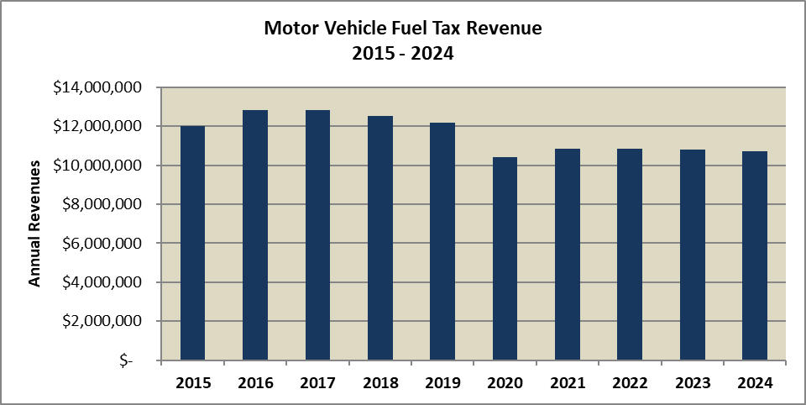



Data Sources: King County EBS – Account 33689 as of 5-1-25

The motor fuel tax allocation to each of the 39 counties in the state is based on population, road costs, and revenue need. Prior to the pandemic, King County was receiving a little more than $12 million per year with a high point in 2017 of $12.82 million. Since the pandemic, the amount of motor fuel tax revenue tax declined 14.6% in 2020 to $10.4 million for King County. The steep decline in 2020 is largely due to the COVID-19 pandemic lockdowns reducing car travel and substantial increasing remote work. In 2021, the County rebounded back a little with a 4.4% annual increase and collected $10.855 million in revenues from the motor vehicle fuel tax. This was counter to statewide total gas and diesel consumption for that year which declined by 6.5% annually. King County’s motor vehicle excise taxes have had slight declines in 2022 and 2023 while the statewide gas consumption rebounded back from the pandemic by 7% in 2022 and declined 2% in 2023. In 2024, King County’s motor vehicle excise tax totaled $10.73 million which was down 0.5% from last year. The amount of gas tax collected by the state to be allocated to all counties, in 2024, is still 7.8% below the pandemic high of $247.6 million in 2019. Statewide motor vehicle fuel consumption and taxes have historically grown very slowly, and there has not been a significant post pandemic rebound for motor vehicle fuel demand, thus King county’s share of motor vehicle fuel taxes has been flat and declining for the past three years.

# E-911 Excise Tax

|  |  |  |
| --- | --- | --- |
| **Revenue Description** |  | The County levies an excise tax on telecommunications service to be used for enhanced 911 services. |
|  |  |  |
| **Legal Authorization for Collection:** |  | RCW 82.14B.030, 82.14B.050, 82.14B.060 |
|  |  |  |
| **Fund:** |  | 000001110 |
| **Account Number(s):**  **Department** |  | 31741 (Switched Lines), 31742 (Wireless), 31364 (Wireless-prepaid) and 40003 (Voice over Internet Protocol Access Line)  Office of Emergency Management |
|  |  |  |
| **Source:** |  | Users of switched access or wireline telephones, wireless lines, and VOIP service lines |
| **Use:** |  | Expenditures related to the emergency services communication system. |
|  |  |  |
| **Fee Schedule:** |  | $0.70 per month per line |
| **Method of Payment:** |  | Taxes are collected by wireline and wireless companies from their customers |
| **Frequency of Collection:** |  | Taxes are remitted to the Washington State Department of Revenue by the last day of the month following the date in which the tax liability accrued. |
| **Exemptions:** |  | N/A |
| **Enacted / Expiration:** |  | 1981 / No Expiration |
| **Revenue Collector:** |  | Washington State Department of Revenue (DOR) |
| **Distribution:**  **Restrictions:**  **Budgeting:**  **Forecast:** |  | Revenues are remitted monthly by the Washington State Treasurer to the County and deposited to multiple funds.  Tax rate is limited to 70 cents per month.  Amount is budgeted separately for each account – switched, wireless, and VOIP. Wireless-prepaid was new in 2014 and not budgeted for. Starting in 2015 it is budgeted for in 31364.  Provided by the King County Office of Economic and Financial Analysis (OEFA). |
|  |  |  |

**Fiscal History**

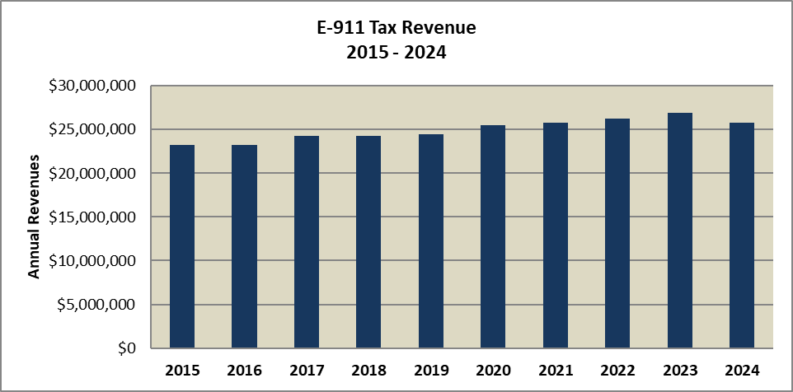



Data Sources: King County EBS – Accounts 31741, 31742, 40003 (2013 –present), 41741 (2009 – 2012), 31364 as of 5-1-25

In 2011, the E-911 excise tax rate limit was raised to $0.70 per month from $0.50 per month. Revenue growth slowed to 0.85% in 2013 but increased again in 2014 with the tax being collected on pre-paid wireless service. With a fixed tax rate of $0.70 per month per line, growth comes solely from a net increase in new switched, wireless, or VOIP lines available for taxation. The number of switched lines has been decreasing every year as customers give up landlines but the number of wireless and VOIP lines has been growing so the net is that revenue grew slowly until 2024, when they declined 4.1% to $25.8 million.

# Transit Fares

|  |  |  |
| --- | --- | --- |
| **Revenue Description** |  | The County collects fares from Metro bus passengers. |
|  |  |  |
| **Legal Authorization for Collection:** |  | KCC 4A.700.010 establishes the rates of fare for the Transit program |
|  |  |  |
| **Fund:** |  | 000004641 |
| **Account Number(s):**  **Department** |  | 44233, 44234, 44235, 44237, 44249, 44253, 44269  King County Department of Transportation – Metro Transit Division |
|  |  |  |
| **Source:** |  | Fares paid by Metro bus users |
| **Use:** |  | Public transportation purposes |
|  |  |  |
| **Fee Schedule:** |  | Fares vary based on user type and payment method. |
| **Method of Payment:** |  | Various |
| **Frequency of Collection:** |  | Paid by purchasers at time of transaction. |
| **Exemptions:** |  | The code supports “Special Rates of Fares” which provides authority for promotional or discounted rates in limited circumstances.  The code also supports the regional collection and sharing of fares through the ORCA Interlocal agreement. |
| **Enacted / Expiration:**  **Special Requirements:** |  | Metro enacted in 1973 / No Expiration  Revenues from this source are to be used exclusively for transportation. |
| **Revenue Collector:** |  | King County Department of Transportation – Metro Transit Division |
| **Distribution:**  **Restrictions:**  **Budgeting:**  **Forecast:** |  | N/A  N/A  Budgeted in Fund 4641, Acct 44269  Provided by King County Department of Transportation – Metro Transit Division |
|  |  |  |

**Fiscal History**

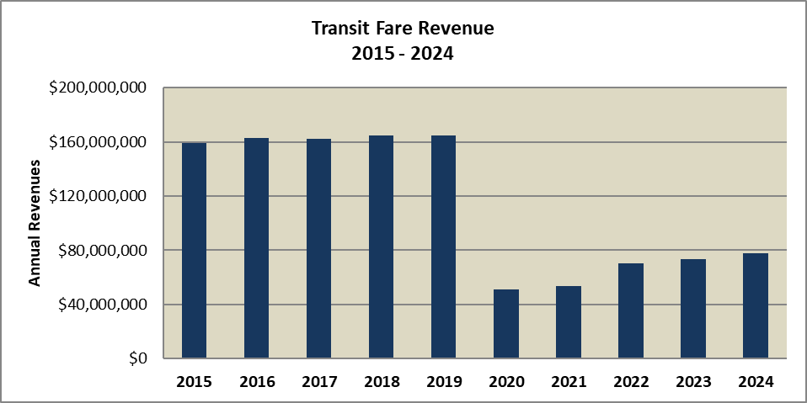



Data Sources: King County EBS – Accounts 44233, 44234, 44235, 44237, 44249, 44253, 44269 as of 5-1-25

Transit revenue is based on the annual adopted bus fares and ridership. Transit fare revenue increased each year between 2012 and 2016, before declining slightly in 2017. Fare revenue rebounded a bit in 2018, collecting $164.8 million and remained at $164.7 million in 2019. In 2020, revenues plummeted by 69% to $51.3 million as the COVID-19 pandemic greatly decreased ridership and the County suspended collection of transit fares. Low revenue collection continued in 2021 with only a 4.4% rebound in transit fares from 2020. Transit fares did have a strong 2022 with 31.5% year over year growth to hit $70.4 million. Slower growth followed in 2023 and 2024, with $77.8 million collected in 2024, still 53% lower than the pre-pandemic high in 2019.

# Rental Car Sales Tax

|  |  |  |
| --- | --- | --- |
| **Revenue Description** |  | A tax levied on the rental of a passenger car for a period of less than 30 days. |
|  |  |  |
| **Legal Authorization for Collection:** |  | Revised Code of Washington RCW 82.08.020 |
|  |  |  |
| **Fund:** |  | 000001290 |
| **Account Number(s):**  **Department** |  | 31311  Department of Natural Resources and Parks |
|  |  |  |
| **Source:** |  | Paid by the consumer at the time of sale |
| **Use:** |  | Youth amateur sports grants |
|  |  |  |
| **Fee Schedule:** |  | 7.7 percent sales tax |
| **Method of Payment:** |  | Various |
| **Frequency of Collection:** |  | Paid by purchasers at time of transaction. |
| **Exemptions:** |  | There are numerous sales tax exemptions as described in RCW 82.08 |
| **Enacted / Expiration:**  **Special Requirements:** |  | 1992 / No Expiration  Revenues are to be used exclusively to fund youth sports grants. |
| **Revenue Collector:** |  | Washington State Department of Revenue (DOR) |
| **Distribution:**  **Restrictions:**  **Budgeting:**  **Forecast:** |  | 1 percent of the total is distributed to King County, with the remainder allocated to the State (5.9 percent) and to the Regional Transit Authority (0.8 percent)  N/A  Budgeted in Fund 1290, Account 31311  Provided by King County Office of Economic and Financial Analysis (OEFA) |
|  |  |  |

**Fiscal History**

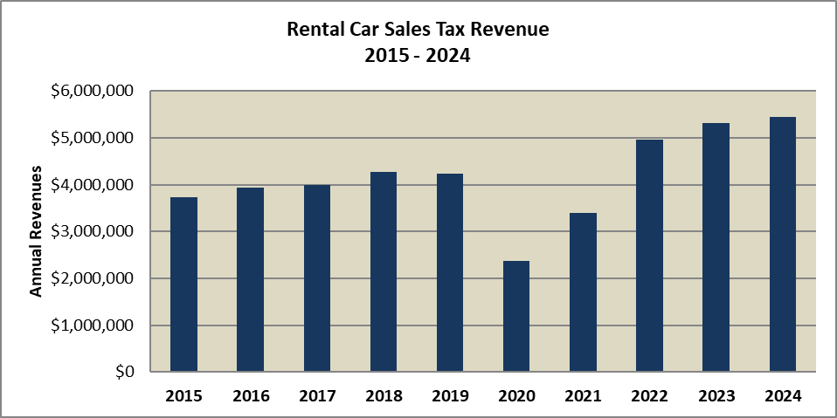



Data Sources: Washington State Department of Revenue

Rental car tax revenue correlates with tourism activity in King County. Revenues have increased most years, with the notable exception of 2020 when tourist activity fell during the COVID-19 pandemic. Revenues rebounded in 2021 and were back above pre-pandemic levels in 2022 through 2024. The $5.4 million in revenue collected in rental car taxes in 2024 was only small increase from the prior year, indicating a slowing of the growth of this tax.

# Gambling Tax

|  |  |  |
| --- | --- | --- |
| **Revenue Description** |  | A tax levied on gambling activities such as bingo, raffles, pull tabs, and card playing |
|  |  |  |
| **Legal Authorization for Collection:** |  | Revised Code of Washington RCW 9.46.110 |
|  |  |  |
| **Fund:** |  | 000000010 |
| **Account Number(s):** |  | 31751 (Punch Boards and Pulltabs), 31752 (Bingo and Raffles), 31753 (Amusement Games), 31754 (Card Rooms) |
|  |  |  |
| **Source:** |  | Paid by the business or organization conducting gambling activity |
| **Use:** |  | General Fund |
|  |  |  |
| **Fee Schedule:** |  | Varies by gambling activity and the type of organization conducting the activity |
| **Method of Payment:** |  | Various |
| **Frequency of Collection:** |  | Paid quarterly by businesses and non-profit organizations conducting gambling activity |
| **Exemptions:** |  | There are numerous exemptions as described in RCW 9.46.110 |
| **Enacted / Expiration:** |  | 1973 (local) and 1941 (state gambling tax) / No Expiration |
| **Revenue Collector:** |  | King County Treasury |
| **Distribution:**  **Restrictions:**  **Budgeting:**  **Forecast:** |  | King County Treasury  N/A  Budgeted in Fund 0010  Provided by King County Office of Economic and Financial Analysis (OEFA) |
|  |  |  |

**Fiscal History**

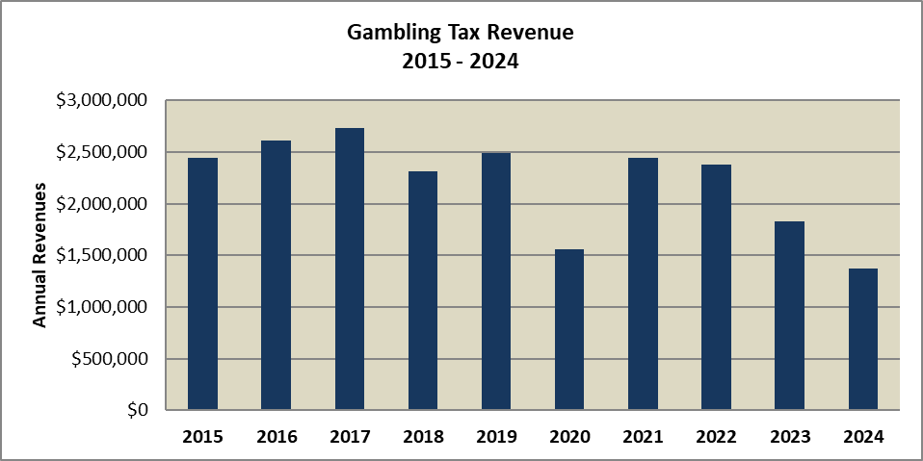



Data Sources: King County EBS – Accounts 31751, 31752, 31753, and 31754 as of 06-05-25

Gambling taxes are collected on gambling and gaming activity in unincorporated areas of King County. With the lack of annexations in recent years, pre-pandemic revenues were relatively stable. Like most taxes, gambling taxes fell significantly in 2020 due to business closures in response to the COVID-19 pandemic. In 2021, taxes increased nearly 57% but were still not at pre-pandemic levels. Then in 2023, gambling taxes declined significantly, to $1.8 million, down 23% from the year prior. Revenue declined sharply again in 2024 to $1.37 million, down 25% and below 2020’s pandemic affected level of $1.56 million.

1. The limit is the minimum of 1% or the June-to-June change in the value of the implicit price deflator for personal consumption expenditures. However, if the IPD governs, the county can still increase the levy by 1% by passing a substantial need ordinance.
2. In unincorporated areas, there is no city levy, but Washington State authorized a county road levy of up to $2.25/$1,000 of AV.
3. 3 per KC Assessor.
4. For a full discussion of property and other taxes, see *A Revenue Guide for Washington Counties*, Municipal Research and Services Center, February 2019.

   http://mrsc.org/getmedia/4865001B-1F63-410A-A5ED-8D1AD8D752F3/countyrg10.aspx
5. Enumclaw and Maple Valley levies 8.9%, Duvall levy 9.0%, Covington and North Bend levies 9.1%, Snoqualmie levy 9.2%, Kirkland, Issaquah, Lake Forest Park, Redmond, Yarrow Point, and Renton levy 10.3%, Seattle levies 10.35%, and Shoreline levies 10.4%
6. The metro transit tax rate is 0.6% on large lodging facilities.
7. **See King County Code 10.12.021, Fees for Use of Disposal Sites** (<http://www.kingcounty.gov/council/legislation/kc_code/13_Title_10.aspx>)